

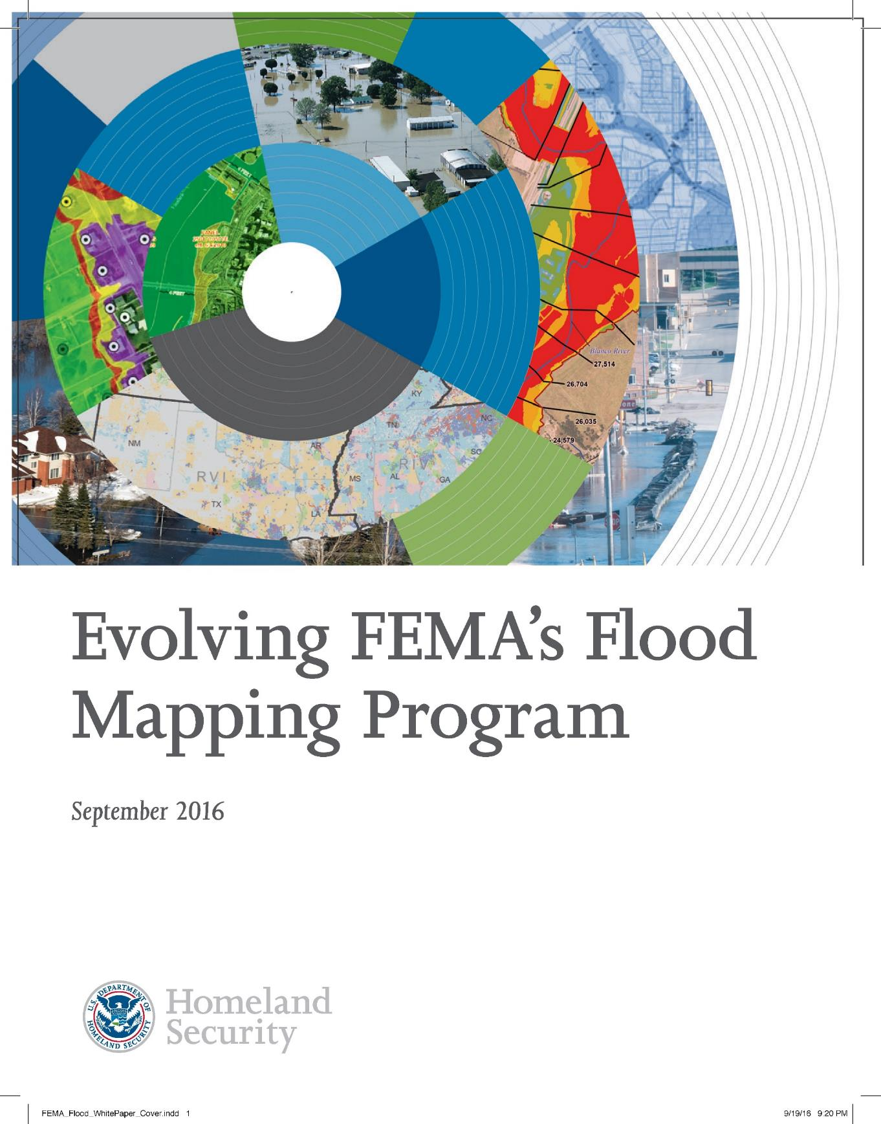

Report Prepared for:
9/5/2025
Base Level Engineering Report
Middle Canadian-Trujillo Watershed (11090101)
CASE NUMBER: 22-06-0048S

September 5, 2025

TWDB (Texas Water Development Board)
1700 Congress Avenue
Austin, TX 78701

Report Prepared by:

Gauge Engineering, LLC
11750 Katy Freeway, Ste. 400
Houston, TX 77079


Maestas & Associates, LLC
8122 Datapoint Drive, Ste. 840
San Antonio, TX 78229

Document History
Document Location
K:/FY2022/22-06-0048S

Revision History
Version Number | Version Date | Summary of Changes | Author
1.0 | 7/7/2023 | Initial M1 Submittal | Gavin Wood/ Ian Hudson
1.1 | 9/22/2023 | M1 Backcheck Submittal | Gavin Wood/ Ian Hudson/ Douglas Campbell
1.2 | 7/12/2024 | Initial M2 Submittal | Shelby Chasteen
2 | 9/5/2025 | M3 Submittal | Douglas Campbell

Table of Contents
Executive Summary 7
1 Introduction and Project Scope 9
2 Topographic and Watershed Data 12
2.1 Terrain Data Development 12
2.2 Final Seamless DEM 14
2.3 Watershed Data Development 14
2.4 Final Arc Hydro Data Model 14
2.4.1 Arc Hydro Data Model (Geodatabase and Rasters) 14
2.4.2 Hydrography Data (Geodatabase) 15
2.5 Task 1 (Phase 01 and Phase 02) Submitted Deliverables 15
3 Hydrology 17
3.1 Infiltration Parameters 18
4 Hydraulics 20
4.1 2D Computational Mesh and Settings 20
4.1.1 Model Computational Settings 21
4.2 Breaklines and Refinement Regions 21
4.2.1 Breaklines 21
4.2.2 Mesh Refinement Regions 22
4.3 Manning’s Roughness Coefficients and Land Use 24
4.4 Terrain Modification 25
4.5 HUC8 Model Integration 25
4.5.1 Upper Canadian (1108) and Horse Creek (1109010101) Boundary 28
4.5.2 Horse Creek (1109010101) and Minneosa Creek (1109010102) & Romero Creek – Canadian River (1109010106) Boundary 29
4.5.3 Arroyo Trujillo (1109010103), Trujillo Creek (1109010104), & Mujares Creek-Trujillo Creek (1109010105) and Minneosa Creek (1109010102) & Romero Creek – Canadian River (1109010106) Boundary 31
4.5.4 Minneosa Creek (1109010102) & Romero Creek – Canadian River (1109010106) and Alamocitos Creek – Canadian River (1109010107) Boundary 33
4.6 Calibration and Validation 34
4.6.1 Comparison to USGS Regression Estimates for Unregulated Streams and Watersheds 36
4.7 Results 37
4.7.1 Comparison to Existing Study Data 37
4.7.2 Challenges and Recommendations 37
4.7.3 Crossing Profile Errors 37
4.7.4 Modeled Results 40
5 Quality Control 42
6 Floodplain Delineation (10%, 1% and 0.2% events) 43
6.1 Internal Mapping Tie-Ins 43
6.2 Hazus 43
6.3 Special Consideration 43
7 CNMS Validation of Effective Zone A Special Flood Hazard Area (SFHA) 44
7.1 Deliverables 47
References 48
Appendix A – Bulletin 17C Statistical Analysis Technical Memo and Peak FQ Output 50
Appendix B – HEC-HMS Model Development for Upstream Inflows 51

List of Figures
Figure 1-1. Middle Canadian-Trujillo watershed (11090101) – HUC8 Basin 11
Figure 2-1. Extent and coverage of LiDAR Data as it relates to project watershed. 13
Figure 3-1 – Example of HUC10 Hyetograph for 1% Annual-Chance Storm 17
Figure 4-1. Overview of HUC8 Scale Breaklines for Middle Canadian-Trujillo watershed 22
Figure 4-2. Example of Refinement Region Polygon 23
Figure 4-3. Overview of HUC8 Scale Mesh Refinement Regions for Middle Canadian-Trujillo Watershed 23
Figure 4-4. Example of localized original terrain (left) and terrain after addition of modification layer (right) 25
Figure 4-5. Overview of HUC8 with HUC10 Model Connectivity 26
Figure 4-6. SA/2D Normal Depth sensitivity and placement example 27
Figure 4-7 - Upper Canadian (1108) and Horse Creek (1109010101) Boundary Plan View 29
Figure 4-8 - Horse Creek (1109010101) and Minneosa Creek (1109010102) & Romero Creek – Canadian River (1109010106) Boundary Plan View 30
Figure 4-9 - Arroyo Trujillo (1109010103), Trujillo Creek (1109010104), & Mujares Creek-Trujillo Creek (1109010105) and Minneosa Creek (1109010102) & Romero Creek – Canadian River (1109010106) Boundary Plan View 32
Figure 4-10 - Minneosa Creek (1109010102) & Romero Creek – Canadian River (1109010106) and Alamocitos Creek – Canadian River (1109010107) Boundary Plan View 33
Figure 4-111. HUC 1109010101 Profile Plot-all modeled events 38
Figure 4-122. HUC 1109010102-06 Profile Plot-all modeled events 38
Figure 4-13. HUC 1109010103-04-05 Profile Plot-all modeled events 39
Figure 7-1. CNMS Validation Results 47

List of Tables
Table 0-1: Summary of Stream Miles 7
Table 0-2: Zone A Validation Results 7
Table 1-1. BLE Task Configuration 9
Table 2-1: LiDAR Data Sources 12
Table 3-1. Atlas 14 Rainfall Volumes for HUC11100202 18
Table 3-2. SCS Hydrologic Soil Groups and Infiltration Parameters (Source: USACE 2022) 18
Table 3-3. Land use -Soils -CN Matrix for Computing Initial Curve Numbers (Source: USGS 2015) 19
Table 4-1. HUC10 Mesh Parameters 20
Table 4-2. Manning's N Values 24
Table 4-3. Imperviousness Values (Source: USDA Urban Hydrology for Small Watersheds (TR-55)) 25
Table 4-3. HUC10 Model Integration Summary 28
Table 4-4 Upper Canadian (1104) and Horse Creek (1109010101) Boundary Continuity – all modeled events 29
Table 4-5 Horse Creek (1109010101) and Minneosa Creek (1109010102) & Romero Creek – Canadian River (1109010106) Continuity – all modeled events 31
Table 4-6 Arroyo Trujillo (1109010103), Trujillo Creek (1109010104), & Mujares Creek-Trujillo Creek (1109010105) and Minneosa Creek (1109010102) & Romero Creek – Canadian River (1109010106) Continuity – all modeled events 32
Table 4-7 Minneosa Creek (1109010102) & Romero Creek – Canadian River (1109010106) and Alamocitos Creek – Canadian River (1109010107) Continuity – all modeled events 34
Table 4-7. 1% Annual Storm Calibration Results Summary for Middle Canadian-Trujillo watershed 36
Table 4-8. 10% Storm Results Summary for Middle Canadian-Trujillo watershed 40
Table 4-9. 1% Storm Results Summary for Middle Canadian-Trujillo watershed 40
Table 4-10. 0.2% Storm Results Summary for Middle Canadian-Trujillo watershed 41
Table 7-1: Zone A Initial Assessment Results 45
Table 7-2: Zone A Validation Results 46
Table 7-3: BLE Comparison Results 46

Acronyms
AAL | Average Annualized Loss
BLE | Base Level Engineering
CN | Curve Number
CNMS | Coordinated Needs Management Strategy
DEM | Digital Elevation Map
FEMA | Federal Emergency Management Agency
GIS | Geographic Information System
HAZUS | Hazards United States
HC | Hydraulic Connector
H&H | Hydrology and Hydraulics
HUC | Hydrologic Unit Code
LiDAR | Light Detection and Ranging
NAVD | North American Vertical Datum
NHD | National Hydrography Dataset
NID | National Inventory of Dams
NLCD | National Land Cover Database
NRCS | Natural Resources Conservation Service
SCS | Soil Conservation Service
SFHA | Special Flood Hazard Area
TNRIS | Texas Natural Resource Information Systems
TWDB | Texas Water Development Board
USACE | United States Army Corps of Engineers
USGS | United States Geological Survey
WSEL | Water Surface Elevation
QA/QC | Quality Assurance/Quality Control

Executive Summary
The Texas Water Development Board’s (TWDB) statewide floodplain modeling and mapping project is part of the TWDB’s effort to understand and evaluate regional flood risks to drive statewide efforts in the creation of effective flood mitigation strategies in Texas. Stantec Consulting Services, Inc. (Stantec) is working with TWDB to develop base level engineering (BLE) floodplain modeling and mapping studies with a multi-year contract that will include two-dimensional (2D) riverine model development, floodplain and flood hazard mapping, and Coordinated Needs Management Strategy (CNMS) data development for FEMA Region 6. This report summarizes the BLE hydrologic and hydraulic (H&H) analyses performed by Stantec for the Middle Canadian-Trujillo (11090101) watershed, as part of CONTRACT 177312017, Task Order # 3. A summary of the study parameters and results for the Upper Wolf watershed is provided below in Table 0-1 and Table 0-2.

Table 0-1: Summary of Stream Miles
Source | Stream Miles
Current Inventory – CNMS (S_Studies_Ln) | 1 mi
New Study Streams – CNMS  (S_Unmapped_Ln)  Informed by NHD 1:100 | 2,435 mi
Total (BLE) Stream Miles | 2,436 mi

Table 0-2: Zone A Validation Results
Validation Status | CNMS Validation Status | CNMS Project Start | CNMS Post-BLE Assessment | Total Miles
VALID | NVUE COMPLIANT | 0 mi | 0 mi | 0 mi
UNKNOWN | Deferred, To Be Assessed and  To Be Studied | 0 mi | 0 mi | 0 mi
UNVERIFIED | TO BE STUDIED | 0.5 mi | 0.5 mi | 0.5 mi

TWDB contracted Stantec under Task Order #3 to complete a BLE analysis for the following HUC8-scale watersheds in the Middle Canadian River (110901) and Lower Beaver (111002) basins and Texas flood planning region:
- Middle Canadian-Trujillo - #11090101
- Punta de Agua - #11090102
- Rita Blanca - #11090103
- Lake Meredith - #11090105
- Middle Canadian-Spring - #11090106
- Upper Wolf - #11100202

The BLE Analysis under this Task Order was divided into five tasks covered in this report:
- Task 1 – Terrain Development (Section 2)
- Task 2 – Hydrologic and Hydraulic Analysis (Section 3 and 4)
- Task 3 – Floodplain Mapping (Section 6)
- Task 4 – Average Annualized Loss (AAL) Analysis
- Task 5 – CNMS (Section 7)

Introduction and Project Scope
TWDB contracted Stantec under Task Order # 3 to complete a BLE analysis for the following National Hydrography Dataset (NHD) Hydrologic Unit Code 8 (HUC8) scale watersheds in the Middle Canadian River (110901) and Lower Beaver (111002) basins and Texas flood planning region:
- Middle Canadian-Trujillo - #11090101
- Punta de Agua - #11090102
- Rita Blanca - #11090103
- Lake Meredith - #11090105
- Middle Canadian-Spring - #11090106
- Upper Wolf - #11100202
The Middle Canadian-Trujillo HUC8 watershed comprises a total of approximately 1,850 sq miles of drainage area, and 3,300 stream miles spanning portions of northeastern New Mexico and the western Texas Panhandle. Results of this study affect the Texas counties of Hartley, Oldham, and Deaf Smith. New Mexico counties overlapped include Union, Harding, Quay, and Curry.
The BLE process involves using best available data and incorporating automated techniques with traditional hydrologic and hydraulic model development procedures to produce regulatory quality flood hazard boundaries for the 1-percent-annual-chance event as well as estimates of flood hazard boundaries for multiple recurrence intervals. The BLE analysis under this Task Order was divided into six tasks, most of which are covered in this report:
- Task 1 – Terrain Development (Section 2)
- Task 2 – Hydrologic and Hydraulic Analysis (Section 3 and 4)
- Task 3 – Floodplain Mapping (Section 6)
- Task 4 – Average Annualized Loss (AAL) Analysis
- Task 5 – CNMS (Section 7)
- Task 6 – Project Management (includes community outreach)
A breakdown of each task is summarized in Table 1-1.
Table 1-1. BLE Task Configuration
Task ID | Task | Task Phase ID | Task Phase
1 | Terrain Data Development | 1.1 | Phase1: Seamless HUC8 DEM
1 | Terrain Data Development | 1.2 | Phase2: Streams and sub-watersheds
1 | Terrain Data Development | 1.3 | Phase3: Incremental deliverables, report, internal QA/QC
1 | Terrain Data Development | 1.4 | Phase4: Independent QA/QC (Respond/Resolve comments only)
2 | Hydrology and Hydraulic Analyses | 2.1 | Phase1: Draft HEC-RAS Model
2 | Hydrology and Hydraulic Analyses | 2.2 | Phase2: Model Adjustments/Calibration
2 | Hydrology and Hydraulic Analyses | 2.3 | Phase3: Multi-frequency Runs
2 | Hydrology and Hydraulic Analyses | 2.4 | Phase4: Incremental deliverables, report, internal QA/QC
2 | Hydrology and Hydraulic Analyses | 2.5 | Phase5: Independent QA/QC (Respond/Resolve comments only)
3 | Floodplain Mapping & Grids | 3.1 | Phase1: Mapping/Grid products and Geodatabase
3 | Floodplain Mapping & Grids | 3.2 | Phase2: Incremental deliverables, report, internal QA/QC
3 | Floodplain Mapping & Grids | 3.3 | Phase3: Independent QA/QC (Respond/Resolve comments only)
4 | Hazus Estimation (Level2) | 4.1 | Phase1: Loss Estimation and Geodatabase
4 | Hazus Estimation (Level2) | 4.2 | Phase2: Incremental deliverables, report, internal QA/QC
4 | Hazus Estimation (Level2) | 4.3 | Phase3: Independent QA/QC (Respond/Resolve comments only)
5 | CNMS | 5.1 | Phase1: Round1 CNMS
5 | CNMS | 5.2 | Phase2: Independent QA/QC (Respond/Resolve comments only)
5 | CNMS | 5.3 | Phase3: Round2 CNMS
5 | CNMS | 5.4 | Phase4: Independent QA/QC (Respond/Resolve comments only)
6 | Project Management | 6.1 | Project Kickoff & Community Outreach
6 | Project Management | 6.2 | TWDB Coordination/Invoicing/Reporting
6 | Project Management | 6.3 | FEMA/USGS Coordination and Project Closeout

The BLE results from this study may be used for eventual production of regulatory and non-regulatory products. This report describes the BLE analysis performed for the Middle Canadian-Trujillo watershed (Figure 1-1) which includes coverage of Hartley, Oldham, and Deaf Smith counties in Texas.
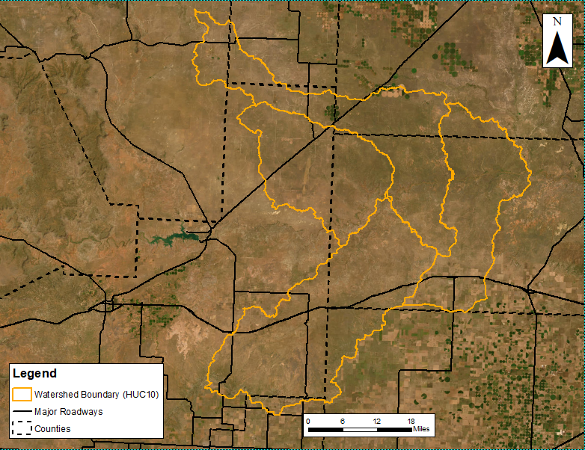
Figure 1-1. Middle Canadian-Trujillo watershed (11090101) – HUC8 Basin
The BLE assessment prepared cursory engineering analysis for approximately 1,800 miles of stream reaches within the Middle Canadian-Trujillo watershed with a minimum drainage area tolerance of one square mile. The selection and extent of stream reaches studied was based upon the number of stream miles with minimum drainage area of one square mile and not the number of effective Zone A stream miles. The following sections will summarize the BLE process and will discuss the results along with their recommended use.

Topographic and Watershed Data

Terrain Data Development
This HUC8 watershed is covered by three data sources: Texas Panhandle 2018 D18, NM Northeast 2018, and NM Roosevelt Curry 2015 Lidar projects obtained from the United States Geological Survey (USGS). These data sources cover the entirety of the Middle Canadian-Trujillo HUC8 11090101 boundary.
The individual Digital Elevation Model (DEM) tiles from the data sources were used to create one seamless DEM mosaic for Middle Canadian-Trujillo using various methodologies and tools in ESRI’s ArcGIS Pro 2.9.2 environment as described below.
The HUC8_11090101_20221021 seamless DEM was developed by cataloging the tiles then mosaicking them into one DEM while maintaining the original projection and raster cell values (vertical coordinate system NAD 1983 UTM Zone 14N; horizontal coordinate system GCS North American 1983; 1-meter by 1-meter); this was done for each individual data source applicable to the project watershed. The raster was converted from values in meters to values in feet. Then, the DEM was re-projected into the NAD83 Texas North FIPS 4201 (US Feet) NAVD 1988 horizontal coordinate system and clipped to a one-mile buffer based on the NHD HUC8 boundary.
In instances where the watershed was covered by multiple overlapping data sources, the mosaicking process prioritized using the most recent data source within the overlapping area. Otherwise, a Blend option was used in areas where tiles may overlap with one another.
Table 2-1: LiDAR Data Sources
County¹ | Age/Year | Accuracy | Source & Contact | Approximate Footprint (Sq Mi)
Texas: Deaf Smith, Oldham, and Hartley counties. | February 9, 2018 – May 20, 2018 | DEM VVA RMSEz at 95th Percentile 0.218 m  DEM NVA RMSEz at 95% Confidence Level 0.072 m | United States Geological Survey (USGS) | 34,005⁴
New Mexico: Harding, Quay, and Union counties | November 20, 2017 – February 11, 2018 | Horizontal²: USGS QL2  Vertical³: NVA 0.1 meters using QL2 or better quality lidar data with USGS Base Spec v1.2 products | United States Geological Survey (USGS) | 16,019⁴
New Mexico: Curry County | September 30, 2015 – March 25, 2016 | Horizontal²: USGS QL2  Vertical²: NVA of 0.078 meters using QL2 or better quality lidar data with USGS Base Spec v1.2 products | United States Geological Survey (USGS) | 4,032⁴
¹Counties listed are only those applicable to current project watershed.
²Explicit accuracy not specified in the report.
³Accuracy derived from original Lidar project report.
⁴Area reported reflects coverage of entire lidar project beyond the current project watershed.

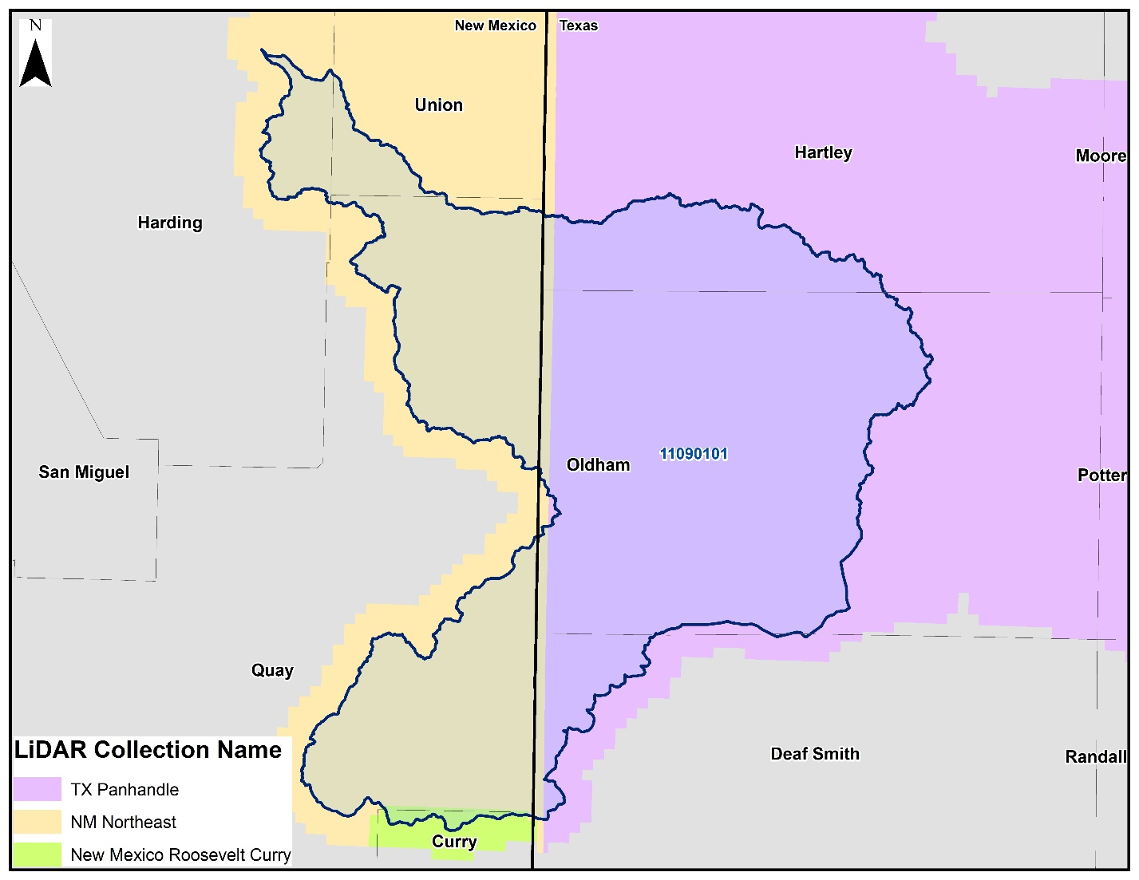
Figure 2-1. Extent and coverage of LiDAR Data as it relates to project watershed.

Final Seamless DEM
The final DEM developed covers the project watershed (plus additional tile extensions were incorporated for modeling purposes), has been re-projected into the local State Plane horizontal coordinate system: NAD 1983 State Plane Texas North FIPS 4201 Feet and the vertical coordinate system of NAVD88 height (ft US). The raster cells values were adjusted from meters to feet. The DEM is a 32-Bit floating point with a single band (1) and 3.28084 by 3.28084 feet cell size.

Watershed Data Development
The primary data source for this phase was the seamless DEM developed in the first phase. The seamless DEM was the basis for subsequent processing using the Arc Hydro toolset. The Arc Hydro processing steps outlined below create output that collectively creates the Arc Hydro data model for this watershed.
- Hydro DEM
- Fill Sinks
- Flow Direction
- Flow Accumulation (Spatial Analyst Tools)
- Stream Definition (0.5 sq mile threshold used)
- Stream Segmentation
- Catchment Grid Delineation
- Catchment Polygon Processing
- Drainage Line Processing
- Adjoint Catchment Processing
- Watershed Delineation
The final data products from this phase include a geodatabase developed using Arc Hydro tools, a collection of rasters developed using Arc Hydro tools, a geodatabase containing the drainage lines within the study watershed, and a new HUC8 watershed boundary.

Final Arc Hydro Data Model
The final watershed data is composed of an Arc Hydro data model and hydrography data. The Arc Hydro data model contains vector, raster, and tabular data outputs from using the various Arc Hydro and Spatial Analyst processing tools in ESRI’s ArcGIS Pro 2.x environment. The hydrography data contains streams that represent drainage of at least 0.5 square mile, the raw watershed delineation from ArcHydro, updated HUC8 watershed boundary smoothed with a 10-foot tolerance, and a comparison between the NHD HUC8 watershed boundary and the projection watershed delineation.
All data submitted, vector and raster, is in NAD83 Texas North FIPS 4201 (US Foot) NAD 1988 horizontal coordinate system.

Arc Hydro Data Model (Geodatabase and Rasters)
- Geodatabase (.gdb)
  - ArcHydro (feature dataset)
    - Adjoint Catchment – An adjoint catchment is the total upstream area (if any) draining into a single catchment.
    - Catchment – Polygon feature class out of the catchment grid.
    - DrainageLine – Streamline line feature class derived from stream link grid.
  - APUNIQUEID – A table created and managed through Arc Hydro tools; contains the last hydro identifier assigned to a new feature within the geodatabase.
- Rasters (.tif)
  - Hydro DEM (HydroDEM) – A modified DEM with hydro-connections burned into the data allowing possible flow to pass through certain hydraulic obstructions. The hydro DEM will have a distinct flow path represented through features such as dams, culverts, and bridges. This raster is used for building the Arc Hydro data model and not intended to be used in place of the Seamless DEM or for purposes where elevation accuracy is important.
  - Catchment Grid (Cat) – Drainage areas for segments in the stream link grid or sinks in the sink link grid.
  - Flow Accumulation Grid (Fac) – Created from the flow direction grid; each cell value represents the total quantity of upstream cells draining to that cell.
  - Flow Direction Grid (Fdr) – Represents the direction of flow from a given cell; 8 different directional values are possible based on the eight-direction (D8) flow model.
  - Fill Sinks Grid (Fill) – Gridded DEM with sinks or depressions removed.
  - Stream Grid (Str) – A stream grid with cells from a flow accumulation grid that exceed a user defined cell count and/or area threshold.
  - Stream Link Grid (StrLnk) – A stream grid with unique values for every link between two stream junctions.

Hydrography Data (Geodatabase)
- Drainage Lines – Drainage lines from the Arc Hydro data modeling within the study HUC8.
- NHD WBD Watershed – The NHD HUC8 boundary downloaded from USGS National Hydrography Dataset representing the project area.
- Raw Watershed Delineation – The direct output from ArcHydro data model of the HUC8 watershed delineation.
- Raw Watershed Delineation Point – The point at which ArcHydro created the Raw Watershed Delineation boundary based on elevations within the Seamless DEM created in Task 1 Phase 1.
- Watershed – A watershed delineation developed through Arc Hydro smoothed to a 10-foot tolerance and based on the elevations within the Seamless DEM created in Task 1 Phase 1.
- Watershed Comparison – A comparison of the Watershed feature class and the NHD WBD HUC8 feature class boundary.

Task 1 (Phase 01 and Phase 02) Submitted Deliverables
- Final
  - Bare_Earth_DEM
    - One seamless DEM covering the boundary of the HUC with a one-mile buffer (.tif)
    - Tile index covering extent of DEM (.shp)
  - ArcHydro_Data_Model
    - Arc Hydro Geodatabase (.gdb)
    - Arc Hydro Rasters (ESRI grid or .tif)
    - Hydrography (.gdb)
- Independent QA/QC
  - Documentation related to independent review of task submittal
- Spatial Files
  - L_Source_Cit table (.dbf)
  - S_Submittal_Info (.shp) – reflects project watershed boundary that final data will be clipped too.
- Supplemental Data
  - Tile index for each elevation data source (.shp/.gdb)
  - Any additional information or data collected and used in preparation of this project task
- Task Documentation
  - Draft Report – only includes sections applicable to Task 1
Terrain Metadata - .xml

Hydrology
TWDB Task Order 3 used balanced hyetographs derived from HMS 4.10 as rain-on-grid precipitation input. Inputs into the HMS model were the model boundary and the basin-mean Atlas-14 precipitation frequency values for the 10pct, 4pct, 2pct, 1pct, 0_2pct, 1PLUpct and 1MINpct for durations of 5-minutes, 15-minutes, 1-hour, 2-hours, 3-hours, 6-hours, 12-hours and 1-day. The intensity duration was set to 5-minutes and positioned to peak at the center of the time-series (24-hours). The hyetograph with aerial reduction was applied within HMS using TP40-TP49, where area was taken as the area of the input model boundary. All other input variables were set to “--None--“, and a depth-area analysis was performed from 0000 01JAN2000 to 0000 02JAN2000 at a 5-minute interval (HEC-HMS User’s Manual, Version 4.2, 2016). See Figure 3-1 below for an example of the resulting hyetograph for HUC10-scale model 1109010101, 1pct event.
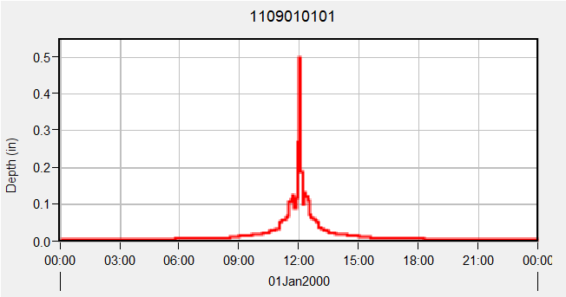
Figure 3-1 – Example of HUC10 Hyetograph for 1% Annual-Chance Storm
Note that the hyetographs (example shown in Figure 3-1) used for this BLE study are not smooth. This is anticipated when developing nested, storm frequency hyetographs and using a small timestep. The graphs can be smoothed by increasing the hyetograph timestep, but HEC-HMS 4.10 recommends users set their output timestep equal to the minimum storm duration being considered.
The Middle Canadian-Trujillo HUC8 watershed consists of a seven HUC10 basins. Four HMS models were created for the HUC8 catchment. The resulting rainfall volumes for all modeled events are summarized in Table 3-1 below:
Table 3-1. Atlas 14 Rainfall Volumes for HUC11100202
HUC10 Models | Event Duration | Rainfall Volume (inches)
HUC10 Models | Event Duration | 10YR | 25YR | 50YR | 100YR | 500YR | 100PLUS | 100MINUS
1109010101 | 24-Hour | 3.59 | 4.38 | 5.02 | 5.70 | 7.49 | 6.37 | 5.04
1109010102/6 | 24-Hour | 3.59 | 4.39 | 5.04 | 5.73 | 7.57 | 6.57 | 4.89
1109010103/4/5 | 24-Hour | 3.51 | 4.29 | 4.92 | 5.59 | 7.41 | 6.26 | 4.92
1109010107 | 24-Hour | 3.62 | 4.44 | 5.09 | 5.79 | 7.76 | 6.89 | 4.69

Infiltration Parameters
The infiltration layer containing attributes for Soil Conservation Service (SCS; now the Natural Resources Conservation Service (NRCS)) curve numbers (CN), abstraction ratio, and minimum infiltration rate (Table 3-2) was developed in ArcGIS using the National Land Cover Database (NLCD) and NRCS soil data from the USGS Soils Survey Geographic Database (SSURGO) (SSURGO 2020; MRCL 2019).
Table 3-2. SCS Hydrologic Soil Groups and Infiltration Parameters (Source: USACE 2022)
Hydrologic Soil Group | Range of Loss Rates (in./hour) (SCS 1986) | Base Model Loss Rates (in./hour) *
A – deep sand, deep loess, aggregated silts | 0.30 – 0.45 | 0.38
B – shallow loess, sandy lam | 0.15 – 0.30 | 0.23
C – clay loams, shallow sandy loam, soils low in organic content, and soils usually high in clay | 0.05 – 0.15 | 0.10
D – Soils that swell significantly when wet, heavy plastic clays, and certain saline soils | 0.00 – 0.05 | 0.025
* Base minimum infiltration rate chosen based HEC-RAS 6.3 technical guidance manual

A land-use – soils – CN table (Table 3-3) was used to determine CN values for the study area. This table was acquired from a USGS study in the Upper Colorado River Basin but is a composite of published data (USGS 2015). Provided that the table in the HEC-RAS manual requires assumptions or investigation outside the scope of a BLE study, it is believed these reported values more accurately represent the study area. This table was set up to calculate a base infiltration raster layer which was input and processed in each hydraulic model; initial abstraction for the base layer was set to an abstraction ratio of 0.2 based on HEC-RAS 2D user’s manual (USACE 2021). The base infiltration layer was processed in HEC-RAS RASMapper to create a spatially distributed raster dataset of the infiltration parameters. The base infiltration parameters, CN and abstraction ratio, were adjusted to calibrate the HEC-RAS hydraulic model response to the Bulletin 17C gage analysis for the 1% annual-chance storm event where adequate gages records were available. Additional discussion on model calibration is discussed in Section 4.6.

Table 3-3. Land use -Soils -CN Matrix for Computing Initial Curve Numbers (Source: USGS 2015)
LU_GridCode | NLCD LU Description | Hydrologic Soil Group
LU_GridCode | NLCD LU Description | A | B | C | D
11 | Open Water | 99 | 99 | 99 | 99
12 | Perennial ice/snow | 40 | 40 | 40 | 40
21 | Developed Open Space | 49 | 69 | 79 | 84
22 | Developed Low Intensity | 39 | 61 | 74 | 80
23 | Developed Medium Intensity | 39 | 61 | 74 | 80
24 | Developed High Intensity | 39 | 61 | 74 | 80
31 | Barren Land | 39 | 61 | 74 | 80
41 | Deciduous Forest | 30 | 55 | 70 | 77
42 | Evergreen Forest | 30 | 55 | 70 | 77
43 | Mixed Forest | 30 | 55 | 70 | 77
52 | Shrub Scrub | 30 | 48 | 65 | 73
71 | Herbaceous | 49 | 62 | 74 | 85
81 | Hay Pasture | 39 | 61 | 74 | 80
82 | Cultivated Crops | 51 | 67 | 76 | 80
90 | Woody Wetlands | 72 | 80 | 87 | 93
95 | Emergent Herbaceous Wetlands | 72 | 80 | 87 | 93

Hydraulics
The hydraulic approach for the Middle Canadian-Trujillo watershed’s BLE analysis consisted of developing HUC8-scale two-dimensional (2D) hydraulic models with the Hydrologic Engineering Center’s River Analysis System (HEC-RAS) program version 6.3. Hydraulic routing was performed with an unsteady-state analysis by applying NOAA Atlas 14 spatially varying rainfall data to the final model mesh, which is comprised of the terrain model (described in section 2.1) and the hydrologic inputs (described in Section 3). The models were refined based on USGS historic gages records in the downstream basin (HUC11090105– Lake Meredith) to simulate predictions of WSEL and inundation extent during the 10%, 4%, 2%, 1%, +1%, -1% and 0.2% annual chance events.

The Middle Canadian-Trujillo HUC8 watershed consists of a seven HUC10 basins. Four hydraulic models were created for the HUC8 catchment:
- Horse Creek 1109010101
- Arroyo Trujillo (1109010103), Trujillo Creek (1109010104), & Mujares Creek-Trujillo Creek (1109010105)
- Minneosa Creek 1109010102 & Romero Creek – Canadian River 1109010106
- Alamocitos Creek – Canadian River 1109010107

2D Computational Mesh and Settings
The base computational mesh for the models in the Middle Canadian-Trujillo watershed was developed at a 200 ft x 200 ft grid cell size. Breaklines and refinement regions were implemented to create a higher mesh resolution for both channels with contributing drainage area of at least 1 square mile (0.5 square mile for populated areas) and in areas of terrain elevation change, which is detailed further in section 4.2. The total number of mesh elements, average cell size, and spatial parameters of the HUC8 model for the Middle Canadian-Trujillo watershed are summarized in Table 4-1.
Table 4-1. HUC10 Mesh Parameters
HUC10 Model Name and Number | Size of Study Area (sq mi) | Number of Mesh Elements (grid cells) | Average cell size (sq ft)
Horse Creek 1109010101 | 365.93 | 295,985 | 34,466
Minneosa Creek 1109010102 & Romero Creek – Canadian River 1109010106 | 486.67 | 396,121 | 34,251
Arroyo Trujillo (1109010103), Trujillo Creek (1109010104), & Mujares Creek-Trujillo Creek (1109010105) | 678.95 | 580,091 | 32,629
Alamocitos Creek – Canadian River 1109010107 | 371.92 | 310,953 | 33,344

Model Computational Settings
Models were run using the Diffusion Wave equation set for 2D flow using an adaptive 30-second timestep for each frequency event discussed in this report. Diffusion Wave (simplified Full Momentum) computational method was selected rather than the Shallow Water equations due to hydraulic structures, such as bridges, culverts and dams, not being modeled in detail as part of this BLE study. The Full Momentum equation is typically selected to better account for energy losses in and around structures (USACE 2021). More information on the application of Diffusion Wave Equations versus the Shallow Water equations can be found in the HEC-RAS version 6.3 2D user’s manual.
An adaptive 30-second timestep was applied to iteratively control the maximum courant number below 2 for the duration of each simulation. With the advanced timestep controls in RAS, the adaptive timestep was set with a max allowance of 240 seconds, and a minimum of 3.75 seconds. Courant values of less than or equal to 2 are considered ideal, with 5 considered the maximum acceptable for simulations applying Diffusion Wave computational methods (USACE 2021). The default 2D flow options were applied for the multi-frequency runs.

Breaklines and Refinement Regions
Breaklines and refinement regions were enforced in the model mesh at half the base cell resolution. Refinement regions for smaller tributaries were enforced at higher resolution (general cell size of 100 ft x 100 ft) on a case-by-case basis per engineering judgement. The spatial properties of breaklines and refinement regions for the Middle Canadian-Trujillo watershed model are found in Figure 4-1 and Figure 4-3. The development of these features is described in the following sections.

Breaklines
Breaklines were enforced in the models’ computational meshes for state and federal roadways and dams found in the National Inventory of Dams (NID). Additional breaklines were added using engineering judgement after inspection of individual models to better represent areas such as agricultural ponds, dams, embankments, or other changes in elevation found to be hydraulically significant to a model domain. Breaklines were specifically added in the main reach adjacent to urbanized areas, or individual structures, to capture channel bank geometry correctly in the mesh. An overview of the breaklines for the Middle Canadian-Trujillo watershed is shown in Figure 4-1.
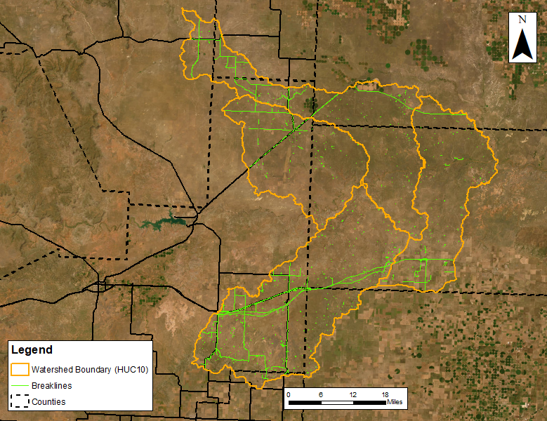
Figure 4-1. Overview of HUC8 Scale Breaklines for Middle Canadian-Trujillo watershed

Mesh Refinement Regions
A mesh refinement region was enforced to provide a more detailed drainage pathway in the computational mesh. A refinement region polygon was developed for each model to represent the bank full flow (Figure 4-2).
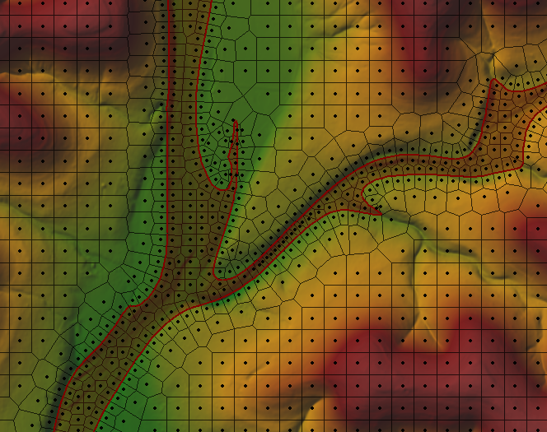
Figure 4-2. Example of Refinement Region Polygon
The refinement region polygon was created using a proprietary ArcGIS python toolbox. The process used a coarse-run (1000x1000-ft cells) 10-year inundation raster in conjunction with orthographically corrected stream centerlines. Aerial imagery and the terrain DEM were used to make any necessary adjustments to the toolbox polygon to more accurately capture bank-full extents. The processed polygon was imported into the model geometry as a refinement region in the HEC-RAS geometry. An overview of the refinement regions for the Middle Canadian-Trujillo watershed is shown in Figure 4-3.
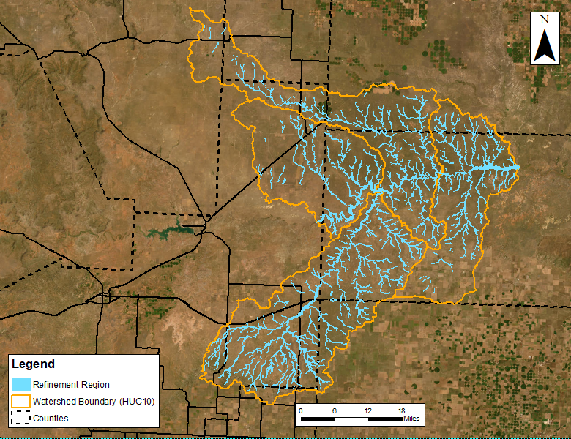
Figure 4-3. Overview of HUC8 Scale Mesh Refinement Regions for Middle Canadian-Trujillo Watershed

Manning’s Roughness Coefficients and Land Use
The 2019 National Land Cover Database (NLCD) Land Use Classification raster was used to develop the Manning’s n roughness coefficients for the study area. Manning’s n selected for the Upper Salt Fork Red watershed are presented in Table 4-2 below. The values selected are within the range of values provided by the Texas Water Development Board’s Base Level Engineering Guidelines (May 2022) and the HEC-RAS 2D manual (USACE 2021).
Table 4-2. Manning's N Values
Land Use Classification | Allowable Range of n values | Middle Canadian-Trujillo  Manning’s Values
Open Water | 0.025 – 0.050 | 0.040
Developed, Open Space | 0.030 – 0.050 | 0.040
Developed, Low Intensity | 0.080 – 0.120 | 0.100
Developed, Medium Intensity | 0.060 – 0.140 | 0.120
Developed, High Intensity | 0.120 – 0.200 | 0.150
Barren Land | 0.023 – 0.300 | 0.025
Deciduous Forest | 0.100 – 0.160 | 0.160
Evergreen Forest | 0.100 – 0.160 | 0.160
Mixed Forest | 0.100 – 0.160 | 0.160
Scrub/Shrub | 0.070 – 0.160 | 0.100
Grassland/Herbaceous | 0.025 – 0.050 | 0.035
Pasture/Hay | 0.025 – 0.050 | 0.030
Cultivated Crop | 0.025 – 0.050 | 0.035
Woody Wetlands | 0.045 – 0.150 | 0.120
Emergent Herbaceous Wetland | 0.050 – 0.085 | 0.070
Manning’s n override region/channels | 0.025 – 0.150 | 0.055 – 0.065

Manning’s n override regions were enforced in the models to represent the channels’ high-stage preferential flow paths, spatially corresponding to the channel mesh refinement regions as discussed in Section 4.2.2. Initial Manning’s override n values were set based on examination of aerial imagery and engineering judgement. If necessary, channel Manning’s values were modified on a per-model basis for calibration, as discussed further in Section 4.6, as applicable.
Percent impervious was added as an attribute to the land use classification layer corresponding to the 2019 NLCD land use classification data. The percent impervious values applied for developed land use classifications were derived from USDA’s TR-55 and are summarized in Table 4-3.
Table 4-3. Imperviousness Values (Source: USDA Urban Hydrology for Small Watersheds (TR-55))
Land Use Classification | Percent Impervious
Developed, Low Intensity | 38
Developed, Medium Intensity | 72
Developed, High Intensity | 85

Terrain Modification
Terrain modifications were made through the HEC-RAS layer modifications feature in RASMapper Version 6.3. Direct modifications were not made to the original terrain. A modifications layer was added to each model terrain to apply Hydraulic Connectors (HCs) which allow flow to be conveyed through structures, such as roadway culverts, that the original DEM otherwise impedes. After adding a modifications layer with all final HCs, the terrain with modification layer was used for the analysis (Figure 4-4).
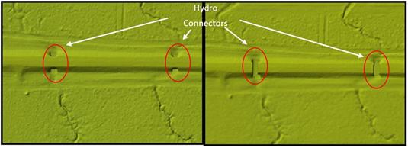
Figure 4-4. Example of localized original terrain (left) and terrain after addition of modification layer (right)

HUC8 Model Integration
A diagram showing inter-basin connectivity and boundary condition (BC) locations for the Middle Canadian-Trujillo watershed is included in Figure 4-5.
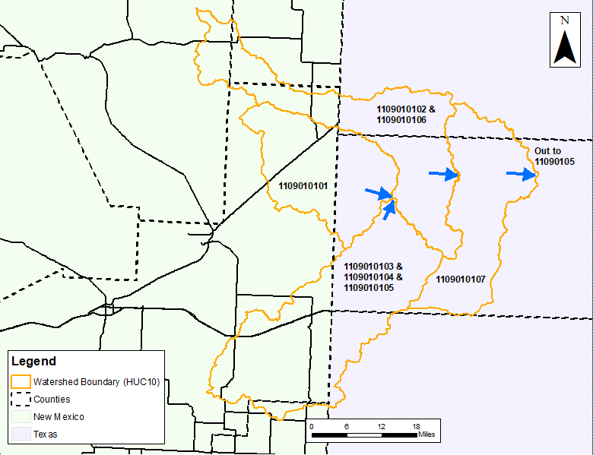
Figure 4-5. Overview of HUC8 with HUC10 Model Connectivity
The Middle Canadian-Trujillo HUC8 has seven HUC10s that have been combined into four separate models. This was done to help mitigate issues with tie ins between models. The HUC10s ending in 102 and 106 have been combined into one model and the HUC10s 103, 104, and 105, have been combined into another single model. A downstream SA/2D connection exists in the 107 model to transfer flow to the downstream HUC8, 11090105 Lake Meredith. The SA/2D connectors in the upstream model were placed perpendicular to channel flow a sufficient distance upstream of the channel outlet to avoid influence of the downstream normal depth BCs. The upstream SA/2D location was isolated based on a normal depth sensitivity analysis where the placement distance from the downstream BC was determined by the location of channel WSEL convergence for runs of varying normal depth BC values (Figure 4-6). This was done in order to minimize the margin of error in floodplain delineation due to potential inaccuracies in normal depth input in the upstream model’s downstream BC. The Middle Canadian-Trujillo model has an upper tie-in region from a New Mexico HUC 4 basin 1108 Upper Canadian, as discussed in Appendix B – HEC-HMS Model Development for Upstream Inflows.
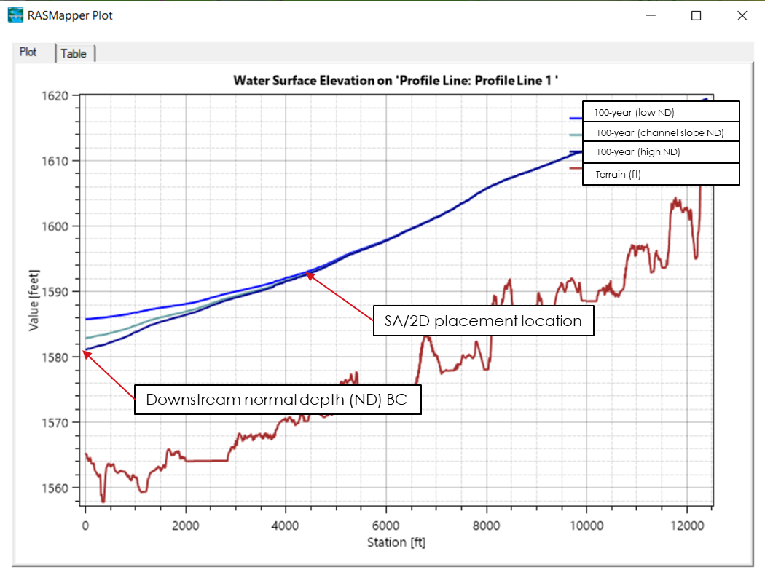
Figure 4-6. SA/2D Normal Depth sensitivity and placement example

The USGS HUC8 boundary did not accurately model the true extent of the watershed. To correct this, the HUC8 model was merged with an ArcHydro delineation of the watershed so that the greatest extent of the two was used for modeling.
The upstream and downstream model meshes were modified from the USGS HUC10 delineation to overlap at the location of the SA/2D connection. To optimize the hydraulic performance of the connection, the SA/2D placement varied per model based on unique features such as terrain slope, channel dimensions, instream flow obstructions (dams, railroad crossings, low water crossings etc.) and normal depth sensitivity. Therefore, model overlap size varied per model and connection location. Final model meshes for the Middle Canadian-Trujillo watershed models are shown in Figure 4-7. In locations where the models overlap the downstream model’s water surface elevation and flow in the receiving model represents the overlapped area.
The SA/2D connections were calibrated to ensure continuity of both flow and water surface elevation (+/- 0.5 ft) between upstream and downstream models. Flow hydrograph inflows were calibrated by first setting the initial Energy Grade (EG) slope of the boundary condition as the channel slope derived from the terrain, and the EG was revised iteratively to reflect modeled EG and maintain modeled WSEL continuity between models. The BCs for each model are described in more detail in the following sections. Final continuity metrics for the Middle Canadian-Trujillo watershed are summarized in Table 4-4.
Table 4-4. HUC10 Model Integration Summary
Upstream Model Name and Number | Downstream Model Name and Number | Number of SA/2D Connectors | Distance from SA/2D Connector to DS BC (ft) | 100-Year Flow Difference (%) | 100-Year Stage Difference (ft)
Upper Canadian (1108) | Horse Creek (1109010101) | 1 | 4,800 | 0.00% | N/A*
Horse Creek (1109010101) | Minneosa Creek (1109010102) & Romero Creek – Canadian River (1109010106) | 1 | 2,800 | 0.00% | 0.1
Arroyo Trujillo (1109010103), Trujillo Creek (1109010104), & Mujares Creek-Trujillo Creek (1109010105) | Minneosa Creek (1109010102) & Romero Creek – Canadian River (1109010106) | 1 | 6,100 | 0.00% | 0.2
Minneosa Creek (1109010102) & Romero Creek – Canadian River (1109010106) | Alamocitos Creek – Canadian River (1109010107) | 1 | 8,00 | 0.00% | -0.2
* - Inflows from HMS Model (Appendix B – HEC-HMS Model Development for Upstream Inflows )

Upper Canadian (1108) and Horse Creek (1109010101) Boundary
The upmost HUC10 (Horse Creek 1109010101) in the Middle Canadian-Trujillo HUC8 receives flow from an entire HUC 4 located in New Mexico. Please see Figure 4-7 below for an exhibit concerning the location of the inflow hydrograph, as well as a table presenting the inflow parameters, Table 4-5.
Similar to a normal depth sensitivity analysis performed for flow leaving a HUC10 model, an energy grade sensitivity analysis was performed for the flow entering the Horse Creek 1109010101 model. A buffer of 4,800 feet was created upstream of the model limits, the flow hydrograph was introduced via an inflow BC line, and an energy grade slope was approximated. Multiple runs were performed with varying energy grade slopes for the inflow hydrograph in order to ensure smooth transition of flow at the original HUC 1109010101 upstream boundary – please refer to exhibit below.
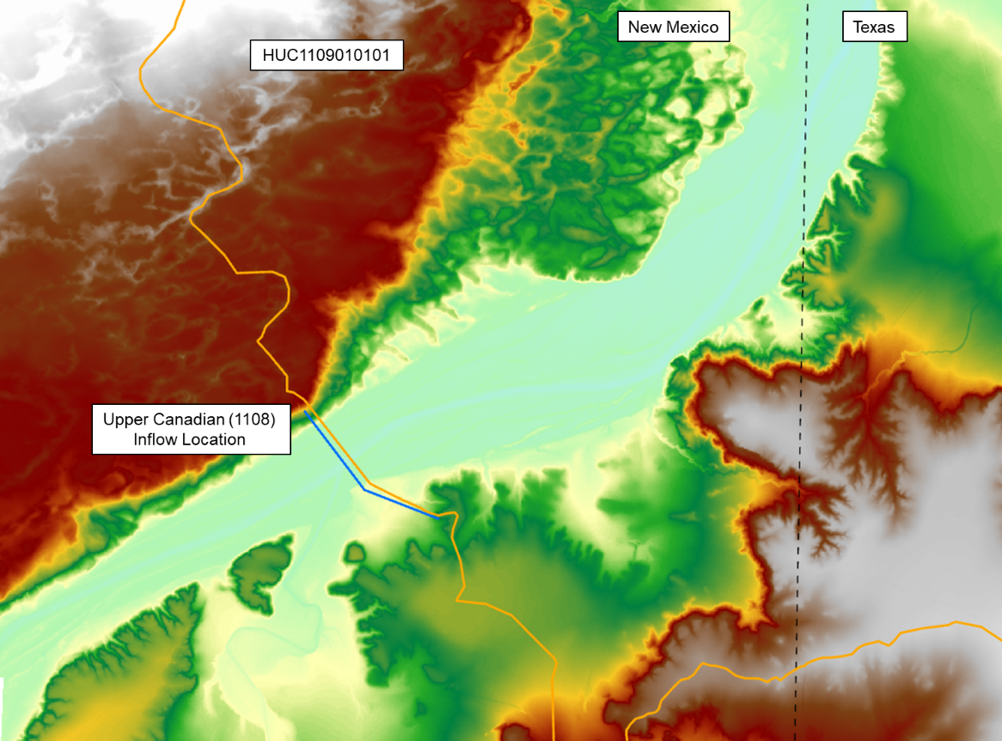
Figure 4-7 - Upper Canadian (1108) and Horse Creek (1109010101) Boundary Plan View
Table 4-5 Upper Canadian (1104) and Horse Creek (1109010101) Boundary Continuity – all modeled events
Annual-chance Event | HUC1108 (Upstream Revised) |  | HUC101 (Upstream Boundary) |  | Absolute Difference
Annual-chance Event | Max WSEL (ft) | Peak Flow (cfs) | Max WSEL (ft) | Peak Flow (cfs) | Max WSEL (ft) | Peak Flow (cfs)
10pct | N/A | 4,137 | 3,524.00 | 4,137 | N/A | 0
4pct | N/A | 13,309 | 3,526.70 | 13,309 | N/A | 0
2pct | N/A | 24,169 | 3,528.90 | 24,169 | N/A | 0
1pct | N/A | 38,917 | 3,531.40 | 38,917 | N/A | 0
0_2pct | N/A | 88,572 | 3,537.50 | 88,572 | N/A | 0
1PLUpct | N/A | 48,893 | 3,532.80 | 48,893 | N/A | 0
1MINpct | N/A | 29,920 | 3,529.90 | 29,920 | N/A | 0

Horse Creek (1109010101) and Minneosa Creek (1109010102) & Romero Creek – Canadian River (1109010106) Boundary
The Horse Creek HUC10 is part of the Middle Canadian-Trujillo watershed and is approximately 370 square miles in size. The characteristics of this basin, and the entire HUC8, are rural with little to no development. This area contains upper flat plains area which flow into steep canyon areas. In addition, large natural playa ponds exist throughout the area. The runoff from this HUC10 flows generally west to east and outflows to the into the next HUC10, 1109010102. A single SA/2D connector outflow to an inflow flow hydrograph was the preferred method to transfer flow from Horse Creek (1109010101 to the Minneosa Creek (1109010102) & Romero Creek – Canadian River (1109010106) basin. This method was chosen due to the relatively short distances between the inflow boundary, confluence, and outflow boundary. The resulting model meshes and hydraulic continuity results are summarized in Figure 4-8 and Table 4-6.
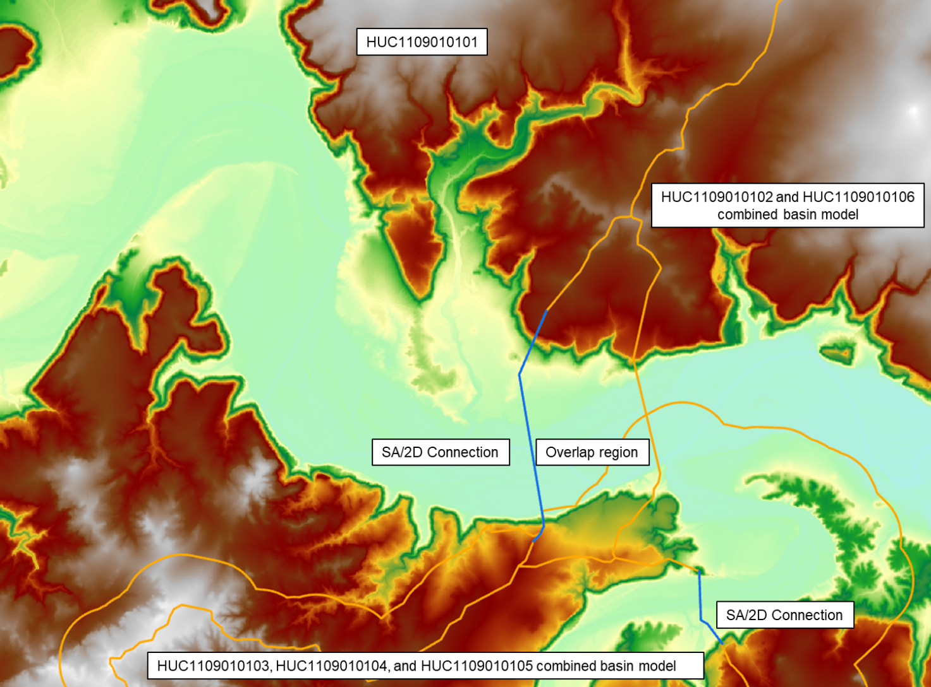
Figure 4-8 - Horse Creek (1109010101) and Minneosa Creek (1109010102) & Romero Creek – Canadian River (1109010106) Boundary Plan View
Table 4-6 Horse Creek (1109010101) and Minneosa Creek (1109010102) & Romero Creek – Canadian River (1109010106) Continuity – all modeled events
Annual-chance Event | HUC101 (Upstream) |  | HUC102&HUC106 (Downstream) |  | Absolute Difference
Annual-chance Event | Max WSEL (ft) | Peak Flow (cfs) | Max WSEL (ft) | Peak Flow (cfs) | Max WSEL (ft) | Peak Flow (cfs)
10pct | 3421.0 | 3386 | 3420.9 | 3386 | 0.1 | 0.0
4pct | 3423.1 | 11438 | 3423.0 | 11438 | 0.1 | 0.0
2pct | 3424.7 | 20584 | 3424.7 | 20584 | 0.0 | 0.0
1pct | 3426.5 | 33105 | 3426.5 | 33105 | 0.0 | 0.0
0_2pct | 3431.5 | 91493 | 3431.4 | 91493 | 0.1 | 0.0
1PLUpct | 3427.7 | 41587 | 3427.6 | 41587 | 0.1 | 0.0
1MINpct | 3425.3 | 25470 | 3425.3 | 25470 | 0.0 | 0.0

Arroyo Trujillo (1109010103), Trujillo Creek (1109010104), & Mujares Creek-Trujillo Creek (1109010105) and Minneosa Creek (1109010102) & Romero Creek – Canadian River (1109010106) Boundary
The Arroyo Trujillo (1109010103), Trujillo Creek (1109010104), & Mujares Creek-Trujillo Creek (1109010105) are part of the Middle Canadian-Trujillo watershed and in total are approximately 680 square miles in size. The characteristics of this basin, and the entire HUC8 are rural with little to no development. This area contains upper flat plains area which flow into steep canyon areas. In addition, large natural playa ponds exist throughout the area. The runoff from this HUC10 flows generally southwest to northeast and outflows to the into the next HUC10, 1109010102. A single SA/2D connector outflow to an inflow flow hydrograph was the preferred method to transfer flow from Horse Creek (1109010101 to the Minneosa Creek (1109010102) & Romero Creek – Canadian River (1109010106) basin. This method was chosen due to the relatively short distances between the inflow boundary, confluence, and outflow boundary. The resulting model meshes and hydraulic continuity results are summarized in Figure 4-9 and Table 4-7.

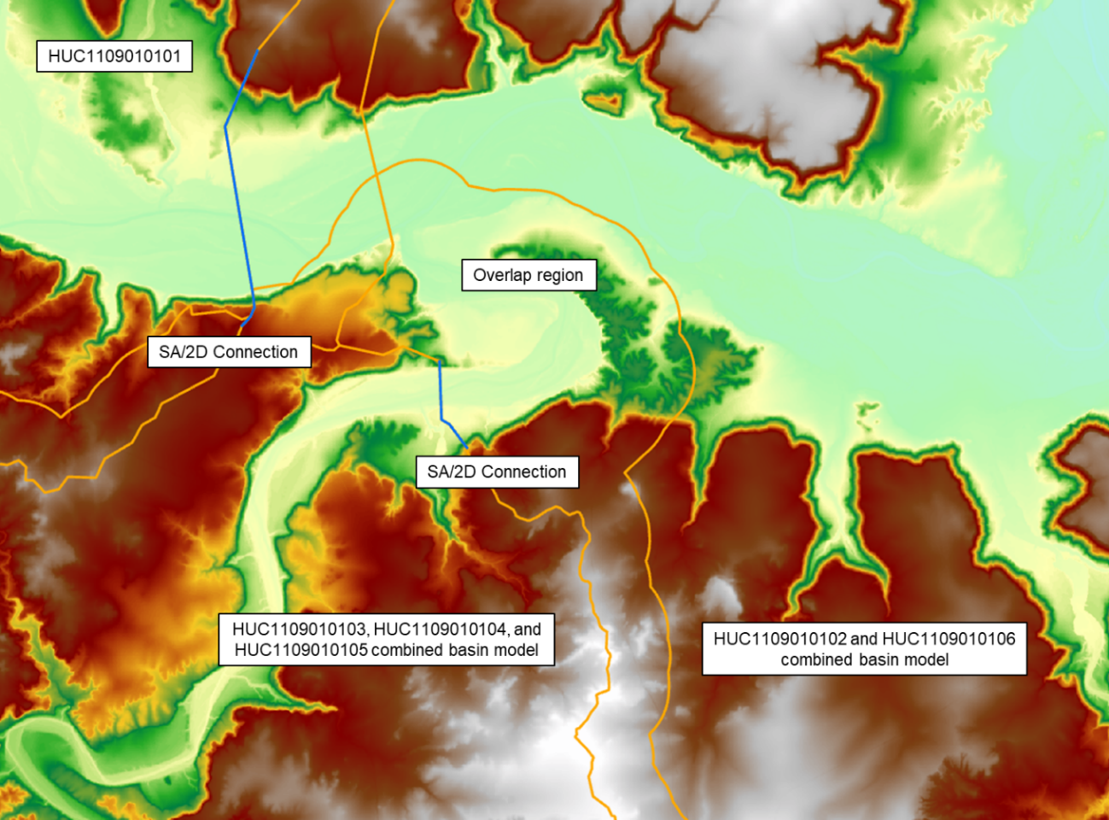
Figure 4-9 - Arroyo Trujillo (1109010103), Trujillo Creek (1109010104), & Mujares Creek-Trujillo Creek (1109010105) and Minneosa Creek (1109010102) & Romero Creek – Canadian River (1109010106) Boundary Plan View
Table 4-7 Arroyo Trujillo (1109010103), Trujillo Creek (1109010104), & Mujares Creek-Trujillo Creek (1109010105) and Minneosa Creek (1109010102) & Romero Creek – Canadian River (1109010106) Continuity – all modeled events
Annual-chance Event | HUC103&104&105 (Upstream) |  | HUC102&HUC106 (Downstream) |  | Absolute Difference
Annual-chance Event | Max WSEL (ft) | Peak Flow (cfs) | Max WSEL (ft) | Peak Flow (cfs) | Max WSEL (ft) | Peak Flow (cfs)
10pct* | 3430.5 | 2154 | 3432.3 | 2154 | -1.8 | 0.0
4pct* | 3432.0 | 4862 | 3433.2 | 4862 | -1.3 | 0.0
2pct | 3433.3 | 8120 | 3433.0 | 8120 | 0.3 | 0.0
1pct* | 3434.8 | 12679 | 3438.6 | 12679 | -3.8 | 0.0
0_2pc*t | 3439.0 | 31122 | 3439.7 | 31122 | -0.7 | 0.0
1PLUpc*t | 3436.3 | 18528 | 3438.6 | 18528 | -2.2 | 0.0
1MINpct | 3433.3 | 8107 | 3433.0 | 8107 | 0.3 | 0.0
*The SA/2D location was outside of the +/- 0.5 ft WSEL difference metric. The mapping for this interval was tied-in, within 0.5 ft, downstream of the SA/2D location within the overlap region between models.

Minneosa Creek (1109010102) & Romero Creek – Canadian River (1109010106) and Alamocitos Creek – Canadian River (1109010107) Boundary
Minneosa Creek (1109010102) & Romero Creek – Canadian River (1109010106) and Alamocitos Creek – Canadian River (1109010107) are part of the Middle Canadian-Trujillo watershed. The combines model of Minneosa creek and Romero Creek – Candian River is about 490 square miles in size, which the Alamocitos Creek basin model is about 370 miles in size. The characteristics of these basins, and the entire HUC8 are rural with little to no development. This area contains upper flat plains area which flow into steep canyon areas. In addition, large natural playa ponds exist throughout the area. The runoff from these HUC10s flow generally west to east and outflows to the into the next HUC8, 11090105, Lake Meredith. A single SA/2D connector outflow to an inflow flow hydrograph was the preferred method to transfer flow from Minneosa Creek (1109010102) & Romero Creek – Canadian River (1109010106) to the Alamocitos Creek – Canadian River (1109010107) basin. This method was chosen due to the relatively short distances between the inflow boundary, confluence, and outflow boundary. The resulting model meshes and hydraulic continuity results are summarized in Figure 4-10 and Table 4-8.
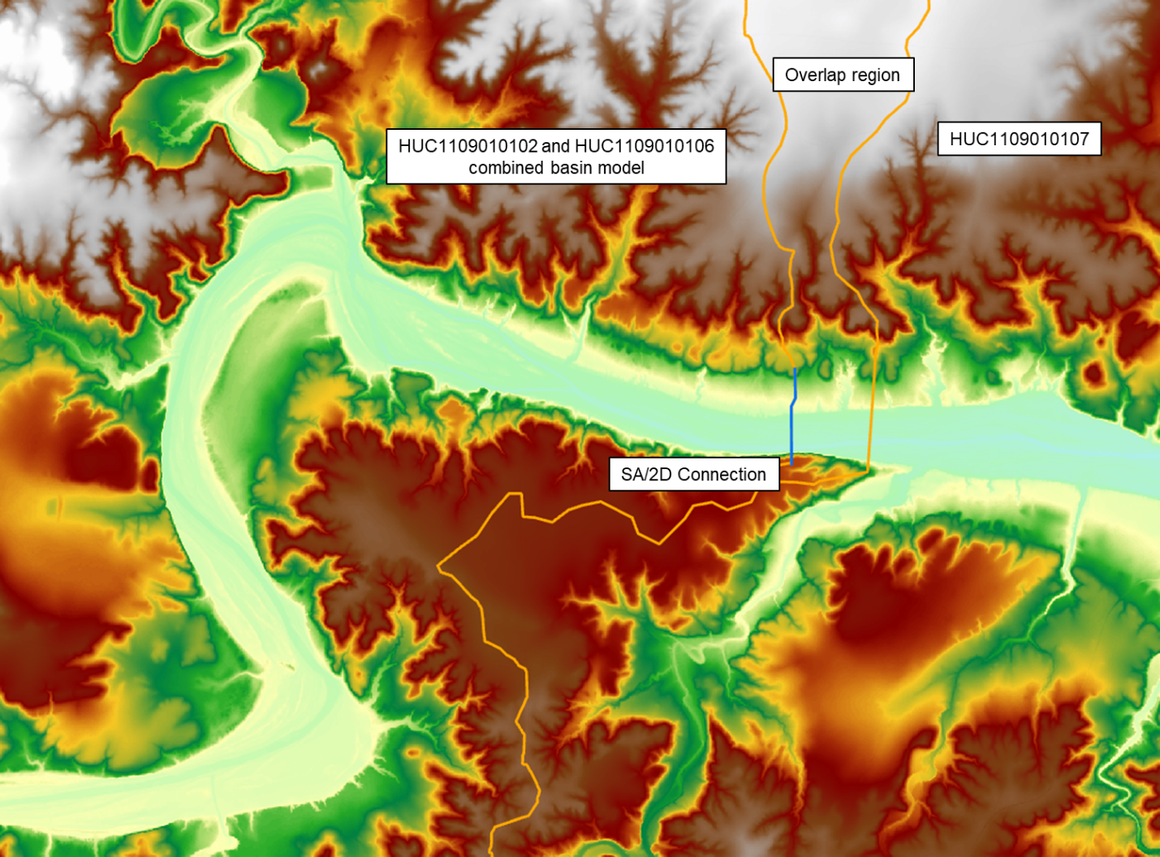
Figure 4-10 - Minneosa Creek (1109010102) & Romero Creek – Canadian River (1109010106) and Alamocitos Creek – Canadian River (1109010107) Boundary Plan View
Table 4-8 Minneosa Creek (1109010102) & Romero Creek – Canadian River (1109010106) and Alamocitos Creek – Canadian River (1109010107) Continuity – all modeled events
Annual-chance Event | HUC102&HUC106 (Upstream) |  | HUC107 (Downstream) |  | Absolute Difference
Annual-chance Event | Max WSEL (ft) | Peak Flow (cfs) | Max WSEL (ft) | Peak Flow (cfs) | Max WSEL (ft) | Peak Flow (cfs)
10pct | 3333.2 | 5269 | 3333.2 | 5269 | -0.1 | 0.0
4pct | 3337.2 | 15261 | 3337.1 | 15261 | 0.1 | 0.0
2pct | 3340.6 | 27305 | 3340.5 | 27305 | 0.2 | 0.0
1pct | 3344.2 | 43518 | 3344.0 | 43518 | 0.2 | 0.0
0_2pct | 3352.4 | 96930 | 3352.4 | 96930 | 0.0 | 0.0
1PLUpct | 3346.7 | 56644 | 3346.4 | 56644 | 0.3 | 0.0
1MINpct | 3341.6 | 31392 | 3341.4 | 31392 | 0.2 | 0.0

Calibration and Validation
Model parameter adjustments and calibration in the Task Order #3 BLE study were performed for models encompassing USGS gages with a minimum of 10 years of record. Model adjustments were based on estimates of a 1% annual chance peak flow values but did not consider hydrograph timing or flow volume. No model adjustments were made based on USGS regional regression estimates.
The model perimeter was extended downstream by approximately a mile to establish an SA/2D connector to capture flow at the gage location. To ensure that the SA/2D connector was outside of the influence of the downstream boundary condition’s normal depth sensitivity, a normal depth sensitivity analysis was conducted. It was found that the gage SA/2D connector is two-thirds of a mile upstream from where the limit of normal depth sensitivity ends.
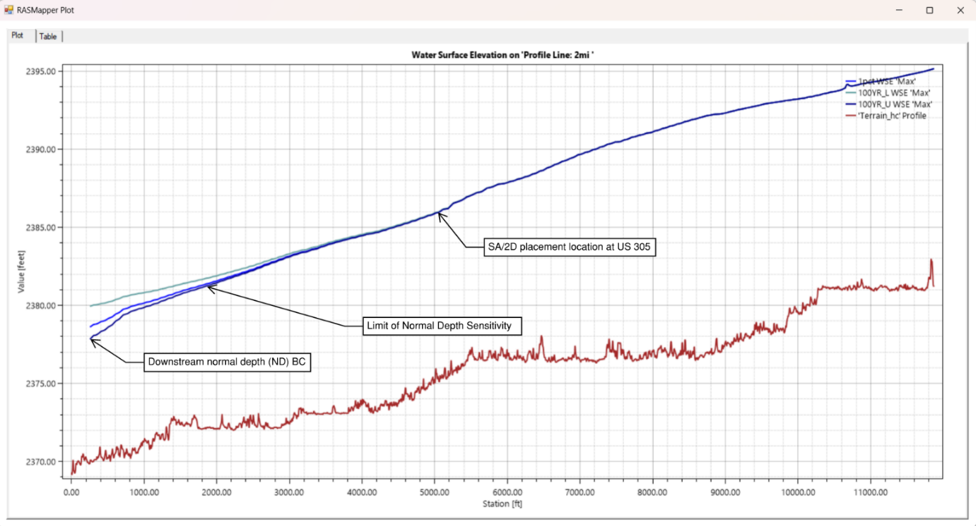
Figure 4-6. SA/2D Normal Depth sensitivity and placement example
As shown in Figure 4-12 below, there is no USGS gage within the Middle Canadian-Trujillo (11090101) watershed. The closest downstream gage suitable for calibration is 07227500 in the Lake Meredith (11090105) watershed, within Stantec’s Task Order 3. The gage had a robust record history of 83 years (including 66 years with recorded data) which was used to develop a Bulletin 17C analysis with a calculated peak 1% annual. Calibration was based on the 1% annual chance peak flow value estimates from a Bulletin 17C statistical flood frequency analysis using the USGS program PeakFQ version 7.3. Gage extension was not considered as part of this study. A technical memo describing the Bulletin 17C analyses for the gage in the Task Order 3 study area, as well as raw PeakFQ output for gage 07227500 in the Lake Meredith (11090105) watershed is included in Appendix A – Bulletin 17C Statistical Analysis Technical Memo and Peak FQ Output.
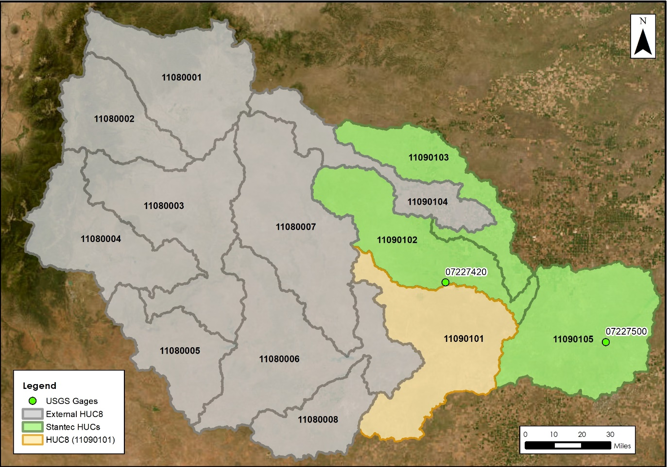
Figure 4-12. USGS Gages in Middle Canadian-Trujillo watershed
The base model results at gage 07227500 was within 2% of the median 1% annual chance flow from the Bulletin 17C analysis. Therefore no further calibration was undertaken in the Middle Canadian-Trujillo (11090101), Rita Blanca (11090103), Middle Canadian-Trujillo (11090102), and Lake Meredith (11090105) watersheds. The resulting flows in relation to the Bulletin 17C analysis is shown in Table 4-9.
Table 4-9. 1% Annual Storm Calibration Results Summary for Middle Canadian-Trujillo watershed
USGS Gage | Drainage Area (Sq. Mi) | Historic Record Bulletin 17C Flood Frequency Analysis -  1% Annual chance Flow (CFS) |  |  | Modeled Peak Flow (1%) | Percent Difference (Modeled v. Historic median)
USGS Gage | Drainage Area (Sq. Mi) | Median | Lower 5% Confidence Limit | Upper 95% Confidence Limit | Modeled Peak Flow (1%) | Percent Difference (Modeled v. Historic median)
07235000 | 15,376 | 74,900 | 52,190 | 140,900 | 73,846 | 1.42%

Comparison to USGS Regression Estimates for Unregulated Streams and Watersheds
No existing regional regression publications provide coverage for the Middle Canadian-Trujillo watershed. While regression equations exist for undeveloped watersheds in Texas, the equations are limited to watersheds less than 10,000 square miles. With the inclusion of the incoming HUC4 basin (HUC1108), which is greater 10,000 square miles and includes multiple significant reservoirs, there are no applicable regression equations available for this watershed.

Results

Comparison to Existing Study Data
The modeled WSEL and floodplain extents were compared to effective FEMA data, where existing. Currently, National Flood Hazard Layer (NFHL) regulatory data is only available for HUC8 11090101 in Curry County, NM. The Middle Canadian-Trujillo watershed has minimal overlap with Curry County, therefore no useful comparisons with the regulatory data were found. Challenges and Recommendations

Challenges and Recommendations
Particular concerns in accurately modeling the Middle Canadian–Trujillo watershed have to do with the lack of existing data to provide meaningful comparison to, the inflow from the New Mexican HUC4 basin 1108 for which an HMS model was created, and the general playa lake and canyon like stream centerline topography of the basin in general.
A lack of USGS gages and NFHL data were one of the primary challenges for the Middle Canadian-Trujillo watershed. This may be attributed to the lack of developed areas within the basin.
Another challenge in the modeling of the Middle Canadian-Trujillo watershed was the topography of the basin. In general, the large depressions of the area known as playa lakes generally retain flow which contrasts with the narrow canyon-like stream centerlines in the model which have generally high velocity and sharper peak flow behavior. This led to a challenge particularly in the boundary between the 1109010102 & 1109010106 upstream model and the 1109010107 downstream model, which required many iterations to achieve an acceptable tie-in according to TWDB guidelines.
It is recommended that the upstream area currently being approximated with the HEC-HMS model referenced in Appendix B – HEC-HMS Model Development for Upstream Inflows, be modeled in more detail to better capture the upstream inflow hydrograph for HUC10-1109010101.

Crossing Profile Errors
To verify the results, profile lines were generated at the downstream end of each model and multi-frequency data was plotted along these lines to identify any potential crossing profile errors. On performing a detailed review of these profile lines no such errors were found.
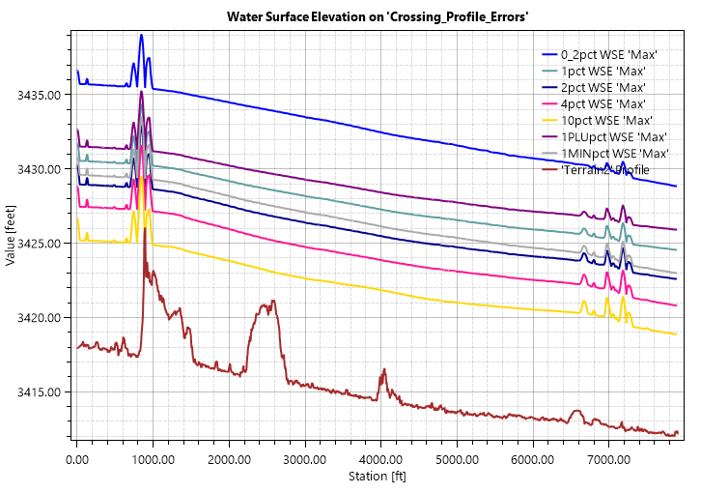
Figure 4-111. HUC 1109010101 Profile Plot-all modeled events
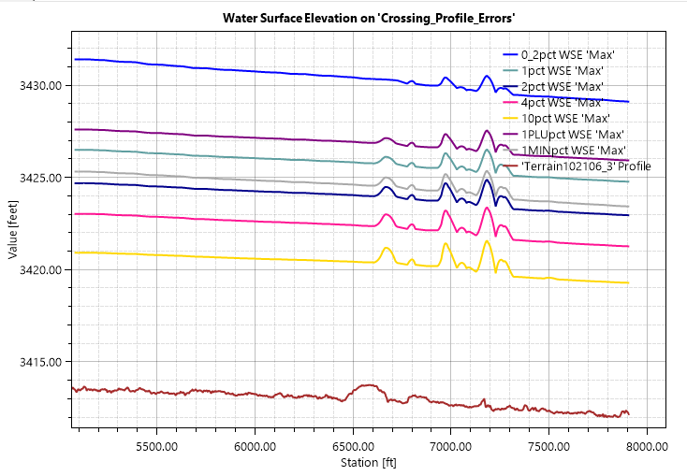
Figure 4-122. HUC 1109010102-06 Profile Plot-all modeled events
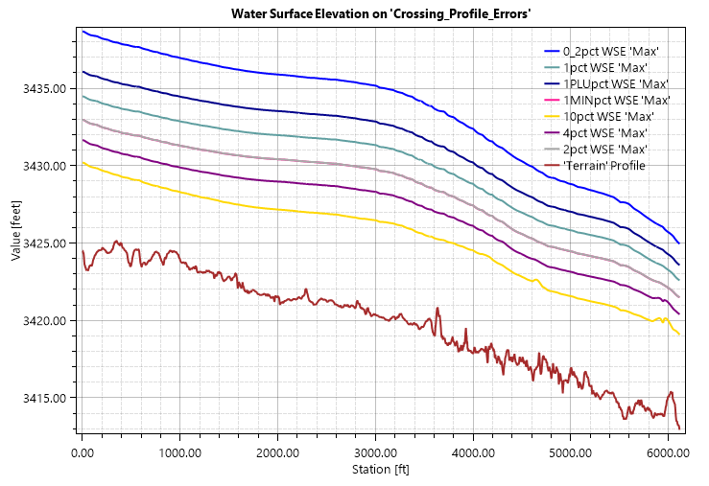
Figure 4-13. HUC 1109010103-04-05 Profile Plot-all modeled events
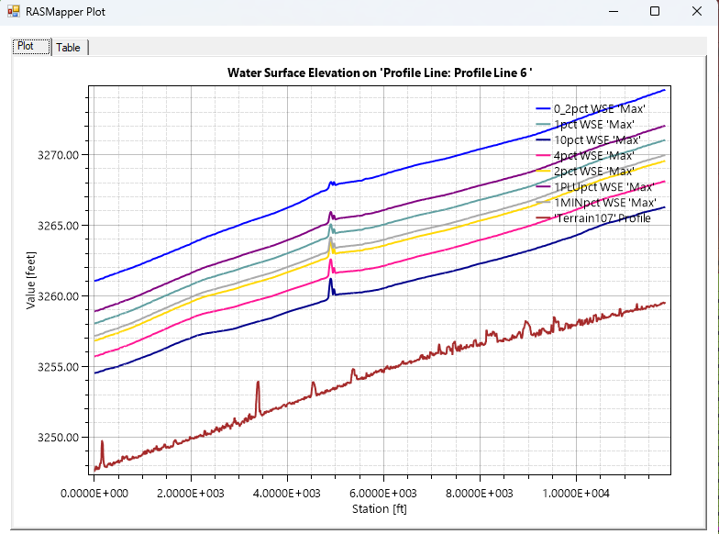
Figure 4-14. HUC 1109010107 Profile Plot-all modeled events

Modeled Results
A summary of modeled HEC-RAS peak flow and WSEL results for the 10%, 1% and 0.2%-annual-chance events are summarized in Table 4-10, Table 4-11, and Table 4-12 at each model’s primary flow transfer location. Floodplain delineation for these events is described in the following section (Chapter 6 Floodplain Delineation (10%, 1% and 0.2% events)) and exhibits corresponding to modeled results are included in (Chapter 7).
Table 4-10. 10% Storm Results Summary for Middle Canadian-Trujillo watershed
HUC 10 Model Name and Number | Gage Description | Peak Flow (CFS) | WSEL* (ft)
Horse Creek 1109010101 | N/A | 3,386 | 3,421.0
Minneosa Creek 1109010102 & Romero Creek – Canadian River 1109010106 | N/A | 5,269 | 3,333.2
Arroyo Trujillo (1109010103), Trujillo Creek (1109010104), & Mujares Creek-Trujillo Creek (1109010105) | N/A | 2,154 | 3,430.5
Alamocitos Creek – Canadian River 1109010107 | N/A | 5,015 | 3,260.5
*Note: vertical datum of modeled WSEL is NAVD88

Table 4-11. 1% Storm Results Summary for Middle Canadian-Trujillo watershed
HUC 10 Model Name and Number | Gage Description | Peak Flow (CFS) | WSEL (ft)
Horse Creek 1109010101 | N/A | 33,105 | 3,426.5
Minneosa Creek 1109010102 & Romero Creek – Canadian River 1109010106 | N/A | 43,518 | 3,344.2
Arroyo Trujillo (1109010103), Trujillo Creek (1109010104), & Mujares Creek-Trujillo Creek (1109010105) | N/A | 12,679 | 3,434.8
Alamocitos Creek – Canadian River 1109010107 | N/A | 42,831 | 3,265.0
*Note: vertical datum of modeled WSEL is NAVD88

Table 4-12. 0.2% Storm Results Summary for Middle Canadian-Trujillo watershed
HUC 10 Model Name and Number | Gage Description | Peak Flow (CFS) | WSEL (ft)
Horse Creek 1109010101 | N/A | 91,493 | 3431.5
Minneosa Creek 1109010102 & Romero Creek – Canadian River 1109010106 | N/A | 96,930 | 3,352.4
Arroyo Trujillo (1109010103), Trujillo Creek (1109010104), & Mujares Creek-Trujillo Creek (1109010105) | N/A | 31,122 | 3,439.0
Alamocitos Creek – Canadian River 1109010107 | N/A | 95,870 | 3,268.6
*Note: vertical datum of modeled WSEL is NAVD88

Quality Control
Following the initial BLE analysis in each watershed, the flood hazard area delineations were reviewed for areas where the inundation impacted either critical public infrastructure or private property. Revisions were made, if necessary, to reflect potential flooding risk on these properties more accurately.
Quality Assurance/Quality Control (QA/QC) review necessitated some manual editing including adding/moving computational points, breaklines, hydraulic connectors, and mesh refinement regions. The areas in or adjacent to channelized areas or significant ponding were the focus of this review.

Floodplain Delineation (10%, 1% and 0.2% events)
Floodplain Delineation for the Middle Canadian-Trujillo watershed was developed using the TWDB Matrix Tool, followed by running a set of ArcGIS Cartography tools against the output results from the Matrix Tool. The Matrix Tool processes the raw depth grid input data (from HEC-RAS) to remove small islands that have the following parameter: areas of floodplain that are less than 0.33 acres with an average depth less than 0.33 feet were removed. Lake, reservoir, and/or ponding areas of approximately 20 acres or greater were incorporated into the final mapping.

After the Matrix Tool is run, post-processing was performed to fill any additional islands of 2 aces or less for 0.2% and 1% floodplains while 10% floodplain received an 0.5 acre fill. Disconnected floodplains less than 0.33 acres were removed as well. In order for the flooding product extents to match, a 0.1ft was applied to the Depth Grid resulting in a 0.1ft depth low value. The Depth Grid was then used to extract the Water Surface Elevation Grid to have 1:1 match per FEMA standards.
Additional post processing steps were applied using ArcGIS Simplifying and Smoothing tools to the 0.2% and 1% floodplain polygons. A 5-foot threshold for simplifying and 25-foot tolerance for smoothing were applied in this process. Per TWDB 2D BLE Guidance, the 10% floodplains did not go through this post processing step (TWDB 2022). This was to maintain the 10% flood extents as close to the original model export as possible. Disconnected floodplain extents for the 10-year, 100-year, and 500-year less than 0.33ac are removed during the postprocess as preferred by the TWDB.

Internal Mapping Tie-Ins
The hydraulic models in this task order were setup for upstream and downstream overlap in sequential models to maintain flow continuity of the mainstem between models. This overlap also provided an area to achieve a mapping tie-in within +/-0.5 ft of WSEL difference for the 10-year, 100-year and 500-year storms per FEMA Region 6 requirements. The Middle Canadian-Trujillo watershed mapping products demonstrate a 0.5ft tie-ins at all overlap locations.

Hazus
As a part of the Base Level Engineering assessment effort, Hazus was run using version 6.1 and resampled 10ft cell size 1% Depth Grid. Hazus 6.1 uses parcel data to map the results but, attribute data by census block number. S_FRAC_Ar was populated with the 1% Hazus results. Data that intersects the HUC8 boundary is left as is, no clipping was performed. All census/parcel data completely outside of the HUC8 boundary was removed.

Special Consideration
Unique challenges to modeling this watershed were discussed in Chapter 4. In addition, the following items should be considered in reviewing the mapping products, and for potential future studies in the watershed:
- Significant artificial depth increases at floodplain fringes occur in some areas of the mapping products because of RASMapper raster generation. In the sloping rendering mode, RASMapper attempts to interpolate between adjacent cells to “slope” the water surface, but in doing so, steep canyon walls or bluffs on the floodplain fringe can artificially cause the water surface to be interpolated upstream, resulting in significant areas of inundation where there should really be no inundation. This erroneous mapping result is referred to herein as “cupping”.
- In Middle Canadian-Trujillo watershed products, stream centerlines are contained within the 1% floodplain. However, in areas where there are road crossings and embankments, there is no streamline containment because the floodplain is not overtopping.
  - There is a shapefile provided within the Supplemental Folder that categorizes whether the stream segment outside the 1% floodplain was fixed (Y) to be within the boundary or a ROAD/Embankment was present and no containment was possible.
- Portions of Middle Canadian-Trujillo watershed are playa-driven due to the caprock geology resulting in very limited 1% floodplain stream centerline containment. As a result, the stream centerlines within areas of caprock have been removed from the WTR_LN feature class within the Flood Risk Database and placed within the Supplemental Folder for reference.
- Areas in the Texas panhandle with flat topography do not have well defined drainage patterns resulting in disconnected pluvial floodplains and streams originating and terminating without well defined headwaters or confluences. The water lines representing these streams were routed to follow the topography and maintaining some pluvial floodplain coverage or removed in areas with no pluvial floodplain coverage. Any removed lines have been placed in the supplemental folder.

CNMS Validation of Effective Zone A Special Flood Hazard Area (SFHA)
All the Zone A studies (0.5 miles) in the Middle Canadian-Trujillo watershed were classified in CNMS with a validation status of “UNVERIFIED” and status type of “BEING STUDIED”. The following is a summary of the results of the CNMS validation assessment for the effective Zone A studies in the study area. Initial Assessment checks A1-A5 were evaluated for the CNMS inventory of Zone A studies.
Initial Assessment A1 – Significant Topography Update Check
This check involves determining whether a topographic data source is available that is significantly better than what was used for the effective Zone A modeling and mapping. For the Upper Salt Fork Red watershed study area, the effective Zone A topographic data leveraged a variety of sources.
The effective topo used for the effective Zone A in HUC8 11090101 does not meet vertical accuracy requirements of SID 43. There is new topo available that does meet SID 43 from Texas Natural Resources Information System (TNRIS). Therefore, all effective Zone A studies in HUC8 11090101 fail A1.
Initial Assessment A2 – Check for Significant Hydrology Changes
This check involves first determining whether regression equations were used in the effective study. If they were then it was determined if new regression equations have become available from the USGS since the date of the effective Zone A study. If newer regression equations exist for the area of interest, then an engineer must determine whether these regression equations would significantly affect the 1-percent-annual chance flow.
Neither of the 2 effective Zone A reaches in 11090101 use regression equations. Therefore, both effective Zone A studies pass A2.
Initial Assessment A3 – Check for Significant Development
This check involves using the National Urban Change Indicator (NUCI) dataset to assess increased urbanization in the watershed of the Zone A study. If the percentage of urban area within the HUC-12 watershed containing the effective Zone A study is 15% or more, and has increased by 50% or more since the effective analysis, the study would fail this check. Although the NUCI data provide year-to-year changes in urbanization, the NLCD also is needed to establish a baseline of urban land cover for this analysis.
National Land Cover Data and National Urban Change Indicator were analyzed, and urbanization increase for HUC8 11090101 was deemed insignificant for all effective Zone A reaches. Therefore, all effective Zone A reaches pass this check.
Table 7-1: Zone A Initial Assessment Results
Assessment Check | Pass/Fail | Comments/Notes
A1 - Topography | Fail | Old topo does not meet SID 43, new topo does
A2 - Hydrology | Pass | Regression equations not used
A3 - Development | Pass | Urbanization increase is not significant

Initial Assessment A4 – Check of Studies Backed by Technical Data
Zone A studies that pass all initial assessment checks described above may be categorized as “Valid” in the CNMS Inventory only if the effective Zone A study is supported by modeling or sound engineering judgment and all regulatory products are in agreement. If the effective Zone A study passes all initial assessment checks, but is not supported by modeling, or if the original engineering method used is unsupported or undocumented, a comparison of the BLE results and effective Zone A’s is performed.
Both effective Zone A reaches in HUC8 11090101 do not have documented hydraulic models and are therefore not considered to be model backed. These reaches both fail A4.
Initial Assessment A5 – Comparison of BLE and Effective Zone A Floodplains
The BLE /effective Zone A comparison method leverages the existing Floodplain Boundary Standard (FBS) certification procedures described in FEMA SID 113, but with a slight modification. This modified FBS comparison approach uses the 1-percent plus and 1-percent minus flood profiles and horizontal and vertical tolerances described in the First Order Approximation - Methodology, Validation, and Scalability Guidance Procedures (Version 1.5). For the comparison of BLE and effective Zone A in the study area, the following vertical and horizontal tolerances were used to conduct the modified FBS procedure. Points were sampled on the effective floodplain boundary at 200 ft intervals for comparison.
Vertical Tolerance: +/- 0.5 feet (one-half contour interval of assumed effective topographic source).
Horizontal Tolerance: +/-75 feet (standard horizontal tolerance for BLE comparison testing).

All effective Zone A studies in HUC8 11090101 failed the BLE comparison check. The National Risk Index risk deciles were grouped to represent risk classes and used to evaluate the threshold of points needed to assign a passing A5 score for each HUC12. Results are listed in Table 7-3.
CNMS Validation Results
Based on the validation assessments and BLE comparison results described above, the CNMS inventory of Zone A studies in Middle Canadian-Trujillo watershed study area has been updated, total miles in each of these categories are summarized in Table 7-2 and illustrated in Figure 7-1 below.
Table 7-2: Zone A Validation Results
Validation Status | Status Type | Total Mileage
Valid | NVUE Compliant | 0
Unverified | Being Studied | 0.5 mi

Table 7-3: BLE Comparison Results
HUC-12 Watershed |  | Total FBS Points | Fail | Pass | % Pass | BLE Comparison Pass? (>85%) | Priority Score
Watershed Name | HUC12 ID
Randall Lake | 110901010703 | 40 | 40 | 0 | 0% | >85% | FAIL

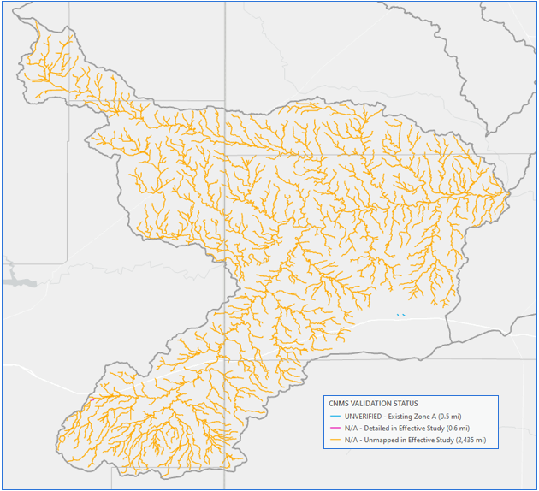
Figure 7-1. CNMS Validation Results

Deliverables
- Coordinated Needs Management Strategy (CNMS) Geodatabase
  - Contains all CNMS relationship and feature classes for reaches in HUC8 11090101.
- Results generated by A5 analysis using the Basic method
  - FBS points and A5 Pass/Fail results aggregated by HUC12 feature classes.

References
Bibliography list of references used and referred to throughout document.
- Multi-Resolution Land Characteristics Consortium (MRCL). National Land Cover Database (NLCD) 2019 Land Cover (CONUS). Online at: https://www.mrlc.gov/data/nlcd-2019-land-cover-conus
- Ajmal, M., Waseem, M., Kim, D., and Kim, T.W. 2020. A Pragmatic Slope-Adjusted Curve Number Model to Reduce Uncertainty in Predicting Flood Runoff from Steep Watersheds. Water. 2020, 12, 1469.
- Chow, Ven T. "Development of Uniform Flow and Its Formulas." Open Channel Hydraulics. Caldwell, NJ: Blackburn, 1959. 109-113. Print.
- Cleveland, Theodore G; Fang, Nick, 2021, “texas-skew-update-2021", https://doi.org/10.18738/T8/SVLCOQ, Texas Data Repository, V6
- England, J.F., Jr., Cohn, T.A., Faber, B.A., Stedinger, J.R., Thomas, W.O., Jr., Veilleux, A.G., Kiang, J.E., and Mason, R.R., Jr., 2018, Guidelines for determining flood flow frequency--Bulletin 17C: U.S. Geological Survey Techniques and Methods, book 4, chap. B5, 148 p., https://doi.org/10.3133/tm4B5.
- URS Corporation. (2016). FINAL Upper Brushy Creek Watershed Flood Protection Plan. June 2016.
- United States Army Corps of Engineers (USACE). (2021). River Analysis System, HEC-RAS, v. 6.0.0
- United States Geological Study (USGS). (2015). Documentation of Input Datasets for the Soil-Water Balance Groundwater Recharge Model for the Upper Colorado River Basin. Fred D. Tillman. Online at: cover v 3.5.1 (usgs.gov)
- United States Geological Study (USGS). (2020). Methods for Estimating the Magnitude and Frequency of Peak Streamflows for Unregulated Streams in Oklahoma Developed by Using Streamflow Data Through 2017. USGS Report 2019-5143, version 1.1. Online at: Methods for Estimating the Magnitude and Frequency of Peak Streamflows for Unregulated Streams in Oklahoma Developed by Using Streamflow Data Through 2017 (usgs.gov)
- Hydrologic Engineering Center (USACE HEC). HEC-RAS 2D User’s Manual. 2022. https://www.hec.usace.army.mil/confluence/rasdocs/r2dum/latest
- FEMA, “Guidance for Flood Risk Analysis and Mapping – First Order Approximation”, November 2014. (http://www.fema.gov/media-library-data/1420849667914-c1656173985d814d0e62f80818505969/FOA_Guidance_Nov_2014.pdf).
- FEMA Region 6, “Base Level Engineering Submittal Guidance”, June 2017. (https://rmd.msc.fema.gov/Regions/VI/Ph0_Investment/1/Base%20Level%20Engineering/Submittal%20Guidance/20170615_BLE%20Submittal%20Guidance_R6.pdf).
- ESRI ArcMap (2018). ArcGIS v. 10.6.1
- NOAA. (2017). “NOAA Atlas 14 Precipitation Frequency Estimates in GIS Compatible Format”. Webpage last modified April 21, 2017. Downloadable online at: PF in GIS Format - PFDS/HDSC/OWP (noaa.gov)
- NOAA. (2018). NOAA Atlas 14 Precipitation-Frequency Atlas of the United States. Volume 11 Version 2.0: Texas. Online at: NOAA Atlas 14 (weather.gov)
- NRCS. (2016). Manning’s n Values for Various Land Covers to Use for Dam Breach Analysis by NRCS in Kansas. Online at: Microsoft Word - Manning’s n-values for Kansas Dam Breach Analyses - Adopted 071216.docx (rashms.com)
- Soil Survey Staff, Natural Resources Conservation Service, United States Department of Agriculture. Soil Survey Geographic (SSURGO) Database. Available online at https://sdmdataaccess.sc.egov.usda.gov. Accessed [July/07/2021]
- USGS. (2015). Documentation of Input Datasets for the Soil-Water Balance Groundwater Recharge Model for the Upper Colorado River Basin. Fred D. Tillman. Online at: cover v 3.5.1 (usgs.gov)

Appendix A – Bulletin 17C Statistical Analysis Technical Memo and Peak FQ Output

Provided under a separate cover.

Appendix B – HEC-HMS Model Development for Upstream Inflows

Provided under a separate cover.

