

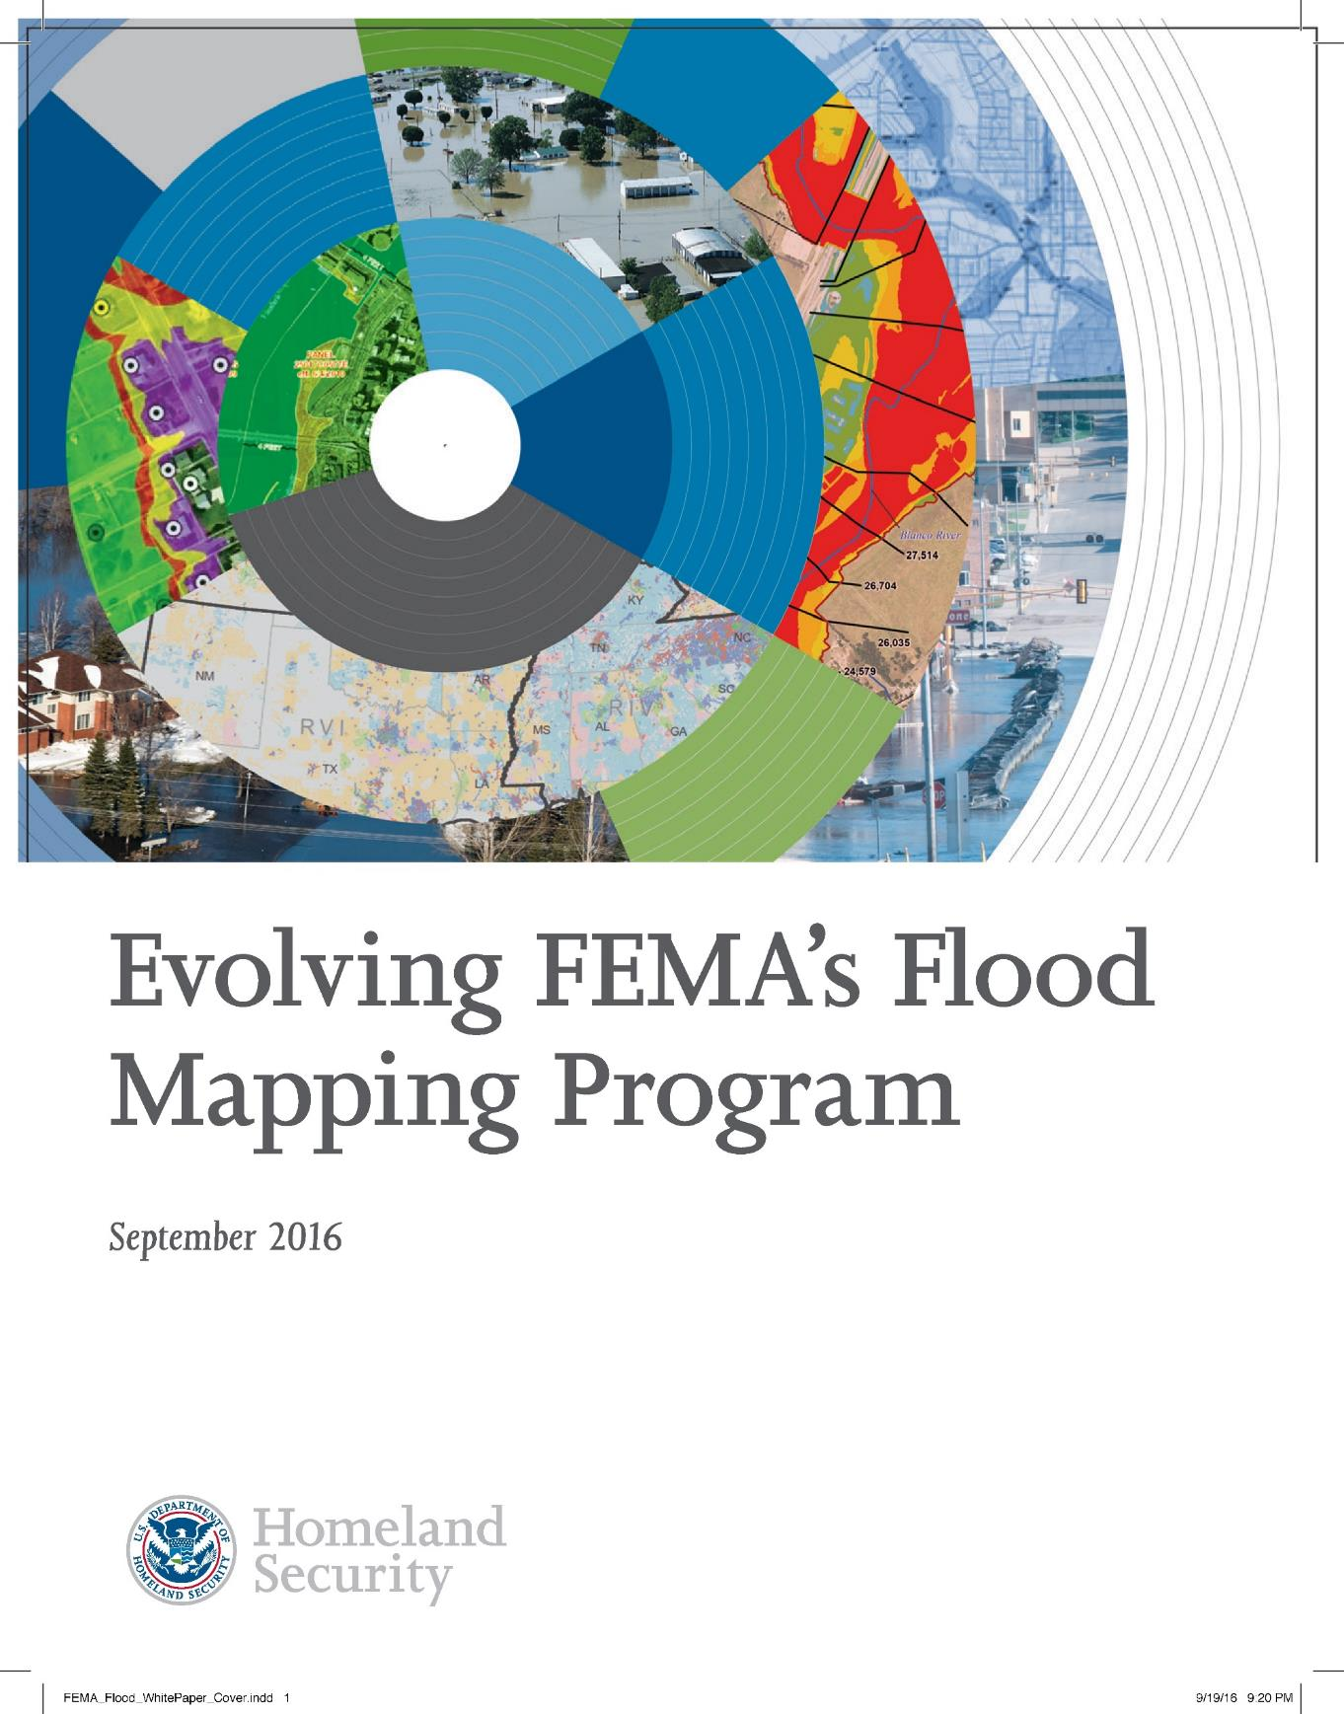

Report Prepared for:
9/5/2025
Base Level Engineering Report
Punta de Agua Watershed (11090102)
CASE NUMBER: 22-06-0048S

September 5, 2025

Report Prepared by:
Stantec
1905 Aldrich St Suite 300
Austin, TX 78723-3544
Texas Water Development Board
1700 Congress Avenue
Austin, TX 78701

Document History
Document Location
K:/FY2022/22-06-0048S

Revision History
Version Number | Version Date | Summary of Changes | Author
1.0 | September 2023 | Draft report for external technical review | Stantec
2.0 | September 2025 | M3 Submittal | Stantec

Table of Contents
Executive Summary 8
1 Introduction and Project Scope 10
2 Topographic and Watershed Data 12
2.1 Terrain Data Development 12
2.2 Watershed Data Development 14
2.3 Final Seamless DEM 15
2.4 Final Arc Hydro Data Model 15
2.4.1 Arc Hydro Data Model (Geodatabase and Rasters) 15
2.4.2 Hydrography Data (Geodatabase) 16
3 Hydrology 17
3.1 Infiltration Parameters 18
LU_GridCode 19
NLCD LU Description 19
Hydrologic Soil Group 19
4 Hydraulics 20
4.1 2D Computational Mesh and Settings 20
4.1.1 Model Computational Settings 20
4.2 Breaklines and Refinement Regions 21
4.2.1 Breaklines 21
4.2.2 Mesh Refinement Regions 22
4.3 Manning’s Roughness Coefficients and Land Use 24
4.4 Terrain Modification 25
4.5 HUC 8 Model Integration 26
4.5.1 Pinabetes Creek Watershed (1109010201) and Tramperos Creek – Punta de Agua Creek Watershed (1109010203) Boundary 29
4.5.2 Pedernal Creek – Tramperos Creek Watershed (1109010202) and Tramperos Creek – Punta de Agua Creek Watershed (1109010203) Boundary 31
4.5.3 Tramperos Creek – Punta de Agua Creek Watershed (1109010203) and Monia Creek – Punta de Agua Creek Watershed (1109010204) Boundary 32
4.5.4 Monia Creek – Punta de Agua Creek Watershed (1109010204) and Sand Well – Punta de Agua Creek Watershed (1109010206) Boundary 34
4.5.5 Syndicate Hills Watershed (1109010205) and Sand Well – Punta de Agua Creek Watershed (1109010206) Boundary 35
4.5.6 Cottonwood Draw - Punta de Agua Creek (1109010305) and Sand Well – Punta de Agua Creek Watershed (1109010206) Boundary 37
4.6 Calibration and Validation 39
4.6.1 Comparison to USGS Regression Estimates for Unregulated Streams and Watersheds 40
4.7 Results 41
4.7.1 Comparison to Existing Study Data 41
4.7.2 Challenges and Recommendations 41
4.7.3 Crossing Profile Errors 41
4.7.4 Modeled Results 45
5 Quality Control 49
6 Floodplain Delineation (10%, 1% and 0.2% events) 50
6.1 Internal Mapping Tie-Ins 50
6.2 Hazus 50
6.3 Special Consideration 50
7 CNMS Validation of Effective Zone A Special Flood Hazard Area (SFHA) 51
7.1 Deliverables 51
References 52
Appendix A – Bulletin 17C Statistical Analysis Technical Memo and Peak FQ Output 54

List of Figures
Figure 1-1. Punta de Agua Watershed (11090102) – HUC 10 Basins 12
Figure 2-1. Extent and coverage of LiDAR Data as it relates to the project watershed 14
Figure 3-1 – Example of HUC 10 Hyetograph for 1% Annual-Chance Storm 17
Figure 4-1. Overview of HUC 8 Scale Breaklines for Punta de Agua Watershed 22
Figure 4-2. Example of Refinement Region Polygon 23
Figure 4-3. Overview of HUC 8 Scale Mesh Refinement Regions for Punta de Agua Watershed 24
Figure 4-4. Example of localized original terrain (left) and terrain after resampling and addition of modification layer (right) 26
Figure 4-5. Overview of HUC 8 with HUC 10 Model Connectivity 26
Figure 4-6. SA/2D Normal Depth sensitivity and placement example 27
Figure 4-7. Overview of Adjusted Model Domains 28
Figure 4-8. Pinabetes Creek Watershed (1109010201) and Tramperos Creek – Punta de Agua Creek Watershed (1109010203) Boundary Plan View 30
Figure 4-9. Pedernal Creek – Tramperos Creek (1109010203) and Tramperos Creek – Punta de Agua Creek Watershed (1109010203) Boundary Plan View 31
Figure 4-10. Tramperos Creek – Punta de Agua Creek Watershed (1109010203) and Monia Creek – Punta de Agua Creek Watershed (1109010204) Boundary Plan View 33
Figure 4-11: Monia Creek – Punta de Agua Creek Watershed (1109010204) and Sand Well – Punta de Agua Creek Watershed (1109010206) Boundary Plan View 34
Figure 4-12: Syndicate Hills Watershed (1109010205) and Sand Well – Punta de Agua Creek Watershed (1109010206) Boundary Plan View 36
Figure 4-13: Cottonwood Draw - Punta de Agua Creek (1109010305) and Sand Well – Punta de Agua Creek Watershed (1109010206) Boundary Plan View 38
Figure 4-14 HUC 1109010201 Profile Plot-all modeled events 42
Figure 4-15 HUC 1109010202 Profile Plot-all modeled events 42
Figure 4-16 HUC 1109010203 Profile Plot-all modeled events 43
Figure 4-17 HUC 1109010204 Profile Plot-all modeled events 43
Figure 4-18 HUC 1109010205 Profile Plot-all modeled events 44
Figure 4-19 HUC 1109010206-7 Profile Plot-all modeled events 44
Figure 4-20. Overview of Peak Flow Locations for Punta de Agua Watershed 45

List of Tables
Table 0-1: Summary of Stream Miles 8
Table 0-2: Zone A Validation Results 8
Table 1-1. BLE Task Configuration 11
Table 2-1: LiDAR Data Sources 13
Table 3-1. Atlas 14 Rainfall Volumes for HUC 11090102 18
Table 3-2. SCS Hydrologic Soil Groups and Infiltration Parameters (Source: USACE 2022) 18
Table 3-3. Land use -Soils -CN Matrix for Computing Initial Curve Numbers (Source: USDA Urban Hydrology for Small Watersheds (TR-55)) 19
Table 4-1. HUC 10 Mesh Parameters 20
Table 4-2.Manning’s N Values 24
Table 4-3. Imperviousness Values (Source: USDA Urban Hydrology for Small Watersheds (TR-55)) 25
Table 4-4. HUC 10 Model Integration Summary 28
Table 4-5. Pinabetes Creek Watershed (1109010201) and Tramperos Creek – Punta de Agua Creek Watershed (1109010203) Continuity – all modeled events 30
Table 4-6. Pedernal Creek – Tramperos Creek (1109010202) and Tramperos Creek – Punta de Agua Creek Watershed (1109010203) Continuity – all modeled events 32
Table 4-7. Tramperos Creek – Punta de Agua Creek Watershed (1109010203) and Monia Creek – Punta de Agua Creek Watershed (1109010204) Continuity – all modeled events 33
Table 4-8: Monia Creek – Punta de Agua Creek Watershed (1109010204) and Sand Well – Punta de Agua Creek Watershed (1109010206) Continuity – all modeled events 35
Table 4-9: Syndicate Hills Watershed (1109010205) and Sand Well – Punta de Agua Creek Watershed (1109010206) Continuity – all modeled events 37
Table 4-10: Cottonwood Draw - Punta de Agua Creek (1109010305) and Sand Well – Punta de Agua Creek Watershed (1109010206) Continuity – all modeled events, SA/2D #1 38
Table 4-11: Cottonwood Draw - Punta de Agua Creek (1109010305) and Sand Well – Punta de Agua Creek Watershed (1109010206) Continuity – all modeled events, Sa/2D #2 39
Table 4-12: 10% Storm Results Summary for Punta de Agua Watershed 46
Table 4-13: 1% Storm Results Summary for Punta de Agua Watershed 47
Table 4-14: 0.2% Storm Results Summary for Punta de Agua Watershed 48

Acronyms
AAL | Average Annualized Loss
BLE | Base Level Engineering
CN | Curve Number
CNMS | Coordinated Needs Management Strategy
DEM | Digital Elevation Map
FEMA | Federal Emergency Management Agency
GIS | Geographic Information System
HAZUS | Hazards United States
HC | Hydraulic Connector
H&H | Hydrology and Hydraulics
HUC | Hydrologic Unit Code
LiDAR | Light Detection and Ranging
NAVD | North American Vertical Datum
NHD | National Hydrography Dataset
NID | National Inventory of Dams
NLCD | National Land Cover Database
NRCS | Natural Resources Conservation Service
SCS | Soil Conservation Service
SFHA | Special Flood Hazard Area
TNRIS | Texas Natural Resource Information Systems
TWDB | Texas Water Development Board
USACE | United States Army Corps of Engineers
USGS | United States Geological Survey
WSEL | Water Surface Elevation
QA/QC | Quality Assurance/Quality Control

Executive Summary
The Texas Water Development Board’s (TWDB) statewide floodplain modeling and mapping project is part of the TWDB’s effort to understand and evaluate regional flood risks to drive statewide efforts in the creation of effective flood mitigation strategies in Texas. Stantec Consulting Services, Inc. (Stantec) is working with TWDB to develop base level engineering (BLE) floodplain modeling and mapping studies with a multi-year contract that will include two-dimensional (2D) riverine model development, floodplain and flood hazard mapping, and Coordinated Needs Management Strategy (CNMS) data development for FEMA Region 6. This report summarizes the BLE hydrologic and hydraulic (H&H) analyses performed by Stantec for the Punta de Agua Watershed, as part of CONTRACT 2101792546, Task Order # 3. A summary of the study parameters and results for the Hondo watershed is provided below in Table 0-1 and Table 0-2.

Table 0-1: Summary of Stream Miles
Source | Stream Miles
Current Inventory – CNMS (S_Studies_Ln) | 0
New Study Streams – CNMS  (S_Unmapped_Ln)  Informed by NHD 1:100 | 1,524
Total (BLE) Stream Miles | 1,524

Table 0-2: Zone A Validation Results
Validation Status | CNMS Validation Status | CNMS Project Start | CNMS Post-BLE Assessment | Total Miles
VALID | NVUE COMPLIANT | 0 | 0 | 0
UNKNOWN | Deferred, To Be Assessed and  To Be Studied | 0 | 0 | 0
UNVERIFIED | TO BE STUDIED | 0 | 0 | 0

TWDB contracted Stantec under Task Order #3 to complete a BLE analysis for the following six HUC8-scale watersheds in the Arkansas-White-Red River basins and Texas flood planning region:
- Middle Canadian Trujilo - #11090101
- Punta de Agua - #11090102
- Rita Blanca - #11090103
- Lake Meredith - #11090105
- Middle Canadian-Spring - #11090106
- Upper Wolf - #11100202
The BLE Analysis under this Task Order was Divided into five tasks covered in this report:
- Task 1 – Terrain Development (Section 2)
- Task 2 – Hydrologic and Hydraulic Analysis (Section 3 and 4)
- Task 3 – Floodplain Mapping (Section 6)
- Task 4 – Average Annualized Loss (AAL) Analysis
- Task 5 – CNMS (Section 7)

Introduction and Project Scope
TWDB contracted Stantec under Task Order # 3 to complete a BLE analysis for the National Hydrography Dataset (NHD) Hydrologic Unit Code 8 (HUC 8) scale Punta de Agua Watershed (11090102), which is in the in the Middle Canadian (110901) Watershed. The Punta de Agua Watershed includes the following seven HUC 10 scale watersheds:
- HUC 1109010201: Pinabetes Creek Watershed
- HUC 1109010202: Pedernal Creek – Tramperos Creek Watershed
- HUC 1109010203: Tramperos Creek – Punta de Agua Creek Watershed
- HUC 1109010204: Monia Creek – Punta de Agua Creek Watershed
- HUC 1109010205: Syndicate Hills Watershed
- HUC 1109010206: Sand Well – Punta de Agua Creek Watershed
- HUC 1109010207: Los Redos Creek – Punta de Agua Creek Watershed
The seven watersheds comprise a total of approximately 1,500 square miles of drainage area, and approximately 1,900 stream miles spanning both the Northwest portion of the Texas Panhandle and a portion of Northeast New Mexico. Results of this study span a portion of both Texas and New Mexico and affect the Texas counties of Dallam, Hartley, and Oldham, and the New Mexico counties of Harding, Quay, and Union.
The BLE process involves using best available data and incorporating automated techniques with traditional hydrologic and hydraulic model development procedures to produce regulatory quality flood hazard boundaries for the 1-percent-annual-chance event as well as estimates of flood hazard boundaries for multiple recurrence intervals. The BLE analysis under this Task Order was divided into six tasks, most of which are covered in this report:
- Task 1 – Terrain Development (Section 2)
- Task 2 – Hydrologic and Hydraulic Analysis (Section 3 and 4)
- Task 3 – Floodplain Mapping (Section 6)
- Task 4 – Average Annualized Loss (AAL) Analysis
- Task 5 – CNMS (Section 7)
- Task 6 – Project Management (includes community outreach)
A breakdown of each task is summarized in Table 1-1.

Table 1-1. BLE Task Configuration
Task ID | Task | Task Phase ID | Task Phase
1 | Terrain Data Development | 1.1 | Phase1: Seamless HUC 8 DEM
1 | Terrain Data Development | 1.2 | Phase2: Streams and sub-watersheds
1 | Terrain Data Development | 1.3 | Phase3: Incremental deliverables, report, internal QA/QC
1 | Terrain Data Development | 1.4 | Phase4: Independent QA/QC (Respond/Resolve comments only)
2 | Hydrology and Hydraulic Analyses | 2.1 | Phase1: Draft HEC-RAS Model
2 | Hydrology and Hydraulic Analyses | 2.2 | Phase2: Model Adjustments/Calibration
2 | Hydrology and Hydraulic Analyses | 2.3 | Phase3: Multi-frequency Runs
2 | Hydrology and Hydraulic Analyses | 2.4 | Phase4: Incremental deliverables, report, internal QA/QC
2 | Hydrology and Hydraulic Analyses | 2.5 | Phase5: Independent QA/QC (Respond/Resolve comments only)
3 | Floodplain Mapping & Grids | 3.1 | Phase1: Mapping/Grid products and Geodatabase
3 | Floodplain Mapping & Grids | 3.2 | Phase2: Incremental deliverables, report, internal QA/QC
3 | Floodplain Mapping & Grids | 3.3 | Phase3: Independent QA/QC (Respond/Resolve comments only)
4 | Hazus Estimation (Level2) | 4.1 | Phase1: Loss Estimation and Geodatabase
4 | Hazus Estimation (Level2) | 4.2 | Phase2: Incremental deliverables, report, internal QA/QC
4 | Hazus Estimation (Level2) | 4.3 | Phase3: Independent QA/QC (Respond/Resolve comments only)
5 | CNMS | 5.1 | Phase1: Round1 CNMS
5 | CNMS | 5.2 | Phase2: Independent QA/QC (Respond/Resolve comments only)
5 | CNMS | 5.3 | Phase3: Round2 CNMS
5 | CNMS | 5.4 | Phase4: Independent QA/QC (Respond/Resolve comments only)
6 | Project Management | 6.1 | Project Kickoff & Community Outreach
6 | Project Management | 6.2 | TWDB Coordination/Invoicing/Reporting
6 | Project Management | 6.3 | FEMA/USGS Coordination and Project Closeout

The BLE results from this study may be used for eventual production of regulatory and non-regulatory products. This report describes the BLE analysis performed for the Punta de Agua Watershed (Figure 1-1) which includes coverage of Texas counties of Dallam, Hartley, and Oldham, and the New Mexico counties of Harding, Quay, and Union.
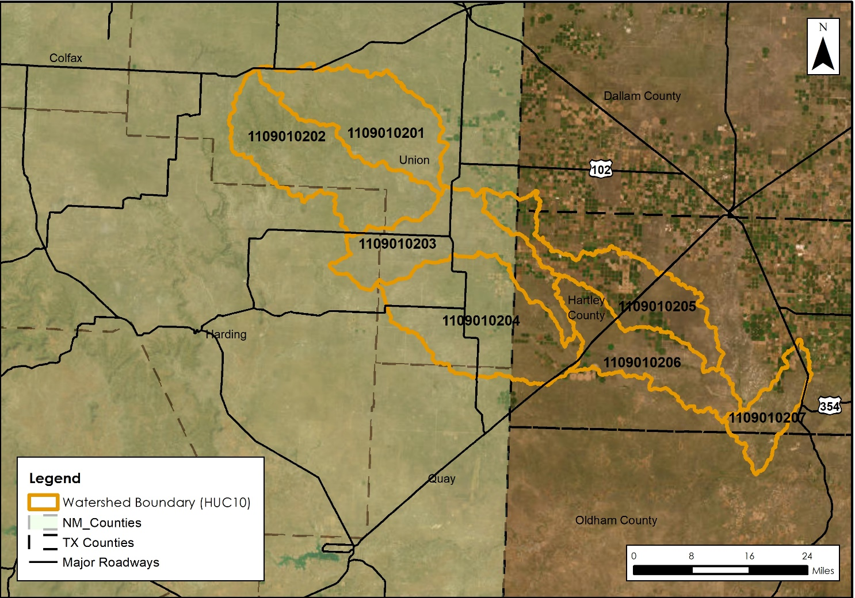
Figure 1-1. Punta de Agua Watershed (11090102) – HUC 10 Basins
The BLE assessment prepared cursory engineering analysis for approximately 1,900 miles of stream reaches within the Punta de Agua Watershed with a minimum drainage area tolerance of one square mile. The selection and extent of stream reaches studied was based upon the number of stream miles with minimum drainage area of one square mile and not the number of effective Zone A stream miles. The following sections will summarize the BLE process and will discuss the results along with their recommended use.

Topographic and Watershed Data

Terrain Data Development
This HUC8 watershed is entirely covered by two data sources. The data sources for this watershed include the Texas Panhandle 2018 D18 Lidar project obtained from the United States Geological Survey (USGS), and the New Mexico Natural Resources Conservation Service (NRCS)-Federal Emergency Management Agency (FEMA) Northeast 2017 D17 project obtained from the USGS within the Punta de Agua HUC-8 NHD boundary.
The individual Digital Elevation Model (DEM) tiles from each of the data sources were used to create one seamless DEM mosaic for the Punta de Agua Watershed using various methodologies and tools in ESRI’s ArcGIS Pro 2.9.2 environment as described below.
The final seamless DEM was developed by cataloging the tiles then mosaicking them into one DEM while maintaining the original projection and raster cell values (NAD 1983 2011 UTM Zone 13N 1-meter by 1-meter); this was done for each individual data source applicable to the project watershed. Each raster was individually converted from values in meters to values in feet. Then, where applicable, the DEM was resampled from 2-meter to 1-meter to favor the other higher resolution data sources. Each DEM was then re-projected into the NAD83 Texas North FIPS 4201 (US Feet) NAVD 1988 horizontal coordinate system and clipped to a one-mile buffer based on the NHD HUC8 boundary.
In instances where the watershed was covered by multiple overlapping data sources, the mosaicking process prioritized using the most recent data source within the overlapping area. Otherwise, a Blend option was used in areas where tiles may overlap with one another.
Special Considerations
There were no issues encountered when developing the final seamless DEM.
Table 2-1: LiDAR Data Sources
County | Age/Year | Accuracy | Source & Contact | Approximate Footprint (Sq Mi)
Texas:  Dallam, Hartley, and Oldham | February 9, 2018 through May 20, 2018 | Horizontal²: USGS QL2  Vertical³: Accuracy Z has been tested to meet 19.6 cm or better Non-Vegetated Vertical Accuracy at 95% confidence level using RMSE(z) x 1.9600 as defined by the National Standards for Spatial Data Accuracy (NSSDA) | United States Geological Survey (USGS) | 34,005⁴
New Mexico: Union, Harding, and Quay ¹ | November 20, 2017 through February 11, 2018 | Horizontal²: USGS QL2  Vertical³: Required Vertical Accuracy = 19.6 cm NVA  This data set was produced to meet ASPRS Positional Accuracy Standard for Digital Geospatial Data (2014) for a 10-cm RMSEz Vertical Accuracy Class. | United States Geological Survey (USGS) | 13,238⁴
¹Counties listed are only those applicable to current project watershed.
²Explicit horizontal accuracy not specified in the report.
³Accuracy derived from original Lidar project report.
⁴Area reported reflects coverage of entire lidar project beyond the current project watershed.
^{Note:} Metadata from project did not specify project footprint.
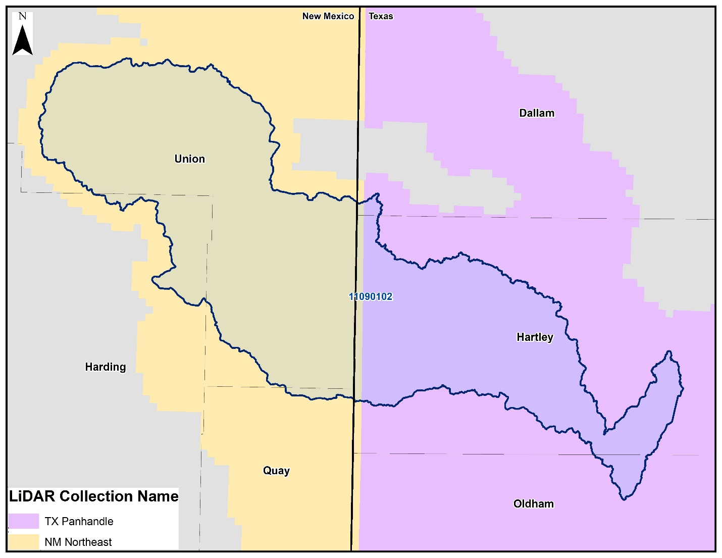
Figure 2-1. Extent and coverage of LiDAR Data as it relates to the project watershed

Watershed Data Development
The primary data source for this phase was the seamless DEM developed in the first phase. The seamless DEM was the basis for subsequent processing using the Arc Hydro toolset. The Arc Hydro processing steps outlined below create output that collectively creates the Arc Hydro data model for this watershed.

- Hydro DEM
- Fill Sinks
- Flow Direction
- Flow Accumulation (Spatial Analyst Tools)
- Stream Definition (0.5 sq mile threshold used)
- Stream Segmentation
- Catchment Grid Delineation
- Catchment Polygon Processing
- Drainage Line Processing
- Adjoint Catchment Processing
- Watershed Delineation

The final data products from this phase include a geodatabase developed using Arc Hydro tools, a collection of rasters developed using Arc Hydro tools, a geodatabase containing the drainage lines within the study watershed, and a new HUC8 watershed boundary.

Final Seamless DEM
The final DEM developed covers the project watershed, has been re-projected into the local State Plane horizontal coordinate system: NAD 1983 State Plane Texas North FIPS 4201 Feet and the vertical coordinate system of NAVD88 height (ft US). The raster cells values were adjusted from meters to feet. The DEM is a 32-Bit floating point with a single band (1) and 3.28084 by 3.28084 feet cell size.

Final Arc Hydro Data Model
The final watershed data is composed of an Arc Hydro data model and hydrography data. The Arc Hydro data model contains vector, raster, and tabular data outputs from using the various Arc Hydro and Spatial Analyst processing tools in ESRI’s ArcGIS Pro 2.x environment. The hydrography data contains streams that represent drainage of at least 0.5 square mile, the raw watershed delineation from ArcHydro, updated HUC8 watershed boundary smoothed with a 10-foot tolerance, and a comparison between the NHD HUC8 watershed boundary and the projection watershed delineation.
All data submitted, vector and raster, is in NAD83 Texas North FIPS 4201 (US Foot) NAD 1988 horizontal coordinate system.

Arc Hydro Data Model (Geodatabase and Rasters)
- Geodatabase (.gdb)
  - ArcHydro (feature dataset)
    - Adjoint Catchment – An adjoint catchment is the total upstream area (if any) draining into a single catchment.
    - Catchment – Polygon feature class out of the catchment grid.
    - DrainageLine – Streamline line feature class derived from stream link grid.
  - APUNIQUEID – A table created and managed through Arc Hydro tools; contains the last hydro identifier assigned to a new feature within the geodatabase.
- Rasters (.tif)
  - Hydro DEM (HydroDEM) – A modified DEM with hydro-connections burned into the data allowing possible flow to pass through certain hydraulic obstructions. The hydro DEM will have a distinct flow path represented through features such as dams, culverts, and bridges. This raster is used for building the Arc Hydro data model and not intended to be used in place of the Seamless DEM or for purposes where elevation accuracy is important.
  - Catchment Grid (Cat) – Drainage areas for segments in the stream link grid or sinks in the sink link grid.
  - Flow Accumulation Grid (Fac) – Created from the flow direction grid; each cell value represents the total quantity of upstream cells draining to that cell.
  - Flow Direction Grid (Fdr) – Represents the direction of flow from a given cell; 8 different directional values are possible based on the eight-direction (D8) flow model.
  - Fill Sinks Grid (Fil) – Gridded DEM with sinks or depressions removed.
  - Stream Grid (Str) – A stream grid with cells from a flow accumulation grid that exceed a user defined cell count and/or area threshold.
  - Stream Link Grid (StrLnk) – A stream grid with unique values for every link between two stream junctions.

Hydrography Data (Geodatabase)
- Drainage Lines – Drainage lines from the Arc Hydro data modeling within the study HUC8.
- NHD WBD Watershed – The NHD HUC8 boundary downloaded from USGS National Hydrography Dataset representing the project area.
- Raw Watershed Delineation – The direct output from ArcHydro data model of the HUC8 watershed delineation.
- Raw Watershed Delineation Point – The point at which ArcHydro created the Raw Watershed Delineation boundary based on elevations within the Seamless DEM created in Task 1 Phase 1.
- Watershed – A watershed delineation developed through Arc Hydro smoothed to a 10-foot tolerance and based on the elevations within the Seamless DEM created in Task 1 Phase 1.
Watershed Comparison – A comparison of the Watershed feature class and the NHD WBD HUC8 feature class boundary.

Hydrology
Balanced hyetographs derived from the Hydrologic Engineering Center’s Hydrologic Modeling System (HEC-HMS) version 4.10 were used as rain-on-grid precipitation input. The HMS model included a model boundary and the basin-mean Atlas-14 precipitation frequency values for the 10pct, 4pct, 2pct, 1pct, 0_2pct, 1PLUpct and 1MINpct for durations of 5-minutes, 15-minutes, 1-hour, 2-hours, 3-hours, 6-hours, 12-hours, and 1-day. The intensity duration was set to 5-minutes and positioned to peak at the center of the time-series. Areal reduction was applied in HMS using TP40-TP49, where area was taken as the area of the input model boundary. Other HMS input variables were set to “--None--“, and a depth-area analysis was performed from 0000 01JAN2000 to 0000 02JAN2000 at a 5-minute interval (HEC-HMS User’s Manual, Version 4.2, 2016). See Figure 3-1 below for an example of the resulting hyetograph for HUC 10 scale model 1109010201, 1pct event.
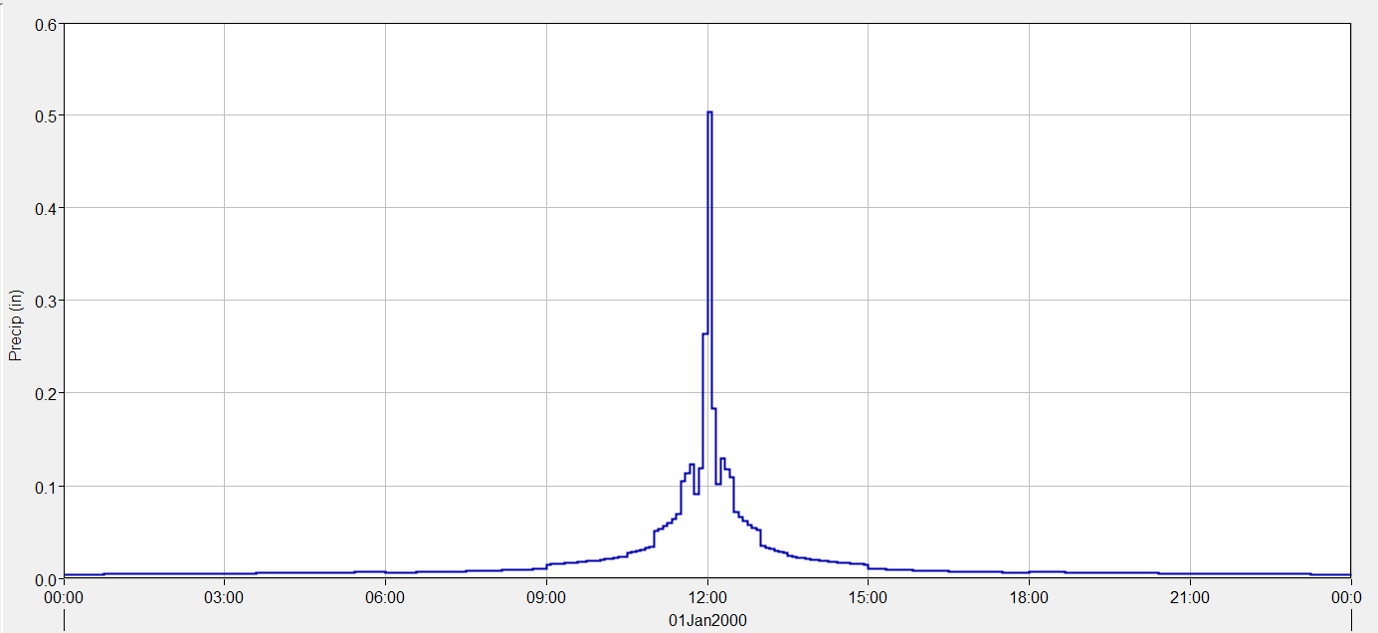
Figure 3-1 – Example of HUC 10 Hyetograph for 1% Annual-Chance Storm
Note that the hyetographs (example shown in Figure 3-1) used for this BLE study are not smooth. This is anticipated when developing nested, storm frequency hyetographs and using a small timestep. The graphs can be smoothed by increasing the hyetograph timestep, but HEC-HMS 4.10 recommends users set their output timestep equal to the minimum storm duration being considered.
The resulting rainfall volumes for HUC 11090102 for modeled events are summarized in Table 3-1 below:
Table 3-1. Atlas 14 Rainfall Volumes for HUC 11090102
HUC10 Model | Event Duration | Rainfall Volume (inches)
HUC10 Model | Event Duration | 10YR | 25YR | 50YR | 100YR | 500YR | 100PLUS | 100MINUS
1109010201 | 24-Hour | 3.45 | 4.22 | 4.85 | 5.51 | 7.19 | 5.92 | 5.10
1109010202 | 24-Hour | 3.43 | 4.21 | 4.83 | 5.50 | 7.18 | 5.91 | 5.08
1109010203 | 24-Hour | 3.45 | 4.22 | 4.84 | 5.50 | 7.19 | 6.02 | 4.98
1109010204 | 24-Hour | 3.49 | 4.26 | 4.88 | 5.55 | 7.25 | 6.10 | 5.00
1109010205 | 24-Hour | 3.47 | 4.26 | 4.90 | 5.57 | 7.37 | 6.53 | 4.61
1109010206 & 1109010207 (combined model) | 24-Hour | 3.58 | 4.38 | 5.02 | 5.71 | 7.57 | 6.76 | 4.65

Infiltration Parameters
The infiltration layer containing attributes for Soil Conservation Survey (SCS; now the Natural Resources Conservation Survey (NRCS)) curve numbers (CN), abstraction ratio, and minimum infiltration rate (Table 3-2) was developed in ArcGIS using the National Land Cover Database (NLCD) and NRCS soil data from the USGS Soils Survey Geographic Database (SSURGO) (SSURGO 2020; MRCL 2019).
Table 3-2. SCS Hydrologic Soil Groups and Infiltration Parameters (Source: USACE 2022)
Hydrologic Soil Group | Range of Loss Rates (in./hour) (SCS 1986) | Base Model Loss Rates (in./hour) *
A – deep sand, deep loess, aggregated silts | 0.30 – 0.45 | 0.38
B – shallow loess, sandy lam | 0.15 – 0.30 | 0.23
C – clay loams, shallow sandy loam, soils low in organic content, and soils usually high in clay | 0.05 – 0.15 | 0.10
D – Soils that swell significantly when wet, heavy plastic clays, and certain saline soils | 0.00 – 0.05 | 0.025
* Base minimum infiltration rate chosen based HEC-RAS 6.3 technical guidance manual

A land-use – soils – CN matrix (Table 3-3) was used to select CN values for the study area and calculate a base infiltration layer. The curve numbers presented in the table were derived from the 2022 TWDB 2D BLE guidance manual and were originally presented in USDA’s TR-55. Initial abstraction for the base layer was set to an abstraction ratio of 0.2 based on HEC-RAS 2D user’s manual (USACE 2021). A separate impervious layer was added to the model and is represented in the HEC-RAS model in the land use classification layer with the manning’s roughness layer; both the manning’s n and impervious data were derived from 2019 NLCD and are discussed further in Section Error! Reference source not found..
The base infiltration layer was processed in HEC-RAS RASMapper to create a spatially distributed raster dataset of the infiltration parameters. The base infiltration parameters, CN and abstraction ratio, were adjusted to calibrate the HEC-RAS hydraulic model response to the Bulletin 17C gage analysis for the 1% annual-chance storm event where adequate gage records were available. Additional discussion on model calibration is discussed in Section 4.6.
Table 3-3. Land use -Soils -CN Matrix for Computing Initial Curve Numbers (Source: USDA Urban Hydrology for Small Watersheds (TR-55))
LU_GridCode | NLCD LU Description | Hydrologic Soil Group
LU_GridCode | NLCD LU Description | A | B | C | D
11 | Open Water | 99 | 99 | 99 | 99
12 | Perennial ice/snow | 40 | 40 | 40 | 40
21 | Developed Open Space | 49 | 69 | 79 | 84
22 | Developed Low Intensity | 39 | 61 | 74 | 80
23 | Developed Medium Intensity | 39 | 61 | 74 | 80
24 | Developed High Intensity | 39 | 61 | 74 | 80
31 | Barren Land | 39 | 61 | 74 | 80
41 | Deciduous Forest | 30 | 55 | 70 | 77
42 | Evergreen Forest | 30 | 55 | 70 | 77
43 | Mixed Forest | 30 | 55 | 70 | 77
52 | Shrub Scrub | 30 | 48 | 65 | 73
71 | Herbaceous | 49 | 62 | 74 | 85
81 | Hay Pasture | 39 | 61 | 74 | 80
82 | Cultivated Crops | 51 | 67 | 76 | 80
90 | Woody Wetlands | 72 | 80 | 87 | 93
95 | Emergent Herbaceous Wetlands | 72 | 80 | 87 | 93

Hydraulics
The hydraulic approach for the Punta de Agua watershed’s BLE analysis consisted of developing HUC 8-scale two-dimensional (2D) hydraulic models with the Hydrologic Engineering Center’s River Analysis System (HEC-RAS) program version 6.3. Hydraulic routing was performed with an unsteady-state analysis by applying NOAA Atlas 14 uniform rainfall data to the final model mesh, which is comprised of the terrain model (described in section 2.1) and the hydrologic inputs (described in section 3). The models were refined based on USGS historic gages records to simulate predictions of WSEL and inundation extent during the 10%, 4%, 2%, 1%, +1%, -1% and 0.2% annual chance events.

The Punta de Agua Watershed includes the following seven HUC 10 scale watersheds in six hydraulic models:
- HUC 1109010201: Pinabetes Creek Watershed– Punta de Agua Creek Watershed
- HUC 1109010202: Pedernal Creek – Tramperos Creek Watershed
- HUC 1109010203: Tramperos Creek – Punta de Agua Creek Watershed
- HUC 1109010204: Monia Creek – Punta de Agua Creek Watershed
- HUC 1109010205: Syndicate Hills Watershed
- HUC 1109010206*: Sand Well – Punta de Agua Creek Watershed HUC
- HUC 1109010207*: Los Redos Creek – Punta de Agua Creek Watershed
*HUC 10 subbasins combined into a single model.

2D Computational Mesh and Settings
The base computational mesh for the models in the Punta de Agua Watershed was developed at a 200 ft x 200 ft grid cell size. Breaklines and refinement regions were implemented to create a higher mesh resolution for both channels with contributing drainage area of at least 1 square mile (0.5 square mile for populated areas) and in areas of terrain elevation change, which is detailed further in section 4.2. The total number of mesh elements and average cell size varies per HUC 10 model; spatial parameters of each HUC 10 model for Punta de Agua Watershed are summarized in Table 4-1.
Table 4-1. HUC 10 Mesh Parameters
HUC 10 Model Name | Size of Study Area (sq mi) | Number of Mesh Elements (grid cells) | Average cell size (sq ft)
1109010201 | 233 | 210,795 | 33,103
1109010202 | 263 | 245,589 | 32,086
1109010203 | 223 | 204,696 | 34,624
1109010204 | 316 | 270,632 | 34,474
1109010205 | 210 | 170,177 | 38432
1109010206/07 | 267 | 251,161 | 32,902

Model Computational Settings
Models were run using the Diffusion Wave equation set for 2D flow using an adaptive 30-second timestep for each frequency event discussed in this report. Diffusion Wave (simplified Full Momentum) computational method was selected rather than the Shallow Water equations due to hydraulic structures, such as bridges, culverts and dams, not being modeled in detail as part of this BLE study. The Full Momentum equation is typically selected to better account for energy losses in and around structures (USACE 2021). More information on the application of Diffusion Wave Equations versus the Shallow Water equations can be found in the HEC-RAS version 6.3 2D user’s manual.
An adaptive 30-second timestep was applied to iteratively control the maximum courant number below 2 for the duration of each simulation. With the advanced timestep controls in RAS, the adaptive timestep was set with a max allowance of 240 seconds, and a minimum of 3.75 seconds. Courant values of less than or equal to 2 are considered ideal, with 5 considered the maximum acceptable for simulations applying Diffusion Wave computational methods (USACE 2021). The default 2D flow options were applied for the multi-frequency runs.

Breaklines and Refinement Regions
Breaklines and refinement regions were enforced in the model mesh at half the base cell resolution. Refinement regions for smaller tributaries were enforced at higher resolution (minimum cell size of 100 ft x 100 ft) on a case-by-case basis per engineering judgement. The development of these features is described in the following sections.

Breaklines
Breaklines were enforced in the models’ computational meshes for state and federal roadways and dams found in the National Inventory of Dams (NID). Additional breaklines were added using engineering judgement after inspection of individual models to better represent areas such as agricultural ponds, dams, embankments, or other changes in elevation found to be hydraulically significant to a model domain. Breaklines were specifically added in the main reach adjacent to urbanized areas, or individual structures, to capture channel bank geometry correctly in the mesh. An overview of the breaklines for the Punta de Agua Watershed is shown in Figure 4-1.
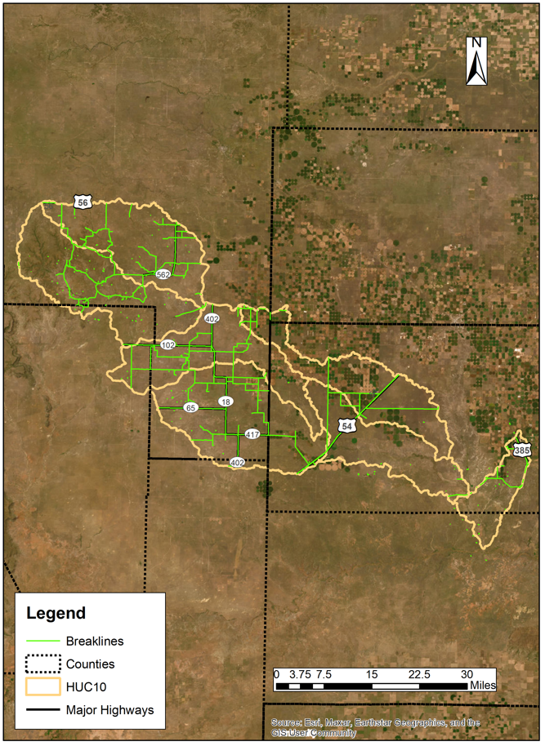
Figure 4-1. Overview of HUC 8 Scale Breaklines for Punta de Agua Watershed

Mesh Refinement Regions
A mesh refinement region was enforced to provide a more detailed drainage pathway in the computational mesh. A refinement region polygon was developed for each model to represent the bank full flow (Figure 4-2).
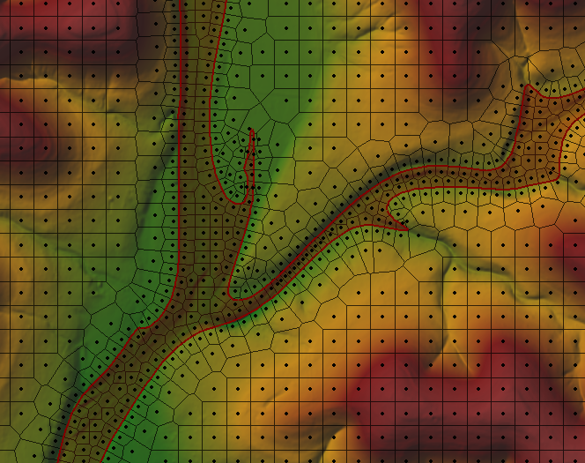
Figure 4-2. Example of Refinement Region Polygon
The refinement region polygon was created using a proprietary ArcGIS python toolbox. The process used a coarse-run (1000x1000-ft cells) 10-year inundation raster in conjunction with orthographically corrected stream centerlines. Aerial imagery and the terrain DEM were used to make any necessary adjustments to the toolbox polygon to more accurately capture bank-full extents. The processed polygon was imported into the model geometry as a refinement region in the HEC-RAS geometry. An overview of the refinement regions for the Punta de Agua Watershed is shown in Figure 4-3.
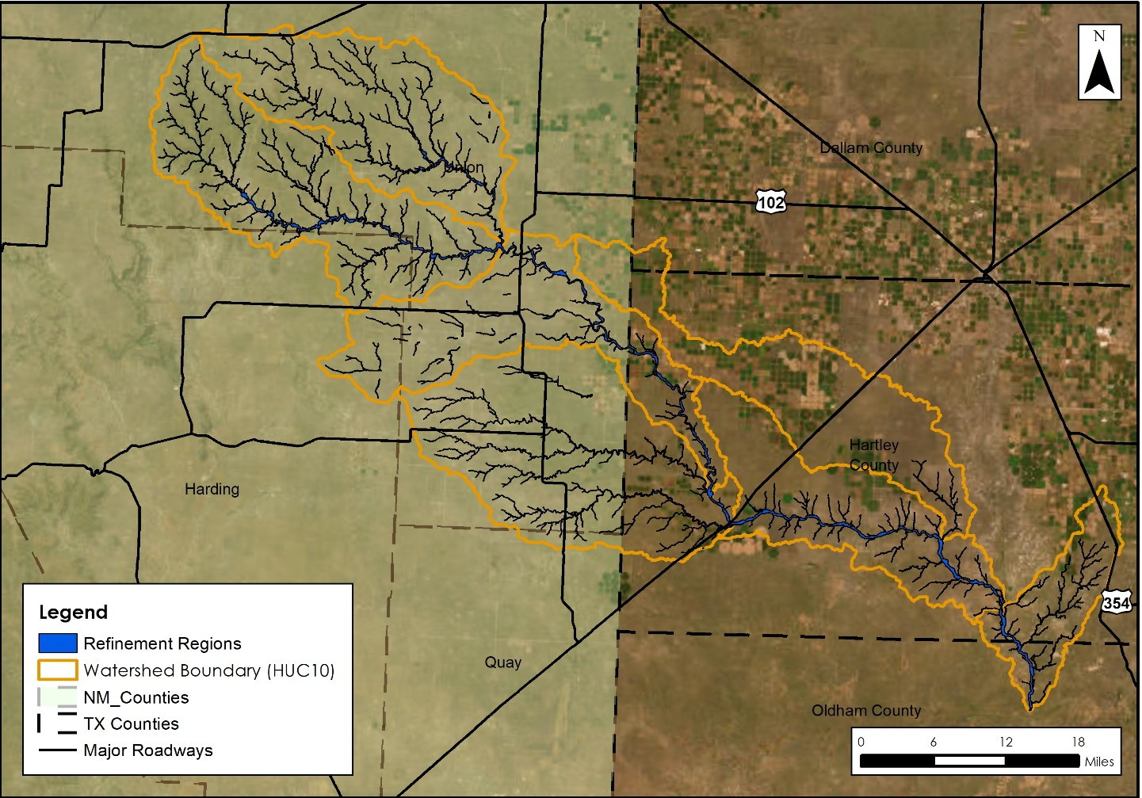
Figure 4-3. Overview of HUC 8 Scale Mesh Refinement Regions for Punta de Agua Watershed

Manning’s Roughness Coefficients and Land Use
The 2019 National Land Cover Database (NLCD) Land Use Classification raster was used to develop the Manning’s n roughness coefficients for the study area. Manning’s n selected for the Punta de Agua Watershed are presented in Table 4-2 below. The values selected are within the range of values provided by the Texas Water Development Board’s BLE Guidelines (May 2022) and the HEC-RAS 2D manual (USACE 2021).
Table 4-2.Manning’s N Values
Land Use Classification | Allowable Range of n values | Punta de Agua  Manning’s Values
Open Water | 0.025 – 0.050 | 0.040
Developed, Open Space | 0.030 – 0.050 | 0.040
Developed, Low Intensity | 0.080 – 0.120 | 0.100
Developed, Medium Intensity | 0.060 – 0.140 | 0.120
Developed, High Intensity | 0.120 – 0.200 | 0.150
Barren Land | 0.023 – 0.300 | 0.025
Deciduous Forest | 0.100 – 0.160 | 0.160
Evergreen Forest | 0.100 – 0.160 | 0.160
Mixed Forest | 0.100 – 0.160 | 0.160
Scrub/Shrub | 0.070 – 0.160 | 0.100
Grassland/Herbaceous | 0.025 – 0.050 | 0.035
Pasture/Hay | 0.025 – 0.050 | 0.030
Cultivated Crop | 0.025 – 0.050 | 0.035
Woody Wetlands | 0.045 – 0.150 | 0.120
Emergent Herbaceous Wetland | 0.050 – 0.085 | 0.070
Manning’s n override region/channels | 0.025 – 0.150 | 0.035 – 0.075

Manning’s n override regions were enforced in the models to represent the channels’ high-stage preferential flow paths, spatially corresponding to the channel mesh refinement regions as discussed in Section 4.2.2. Initial Manning’s n override values were set based on examination of aerial imagery and engineering judgement. If necessary, channel Manning’s values were modified on a per-model basis for calibration, as discussed further in Section 4.6, as applicable.
Percent impervious was added as an attribute to the land use classification layer corresponding to the 2019 NLCD land use classification data. The percent impervious values applied for developed land use classifications were derived from USDA’s TR-55 and are summarized in Table 4-3.
Table 4-3. Imperviousness Values (Source: USDA Urban Hydrology for Small Watersheds (TR-55))
Land Use Classification | Percent Impervious
Developed, Low Intensity | 38
Developed, Medium Intensity | 72
Developed, High Intensity | 85

Terrain Modification
Terrain modifications were made through the HEC-RAS layer modifications feature in RASMapper Version 6.3. Direct modifications were not made to the original terrain. A modifications layer was added to the model terrain to apply Hydraulic Connectors (HCs) which allow flow to be conveyed through structures, such as roadway culverts, that the original DEM otherwise impedes. After adding a modifications layer with all final HCs, the terrain with modification layer was used for the analysis (Figure 4-4).
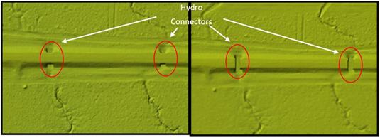
Figure 4-4. Example of localized original terrain (left) and terrain after resampling and addition of modification layer (right)

HUC 8 Model Integration
A diagram showing inter-basin connectivity and boundary condition (BC) locations for the Punta de Agua Watershed is included in Figure 4-5.

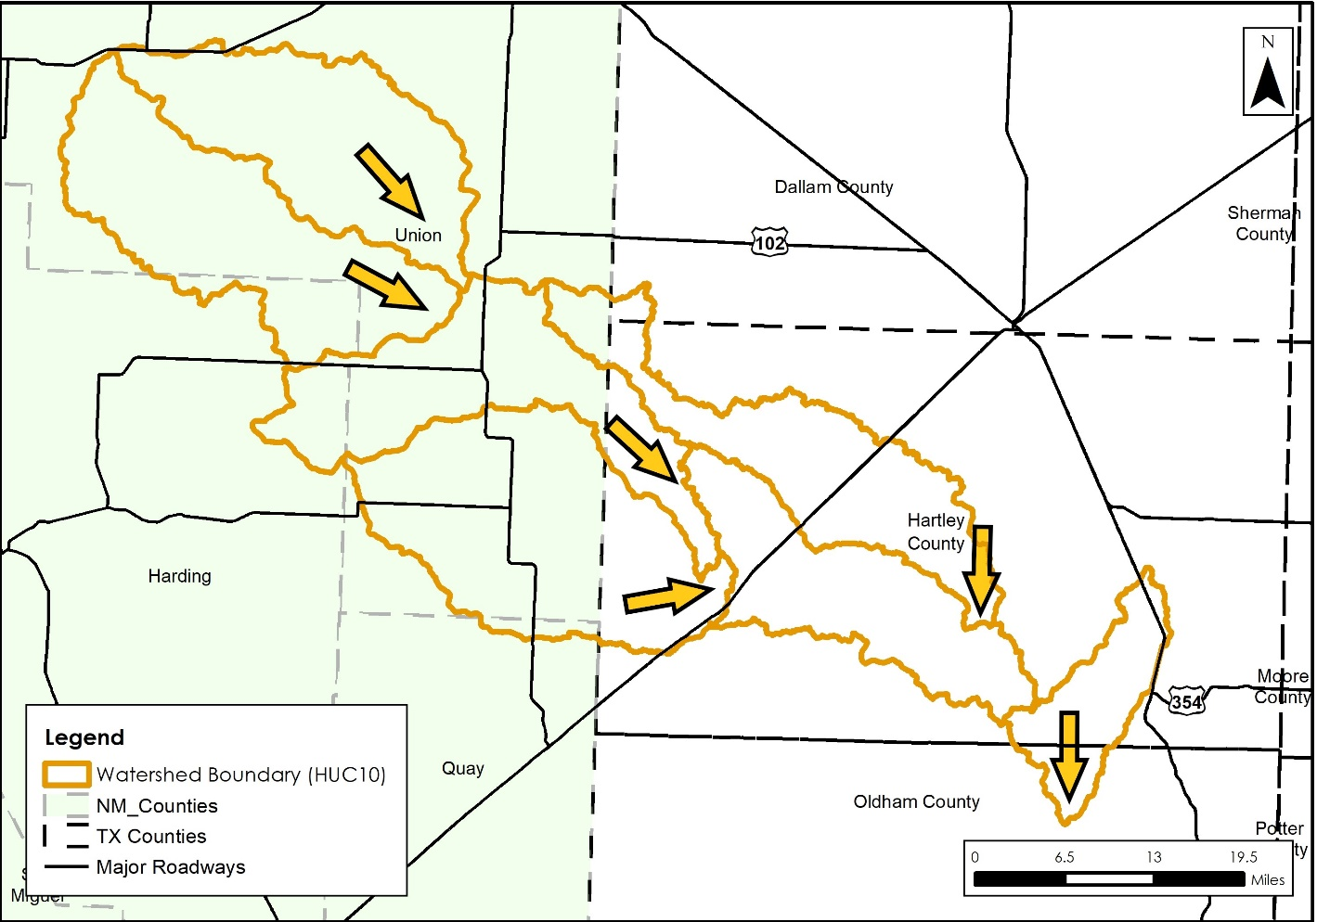
Figure 4-5. Overview of HUC 8 with HUC 10 Model Connectivity
The SA/2D connectors in the upstream model were placed perpendicular to channel flow a distance upstream of the channel outlet to avoid influence of the downstream normal depth BCs. The upstream SA/2D location was isolated based on a normal depth sensitivity analysis where the placement distance from the downstream BC was determined by the location of channel WSEL convergence for runs of varying normal depth BC values (Figure 4-6). This was done in order to minimize the margin of error in floodplain delineation due to potential inaccuracies in normal depth input in the upstream model’s downstream BC.
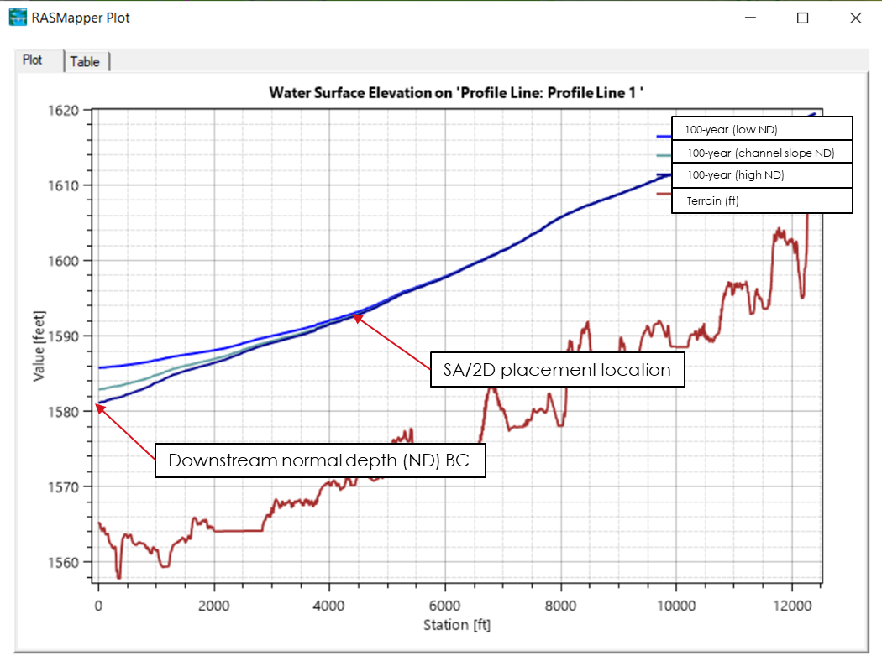
Figure 4-6. SA/2D Normal Depth sensitivity and placement example
The upstream and downstream model meshes were modified from the USGS HUC 10 delineation to overlap at the location of the SA/2D connection. To optimize the hydraulic performance of the connection, the SA/2D placement varied per model based on unique features such as terrain slope, channel dimensions, instream flow obstructions (dams, railroad crossings, low water crossings etc.) and normal depth sensitivity. Therefore, model overlap size varied per model and connection location. Final model meshes for the Punta de Agua Watershed models are shown in Figure 4-7. In locations where the models overlap the downstream model’s water surface elevation and flow in the receiving model represents the overlapped area.
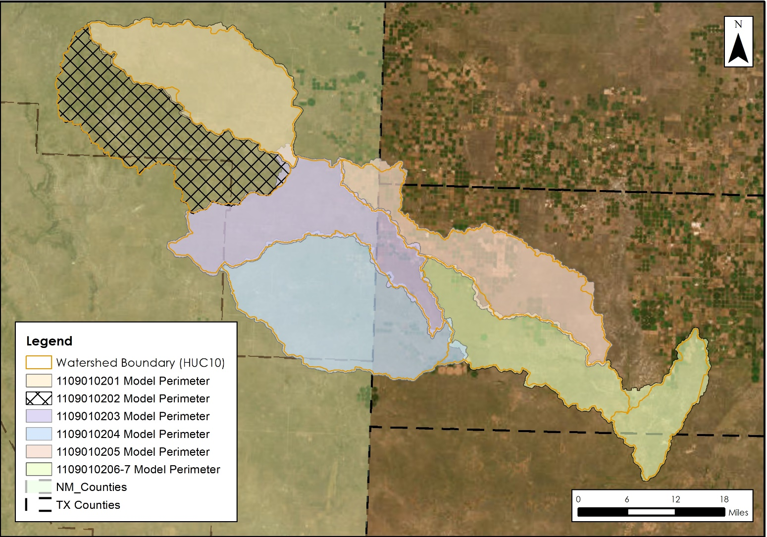
Figure 4-7. Overview of Adjusted Model Domains
The SA/2D connections were calibrated to ensure continuity of both flow and water surface elevation (+/- 0.5 ft) between upstream and downstream models. Flow hydrograph inflows were calibrated by first setting the initial Energy Grade (EG) slope of the boundary condition as the channel slope derived from the terrain, and the EG was revised iteratively to reflect modeled EG and maintain modeled WSEL continuity between models. The BCs for each model are described in more detail in the following sections. Final continuity metrics for the Punta De Agua watershed are summarized in Table 4-4.
Table 4-4. HUC 10 Model Integration Summary
Upstream Model Number | Downstream Model Number | Number of SA/2D Connectors | Distance from SA/2D Connector to DS BC (ft) | 100-Year Flow Difference (%) | 100-Year Stage Difference (ft)
1109010201 | 1109010203 | 1 | 19,315 | 0 | 0.0
1109010202 | 1109010203 | 1 | 9,592 | 0 | 0.3
1109010203 | 1109010204 | 1 | 6,709 | 0 | 0.4
1109010204 | 1109010206/07 | 1 | 3,769 | 0 | 0.3
1109010205 | 1109010206/07 | 1 | 2,704 | 0 | 0.2
1109010305 | 1109010206/07 | 2 | 15,877 | 0 | 0.3
1109010305 | 1109010206/07 | 2 | 20,405 | 0 | 0.2

Pinabetes Creek Watershed (1109010201) and Tramperos Creek – Punta de Agua Creek Watershed (1109010203) Boundary
The boundary between the Pinabetes Creek and the Tramperos Creek was set approximately 19,315ft upstream of the USGS HUC10 delineation. The SA/2D connector location was placed at a well channelized portion of the main stem models upstream of the region influenced by backwater coming in from Pedernal Creek, with the model extended downstream based on the normal depth sensitivity analysis. The resulting model meshes and hydraulic continuity results are summarized in Table 4-5 and Figure 4-8.
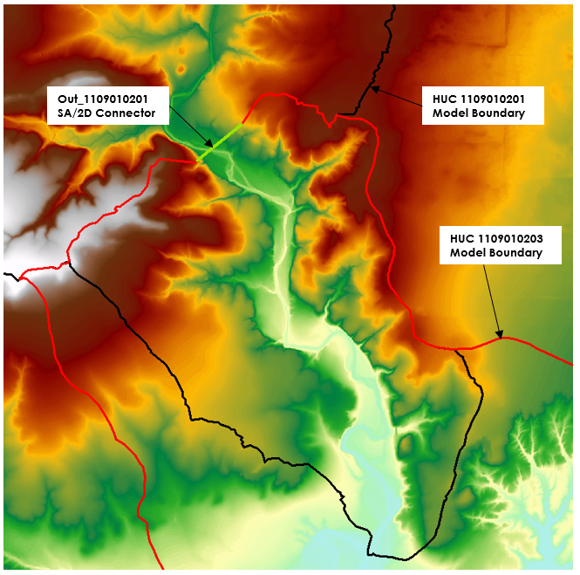
Figure 4-8. Pinabetes Creek Watershed (1109010201) and Tramperos Creek – Punta de Agua Creek Watershed (1109010203) Boundary Plan View

Table 4-5. Pinabetes Creek Watershed (1109010201) and Tramperos Creek – Punta de Agua Creek Watershed (1109010203) Continuity – all modeled events
Annual-chance Event | HUC201 (Upstream) |  | HUC203 (Downstream) |  | Absolute Difference | Absolute Difference
Annual-chance Event | Max WSEL (ft) | Peak Flow (Cfs) | Max WSEL (ft) | Peak Flow (Cfs) | Max WSEL (ft) | Peak Flow (Cfs)
10 PCT | 4611.2 | 5043.0 | 4610.6 | 5043.0 | 0.6 | 0.0
4 PCT | 4613.3 | 9033.1 | 4613.1 | 9033.1 | 0.2 | 0.0
2 PCT | 4614.9 | 13290.9 | 4614.8 | 13290.9 | 0.2 | 0.0
1 PCT | 4616.6 | 18989.7 | 4616.4 | 18989.7 | 0.2 | 0.0
0.2 PCT | 4620.1 | 37918.5 | 4620.0 | 37918.5 | 0.1 | 0.0
1+ PCT | 4617.6 | 23063.0 | 4617.3 | 23063.0 | 0.2 | 0.0
1- PCT | 4615.6 | 15264.9 | 4615.4 | 15264.9 | 0.2 | 0.0

Pedernal Creek – Tramperos Creek Watershed (1109010202) and Tramperos Creek – Punta de Agua Creek Watershed (1109010203) Boundary
The boundary between the Pedernal Creek and Tramperos Creek-Punta de Augua Creek HUC10 models was set approximately 9,592 upstream of the USGS HUC10 delineation, as the downstream end of the HUC10 was the confluence of two tributaries. To prevent the need for numerous connections, the downstream model mesh was extended upstream from the confluence, such that a singular SA/2D connector could be used to connect the models. The resulting model meshes and hydraulic continuity results are summarized in Figure 4-9 and Table 4-6.
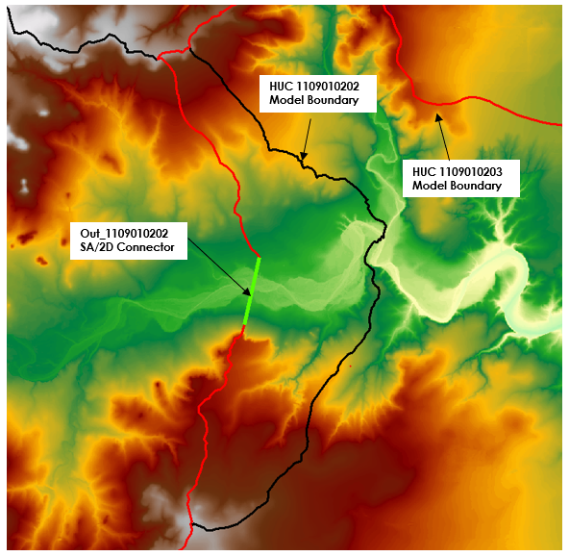
Figure 4-9. Pedernal Creek – Tramperos Creek (1109010203) and Tramperos Creek – Punta de Agua Creek Watershed (1109010203) Boundary Plan View
Table 4-6. Pedernal Creek – Tramperos Creek (1109010202) and Tramperos Creek – Punta de Agua Creek Watershed (1109010203) Continuity – all modeled events
Annual-chance Event | HUC202 (Upstream) |  | HUC203 (Downstream) |  | Absolute Difference | Absolute Difference
Event | Max WSEL (ft) | PeakFlow (Cfs) | Max WSEL (ft) | PeakFlow (Cfs) | Max WSEL (ft) | PeakFlow (Cfs)
10 PCT | 4556.3 | 1330.8 | 4555.8 | 1330.8 | 0.5 | 0.0
4 PCT | 4557.5 | 3321.0 | 4557.1 | 3321.0 | 0.4 | 0.0
2 PCT | 4558.4 | 5544.4 | 4558.1 | 5544.4 | 0.3 | 0.0
1 PCT | 4559.4 | 8517.2 | 4559.2 | 8517.2 | 0.3 | 0.0
0.2 PCT | 4562.0 | 21374.2 | 4561.7 | 21374.2 | 0.3 | 0.0
1+ PCT | 4560.1 | 10904.6 | 4559.8 | 10904.6 | 0.2 | 0.0
1- PCT | 4558.8 | 6558.8 | 4558.5 | 6558.8 | 0.3 | 0.0

Tramperos Creek – Punta de Agua Creek Watershed (1109010203) and Monia Creek – Punta de Agua Creek Watershed (1109010204) Boundary

The boundary between the Tramperos Creek and Monia Creek-Punta De Agua Creek HUC is approximately 6,709ft upstream of the Monia Creek HUC10 delineation. The SA/2D connector location was placed at a well channelized portion of the main stem models, with the model extended downstream based on the normal depth sensitivity analysis. The resulting model meshes and hydraulic continuity results are summarized in Figure 4-10 and Table 4-7.
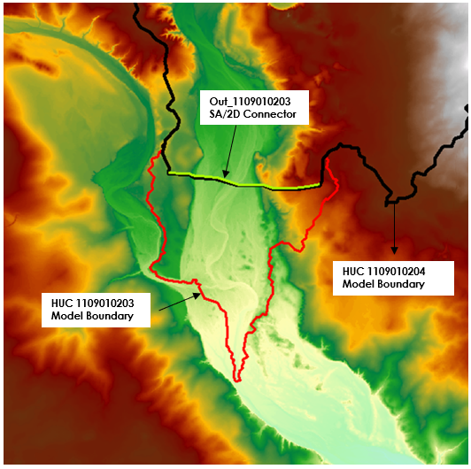
Figure 4-10. Tramperos Creek – Punta de Agua Creek Watershed (1109010203) and Monia Creek – Punta de Agua Creek Watershed (1109010204) Boundary Plan View

Table 4-7. Tramperos Creek – Punta de Agua Creek Watershed (1109010203) and Monia Creek – Punta de Agua Creek Watershed (1109010204) Continuity – all modeled events
Annual-chance Event | HUC203 (Upstream) |  | HUC204 (Downstream) |  | Absolute Difference | Absolute Difference
Event | Max WSEL (ft) | PeakFlow (Cfs) | Max WSEL (ft) | PeakFlow (Cfs) | Max WSEL (ft) | PeakFlow (Cfs)
10 PCT | 4017.9 | 5839.5 | 4017.4 | 5839.5 | 0.5 | 0.0
4 PCT | 4018.8 | 11250.0 | 4018.3 | 11250.0 | 0.5 | 0.0
2 PCT | 4019.5 | 17452.7 | 4019.2 | 17452.7 | 0.3 | 0.0
1 PCT | 4020.4 | 25811.2 | 4020.2 | 25811.2 | 0.2 | 0.0
0.2 PCT | 4022.8 | 55021.9 | 4022.8 | 55021.9 | 0.1 | 0.0
1+ PCT | 4020.9 | 32006.6 | 4020.8 | 32006.6 | 0.1 | 0.0
1- PCT | 4019.8 | 20221.5 | 4019.6 | 20221.5 | 0.3 | 0.0

Monia Creek – Punta de Agua Creek Watershed (1109010204) and Sand Well – Punta de Agua Creek Watershed (1109010206) Boundary
The boundary between the Monia Creek and Sand Well-Punta de Agua model is approximately 3,769ft downstream of the Sand Well HUC10 delineation. The SA/2D connector location was placed at a well channelized portion of the main stem models, with the model extended downstream based on the normal depth sensitivity analysis. SA/2D connector was placed in a spot yielding a continuous floodplain across all the rainfall events. The resulting model meshes, and hydraulic continuity results are summarized in Figure 4-11 and Table 4-8.
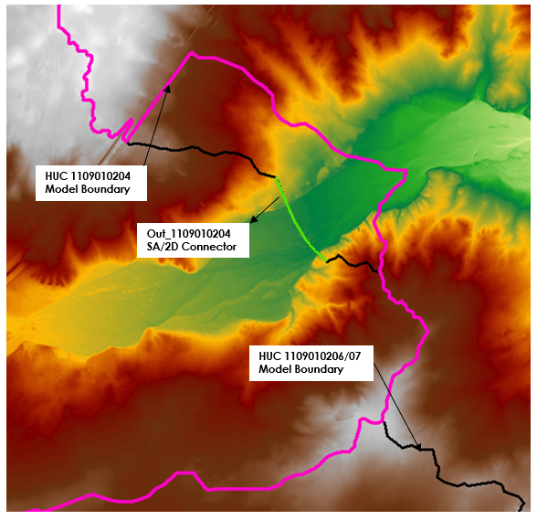
Figure 4-11: Monia Creek – Punta de Agua Creek Watershed (1109010204) and Sand Well – Punta de Agua Creek Watershed (1109010206) Boundary Plan View

Table 4-8: Monia Creek – Punta de Agua Creek Watershed (1109010204) and Sand Well – Punta de Agua Creek Watershed (1109010206) Continuity – all modeled events
Annual-chance Event | HUC204 (Upstream) |  | HUC206 (Downstream) |  | Absolute Difference | Absolute Difference
Event | Max WSEL (ft) | PeakFlow (Cfs) | Max WSEL (ft) | PeakFlow (Cfs) | Max WSEL (ft) | PeakFlow (Cfs)
10 PCT | 3914.4 | 6510.1 | 3914.3 | 6510.1 | 0.1 | 0.0
4 PCT | 3915.3 | 12680.9 | 3915.2 | 12680.9 | 0.1 | 0.0
2 PCT | 3916.1 | 19598.2 | 3916.1 | 19598.2 | 0.1 | 0.0
1 PCT | 3917.1 | 28957.0 | 3917.0 | 28957.0 | 0.0 | 0.0
0.2 PCT | 3919.7 | 61869.7 | 3919.7 | 61869.7 | 0.0 | 0.0
1+ PCT | 3917.7 | 35966.6 | 3917.7 | 35966.6 | 0.0 | 0.0
1- PCT | 3916.5 | 22633.7 | 3916.4 | 22633.7 | 0.1 | 0.0

Syndicate Hills Watershed (1109010205) and Sand Well – Punta de Agua Creek Watershed (1109010206) Boundary
The boundary between Syndicate Hills and San Well-Punta de Agua HUC10 models was set approximately 2,704 upstream of the USGS HUC10 delineation. As Syndicate Hills is a playa dominated HUC10 the outflow from the watershed were relatively low. So, to prevent the need for numerous connections, the downstream model mesh was extended upstream from the confluence, such that a singular SA/2D connector could be used to connect the models. The resulting model meshes and hydraulic continuity results are summarized in Figure 4-12 and Table 4-9
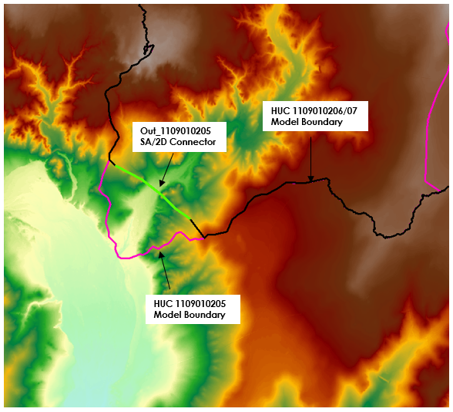
Figure 4-12: Syndicate Hills Watershed (1109010205) and Sand Well – Punta de Agua Creek Watershed (1109010206) Boundary Plan View

Table 4-9: Syndicate Hills Watershed (1109010205) and Sand Well – Punta de Agua Creek Watershed (1109010206) Continuity – all modeled events
Annual-chance Event | HUC205 (Upstream) |  | HUC206 (Downstream) |  | Absolute Difference | Absolute Difference
Event | Max WSEL (ft) | PeakFlow (Cfs) | Max WSEL (ft) | PeakFlow (Cfs) | Max WSEL (ft) | PeakFlow (Cfs)
10 PCT | 3600.2 | 39.6 | 3599.9 | 39.6 | 0.3 | 0.0
4 PCT | 3600.8 | 213.7 | 3600.5 | 213.7 | 0.3 | 0.0
2 PCT | 3601.2 | 511.0 | 3600.8 | 511.0 | 0.3 | 0.0
1 PCT | 3601.7 | 1011.0 | 3601.4 | 1011.0 | 0.3 | 0.0
0.2 PCT | 3603.3 | 3285.8 | 3603.1 | 3285.8 | 0.3 | 0.0
1+ PCT | 3602.6 | 2113.1 | 3602.3 | 2113.1 | 0.3 | 0.0
1- PCT | 3601.0 | 395.8 | 3600.7 | 395.8 | 0.3 | 0.0

Cottonwood Draw - Punta de Agua Creek (1109010305) and Sand Well – Punta de Agua Creek Watershed (1109010206) Boundary
The USGS HUC boundary of Cottonwood Draw-Punta de Agua, which is a neighboring HUC 8 that flows into the most downstream HUC 10 of Punta de Agua, is located upstream of the San Well-Punta de Agua HUC10 boundary in the central north portion. 1109010206 was extended approximately three and half miles into the 1109010305 model. To prevent the need for numerous connections, the downstream model mesh was extended , such that two SA/2Ds connector could be used to pass flows from upstream to downstream( Refer to the 11090103 report for more information on 1109010305). The SA/2D connectors were placed along a rural road which crossed the main channel. The flow hydrograph from an upstream-model SA/2D connection was represented by an inflow hydrograph boundary condition in the downstream model. The resulting model meshes and hydraulic continuity results are summarized in Figure 4-13, Table 4-10 and Table 4-11.
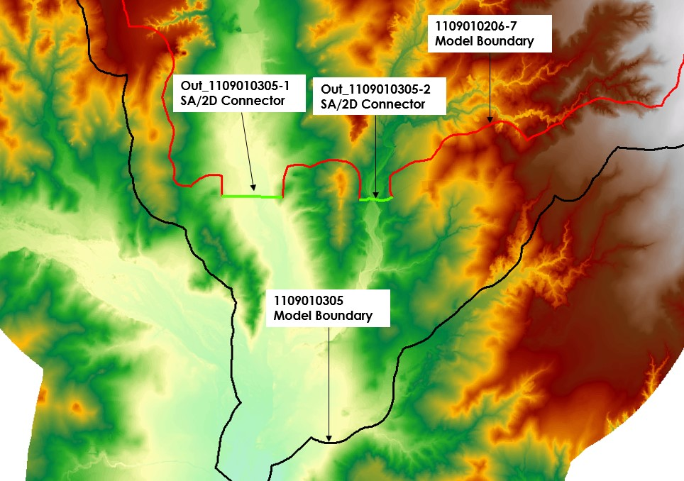
Figure 4-13: Cottonwood Draw - Punta de Agua Creek (1109010305) and Sand Well – Punta de Agua Creek Watershed (1109010206) Boundary Plan View

Table 4-10: Cottonwood Draw - Punta de Agua Creek (1109010305) and Sand Well – Punta de Agua Creek Watershed (1109010206) Continuity – all modeled events, SA/2D #1
Annual-chance Event | HUC305-1 (Upstream) |  | HUC206 (Downstream) |  | Absolute Difference | Absolute Difference
Event | Max WSEL (ft) | PeakFlow (Cfs) | Max WSEL (ft) | PeakFlow (Cfs) | Max WSEL (ft) | PeakFlow (Cfs)
10 PCT | 3435.1 | 5044.0 | 3434.6 | 5044.0 | 0.6 | 0.0
4 PCT | 3435.9 | 7210.7 | 3435.5 | 7210.7 | 0.4 | 0.0
2 PCT | 3438.1 | 16209.6 | 3437.8 | 16209.6 | 0.3 | 0.0
1 PCT | 3440.6 | 31507.1 | 3440.3 | 31507.1 | 0.3 | 0.0
0.2 PCT | 3446.7 | 92035.5 | 3446.4 | 92035.5 | 0.3 | 0.0
1+ PCT | 3442.9 | 50408.4 | 3442.6 | 50408.4 | 0.3 | 0.0
1- PCT | 3438.2 | 16928.8 | 3437.9 | 16928.8 | 0.3 | 0.0

Table 4-11: Cottonwood Draw - Punta de Agua Creek (1109010305) and Sand Well – Punta de Agua Creek Watershed (1109010206) Continuity – all modeled events, Sa/2D #2
Annual-chance Event | HUC305-2 (Upstream) |  | HUC206 (Downstream) |  | Absolute Difference | Absolute Difference
Event | Max WSEL (ft) | PeakFlow (Cfs) | Max WSEL (ft) | PeakFlow (Cfs) | Max WSEL (ft) | PeakFlow (Cfs)
10 PCT | 3476.6 | 89.3 | 3476.3 | 89.3 | 0.3 | 0.0
4 PCT | 3477.6 | 281.9 | 3477.4 | 281.9 | 0.2 | 0.0
2 PCT | 3478.6 | 568.0 | 3478.3 | 568.0 | 0.3 | 0.0
1 PCT | 3479.6 | 1106.8 | 3479.3 | 1106.8 | 0.3 | 0.0
0.2 PCT | 3481.9 | 3807.7 | 3481.6 | 3807.7 | 0.3 | 0.0
1+ PCT | 3481.1 | 2455.2 | 3480.8 | 2455.2 | 0.3 | 0.0
1- PCT | 3478.0 | 369.1 | 3477.8 | 369.1 | 0.2 | 0.0

Calibration and Validation
Model parameter adjustments and calibration in the Task Order #3 BLE study were performed for models encompassing USGS gages with a minimum of 10 years of record. Model adjustments were based on estimates of a 1% annual chance peak flow values but did not consider hydrograph timing or flow volume. No model adjustments were made based on USGS regional regression estimates. As shown in Figure 4-12 below, there is one USGS gage (07227420) within the Punta de Agua (11090102) watershed. Unfortunately this gage did not have the required data to be used and thus model revisions were not made using this gage.

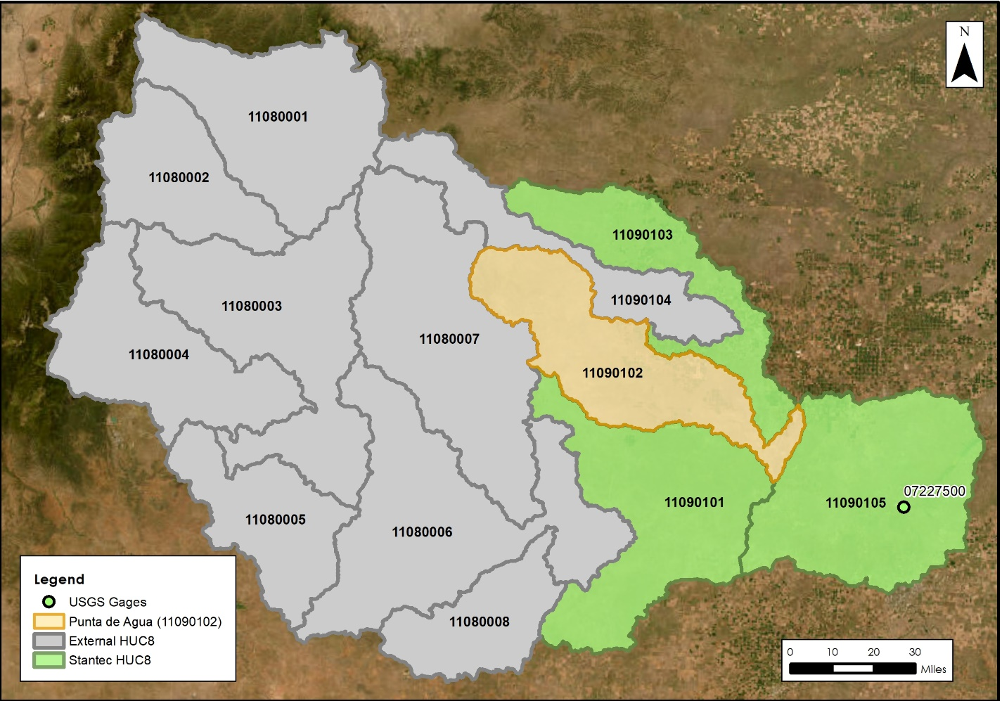
Figure 4-12. USGS Gages Punta de Agua Creek watershed

Comparison to USGS Regression Estimates for Unregulated Streams and Watersheds
A comparison to peak flow estimates from USGS regional regression equations was not made for this BLE study as there are no regional reports directly applicable to the Punta de Agua Creek study area. The Punta de Agua Creek watershed has areas of playa lakes which reduced the confidence in the applicability of the generalized Texas equations for model flow comparison. The presence of the playas affect the timing and volume of runoff downstream of their location, for which regression estimates do not account.

Results

Comparison to Existing Study Data
The model results were unable to be compared to effective data because it does not exist in this area.

Challenges and Recommendations
A significant hurdle in developing accurate models for the Punta de Agua watershed was the lack of USGS gage data and limited NHFL data within the watershed, and the significant distance between the watershed and nearest calibration gage. The topography of the area made the modeling challenging. Due to the presence of playas, it was hard to discern the 1sqmi streams as many channels drained into them.
Upon investigating the aerial imagery in the area, circular farmland with center pivot irrigation systems were observed in additional to playas. Aerial imagery and LiDAR showed a mixture of wet and dry conditions in these varied depressions. It was assumed that the farmland would infiltrate water at a higher rate than natural ground, and in addition to irrigation canals and tiled systems, should not be modeled with an initial water surface. Furthermore, the lack of gages in this watershed makes it difficult to justify adding an initial volume of water just prior to the frequency storms given the general lower rainfall amounts in the region.

Crossing Profile Errors
To verify the modeled results, profile lines were generated at the downstream end of each model and multi-frequency data was plotted along these lines to identify any potential crossing profile errors. The plotted profile lines can be seen below within Error! Reference source not found.-14-Error! Reference source not found.-19 below. On performing a detailed review of these profile lines no such errors were found.

Water Surface Elevation on Profile Line: Crossing Profile Errors
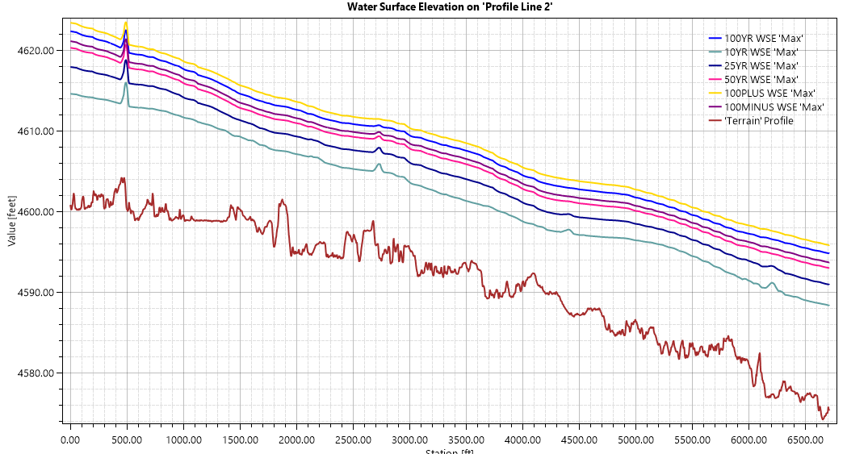
Figure 4-14 HUC 1109010201 Profile Plot-all modeled events

Water Surface Elevation on Profile Line: Crossing Profile Errors
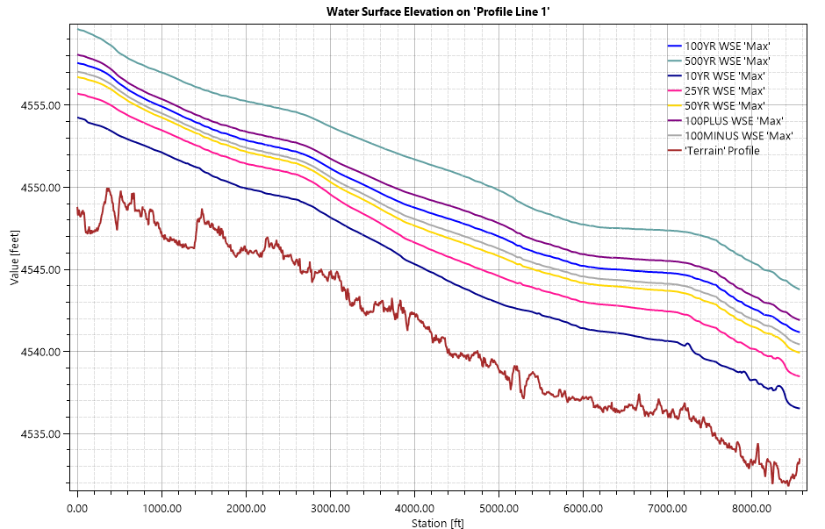
Figure 4-15 HUC 1109010202 Profile Plot-all modeled events
Water Surface Elevation on Profile Line: Crossing Profile Errors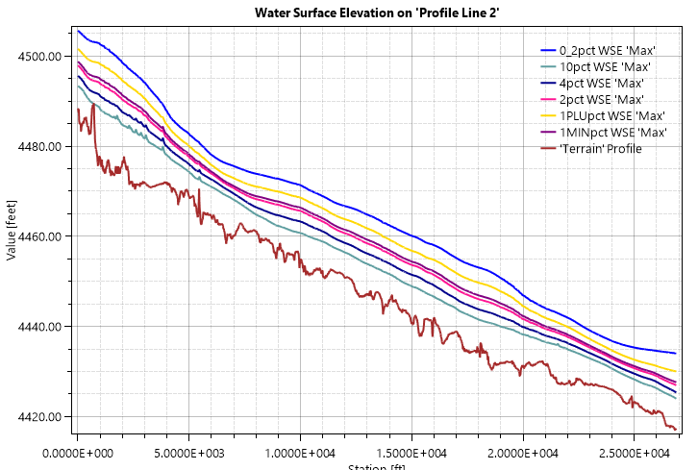
Figure 4-16 HUC 1109010203 Profile Plot-all modeled events

Water Surface Elevation on Profile Line: Crossing Profile Errors
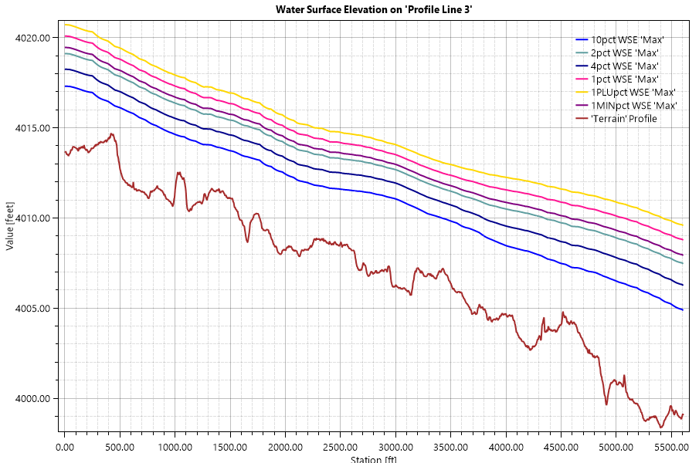
Figure 4-17 HUC 1109010204 Profile Plot-all modeled events
Water Surface Elevation on Profile Line: Crossing Profile Errors
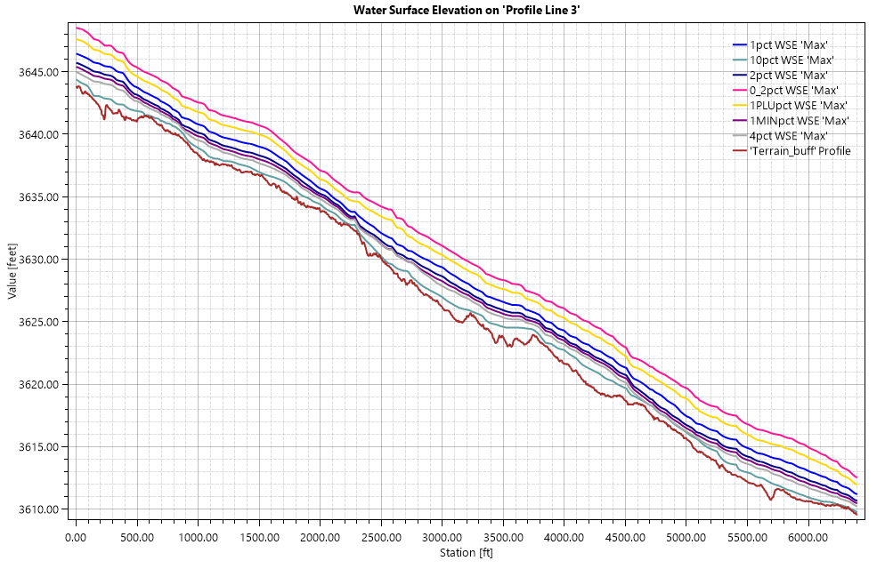
Figure 4-18 HUC 1109010205 Profile Plot-all modeled events
Water Surface Elevation on Profile Line: Crossing Profile Errors
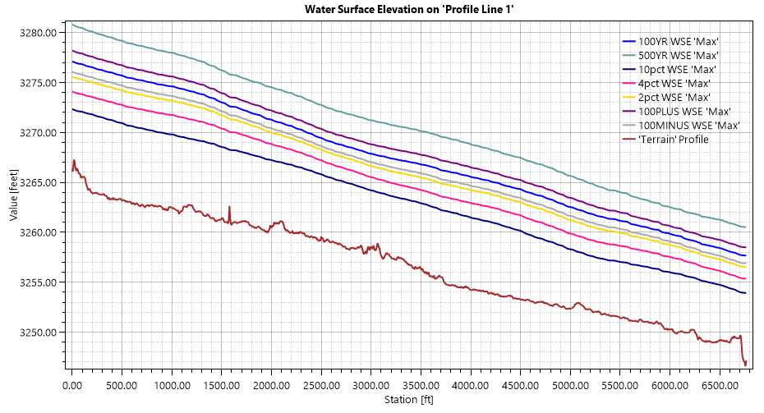
Figure 4-19 HUC 1109010206-7 Profile Plot-all modeled events

Modeled Results
A summary of modeled HEC-RAS peak flow and WSEL results for the 10%, 1% and 0.2%-annual-chance events are summarized in Table 4-12

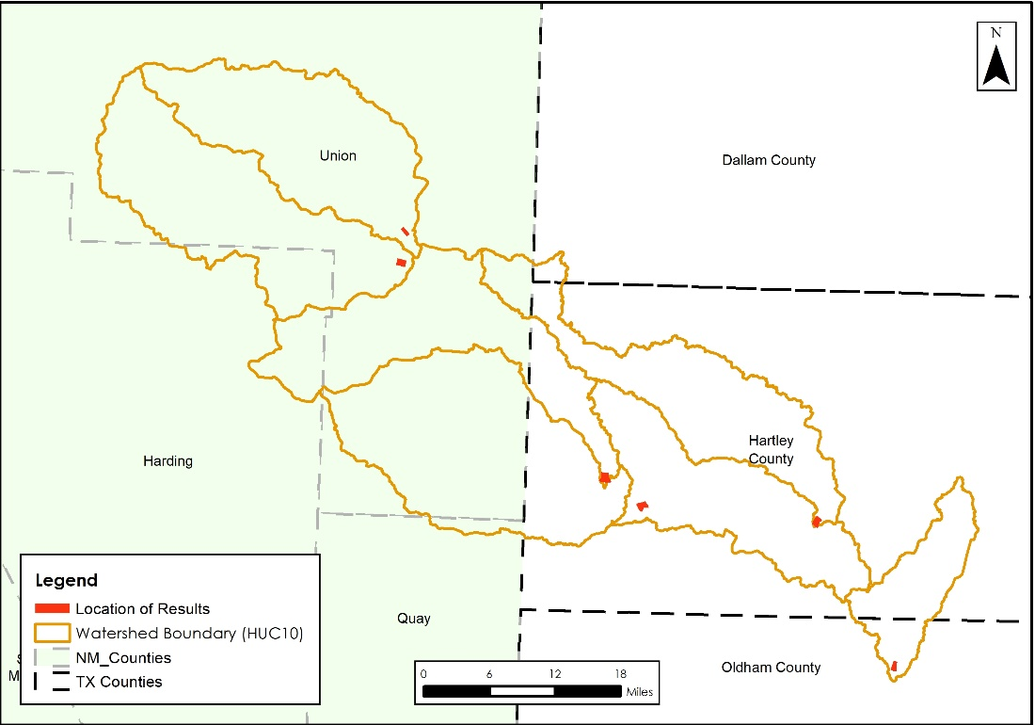
Figure 4 to Table 4-14Error! Reference source not found. Error! Reference source not found. for USGS and NWS gages in the watershed. Floodplain delineation for these events is described in the following section (Chapter 6 Floodplain Delineation (10%, 1% and 0.2% events)) and exhibits corresponding to modeled results are included in (Chapter 7 CNMS Validation of Effective Zone A Special Flood Hazard Area (SFHA)).

Figure 4-20. Overview of Peak Flow Locations for Punta de Agua Watershed
Table 4-12: 10% Storm Results Summary for Punta de Agua Watershed
HUC 10 Model Name and Number | Gage Description | Peak Flow (CFS) | WSEL* (ft)
HUC 1109010201: Pinabetes Creek Watershed | N/A | 5,043 | 4,611.2
HUC 1109010202: Pedernal Creek – Tramperos Creek Watershed | N/A | 1,330.8 | 4,556.3
HUC 1109010203: Tramperos Creek – Punta de Agua Creek Watershed | N/A | 5,839.5 | 4,017.9
HUC 1109010204: Monia Creek – Punta de Agua Creek Watershed | N/A | 6,510.1 | 3,914.4
HUC 1109010205: Syndicate Hills Watershed | N/A | 39.6 | 3,600.2
HUC 1109010206: Sand Well – Punta de Agua Creek Watershed / HUC 1109010207: Los Redos Creek – Punta de Agua Creek Watershed | N/A | 7,115.28 | 3,274.7
*Note: vertical datum of modeled WSEL is NAVD88

Table 4-13: 1% Storm Results Summary for Punta de Agua Watershed
HUC 10 Model Name and Number | Gage Description | Peak Flow (CFS) | WSEL (ft)
HUC 1109010201: Pinabetes Creek Watershed | N/A | 18,989.7 | 4,616.6
HUC 1109010202: Pedernal Creek – Tramperos Creek Watershed | N/A | 8,517.2 | 4,559.4
HUC 1109010203: Tramperos Creek – Punta de Agua Creek Watershed | N/A | 25,811.2 | 4,020.4
HUC 1109010204: Monia Creek – Punta de Agua Creek Watershed | N/A | 28,957 | 3,917.1
HUC 1109010205: Syndicate Hills Watershed | N/A | 1,011 | 3,601.7
HUC 1109010206: Sand Well – Punta de Agua Creek Watershed / HUC 1109010207: Los Redos Creek – Punta de Agua Creek Watershed | N/A | 40,525.35 | 3,279.5
*Note: vertical datum of modeled WSEL is NAVD88

Table 4-14: 0.2% Storm Results Summary for Punta de Agua Watershed
HUC 10 Model Name and Number | Gage Description | Peak Flow (CFS) | WSEL (ft)
HUC 1109010201: Pinabetes Creek Watershed | N/A | 37,918.5 | 4,620.1
HUC 1109010202: Pedernal Creek – Tramperos Creek Watershed | N/A | 21,374.2 | 4,562
HUC 1109010203: Tramperos Creek – Punta de Agua Creek Watershed | N/A | 55,021.9 | 4,022.8
HUC 1109010204: Monia Creek – Punta de Agua Creek Watershed | N/A | 61,869.7 | 3,919.7
HUC 1109010205: Syndicate Hills Watershed | N/A | 3,285.8 | 3,603.3
HUC 1109010206: Sand Well – Punta de Agua Creek Watershed / HUC 1109010207: Los Redos Creek – Punta de Agua Creek Watershed | N/A | 93,343.3 | 3,283.5
*Note: vertical datum of modeled WSEL is NAVD88

Quality Control
Following the initial BLE analysis in each watershed, the flood hazard area delineations were reviewed for areas where the inundation that impacted either critical public infrastructure or private property. Revisions were made, if necessary, to reflect potential flooding risk on these properties more accurately.
Quality Assurance/Quality Control (QA/QC) review necessitated some manual editing including adding/moving computational points, breaklines, hydraulic connectors, and mesh refinement regions. The areas in or adjacent to channelized areas or significant ponding were the focus of this review.

Floodplain Delineation (10%, 1% and 0.2% events)
Floodplain Delineation for the Punta de Agua watershed was developed using the TWDB Matrix Tool, followed by running a set of ArcGIS Cartography tools against the output results from the Matrix Tool. The Matrix Tool processes the raw depth grid input data (from HEC-RAS) to remove small islands that have the following parameter: areas of floodplain that are less than 0.33 acres with an average depth less than 0.33 feet were removed. Lake, reservoir, and/or ponding areas of approximately 20 acres or greater were incorporated into the final mapping.

After the Matrix Tool is run, post-processing was performed to fill any additional islands of 2 aces or less for 0.2% and 1% floodplains while 10% floodplain received an 0.5 acre fill. Disconnected floodplains less than 0.33 acres were removed as well. In order for the flooding product extents to match, a 0.1ft was applied to the Depth Grid resulting in a 0.1ft depth low value. The Depth Grid was then used to extract the Water Surface Elevation Grid to have 1:1 match per FEMA standards.
Additional post processing steps were applied using ArcGIS Simplifying and Smoothing tools to the 0.2% and 1% floodplain polygons. A 5-foot threshold for simplifying and 25-foot tolerance for smoothing were applied in this process. Per TWDB 2D BLE Guidance, the 10% floodplains did not go through this post processing step (TWDB 2022). This was to maintain the 10% flood extents as close to the original model export as possible. Disconnected floodplain extents are maintained through the postprocess as preferred by the TWDB.

Internal Mapping Tie-Ins
The hydraulic models in this task order were setup for upstream and downstream overlap in sequential models to maintain flow continuity of the mainstem between models. This overlap also provided an area to achieve a mapping tie-in within +/-0.5 ft of WSEL difference for the 10-year, 100-year and 500-year storms per FEMA Region 6 requirements. The Punta de Agua watershed mapping products demonstrate a 0.5ft tie-ins at all overlap locations.

Hazus
As a part of the Base Level Engineering assessment effort, Hazus was run using version 6.1 and resampled 10ft cell size 1% Depth Grid. Hazus 6.1 uses parcel data to map the results but, attribute data by census block number. S_FRAC_Ar was populated with the 1% Hazus results. Data that intersects the HUC8 boundary is left as is, no clipping was performed. All census/parcel data completely outside of the HUC8 boundary was removed.

Special Consideration
Unique challenges to modeling this watershed were discussed in Chapter 4. In addition, the following items should be considered in reviewing the mapping products, and for potential future studies in the watershed:
- Significant artificial depth increases at floodplain fringes occur in some areas of the mapping products because of RASMapper raster generation. In the sloping rendering mode, RASMapper attempts to interpolate between adjacent cells to “slope” the water surface, but in doing so, steep canyon walls or bluffs on the floodplain fringe can artificially cause the water surface to be interpolated upstream, resulting in significant areas of inundation where there should really be no inundation. This erroneous mapping result is referred to herein as “cupping”.
- In Punta de Agua watershed products, stream centerlines are contained within the 1% floodplain. However, in areas where there are road crossings and embankments, there is no streamline containment because the floodplain is not overtopping.
  - There is a shapefile provided within the Supplemental Folder that categorizes whether the stream segment outside the 1% floodplain was fixed (Y) to be within the boundary or a ROAD/Embankment was present and no containment was possible.
- Portions of Punta de Agua watershed are playa-driven due to the caprock geology resulting in very limited 1% floodplain stream centerline containment. As a result, the stream centerlines within areas of caprock have been removed from the WTR_LN feature class within the Flood Risk Database and placed within the Supplemental Folder for reference.
- Areas in the Texas panhandle with flat topography do not have well defined drainage patterns resulting in disconnected pluvial floodplains and streams originating and terminating without well defined headwaters or confluences. The water lines representing these streams were routed to follow the topography and maintaining some pluvial floodplain coverage or removed in areas with no pluvial floodplain coverage. Any removed lines have been placed in the supplemental folder.

CNMS Validation of Effective Zone A Special Flood Hazard Area (SFHA)
No effective reaches were present in HUC8 11090102 prior to this study. Therefore, no validation assessments were performed.

Deliverables
- Coordinated Needs Management Strategy (CNMS) Geodatabase
  - Contains all CNMS relationship and feature classes for reaches in HUC8 11090102.

References
Bibliography list of references used and referred to throughout document.
- Multi-Resolution Land Characteristics Consortium (MRCL). National Land Cover Database (NLCD) 2019 Land Cover (CONUS). Online at: https://www.mrlc.gov/data/nlcd-2019-land-cover-conus
- Ajmal, M., Waseem, M., Kim, D., and Kim, T.W. 2020. A Pragmatic Slope-Adjusted Curve Number Model to Reduce Uncertainty in Predicting Flood Runoff from Steep Watersheds. Water. 2020, 12, 1469.
- Chow, Ven T. "Development of Uniform Flow and Its Formulas." Open Channel Hydraulics. Caldwell, NJ: Blackburn, 1959. 109-113. Print.
- Cleveland, Theodore G; Fang, Nick, 2021, “texas-skew-update-2021", https://doi.org/10.18738/T8/SVLCOQ, Texas Data Repository, V6
- England, J.F., Jr., Cohn, T.A., Faber, B.A., Stedinger, J.R., Thomas, W.O., Jr., Veilleux, A.G., Kiang, J.E., and Mason, R.R., Jr., 2018, Guidelines for determining flood flow frequency--Bulletin 17C: U.S. Geological Survey Techniques and Methods, book 4, chap. B5, 148 p., https://doi.org/10.3133/tm4B5.
- URS Corporation. (2016). FINAL Upper Brushy Creek Watershed Flood Protection Plan. June 2016.
- United States Army Corps of Engineers (USACE). (2021). River Analysis System, HEC-RAS, v. 6.0.0
- United States Geological Study (USGS). (2020). Methods for Estimating the Magnitude and Frequency of Peak Streamflows for Unregulated Streams in Oklahoma Developed by Using Streamflow Data Through 2017. USGS Report 2019-5143, version 1.1. Online at: Methods for Estimating the Magnitude and Frequency of Peak Streamflows for Unregulated Streams in Oklahoma Developed by Using Streamflow Data Through 2017 (usgs.gov)
- Hydrologic Engineering Center (USACE HEC). HEC-RAS 2D User’s Manual. 2022. https://www.hec.usace.army.mil/confluence/rasdocs/r2dum/latest
- FEMA, “Guidance for Flood Risk Analysis and Mapping – First Order Approximation”, November 2014. (http://www.fema.gov/media-library-data/1420849667914-c1656173985d814d0e62f80818505969/FOA_Guidance_Nov_2014.pdf).
- FEMA Region 6, “Base Level Engineering Submittal Guidance”, June 2017. (https://rmd.msc.fema.gov/Regions/VI/Ph0_Investment/1/Base%20Level%20Engineering/Submittal%20Guidance/20170615_BLE%20Submittal%20Guidance_R6.pdf).
- ESRI ArcMap (2018). ArcGIS v. 10.6.1
- NOAA. (2017). “NOAA Atlas 14 Precipitation Frequency Estimates in GIS Compatible Format”. Webpage last modified April 21, 2017. Downloadable online at: PF in GIS Format - PFDS/HDSC/OWP (noaa.gov)
- NOAA. (2018). NOAA Atlas 14 Precipitation-Frequency Atlas of the United States. Volume 11 Version 2.0: Texas. Online at: NOAA Atlas 14 (weather.gov)
- NRCS. (2016). Manning’s n Values for Various Land Covers to Use for Dam Breach Analysis by NRCS in Kansas. Online at: Microsoft Word - Manning’s n-values for Kansas Dam Breach Analyses - Adopted 071216.docx (rashms.com)
- Soil Survey Staff, Natural Resources Conservation Service, United States Department of Agriculture. Soil Survey Geographic (SSURGO) Database. Available online at https://sdmdataaccess.sc.egov.usda.gov. Accessed [July/07/2021]

Appendix A – Bulletin 17C Statistical Analysis Technical Memo and Peak FQ Output

