

April 7, 2025
Version 1.0
Base Level Engineering Report
Southern Beaver (11130207)

Report Prepared for: Report Prepared by:
Texas Water Development Board AtkinsRéalis USA, Inc.
1700 North Congress Avenue 11801 Domain Boulevard
Austin, TX 78701 Suite 500
Austin, TX 78758

Document History
Document Storage Location
K:/FY2022/22-06-0048S/Hydraulics – BLE|FY22|/Southern Beaver (11130207)
Revision History
Version No. | Version Date | Summary of Changes | Author
1.0 | April 7, 2025 | Initial report for the Estimated Base Flood Elevation viewer | AtkinsRéalis USA, Inc.

FINAL REPORT FOR SOUTHERN BEAVER (11130207)
PREPARED FOR:



Prepared By:

AtkinsRéalis USA, Inc.


Table of Contents
Page
Executive Summary 1
1.0 Base Level Engineering (BLE) Methodology 3
1.1 Topographic Data 4
1.1.1 Development of the Seamless HUC-8 Digital Elevation Model (DEM) 4
1.1.2 Development of the Stream Networks and Drainage Basins 7
1.2 Hydrologic and Hydraulic Analysis 9
1.2.1 Total Precipitation 10
1.2.2 Infiltration Losses 12
1.2.3 2D Computational Mesh 16
1.2.4 Model Boundary Conditions 17
1.2.5 Reservoir Modeling 24
1.2.6 Computation Settings 24
1.2.7 Regression Analysis 25
1.2.8 Gage Analysis 26
1.2.9 Model Validation 27
1.3 Floodplain Delineation (10%, 1%, and 0.2% events) 31
2.0 Challenges 36
3.0 Results and Recommendations 44
3.1 Quality Control 46
3.2 CNMS Validation of Effective Zone A Special Flood Hazard Area 46
3.3 Flood Risk Analysis 49
4.0 References 51
Appendices:
A Base Level Engineering Results

List of Tables
Page
Table 1: Summary of Stream Miles 2
Table 2: Zone A Validation Results 2
Table 3: Topographic Data Sources 6
Table 4: FEMA’s Vertical Accuracy Requirements for Ground Elevation Data 6
Table 5: Reported and Computed Drainage Areas at Each USGS Gage 8
Table 6: AMC II Curve Number Values 15
Table 7: AMC I Curve Number Values 15
Table 8: Manning’s n Values for Overland and Overbank Areas 16
Table 9: Upstream and Downstream Discharges and WSELs at the Downstream End of Domain SBVR_701 22
Table 10: Upstream and Downstream Discharges and WSELs at the Downstream End of Domain SBVR_702 22
Table 11: Upstream and Downstream Discharges and WSELs at the Downstream End of Domain SBVR_703 23
Table 12: Upstream and Downstream Discharges and WSELs at the Downstream End of Domain SBVR_703 23
Table 13: Summary of USGS Gages in the Southern Beaver Watershed 26
Table 14: Results of the USGS Gage Flow-Frequency Analysis 26
Table 15: Summary of Parameter Adjustments Made During Validation in the Southern Beaver Watershed 28
Table 16: 1% Peak Flow Validation Results for the Southern Beaver Watershed 30
Table 17: Inland Mapping Threshold Matrix 33
Table 18: Zone A Initial Assessment Results 47
Table 19: Zone A Validation Results 48
Table 20: BLE Comparison Results 48
Table 21: Hazus Results for the Southern Beaver Watershed 50

List of Figures
Figure 1: Southern Beaver - 11130207 CNMS Validation Results 2
Figure 2: Southern Beaver Watershed – HUC-8 11130207 4
Figure 3: Topographic Data Extents in the Southern Beaver Watershed 5
Figure 4: HEC-RAS Terrain Modification at a Culvert Crossing to Allow Flow through a Roadway 8
Figure 5: Southern Beaver Model Domains and Linkages 9
Figure 6: Equations for Determining 1% Plus and 1% Minus Rainfall Totals 10
Figure 7: 1% Hyetograph for Domain SBVR_701 11
Figure 8: Cumulative 1% Rainfall Totals for Domain SBVR_701 11
Figure 9: Cumulative Rainfall Totals for All Events in Domain SBVR_701 12
Figure 10: HSGs in the Southern Beaver Watershed 13
Figure 11: Land Cover Types in the Southern Beaver Watershed 14
Figure 12: Placement of the SA/2D Across the Entire Valley 18
Figure 13: BC Line with a Length Equal to the SA/2D Connection Line 19
Figure 14: BC Line with a Length Similar to the Width of the Flooding 19
Figure 15: Extraction of Flow Hydrograph from the SA/2D Connection in the Upstream Domain 20
Figure 16: Application of Upstream Flow Hydrograph in the Downstream Domain 21
Figure 17: HEC-RAS Unsteady Computation Options and Tolerances 24
Figure 18: Regression Equations for the Southern Beaver Watershed 25
Figure 19: Typical Antecedent Moisture Conditions in Texas 28
Figure 20: Computed Flow vs Drainage Area of Select 1% BLE, 1% Regression, and 1% Gage Flows 29
Figure 21: Example of Overlapping Mapping along a Model Domain Boundary 32
Figure 22: WSEL Difference Raster and Split Line for the Overlap Area 33
Figure 23: An Example of Cupping in 2D BLE Mapping 37
Figure 24: SA/2D Connection Outflow BVRC 701 at the Downstream End of Domain SBVR_701 38
Figure 25: Minor Negative Discharges at SA/2D Connection Outflow BVRC 701 39
Figure 26: Stage (Blue) and Flow (green) Hydrographs at SA/2D Connection Outflow BVRC 701 40
Figure 27: SA/2D Connection SBVR_702_PT1 Near Santa Rosa Lake 41
Figure 28: Flow Hydrographs at SA/2D Connection SBVR_702_PT1 42
Figure 29: Stage and Flow Hydrographs at SA/2D Connection Outflow1_BVR_702 43
Figure 30: The Effective 1% Floodplain and the 1% BLE Floodplain in Wichita County, TX 44
Figure 31: Comparison of 1% BLE Mapping with Fathom 1% Mapping 45
Figure 32: CNMS Validation Results 49

Executive Summary
The Texas Water Development Board (TWDB) contracted with AtkinsRéalis USA, Inc. (AtkinsRéalis) to complete two-dimensional (2D) Base Level Engineering (BLE) in the Southern Beaver HUC-8 watershed (11130207). This watershed is located in North Central Texas, between Crowell and Electra, Texas. The watershed area is 679 square miles (mi²). Approximately 980 miles of stream centerlines were modeled. The information produced during this assessment is available on the U.S. Department of Homeland Security’s Federal Emergency Management Agency’s (FEMA) Mapping Information Platform (MIP) under case number 22-06-0048S.
The following guidance documents provided the methodologies for this project:
- Base Level Engineering – Region 6 Submittal Guidance (FEMA, January 2019)
- Base Level Engineering – Region 6 Submittal Guidance – Appendix A: 2-D Base Level Engineering Guidance (FEMA, January 2019)
- Texas Two-Dimensional Base Level Engineering Guidelines, Version 1.0 (TWDB, May 2022)
Light Detection And Ranging (LiDAR) topographic data available for download from the United States Geological Survey’s (USGS) National Map Downloader were leveraged to build a 3D terrain surface for the watershed.
The hydrologic and hydraulic modeling was completed using the U.S. Army Corps of Engineers’ Hydrologic Engineering Center River Analysis System (HEC-RAS), Version 6.2. In accordance with FEMA’s Standard Identification Number (SID) 84, the 10%, 4%, 2%, 1%, 0.2%, 1% plus, and 1% minus annual-chance events were simulated. Precipitation data from the National Oceanic and Atmospheric Administration’s (NOAA) Atlas 14 were leveraged to develop the 24-hour rainfall distribution for each event. A rain-on-grid methodology was applied to distribute the rainfall across the extents of the 2D hydraulic model area. Infiltration losses were computed using the Natural Resources Conservation Service’s (NRCS) Curve Number (CN) loss rate method.
The Southern Beaver watershed was divided into four HEC-RAS model domains — SBVR_701, SBVR_702, SBVR_703, and SBVR_704. Per TWDB guidance, a 200-foot by 200-foot nominal cell spacing was used for the 2D area and a finer 100-foot by 100-foot cell spacing was used along the breaklines and within the refinement regions. Breaklines were added to capture roadways, railroads, dam crests, and embankments to force the terrain surface to drain properly. Refinement regions were defined in and near urban areas, major reservoirs, and dam overflow areas to enhance the identification of the flood hazards in these higher-risk areas.
Model results were validated using regression flows and stream gage data. Effective FEMA discharge data were not available in this watershed.
Floodplain mapping was developed for the 10%, 1%, and 0.2% annual chance events. Raw mapping output from HEC-RAS was post-processed to delineate floodplains that aligned with the TWDB’s 2D BLE mapping standards.
A summary of FEMA’s Coordinated Needs Management Strategy (CNMS) data for the Southern Beaver watershed is in Table 1 and Table 2 and shown on Figure 1.
Table 1: Summary of Stream Miles
Source | Stream Miles
Current Inventory -- CNMS | 63.5
New Study Streams – CNMS | 916.0
Total (BLE) Stream Miles | 979.5

Table 2: Zone A Validation Results
Validation Status | CNMS Validation Status | CNMS Project Start | CNMS Post-BLE Assessment
VALID | BEING STUDIED | 0 | 29.9
VALID | TO BE STUDIED | 0 | 0
UNVERIFIED | BEING STUDIED | 63.5 | 33.6
UNVERIFIED | TO BE STUDIED | 0 | 0

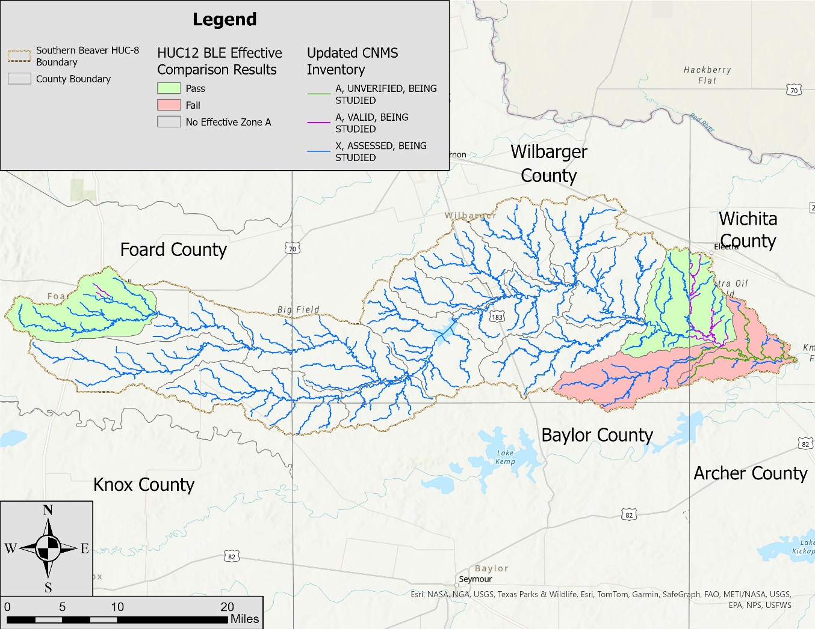
Figure 1: Southern Beaver - 11130207 CNMS Validation Results

Base Level Engineering (BLE) Methodology
Recent innovations and increased efficiency in floodplain mapping have allowed FEMA to develop a process called BLE, which can be used to address current program challenges, including the validation of Zone A studies and the availability of flood risk data in the early stages of a Flood Risk Project. The BLE process involves using best available data and incorporating automated techniques with traditional model development procedures to produce regulatory-quality flood hazard boundaries for the 1% annual chance event, as well as estimates of flood hazard boundaries for multiple recurrence intervals. The cost for developing the data and estimates resulting from the BLE process are lower than standard flood production costs. The BLE results may be used for eventual production of regulatory and non-regulatory products.
As described in Title 42 of the Code of Federal Regulations, Chapter III, Section 4101(e), once every 5 years, FEMA must determine whether the information on its Flood Insurance Rate Maps (FIRMs) reflects the current risks in flood-prone areas. FEMA makes this determination of flood hazard data validity by examining flood study attributes and change characteristics, as specified in the Validation Checklist of the CNMS Technical Reference. The CNMS Validation Checklist provides a series of critical and secondary checks to determine the validity of flood hazard areas studied by detailed methods (e.g., Zone AE, AH, or AO). While the critical and secondary elements in CNMS provide a comprehensive method of evaluating the validity of Zone AE studies, a cost-effective approach for evaluating Zone A studies has been lacking.
In addition to the need for Zone A validation guidance, FEMA standards require flood risk data to be provided in the early stages of a flood risk project. FEMA Program SID 29 requires that during the Discovery process, data must be identified that illustrates potential changes in flood elevation and mapping that may result from the proposed project scope. If available data does not clearly illustrate the likely changes, then an analysis is required that estimates the likely changes. This data and any associated analyses should be shared, and the results should be discussed with stakeholders.
An important goal of the BLE process is the scalability of the results. Scalability means that the results of a BLE analysis cannot only be used for CNMS evaluations of Zone A studies but can also be leveraged throughout the Risk MAP program. The data resulting from a BLE analysis can be updated as needed and used for the eventual production of regulatory and non-regulatory products, outreach and risk communication, and MT-1 processing. Leveraging this data outside the Risk Mapping, Assessment, and Planning (Risk MAP) program may also be valuable to external stakeholders.
The TWDB contracted with AtkinsRéalis and its partner Watearth, Inc. to complete a BLE analysis for the Southern Beaver watershed (HUC-8 11130207). The watershed is mostly rural and the land is predominantly used for farming and ranching. The watershed is located in Baylor, Foard, Wichita, and Wilbarger counties. The city of Crowell resides in the watershed, as does a portion of the city of Electra. See Figure 2 for a map of the Southern Beaver watershed.
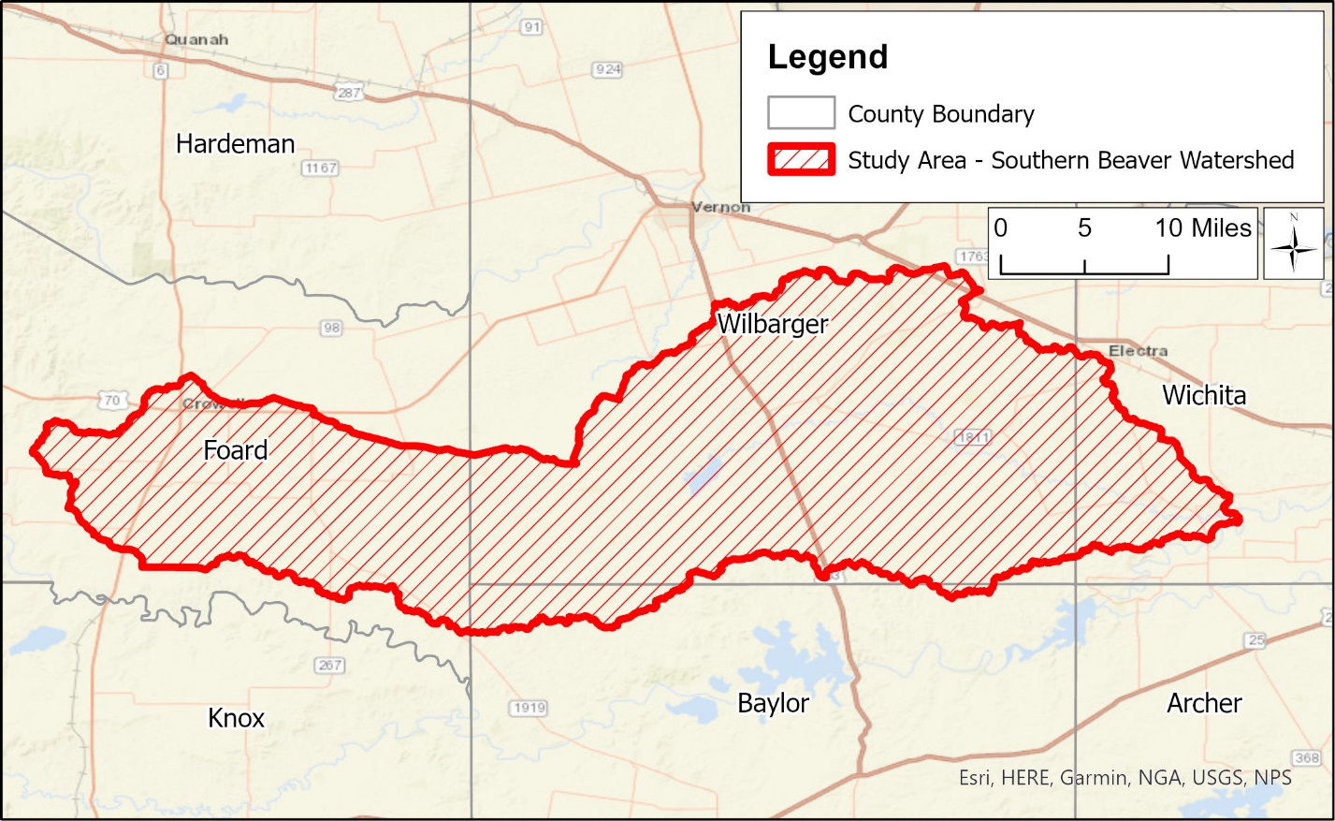
Figure 2: Southern Beaver Watershed – HUC-8 11130207
The BLE assessment prepared a cursory engineering analysis for approximately 980 miles of stream reaches within the Southern Beaver watershed, with a minimum drainage area tolerance of 1 mi². The selection and extent of the stream reaches studied were based on the number of stream miles meeting the minimum drainage area of 1 mi² and not the number of effective Zone A stream miles. Study reaches were extended above this 1-mi² threshold as appropriate so the entire effective Zone A floodplain received an updated analysis. The following sections summarize the BLE process and discuss the results, along with their recommended use.

Topographic Data

Development of the Seamless HUC-8 Digital Elevation Model (DEM)
The topographic data that were used to develop the terrain surface for the Southern Beaver watershed were downloaded from the United States Geological Survey’s (USGS) National Map Downloader. The downloaded data included LiDAR data from the USGS’s Archer & Jack Counties, Panhandle, and Texas West Central LiDAR collections. The data on the National Map Downloader are seamless, with no overlap between data sources. All LiDAR data were downloaded in the format of 1-meter DEMs. A description of each USGS LiDAR collection is in Table 3.
The above-mentioned LiDAR data sets were processed to create a seamless set of tiled 5-foot DEMs for the Southern Beaver watershed and a buffered area around the watershed. Each DEM tile measured 6,000 feet by 6,000 feet. This tile size was used because tiles this size can easily be resampled by other users to 1-, 2-, 3-, 5-, 10-, 20-, or 25-foot rasters, since 6,000 is evenly divisible by all of these numbers. A two-mile buffer was included since the watershed divide was outside the HUC-8 watershed extents in some areas. In addition, the upper reaches of this watershed are very flat, so a large buffer was applied to facilitate clean floodplain and Base Flood Elevation (BFE) transitions between watersheds. A 5-foot cell size was used in accordance with the 10-foot cell size criterion outlined in FEMA’s Region 6 BLE guidance. After projecting the terrain into the Texas State Plane Zone 2 (North Central) projection (North American Datum [NAD] 1983) with units of U.S. feet, the tiles were mosaicked into a single DEM. The source and extents of the original DEMs used to create the mosaicked DEM are shown on Figure 3.
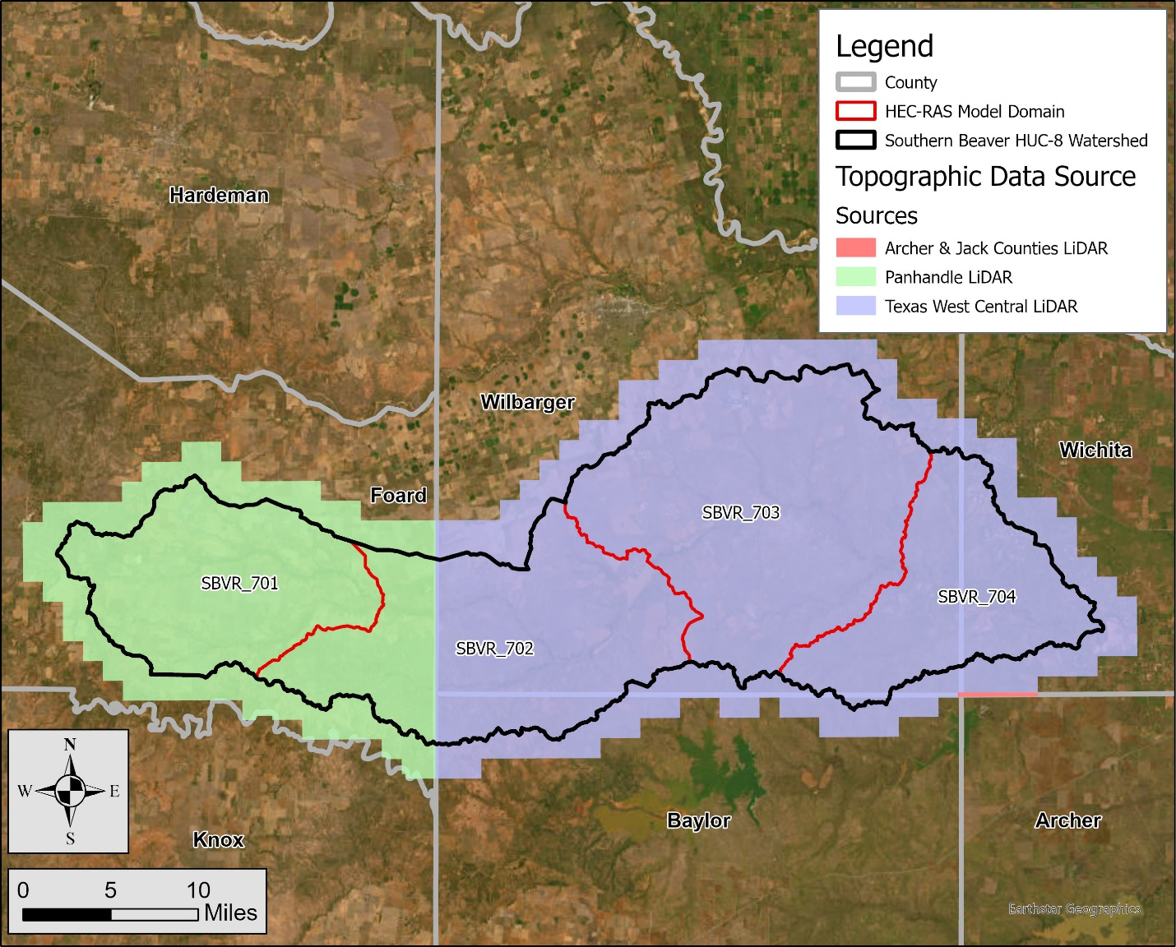
Figure 3: Topographic Data Extents in the Southern Beaver Watershed

Table 3: Topographic Data Sources
County | Year Acquired | Vertical  Accuracy | Source | Approximate  Footprint (mi²)
Archer & Jack Counties LiDAR  (Archer County) | 2015 | 10.6 cm | USGS | < 1
Panhandle LiDAR  (Foard County) | 2018 | 8.4 cm | USGS | 248
West Texas Central LiDAR  (Baylor, Wichita, and Wilbarger Counties) | 2018 | 9.1 cm | USGS | 598
The vertical accuracy presented in Table 3 for each LiDAR dataset is the Non-vegetated Vertical Accuracy (NVA) of the dataset. NVA is defined as 1.96 * RMSEz, which is the root mean square error of the LiDAR data in the z direction.
FEMA Region 6’s BLE guidance states that BLE should be prepared only where high-resolution ground elevation data are available for at least 90% of the study area. The guidance also states that the ground elevation data must comply with the vertical accuracy requirements detailed in SID 43. These requirements have been reproduced in Table 4. Note that the vertical accuracy criteria in the table are the minimum NVA requirements for the elevation data at the 95% confidence level.
Table 4: FEMA’s Vertical Accuracy Requirements for Ground Elevation Data
Level of Flood Risk | Typical Slopes | Specification Level | Vertical Accuracy (NVA) at 95% Confidence Level | LiDAR Nominal Pulse Spacing (NPS)
High  (Deciles 1, 2, 3) | Flattest | Highest | 24.5 cm | ≤ 2 meters
High  (Deciles 1, 2, 3) | Rolling or Hilly | High | 49.0 cm | ≤ 2 meters
High  (Deciles 2, 3, 4, 5) | Hilly | Medium | 98.0 cm | ≤ 3.5 meters
Medium  (Deciles 3, 4, 5, 6, 7) | Flattest | High | 49.0 cm | ≤ 2 meters
Medium  (Deciles 3, 4, 5, 6, 7) | Rolling | Medium | 98.0 cm | ≤ 3.5 meters
Medium  (Deciles 3, 4, 5, 6, 7) | Hilly | Low | 147 cm | ≤ 5 meters
Low  (Deciles 7, 8, 9, 10) | All | Low | 147 cm | ≤ 5 meters
Both requirements have been met for this project. First, LiDAR data were available for the entire study area, so the 90% coverage criterion has been met. Second, the NVAs of the LiDAR datasets that were leveraged to complete the BLE for this watershed (see Table 3) are less than 24.5 cm, which is the most stringent NVA requirement in Table 4.
An overview of each topographic dataset follows. The vertical datum for each dataset was the North American Vertical Datum of 1988 (NAVD 88).

Dataset One – Archer & Jack Counties LiDAR
The USGS’s Archer & Jack Counties LiDAR dataset captured in 2015 contains data for 1,671 mi² across 2 counties in Texas. In the Southern Beaver watershed, this dataset includes part of Archer County. The NVA is 10.6 centimeters (cm). The native cell size of the data is 1 m².
Dataset Two – Panhandle LiDAR
The USGS’s Panhandle LiDAR dataset captured in 2018 contains data for 34,005 mi² across 43 counties in Texas. In the Southern Beaver watershed, this dataset includes parts of Foard County. The NVA is 8.4 cm. The native cell size of the data is 1 m².
Dataset Three – West Texas Central LiDAR
The USGS’s West Texas Central LiDAR dataset captured in 2018 contains data for 42,557 mi² across 70 counties in Texas. In the Southern Beaver watershed, this dataset includes parts of Baylor, Wichita, and Wilbarger counties. The NVA of this dataset is 9.1 cm. The native cell size of the data is 1 m².
No modifications were made to the terrain surface. The goal was to use this terrain ‘as is’ in the hydraulic modeling, floodplain mapping, and grid development tasks. Maintaining the source terrain data in an unmodified state avoids customized changes to the terrain dataset that future users may not be able to replicate. It also reduces the chance of future users applying an outdated version of the terrain. Any changes that were required in the hydraulic model phase were made in the HEC-RAS terrain, not in the processed tiles.

Development of the Stream Networks and Drainage Basins
A hydro-conditioned terrain surface was developed to define the stream networks and drainage basins. A 2-mile buffer was applied to the HUC-8 boundary to capture the watershed divide. A 5-meter mosaicked DEM was developed from the source LiDAR data in the same projection as the source data. Using a 5-meter DEM for hydrologic network development maintained sufficient accuracy and produced datasets that were smaller in size and easier to manipulate.
The process for terrain preparation and network and basin delineation is outlined below:
- The flow direction grid, flow accumulation grid, hydrologic stream network, and hydrologic basins were developed.
- Burn lines were defined as needed at roadway/railroad crossings or where reservoirs/ponds artificially diverted the flow path from the natural alignment. The bridge/culvert crossing burn lines developed in this task were subsequently incorporated into the HEC-RAS terrain as terrain modification features. Terrain modifications, when applied, allowed flow through roadways.
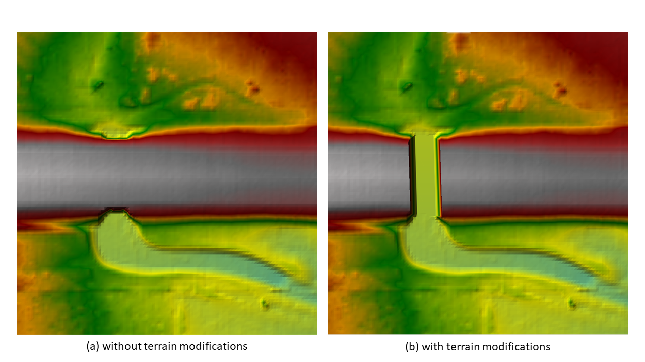
Figure 4: HEC-RAS Terrain Modification at a Culvert Crossing to Allow Flow through a Roadway
- The streamlines and watershed delineations were reviewed and burn lines were continually added and adjusted until the flow paths, basins, and computed drainage areas were reasonable and justifiable.
- There were two USGS gages with drainage areas greater than 1 mi² in the watershed. Table 5 summarizes the differences between the drainage areas reported by USGS and those computed by AtkinsRéalis. AtkinsRéalis’s drainage areas were extracted from a drainage area grid that was computed along the flow paths in the watershed.
Table 5: Reported and Computed Drainage Areas at Each USGS Gage
USGS Gages |  |  | Computed Values
Site No. | Site Name | Drainage Area (mi²) | Drainage Area (mi²) | Difference
07312140 | Beaver Creek Tributary near Crowell, TX | 3.43 | 3.45 | 0.6%
07312200 | Beaver Creek near Electra, TX | 652.0 | 649.4 | -0.4%
The following information has been placed in the terrain supplemental data folder:
- The computed watershed boundaries at the HUC-8, HUC-10, and HUC-12 levels developed during the terrain processing task.
- The 1-mi² stream network developed during the terrain processing task. These lines represent locations where the drainage area is 1 mi² or greater.
- Additional supporting layers such as roads, NHD waterbodies, and NHD flow lines.

Hydrologic and Hydraulic Analysis
A 2D BLE analysis of the Southern Beaver watershed was completed using HEC-RAS Version 6.3.1. The analysis applied a rain-on-grid methodology over the 3D terrain. Average basin rainfall was applied to the 2D computational mesh, and losses were computed using the spatially-varied infiltration capabilities of HEC-RAS. In accordance with SID 84, the 10%, 4%, 2%, 1%, 0.2%, 1% plus, and 1% minus annual-chance events were simulated.
Model Layout
The Southern Beaver watershed was split into 4 model domains — SBVR_701, SBVR_702, SBVR_703, and SBVR_704, as shown on Figure 5. The Southern Beaver HUC-8 watershed is made up of 4 HUC-10 watersheds. The extent of each model domain is similar to one of these HUC-10 watersheds. The name of each domain is the final 3 numbers in the HUC-10 watershed name (e.g., domain 401 is for HUC-10 watershed 1113020701). The primary reason for having a domain size similar to a HUC-10 watershed was to satisfy the assumption that the rainfall across the domain was uniform. The initial model domain boundaries were derived from the revised HUC-10 watershed delineations that were established using the LiDAR data. At the confluences of model domains, the domain of the downstream model was extended upstream along the main channel to facilitate tie-ins between the domains.
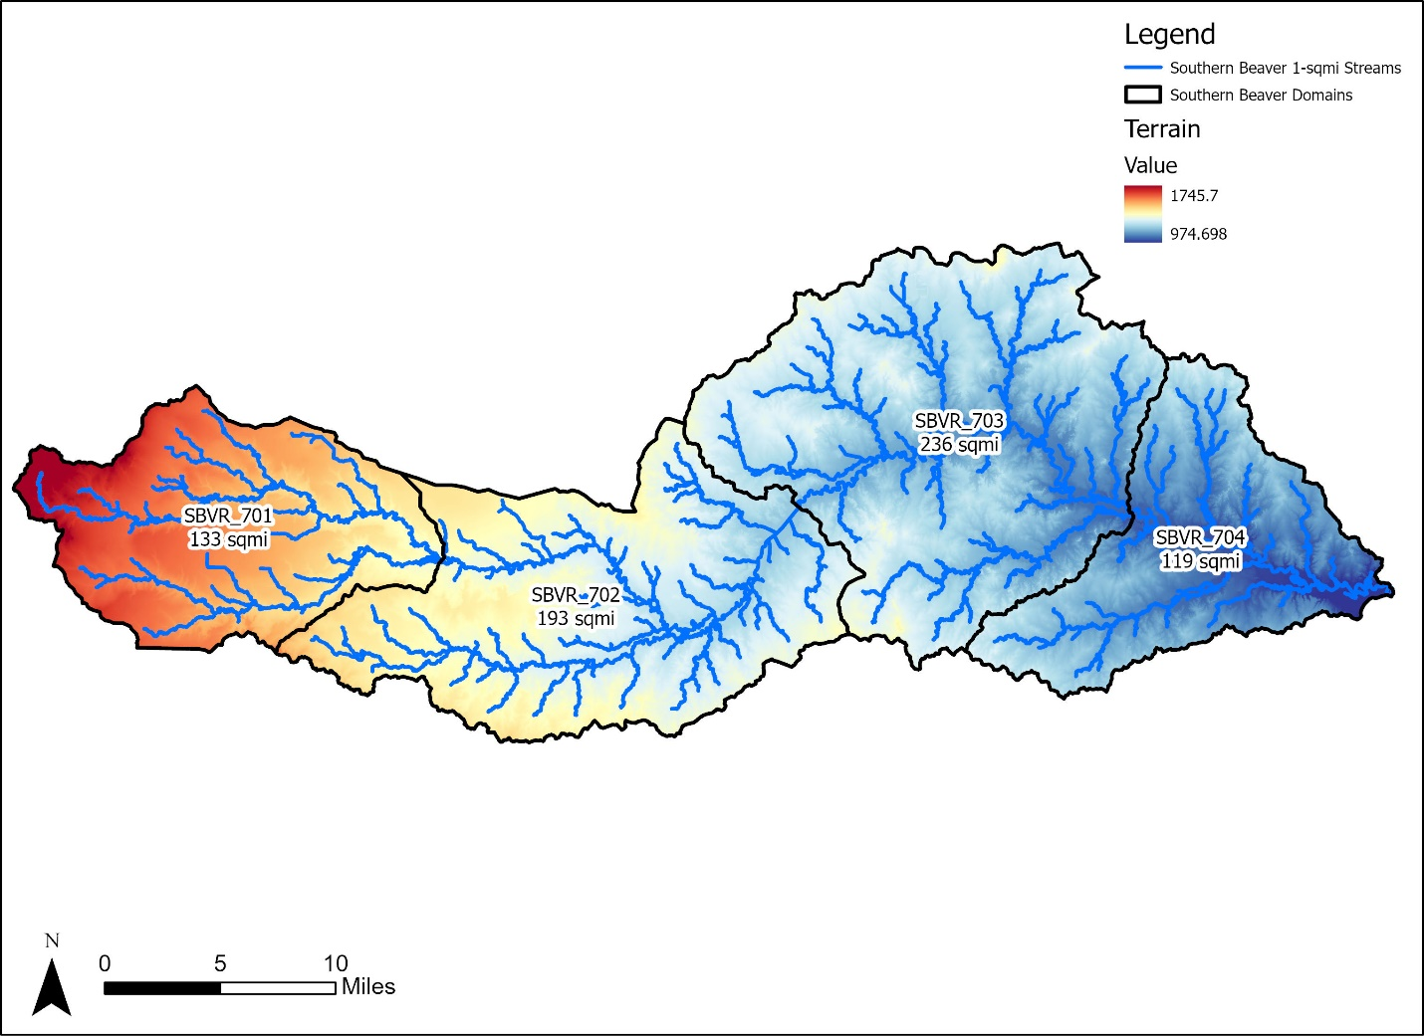
Figure 5: Southern Beaver Model Domains and Linkages

Total Precipitation
The precipitation inputs for the HEC-RAS models were computed using NOAA Atlas 14 rainfall data. The HEC-RAS models included seven events, which were the 10%, 4%, 2%, 1%, 0.2%, 1% plus, and 1% minus annual-chance events. For each event, a hyetograph was required for each domain in the Southern Beaver watershed. The TWDB’s 2D BLE guidelines state that the duration of each hyetograph should be 24 hours.
The hyetographs were developed using the following process:
- Download NOAA Atlas 14 rainfall grids. For each event, grids were acquired for storms with durations of 5 minutes, 15 minutes, 1 hour, 2 hours, 3 hours, 6 hours, 12 hours, and 24 hours. Each cell in a grid stored the rainfall total in the cell for that duration.
- NOAA’s rainfall datasets did not include rainfall totals for the 1% plus and 1% minus events. Instead, NOAA has calculated rainfall grids for the upper and lower 90% confidence intervals of the 1% event. These grids were downloaded for each duration and processed as described below.
- For the 10%, 4%, 2%, 1%, and 0.2% events, intersect the rainfall grids with the HEC-RAS model extent for each domain. Compute an average rainfall total for each domain for each duration of each event.
- For the 1% plus and 1% minus events, intersect the rainfall grids with the HEC-RAS model extent for each domain. Compute an average rainfall total for each domain for the upper and lower 90% confidence intervals for the 1% event. Do this for each duration. The 1% plus and 1% minus rainfall totals for each duration were determined using the following equations:

$$1\% plus precip= 1\% precip+ \frac{Upper 90\% Limit-Lower 90\% Limit}{3.29}$$
$$1\% minus precip= 1\% precip- \frac{Upper 90\% Limit-Lower 90\% Limit}{3.29}$$
Figure 6: Equations for Determining 1% Plus and 1% Minus Rainfall Totals
- Build the hyetographs for each domain using HEC-HMS, version 4.10. Each hyetograph has a duration of 24 hours. Load the domains into HEC-HMS. For each domain, create frequency-based hypothetical storms for the 10%, 4%, 2%, 1%, 0.2%, 1% plus, and 1% minus events using the average rainfall totals in the domain for storm durations of 5 minutes, 15 minutes, 1 hour, 2 hours, 3 hours, 6 hours, 12 hours, and 24 hours. The hyetographs in HEC-HMS assume a one-minute time step.
- Transfer the hyetographs into HEC-RAS.
- No rainfall losses were computed in HEC-HMS. Instead, rainfall losses were computed in HEC-RAS. See Subsection 1.2.2 for more information.
As an example, the figures below show the hyetograph computed in HEC-HMS for the 1% event and the cumulative 1% rainfall totals for domain SBVR_701. The 1% rainfall total for this domain for the 5-minute duration was 0.96 inches. Note how the maximum rainfall in the hyetograph is 0.96 inches. The 1% rainfall total for this domain for the 24-hour duration was 8.03 inches. Note how the total cumulative rainfall in the domain for the 24-hour hyetograph is 8.03 inches.

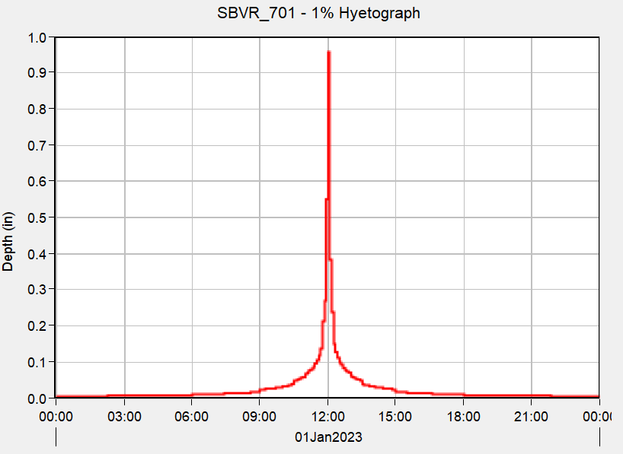
Figure 7: 1% Hyetograph for Domain SBVR_701
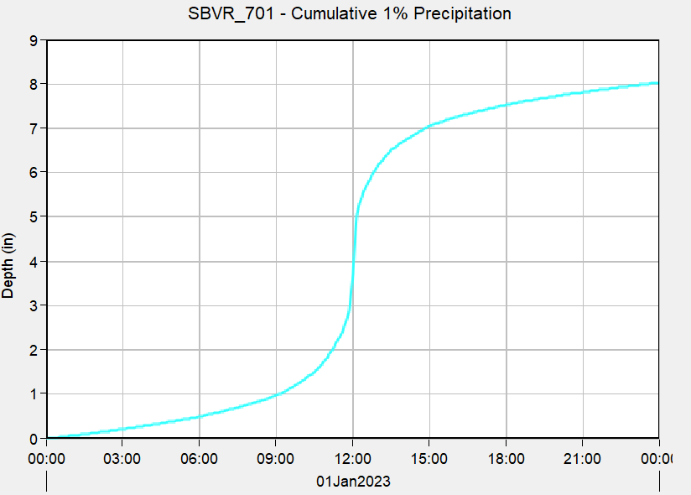
Figure 8: Cumulative 1% Rainfall Totals for Domain SBVR_701
Once the hyetographs were available for all events in a domain, the cumulative rainfall totals were plotted in Excel to confirm that no profiles crossed. In limited instances, the 1% plus or the 1% minus rainfall curve crossed one of the curves for the 10%, 4%, 2%, 1%, or 0.2% events. Whenever this occurred, the 1% plus or 1% minus curve was manually adjusted to eliminate the crossing. The curves for the 10%, 4%, 2%, 1%, or 0.2% events were never revised.
Figure 9 shows the cumulative rainfall curves for all events in domain SBVR_701. Note how none of the curves cross one another.

Figure 9: Cumulative Rainfall Totals for All Events in Domain SBVR_701

Infiltration Losses
The NRCS CN loss rate method was used in HEC-RAS to quantity the infiltration losses. The CN at a given point in the watershed is a function of the hydrologic soil group (HSG) of the soil and the land cover type at that location. Therefore, a spatially varying infiltration layer for the study area was developed in HEC-RAS using gridded soils and gridded land cover data sets.
To develop the soils dataset, the 2021 Gridded Soils Survey Geographic (gSSURGO) database was downloaded from the NRCS website (https://data.nal.usda.gov/dataset/gridded-soil-survey-geographic-database-gssurgo). The SSURGO database included the HSG of each soil type in the study area. The HSGs varied from Group A (low runoff potential when thoroughly wet) to Group D (high runoff potential when thoroughly wet). Figure 10 shows the distribution of the HSGs in the watershed.

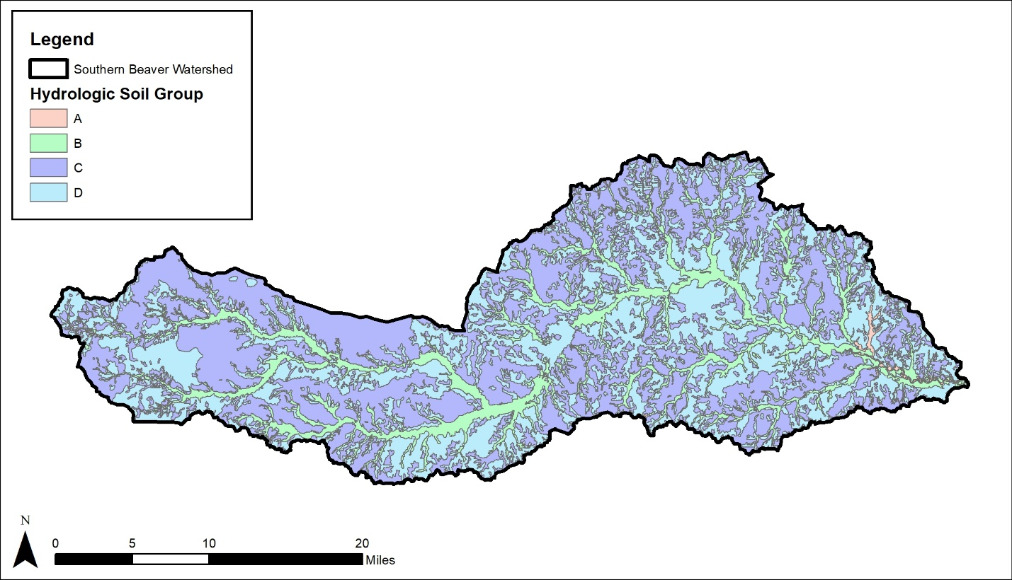
Figure 10: HSGs in the Southern Beaver Watershed
To develop the land cover dataset, the 2019 National Land Cover Database (NLCD) was downloaded from the Multi-Resolution Land Characteristics Consortium (MRLC) website (https://www.mrlc.gov/data/nlcd-2019-land-cover-conus). The land cover dataset provided land use classification codes and the extent of each land use. This information was used to create the gridded land cover dataset. Figure 11 shows the Land Cover Types present in the watershed.
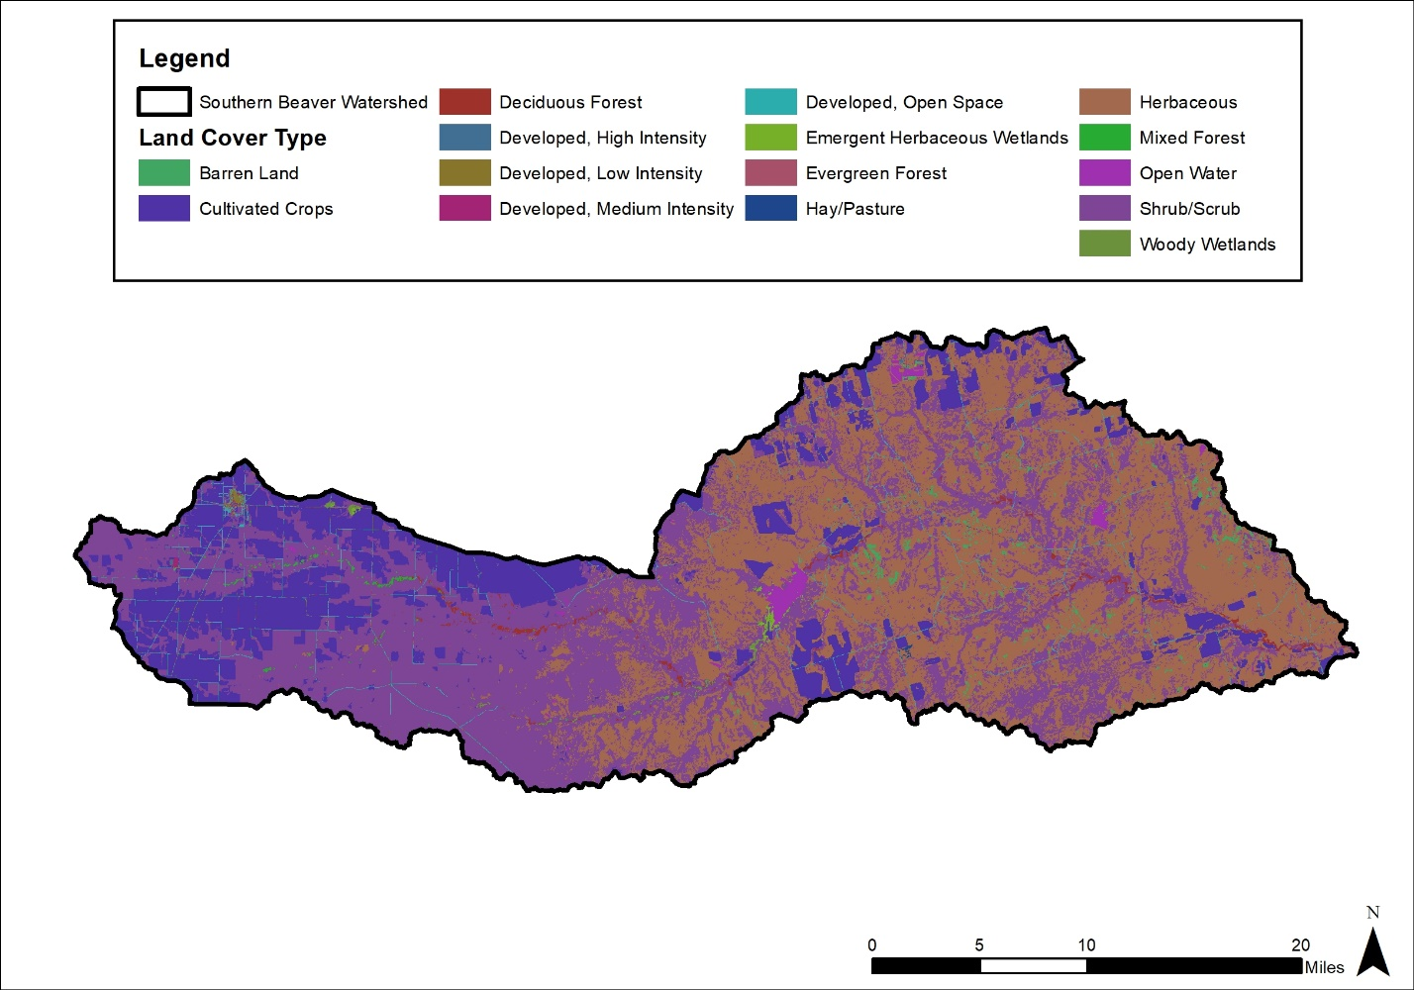
Figure 11: Land Cover Types in the Southern Beaver Watershed
The infiltration layer was created in HEC-RAS by combining the soils and land cover gridded datasets. The CN values required for the loss rate computations were obtained from Table 2.4 of the TWDB’s 2D Base Level Engineering Guidance Version 1.0 (May 2022) and are shown below in Table 5. An initial abstraction ratio of 0.2 was used to obtain the initial loss.
During the model validation phase, the CN values were adjusted to bring the model results into alignment with the validation data (e.g., regression flows). The CN values presented in Table 6 are based on average Antecedent Moisture Condition II (AMC II) and during validation, the values were revised by no more than ±10% of their initial values. In some cases, however, a 10% reduction of the AMC II CN values produced flows that continued to be too high to be considered valid. For these model domains, CN values derived from AMC I conditions were used to achieve model validation. AMC I CN values are shown in Table 7. The AMC I CNs were computed from the AMC II CNs using the following equation (Chow, 1988):
$$CN\left(AMC I\right)= \frac{4.2*CN(AMC II)}{10-0.058*CN(AMC II)}$$
Research completed for this project revealed that antecedent moisture conditions in Texas vary from AMC II in the east to AMC I in the west, and the Southern Beaver watershed resides within the transition from AMC II to AMC I. Therefore, the application of AMC I conditions to support validation was appropriate. See Section 1.2.9 for more information about the use of AMC I and AMC II CNs in the Southern Beaver watershed.

Table 6: AMC II Curve Number Values
Land Use Grid Code | NLCD Land Use Description | CN for Each Hydrologic Soil Group |  |  |  | Percent Impervious
Land Use Grid Code | NLCD Land Use Description | A | B | C | D | Percent Impervious
11 | Open Water | 99 | 99 | 99 | 99 | n/a
21 | Developed, Open Space | 49 | 69 | 79 | 84 | n/a
22 | Developed, Low Intensity | 39 | 61 | 74 | 80 | 38
23 | Developed, Medium Intensity | 39 | 61 | 74 | 80 | 72
24 | Developed, High Intensity | 39 | 61 | 74 | 80 | 85
31 | Barren Land | 39 | 61 | 74 | 80 | n/a
41 | Deciduous Forest | 30 | 55 | 70 | 77 | n/a
42 | Evergreen Forest | 30 | 55 | 70 | 77 | n/a
43 | Mixed Forest | 30 | 55 | 70 | 77 | n/a
52 | Shrub Scrub | 30 | 48 | 65 | 73 | n/a
71 | Herbaceous | 49 | 62 | 74 | 85 | n/a
81 | Hay Pasture | 39 | 61 | 74 | 80 | n/a
82 | Cultivated Crops | 51 | 67 | 76 | 80 | n/a
90 | Woody Wetlands | 72 | 80 | 87 | 93 | n/a
95 | Emergent Herbaceous Wetlands | 72 | 80 | 87 | 93 | n/a

Table 7: AMC I Curve Number Values
Land Use Grid Code | NLCD Land Use Description | CN for Each Hydrologic Soil Group |  |  |  | Percent Impervious
Land Use Grid Code | NLCD Land Use Description | A | B | C | D | Percent Impervious
11 | Open Water | 98 | 98 | 98 | 98 | n/a
21 | Developed, Open Space | 29 | 48 | 61 | 69 | n/a
22 | Developed, Low Intensity | 41 | 49 | 55 | 59 | 38
23 | Developed, Medium Intensity | 41 | 49 | 55 | 59 | 72
24 | Developed, High Intensity | 41 | 49 | 55 | 59 | 85
31 | Barren Land | 21 | 40 | 54 | 63 | n/a
41 | Deciduous Forest | 15 | 34 | 49 | 58 | n/a
42 | Evergreen Forest | 15 | 34 | 49 | 58 | n/a
43 | Mixed Forest | 15 | 34 | 49 | 58 | n/a
52 | Shrub Scrub | 15 | 28 | 44 | 53 | n/a
71 | Herbaceous | 29 | 41 | 54 | 70 | n/a
81 | Hay Pasture | 21 | 40 | 54 | 63 | n/a
82 | Cultivated Crops | 30 | 46 | 57 | 63 | n/a
90 | Woody Wetlands | 52 | 63 | 74 | 85 | n/a
95 | Emergent Herbaceous Wetlands | 52 | 63 | 74 | 85 | n/a

Manning’s n values were defined within the infiltration layer. These values were used to compute the energy losses as the flow was routed through the 2D computational mesh in the HEC-RAS model. For this study, the overbank Manning’s roughness coefficients were obtained from Table 2.2 of the TWDB’s 2D Base Level Engineering Guidance Version 1.0 (May 2022), as shown in Table 8. Manning’s n values for the main channel areas were refined by adding Manning’s n override regions. The extents of the override regions in the channels were established by adding a typical buffer of 100 feet to the streamlines. For larger streams, where the channel polygon widths were wider than 200 feet, the channel polygons were adjusted by reviewing the typical channel widths on the terrain surface and aerial photography. Manning’s n values in the main channels were initially assumed to be 0.045 but ended up being revised in some locations during the validation task.
Table 8: Manning’s n Values for Overland and Overbank Areas
Land Use Grid Code | NLCD Land Use Description | Typical  N Value | N Value Range
11 | Open Water | 0.038 | 0.025–0.050
21 | Developed, Open Space | 0.040 | 0.030–0.050
22 | Developed, Low Intensity | 0.090 | 0.060–0.12
23 | Developed, Medium Intensity | 0.12 | 0.080–0.14
24 | Developed, High Intensity | 0.16 | 0.12–0.20
31 | Barren Land | 0.025 | 0.023–0.030
41 | Deciduous Forest | 0.15 | 0.10–0.20
42 | Evergreen Forest | 0.12 | 0.080–0.16
43 | Mixed Forest | 0.14 | 0.080–0.20
52 | Shrub Scrub | 0.115 | 0.070–0.16
71 | Herbaceous | 0.038 | 0.025–0.050
81 | Hay Pasture | 0.038 | 0.025–0.050
82 | Cultivated Crops | 0.035 | 0.020–0.050
90 | Woody Wetlands | 0.098 | 0.045–0.15
95 | Emergent Herbaceous Wetlands | 0.068 | 0.050–0.085

2D Computational Mesh
The 2D computational mesh is one of the key components of a rain-on-grid 2D model, and it has a significant impact on model outcomes. Per the TWDB’s 2D BLE guidelines, a 200-foot by 200-foot nominal cell spacing was used for the 2D area and a finer 100-foot by 100-foot cell spacing was used along the breaklines and within the refinement regions. Breaklines were included in the model to capture linear features in the topographic data that represented high ground or streamlines. Breaklines were added to capture roadways, railroads, dam crests, and embankments to force the terrain surface to drain properly. For main channel areas where flow depths and velocities are higher and in urban areas, refinement regions were added to enhance the identification of the flood hazards in these higher-risk areas.
The following list provides additional details of the mesh refinement that was performed:
- The stream centerlines defined during the hydro-enforcement task were applied as breaklines to align the mesh cells with the direction of flow. For undeveloped/rural areas, the 1 mi² stream centerlines were used to create the breaklines. For urban areas, the 0.5 mi² stream centerlines were used.
- Texas Department of Transportation (TxDOT) road lines (https://gis-txdot.opendata.arcgis.com/) were used as breaklines.
- Breaklines were placed on the spillways and crests of significant reservoirs.
- Polygons computed by buffering the streamlines were used to establish channel refinement regions. The buffers were 200 feet wide for small streams (100 feet on either side) and increased for wider streams with larger drainage areas.
- Refinement regions were defined in urban areas, major reservoirs, and dam overflow areas.
- Refinement regions were added along the Caprock Escarpment, which is the geological transition in the watershed from the high plains of the Llano Estacado in the western part of the watershed to the rolling terrain that dominates the eastern part of the watershed.
- Breaklines were split into multi-parts at all intersections using the planarize tool in ArcGIS Pro.
- Since the model runtime increases as more breaklines and refinement regions are added, all breaklines and refinement regions were reviewed to confirm that they improved the quality of the model. Those that did not improve the quality were removed.
- The 2D perimeter, refinement regions, and breaklines were smoothed and cleaned using Geographic Information Systems (GIS) software to minimize mesh generation errors.
- As discussed in Subsection 1.1.2, the bridge/culvert crossing burn lines developed for this study were incorporated into the HEC-RAS terrain as terrain modification features to allow flow through roadways.

Model Boundary Conditions
The BLE analysis included four types of model boundary conditions—precipitation, flow hydrograph, stage, and normal depth. The following is a summary of where each type of boundary condition was applied.
Precipitation Boundary Conditions
Subsection 1.2.1 discusses the precipitation hyetographs that were prepared for the HEC-RAS models using HEC-HMS. These hyetographs were applied to the 2D area using a precipitation boundary condition for the rain-on-grid analysis.
Flow Hydrograph Boundary Conditions
Flow hydrograph boundary conditions were added at major stream inflow locations. In this study, a direct-flow approach was used to transfer flows from upstream watersheds to downstream watersheds. In the direct-inflow method, the precipitation and upstream inflows assume the same annual-chance event is occurring simultaneously. So, for each event, the outflows from the upstream watersheds were directly applied as inflows to the model of interest without adjustments to the timing of the peaks.
Storage Area-2D (SA/2D) connections were added near the main channel outflow location in the upstream HEC-RAS model to compute the outflow from the upstream model. A flow boundary condition (BC) line was then added in the downstream model at a location that coincided with the SA/2D line to maintain consistency. The breaklines were enforced at the SA/2D connections and flow BC lines to align the cell faces with the boundary. The purpose of adding SA/2D connections was to limit the impact of the boundary conditions on the inflow applied to the downstream models and to clearly document the flow transfer locations and hydrographs, as this information is stored in the DSS output files.
The lengths of each pair of co-located SA/2D connection and BC line were not the same. Instead, the BC line was shorter than the SA/2D connection, typically somewhere between the width of the 10% floodplain and the 1% floodplain. This was done to prevent the floodplain from being distributed along the full length of the SA/2D connection, which often is not realistic, especially for more frequent events. Figure 12 shows the location of a typical SA/2D connection. Note how the connection extends across the entire valley. In Figure 13, the BC line has been placed so that it is as long as the SA/2D connection. This placement results in a significantly larger floodplain than what is shown in Figure 12, which is not realistic. In Figure 14, the BC line has been shortened. Note how the width of the floodplain in Figure 14 is better aligned with the width shown in Figure 12. Using a BC line that was shorter than the SA/2D connection produced floodplain widths that were consistent in the upstream and downstream domains.
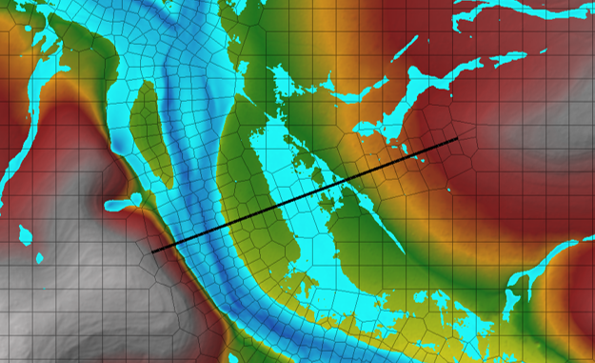
Figure 12: Placement of the SA/2D Across the Entire Valley
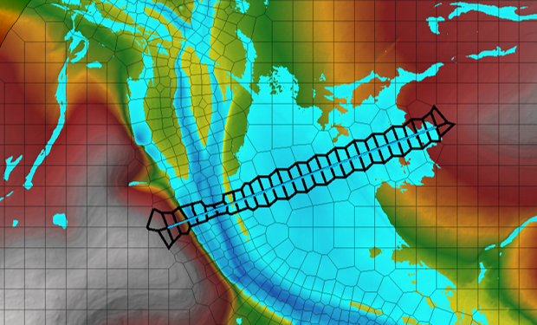
Figure 13: BC Line with a Length Equal to the SA/2D Connection Line
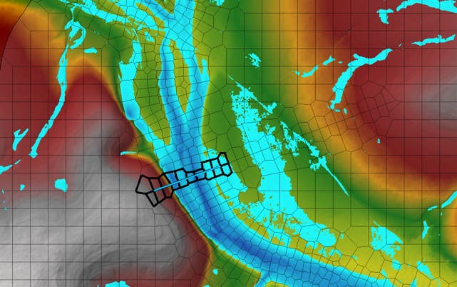
Figure 14: BC Line with a Length Similar to the Width of the Flooding
Stage Hydrograph Boundary Conditions
Stage hydrographs were applied at the main stem outflow locations to account for the downstream backwater elevations. This approach served two purposes. First, it facilitated the tie-ins of the water surface elevations at the model domain boundaries, which were required to be within 0.5 foot. Second, the application of the stage hydrograph boundaries accounted for the timing of the tailwater conditions in the downstream model. In short, the stage hydrograph in the upstream model was obtained from the downstream model at the upstream main channel’s outflow location.
Figure 15 and Figure 16 show an example of the iterative process used to extract and apply a stage hydrograph at the transition of two model domains (which overlap) in the Jim Ned watershed. These figures show the location used to obtain the stage hydrograph between domains 0801_A2 (upstream domain) and 0802_A3 (downstream domain). A stage hydrograph was iteratively extracted from the downstream model results and applied to the upstream model as a boundary condition. This boundary condition was based upon the hydrograph results calculated from a SA/2D connection in the upstream model applied as a discharge in the downstream model. The iterative process was necessary to balance the upstream model’s peak outflow within 5% of the downstream model’s peak inflow while also achieving a WSEL tie-in of 0.5 foot or less at the transition location.
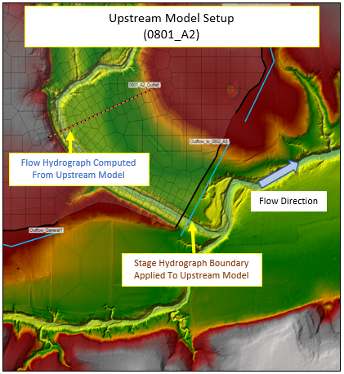
Figure 15: Extraction of Flow Hydrograph from the SA/2D Connection in the Upstream Domain
for Use in the Downstream Domain
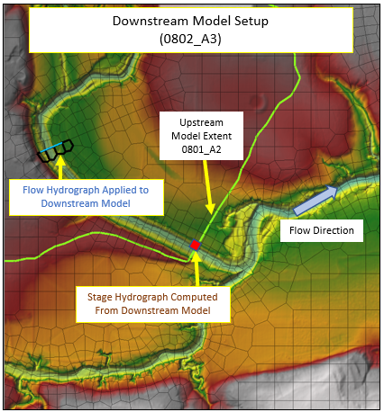
Figure 16: Application of Upstream Flow Hydrograph in the Downstream Domain
See Table 9 through Table 12 for a summary of the upstream and downstream peak discharges and WSELs at the downstream end of each domain in the Southern Beaver watershed. These tables have been included to demonstrate that at the downstream end of each model domain, the peak discharges are within 5% of one another and the WSELs are within 0.5 feet for each profile.
Discharges were extracted from the SA/2D connection (upper discharges) and the BC line (lower discharges). WSELs were typically pulled from where the BC line was located. However, sometimes the WSELs were not within 0.5 feet at that location. When that occurred, the mapping overlap area was reviewed, and WSELs were pulled from a location where the WSELs were within 0.5 feet.

Table 9: Upstream and Downstream Discharges and WSELs at the Downstream End of Domain SBVR_701
Profile (AEP) | Upstream Outflow (cfs)* | Downstream Inflow (cfs)** | Difference  (%) | Upstream  WSEL (ft) | Downstream  WSEL (ft) | Difference (ft)
10% | 2,809 | 2,809 | 0.00% | 1,274.13 | 1,273.70 | 0.43
4% | 6,215 | 6,215 | 0.00% | 1,275.21 | 1,275.04 | 0.17
2% | 9,997 | 9,997 | 0.00% | 1,276.13 | 1,276.12 | 0.01
1% | 15,181 | 15,181 | 0.00% | 1,277.15 | 1,277.26 | -0.11
0.2% | 30,987 | 30,987 | 0.00% | 1,279.48 | 1,279.83 | -0.36
1% minus | 8,677 | 8,677 | 0.00% | 1,275.83 | 1,275.77 | 0.07
1% plus | 23,265 | 23,265 | 0.00% | 1,278.45 | 1,278.76 | -0.31
* Discharges are the sum of the discharges at SA/2D connections Out BVRC 701 1 and Out BVRC 701 2 since these connections both peak at the same time and these discharges commingle in the tie-in area.
** Discharges are the sum of the discharges at BC lines Inflow From BVRCRK 701 1 and Inflow From BVRCRK 701 2 since both lines peak at the same time and these discharges commingle in the tie-in area.
Table 10: Upstream and Downstream Discharges and WSELs at the Downstream End of Domain SBVR_702
Profile (AEP) | Upstream Outflow (cfs)* | Downstream Inflow (cfs)** | Difference  (%) | Upstream  WSEL (ft) | Downstream  WSEL (ft) | Difference (ft)
10% | 5,228 | 5,228 | 0.00% | 1,149.75 | 1,149.72 | 0.03
4% | 9,417 | 9,417 | 0.00% | 1,152.36 | 1,151.95 | 0.41
2% | 13,590 | 13,590 | 0.00% | 1,153.53 | 1,153.31 | 0.22
1% | 18,695 | 18,695 | 0.00% | 1,154.56 | 1,154.31 | 0.25
0.2% | 35,640 | 35,640 | 0.00% | 1,156.99 | 1,156.65 | 0.34
1% minus | 12,005 | 12,005 | 0.00% | 1,153.13 | 1,152.92 | 0.21
1% plus | 27,641 | 27,641 | 0.00% | 1,156.01 | 1,155.68 | 0.33
* Discharges are the sum of the discharges at SA/2D connections Out BVRC 702 1 and Out BVRC 702 2 since these connections both peak at the same time and these discharges commingle in the tie-in area.
** Discharges are the sum of the discharges at BC lines Inflow From BVRCRK 702 1 and Inflow From BVRCRK 702 2 since both lines peak at the same time and these discharges commingle in the tie-in area.

Table 11: Upstream and Downstream Discharges and WSELs at the Downstream End of Domain SBVR_703
(Main Channel)
Profile (AEP) | Upstream Outflow (cfs)* | Downstream Inflow (cfs)** | Difference  (%) | Upstream  WSEL (ft) | Downstream  WSEL (ft) | Difference (ft)
10% | 5,862 | 5,862 | 0.00% | 1,039.87 | 1,039.83 | 0.04
4% | 10,926 | 10,926 | 0.00% | 1,042.89 | 1,042.82 | 0.07
2% | 16,065 | 16,065 | 0.00% | 1,045.09 | 1,045.00 | 0.09
1% | 22,343 | 22,343 | 0.00% | 1,047.25 | 1,047.17 | 0.08
0.2% | 40,625 | 40,625 | 0.00% | 1,050.64 | 1,050.64 | 0.00
1% minus | 14,026 | 14,026 | 0.00% | 1,044.29 | 1,044.21 | 0.08
1% plus | 32,941 | 32,941 | 0.00% | 1,049.59 | 1,049.53 | 0.06
* Discharges are the sum of the discharges at SA/2D connections Outflow2 SB 703 and Outflow3 SB 703 since these connections both peak at the same time and these discharges commingle in the tie-in area.
** Discharges are the sum of the discharges at BC lines Inflow From SBVR 703 2 and Inflow From SBVR 703 3 since both lines peak at the same time and these discharges commingle in the tie-in area.
Table 12: Upstream and Downstream Discharges and WSELs at the Downstream End of Domain SBVR_703
(Tributary East of Main Channel)
Profile (AEP) | Upstream Outflow (cfs) | Downstream Inflow (cfs) | Difference  (%) | Upstream  WSEL (ft) | Downstream  WSEL (ft) | Difference (ft)
10% | 108 | 108 | 0.00% | 1,050.09 | 1,050.06 | 0.03
4% | 252 | 252 | 0.00% | 1,050.35 | 1,050.31 | 0.04
2% | 385 | 385 | 0.00% | 1,050.53 | 1,050.48 | 0.05
1% | 542 | 542 | 0.00% | 1,050.69 | 1,050.65 | 0.04
0.2% | 1,787 | 1,787 | 0.00% | 1,052.06 | 1,051.95 | 0.11
1% minus | 334 | 334 | 0.00% | 1,050.56 | 1,050.43 | 0.13
1% plus | 845 | 845 | 0.00% | 1,050.94 | 1,050.89 | 0.05

Normal Depth Boundary Conditions
Normal depth boundary conditions were applied along each 2D area perimeter to avoid ponding along the perimeter. At main channel outflow or tributary inflow locations where other boundary conditions were already present, a normal depth boundary was not applied.

Reservoir Modeling
There was one major reservoir in the Southern Beaver watershed. This reservoir is called Santa Rosa Lake, and it resides along Beaver Creek, a tributary of the Wichita River. The modeling approach for this reservoir is discussed in this subsection.
Santa Rosa Lake is in model domain SBVR_702, and the Santa Rosa Dam is located at the downstream end of the domain. The lake is on land belonging to the W. T. Waggoner Ranch, and it is owned by the landowner. The lake is used for irrigation and raising livestock. Construction of the dam was completed in 1929. The earthen dam has a conservation pool elevation of 1,167 feet (NGVD 29 assumed).
The dam is approximately 2,400 feet long. Although there are some minor outlet structures in the dam, during high-flow events, nearly all of the water that leaves the lake exits through two spillways, one on either side of the dam.
No operations data or rating tables were available for the dam. The dam was modeled by placing an SA/2D connection along the crest of each spillway. The initial conditions in the lake, derived from the conservation pool elevation, were established using an Initial Conditions (IC) point. The conservation pool elevation, after converting to NAVD 88, was 1,166.8 ft.

Computation Settings
The computation settings applied in the HEC-RAS models are listed below:
- The Diffusion Wave equation was used.
- A 96-hour simulation time was generally applied to capture the peaks and tails of the hydrographs.
- An advanced time step control based on the Courant number was applied as shown below in Figure 17. This option was chosen to decrease run times while generally maintaining Courant number values less than 1.
- Typical model run times with this advanced time step control setting were approximately 5 hours per simulation.
- The mapping and hydrograph output intervals were 10 minutes.
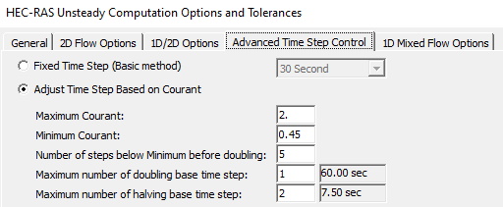
Figure 17: HEC-RAS Unsteady Computation Options and Tolerances

Regression Analysis
Regression flows were used for model validation where gage data was not available. The flow direction and flow accumulation grids created during the hydro-enforcement task were used to develop regression input parameter grids and regression peak flow grids for locations with drainage areas of 1 mi² or larger. The peak flows were computed using the regression equations documented in Regression Equations for Estimation of Annual Peak-Streamflow Frequency for Undeveloped Watersheds in Texas Using an L-moment-Based, PRESS-Minimized, Residual-Adjusted Approach (Asquith and Roussel 2009).
The contributing drainage area (A), mean-annual precipitation (P), dimensionless channel slope (S), and the basin-averaged OmegaEM parameter (Ω) were the input parameters for the regression equations. The regression equations are shown in Table 3 in the regression report (Asquith and Roussel 2009) and below on Figure 18.
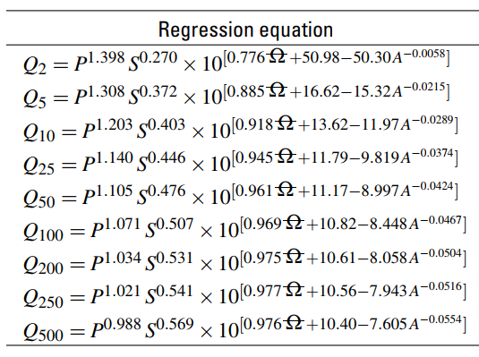
Figure 18: Regression Equations for the Southern Beaver Watershed
The lower and upper limits of the slope in the regression analysis were 0.00023 and 0.0703, respectively. The computed flows are sensitive to the channel slope and unreasonable flows tend to be computed when slopes are outside the range used in the regression analysis. Therefore, when the channel slope was less than 0.00023, 0.00023 foot per mile was used in place of the computed value. Similarly, when the channel slope exceeded 0.0703, 0.0703 was used in place of the computed value.
The average standard error of prediction (SEP) for the 1% annual-chance event was 64.8%, according to the PRESS statistic in Table 3 of the regression report (Asquith and Roussel 2009). The 1% plus and 1% minus gridded flows were computed using the SEP as shown in the equations below. The 1% minus flows were not computed by multiplying the 1% flow by 1 minus SEP to avoid unreasonably low flows when the standard errors were large.

$$Q_{1\%Plus}=Q_{1\%}*1.648$$
$$Q_{1\%Minus}=\frac{Q_{1\%}}{1.648}$$
The flows resulting from the regression analysis were not used downstream of flow-regulating reservoirs or for streams with inflows from other HUC-8 watersheds.

Gage Analysis
There were two USGS gages with drainage areas greater than 1 mi² in the watershed. These gages were USGS gage 07312140 (Beaver Creek Tributary near Crowell, TX) and USGS gage 07312200 (Beaver Creek near Electra, TX).
USGS gage 07312200 included sufficient annual peak flow data for a useful flow-frequency analysis to be completed. A flow-frequency analysis was completed using PeakFQ, which applies the USGS’s Bulletin 17C approach using the Expected Moments Algorithm (EMA). The regional skew was derived from the Water-Resources Investigations Report 96-4117, Techniques to Estimate Generalized Skew Coefficients of Annual Peak Streamflow for Natural Basins in Texas. The PeakFQ analysis and its outcomes have been placed in the supplemental data folder.
USGS gage 07312140 included only 9 years of peak annual discharge data. A flow-frequency analysis was not completed since a gage must have at a minimum 10 years of data (and ideally at least 20 years) for the analysis to be reliable.
The two gages are summarized in Table 13.
Table 13: Summary of USGS Gages in the Southern Beaver Watershed
Site No. | Site Name | Computed Drainage Area (mi²) | Was Gage Analysis Performed? | Source of Gage Analysis | Reason Why Gage Analysis Was Not Performed to Support BLE Validation
07312140 | Beaver Creek Tributary near Crowell, TX | 3.45 | No | N/A | The period of record was less than 10 years.
07312200 | Beaver Creek near Electra, TX | 649.4 | Yes | This BLE assessment | N/A

USGS gage 07312200 (Beaver Creek near Electra, TX) was located in domain SBVR_704. Annual peak flow records were available from 1961 to 2022. The entire flow record was used in the PeakFQ analysis. The discharges computed by PeakFQ are summarized in Table 14.
Table 14: Results of the USGS Gage Flow-Frequency Analysis
Site No. | Site Name | Computed Drainage Area (mi²) | Gage 1%- Flow (cfs) | Gage 1% Flow (cfs) | Gage 1%+ Flow (cfs)
07312200 | Beaver Creek near Electra, TX | 649.4 | 9,798 | 12,610 | 18,310

Model Validation
The Southern Beaver BLE hydraulic models were validated using peak flow information available in the regression analysis previously discussed in Subsection 1.2.7 and the USGS gage flow-frequency analysis described in Subsection 1.2.8. Unfortunately, there were no FEMA effective flow data available.
Validation checks were made at 12 points throughout the Southern Beaver watershed, three in each domain. The locations may be grouped as follows:
- Eleven validation locations compared the 1% BLE flows with the 1% minus, 1%, and 1% plus regression flows.
- One validation location compared the 1% BLE flow with the 1% minus, 1%, and 1% plus regression flows and with the 1% minus, 1%, and 1% plus discharges computed by the flow-frequency analysis for USGS Gage 07312200.
The validation locations were scattered throughout the watershed in locations that provided a comprehensive coverage of drainage areas and stream characteristics. The drainage areas of the validation points ranged from approximately 6 mi² to 661 mi². The 1% BLE flows were between the 1% minus and the 1% plus regression flows at 12 locations, and they were outside of this range at 0 locations. At the location where the USGS gage flow-frequency analysis was available, the 1% BLE flow was between the 1% and 1% plus gage discharges. The comparison of the 1% BLE flows with the regression and gage discharges is shown in Table 16.
The first step of the validation effort was to review the initial 1% BLE results. In general, the initial 1% BLE flows were higher than the 1% plus regression and 1% plus gage discharges. Some different scenarios were tested to determine which adjustments to make to the CN values and the Manning’s n values. The Manning’s n values were revised as needed, provided they remained within the ranges specified in Table 8. The AMC II CN values were adjusted by no more than ±10% of their initial values.
Even after the Manning’s n values and AMC II CN values were adjusted as much as possible, the BLE flows remained too high. The Manning’s n values were reset to their initial values and the baseline AMCs were revised from AMC II to AMC I. Research of published documentation on the topic of AMCs in Texas uncovered Engineering Technical Note 210-18-TX5 – Estimating Runoff for Conservation Practices. Published by the Soil Conservation Service (SCS), this document included a map showing how typical AMCs vary across Texas. As shown in Figure 19 typical AMCs range from AMC I (west Texas) to 40% of the way between AMC II and AMC III in far east Texas.

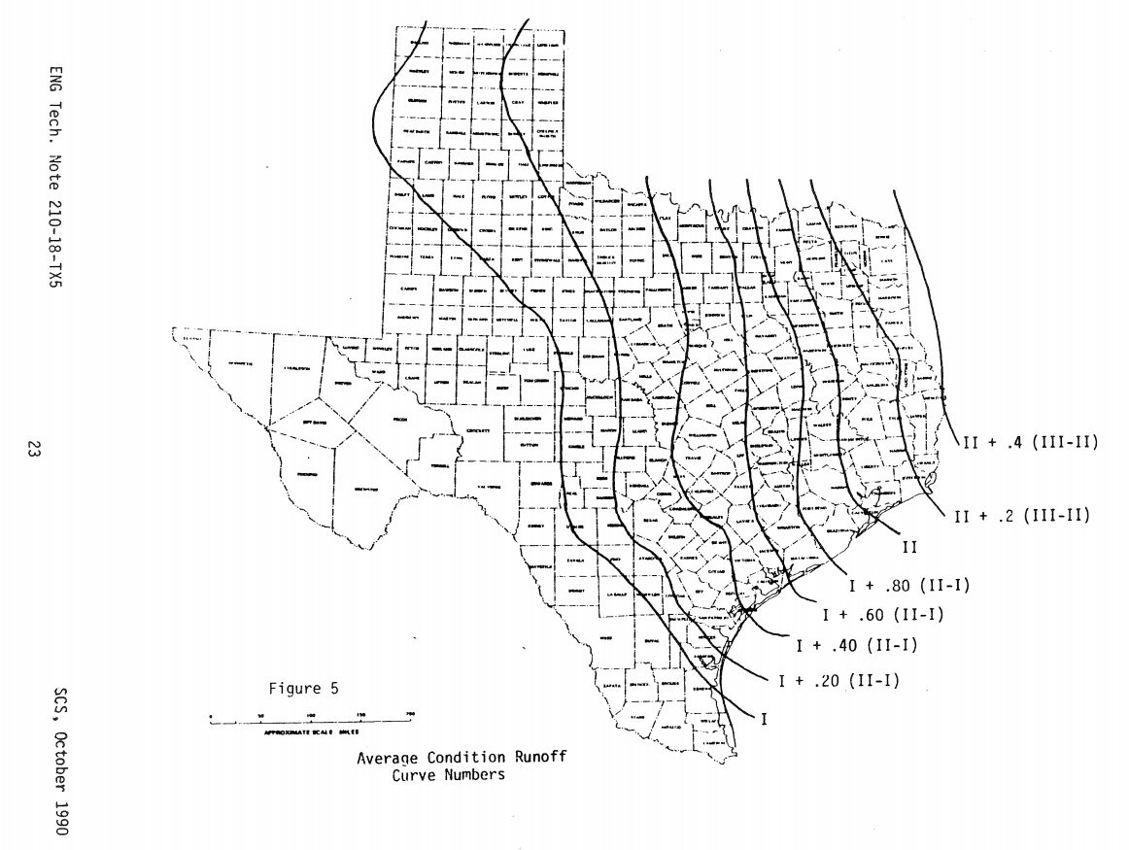
Figure 19: Typical Antecedent Moisture Conditions in Texas
After additional trial and error, the revisions to the CN values and Manning’s n values documented in Table 15 produced 1% BLE discharges that fell between the 1% minus and 1% plus gage flows at the USGS gage and between the 1% minus and 1% plus regression discharges at all 12 validation points.
Table 15: Summary of Parameter Adjustments Made During Validation in the Southern Beaver Watershed
Model Domain | CN Adjustment | Overland n Adjustment | Channel n Adjustment | Number of Validation Locations | Pass | Fail
SBVR_701 | AMC I | No Change | No Change  (n=0.045) | 3 | 3 | 0
SBVR_702 | No Change  (AMC II) | No Change | No Change  (n=0.045) | 3 | 3 | 0
SBVR_703 | AMC I | No Change | No Change  (n=0.045) | 3 | 3 | 0
SBVR_704 | AMC I | No Change | Revised to  n=0.06 | 3 | 3 | 0
 |  |  | Total | 12 | 12 | 0

During the validation process, domain-wide parameter adjustments were applied to the CN values and the Manning’s n values to maximize the number of streams where the 1% BLE flows fell between the 1% minus and 1% plus regressions flows. No particular area or tributary in a domain was considered a priority over the others when these adjustments were made. As a result, in areas where the stream/‌watershed characteristics were significantly different from the rest of the domain, some of the 1% BLE flows might fall outside of the 1% minus and 1% plus bounds. Other factors that contributed to the 1% BLE flows falling outside of the 1% minus and 1% plus bounds included differences in the regression and 2D BLE analysis methodologies; the use of updated topographic data in the BLE analysis; and the higher NOAA Atlas 14 rainfall totals that were used in the BLE analysis.
The model overview and results spreadsheet (SouthernBeaver_Model_Overview_and_Results.xlsx) has been placed in the task documentation folder of this submittal. The validation locations are included in the HEC-RAS models and may also be found on the validation location maps in the model overview and results spreadsheet for each domain.
Typically, a comparison is made between the 1% BLE WSELs and select effective 1% WSELs in the watershed. However, there were no effective 1% WSELs available in the Southern Beaver watershed. Therefore, no such comparison was completed in this watershed.
See Figure 20 and Table 16 on the following pages for a summary of the 1% validation results at the validation points in the Southern Beaver watershed.

Figure 20: Computed Flow vs Drainage Area of Select 1% BLE, 1% Regression, and 1% Gage Flows
Table 16: 1% Peak Flow Validation Results for the Southern Beaver Watershed
Point ID | Point Name | Drainage Area (Mi²) | Regression 1%- Flow (cfs) | Regression 1% Flow (cfs) | Regression 1%+ Flow (cfs) | BLE  1% Flow (cfs) | Gage 1%- Flow (cfs) | Gage 1% Flow (cfs) | Gage 1%+ Flow (cfs) | FIS 1% Flow (cfs)*
 | Domain SBVR_701
PT1 | Outfall (Beaver Creek) | 132.6 | 8,458 | 13,938 | 23,053 | 15,281 | - | - | - | -
PT2 | Middle Beaver Creek | 34.4 | 3,399 | 5,601 | 9,232 | 8,110 | - | - | - | -
PT3 | Beaver Creek | 7.8 | 1,404 | 2,314 | 3,813 | 1,773 | - | - | - | -
 | Domain SBVR_702
PT1 | Beaver Creek | 286.8 | 12,551 | 20,684 | 34,087 | 19,285 | - | - | - | -
PT2 | South Beaver Creek | 9.2 | 1,388 | 2,287 | 3,770 | 2,839 | - | - | - | -
PT3 | Unnamed | 50.4 | 3,893 | 6,415 | 10,572 | 8,763 | - | - | - | -
 | Domain SBVR_703
PT1 | Outfall (Beaver Creek) | 559.8 | 19,032 | 31,365 | 51,689 | 22,439 | - | - | - | -
PT2 | Minnas Creek | 31.7 | 3,292 | 5,425 | 8,940 | 7,071 | - | - | - | -
PT3 | Unnamed | 5.6 | 1,096 | 1,807 | 2,977 | 2,787 | - | - | - | -
 | Domain SBVR_704
PT1 | Outfall (Beaver Creek) | 661.4 | 20,891 | 34,428 | 56,737 | 28,315 | - | - | - | -
PT2 | Bluff Creek | 13.8 | 3,004 | 4,950 | 8,158 | 5,002 | - | - | - | -
PT3 | USGS Gage 07312200 | 649.4 | 20,932 | 34,496 | 56,850 | 18,821 | 9,798 | 12,610 | 18,310 | -
* No effective FIS flows were available for the Southern Beaver watershed.

Floodplain Delineation (10%, 1%, and 0.2% events)
Floodplains were delineated throughout the entire watershed for the 10%, 1%, and 0.2% annual-chance events. The 1% and 0.2% floodplains may be found in the FLD_HZD_AR feature class in the flood risk database. The 10% floodplain may be found in the TENPCT_FP feature class in the database.
The floodplains were derived from the raw modeled grids using the maximum water surface elevation and depth values in each cell of the mesh. These grids were exported from HEC-RAS as rasters in TIF format with an interpolated rendering that slopes values at the center and along the faces/edges of the computational mesh cells. Using GIS software, the TIF rasters were post-processed into 10%, 1%, and 0.2% annual-chance floodplains.
The following general steps were completed to delineate the floodplains:
- Export the depth rasters and WSEL rasters for the 10%, 1%, and 0.2% ACEs from the HEC-RAS models using a sloping water surface elevation render mode to a GIS environment. When exporting the model results, the “Raster based on terrain” parameter in HEC-RAS was changed from “Terrain.HydroEnforced” to “Terrain.” This change was made so the original terrain surface was used to develop the floodplain mapping, not the hydro-enforced terrain surface. Using the hydro-enforced terrain would have led to mapping that would have incorrectly shown the roadway as being overtopped where the hydro-enforced culverts had been added.
- For each ACE, merge the raw WSEL rasters into a single raster that covers the entire watershed. Do the same for the depth rasters. Where the floodplain mapping needed to tie-in across two model domains, the model domain boundaries overlapped. Tie-in locations were identified in these overlap areas using split line shapefiles. Three split line shapefiles were created, one for each of the mapped events (i.e., 10%, 1%, and 0.2%). Split line alignments for each event were determined by creating difference rasters that subtracted the WSEL rasters from one another in the model domain overlap areas. Split lines were then drawn around the entire perimeter of each model domain through areas where the WSELs in the difference rasters were within 0.5 feet of each other. See the split line shapefiles in the Supplement Data folder to understand where the mapping tie-ins are located.
- To understand how a split line is placed, consider Figure 21, which shows two floodplains that overlap along a model domain boundary. The split line must be placed where the WSELs are within 0.5 feet of one another in the overlap area. To determine where the WSELs meet this criterion, a WSEL difference raster was created.
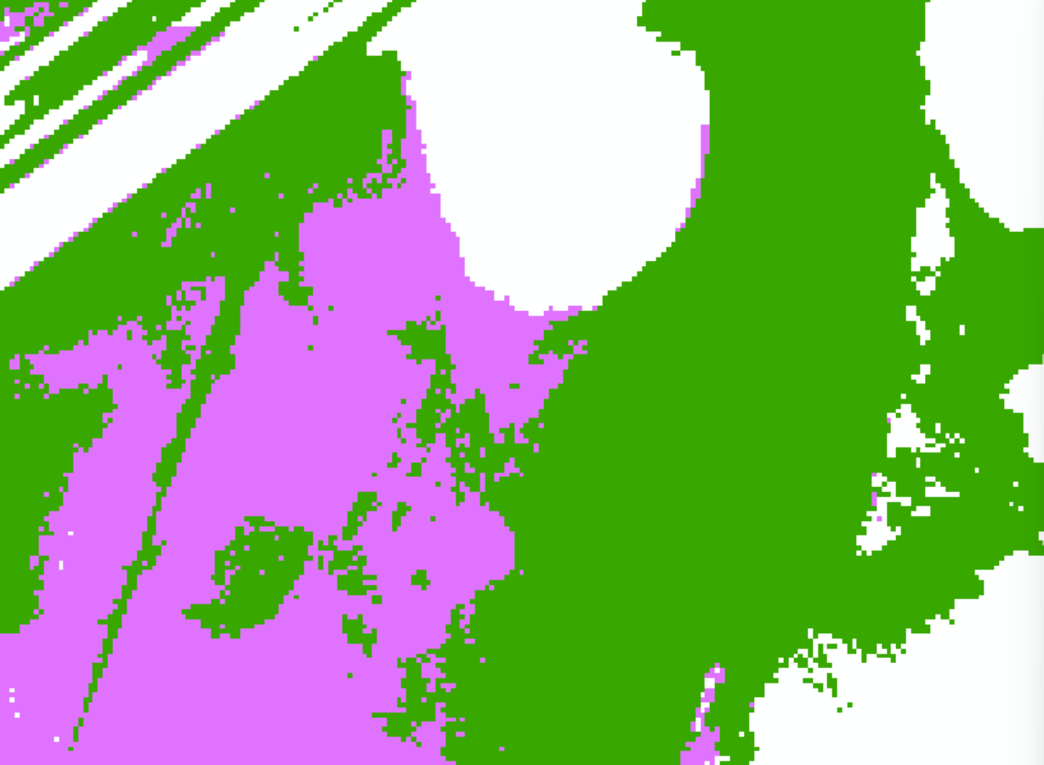
Figure 21: Example of Overlapping Mapping along a Model Domain Boundary
Figure 22 shows what the difference raster looks like for the area in Figure 21. Light green means the WSELs are within 0.5 feet of each other and red means they are not. The blue-black line is the split line. It has been aligned so that it crosses the difference raster where the raster is light green. To the south of this line, the purple raster in Figure 21 is the source of the floodplain mapping. To the north of the split line, the dark green raster is the source of the floodplain mapping. Along the split line is where the source of the mapping transitions from the purple mapping to the dark green mapping.

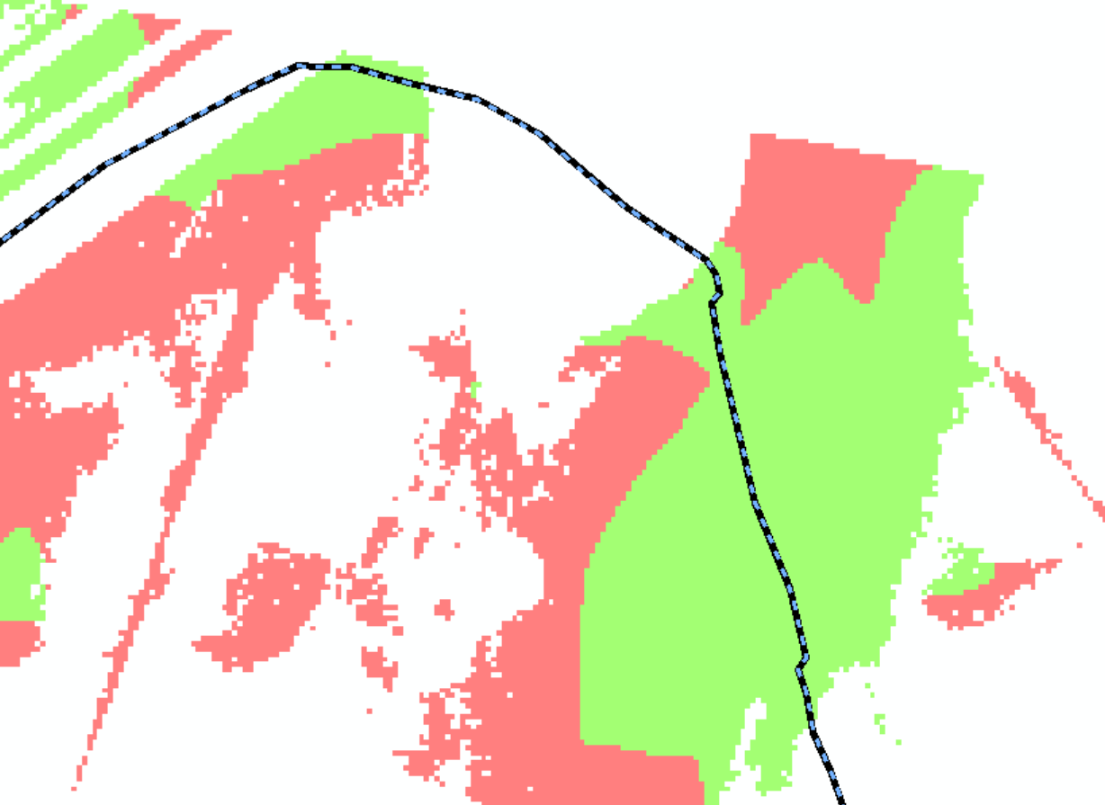
Figure 22: WSEL Difference Raster and Split Line for the Overlap Area
- The merged raw raster grids included connected and disconnected areas of potential flood hazard. To reduce the extent of these disconnected flood areas, process the rasters to filter and remove disconnected small, shallow areas of flooding. To do this, apply the TWDB’s mapping threshold matrix to remove shallow depths, small areas of flood risk, and disconnected areas. According to Figure 3.1 in TWDB’s 2D BLE guidelines, the watershed falls in the Inland Areas of Texas. Therefore, disconnected areas were removed if they met both of the criteria in Table 17.
Table 17: Inland Mapping Threshold Matrix
Area (acres) | Depth (feet)
Less than 0.33 | Remove all flooding
0.33 to 0.50 | Less than 0.33
0.50 to 1.0 | Less than 0.25
1.0 to 2.0 | Less than 0.10

- Fill the holes (i.e., islands) in the rasters using the Elevation Void Fill routine. For the 1% and 0.2% ACEs, holes in the rasters less than 2 acres were filled. For the 10% ACE, holes in the raster less than 0.5 acres were filled. Application of the Elevation Void Fill routine occasionally produces WSELs that are below the ground elevation. In cases where this phenomenon occurred, the WSELs were not revised from their subterranean values, but the depths at these locations were set to 0.1 feet.
- The Elevation Void Fill routine fills the holes in the rasters via an interpolation process that leverages the WSELs around the edge of the hole to estimate the WSELs in the hole. In some locations where this routine was used to fill the holes in the floodplain mapping, minor discontinuities may appear in the WSELs in the raster surface around the perimeter of the hole. Typically, this happens where cupping is occurring in the raster near the edge of the hole. These discontinuities can also form when the WSELs near the hole are changing rapidly. Please be aware of this issue when applying the BLE results. Note that this issue is not occurring at all holes. It is usually limited to holes that approach the maximum fill area of 2 acres.
- Convert each WSEL raster to a floodplain polygon.
- Many ponding areas were present throughout the watershed. Due to the large mesh cells used in the 2D modeling, the extent of the smaller ponds was not always mapped properly in the model output. To properly identify the flood hazard in these areas, transfer the ponding extents available in the National Hydrography Dataset into the 1% and 0.2% floodplain polygons. Do not transfer them into the 10% floodplain polygon.
- If any dams are present that have been catalogued by the National Inventory of Dams and include a normal pool storage of 200 acre-feet or more, review the spillway mapping along each dam. If the 1% and/or the 0.2% model output did not include any flooding along the spillway, manually revise the floodplain polygon(s) to flood the spillway.
- Add waterbodies of lake and reservoir inundation areas of 20 acres or greater to the WTR-LN and FLD_HAZ_AR feature classes. The National Inventory of Dams was used to identify dams with inundation areas greater than 20 acres. The areas of inundation were computed by measuring the areas of the normal pools visible on the aerial photography.
- Clean up each polygon by simplifying it and smoothing it. The intent of the simplify and smooth processes is to eliminate unnecessary/erroneous vertices, remove rough edges, and reduce the size and complexity of the raw floodplain polygons. Apply professional judgement to determine the appropriate tolerance for simplifying and smoothing the floodplain polygons. Set initial thresholds to 5 feet for simplifying and 25 feet for smoothing.
- Merge the 1%, and 0.2% ACE polygons into one feature class. Keep the 10% ACE polygon as a separate feature class.
- The extents of the final depth and WSEL grids must match the extents of the flood inundation polygons. Because of the clipping and smoothing procedures applied to the floodplain polygons, they will no longer match the extents of the rasters. Clip the depth and WSEL grids to each respective flood frequency inundation polygon to align the extents of the rasters with the extents of the floodplain polygons.
- Clip the rasters and the floodplain polygons using the HUC-8 watershed boundary.

Challenges
A handful of challenges were encountered during the Southern Beaver BLE analysis. These challenges and their solutions are catalogued in the following subsections.
Balancing Flows between Small and Large Streams
The BLE models developed for the Southern Beaver watershed are watershed-wide models. Each domain is similar in size to a HUC-10 watershed. As a result, streams with both large and small drainage areas are in the same model and cannot be isolated from one another. One of the main challenges of the BLE analysis was adjusting the model input parameters so that valid flows were produced along streams with both large and small drainage areas. For example, when the CN values were revised to increase flows that were too low along the smaller tributaries, this adjustment would occasionally lower the flows along the more-significant streams to a point below the lower end of that which was considered valid, and vice versa. To address this challenge, a range of acceptable CN values and Manning’s n values was established for the watershed. The parameters were adjusted only within this set range so that the model results did not skew too heavily in favor of the larger streams or the smaller streams. Balancing the validation needs between the small and large streams was further enhanced by assigning an equal weight to all validation locations and choosing validation locations such that a representative coverage of drainage areas and stream characteristics was included.
Modeling of Hydraulic Structures
Although detailed modeling of hydraulic structures was outside the scope of this BLE analysis,
completely ignoring the structures would have produced invalid model results. Therefore, hydraulic structures were modeled using a simplified approach. This included adding breaklines along dam crests, elevated roadways, and railroads to force the terrain surface to drain properly. Bridge and culvert openings were represented by hydro-enforcing burn lines that were roughly equal in width to the bridge and culvert opening sizes. The addition of breaklines at the dam crests throughout AtkinsRéalis’ BLE study area typically resulted in an overestimation of the 1% BLE floodplain extents and WSELs on the upstream side of the dam. On the downstream side of the dams, the floodplains and flows tended to be underestimated.
Limited Data to Support Validation
There were limited data available to support the validation of the Southern Beaver BLE hydraulic analysis. There were only 2 USGS gages in the watershed, and of those, only one had enough annual peak discharge data for a reliable flow-frequency analyses to be completed. At all other validation locations, the regression analysis discussed in Subsection 1.2.7 was applied to validate the HEC-RAS models.
Cupping
Within HEC-RAS, the RAS Mapper interface provides three render modes for visualization of floodplains: Horizontal, Sloping, and Hybrid. Currently, the results of only the horizontal and sloping render modes can be exported. While the horizontal render mode produces “bathtubs” of isolated ponding per cell, the sloping render mode produces “cupping.” Cupping is a ramp-up of the depth in the overbanks occurring most often in areas of significant topographic relief. USACE’s HEC is aware of this issue, which is an error caused by the WSEL projecting to the adjacent cell’s average elevation. However, the timeframe for a solution to this error by the HEC is unknown. Since the TWDB mapping process is based on the sloping render mode output, this cupping effect can be identified in the final mapping products produced, as shown by the pink areas in Figure 23. The areas of cupping will not be removed or cleaned beyond the extents of the mapping clean-up process discussed herein. There is significant topographic relief in the Southern Beaver watershed. Therefore, cupping is prevalent throughout the BLE mapping in much of the watershed.
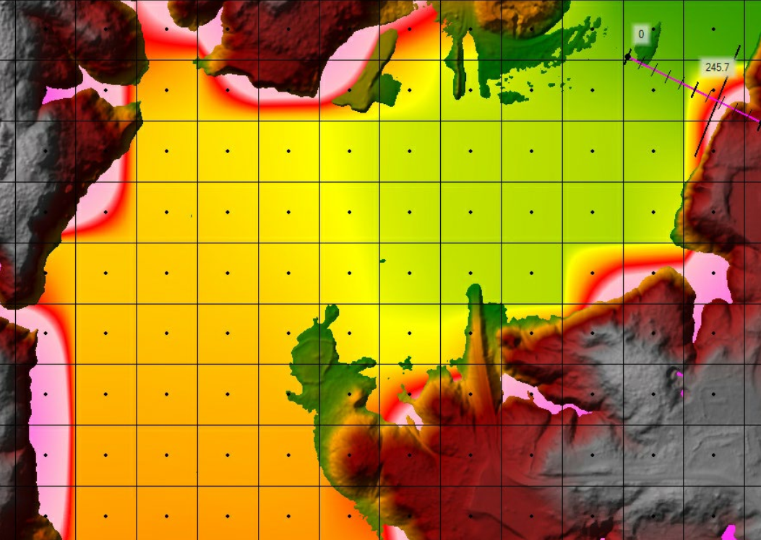
Figure 23: An Example of Cupping in 2D BLE Mapping
Negative Discharges at Two SA/2D Connections
Negative discharges occur at an SA/2D connection when flow moves upstream at the connection instead of downstream. Because of the flat terrain present in some parts of the watershed, there were a few locations where negative discharged occurred.
The first location is at SA/2D connection Outflow BVRC 701 at the downstream end of domain SBVR_701. This area is shown on Figure 24, with SA/2D connection Outflow BVRC 701 highlighted in pink.
Negative discharges appear briefly at this SA/2D connection near the beginning of the model run, as shown on Figure 25. The 0.2% event experiences the largest negative discharge, and it is only 18 cfs. These negative discharges are occurring because the ground elevation at the SA/2D connection and the downstream BC line (highlighted in blue in Figure 24) are both in the vicinity of 1,271 feet to 1,272 feet. The BC line includes a stage hydrograph boundary, and as the stage begins to rise, water moves upstream to the SA/2D connection since the ground is so flat. Soon, water begins to arrive from upstream of the SA/2D connection, and the discharges become positive.
Figure 26 shows the flow and stage hydrographs at the SA/2D connection. Note how minor the negative discharges are compared to the peak discharges. Because these negative discharges occur early in the model run and are soon resolved, they do not adversely affect the BLE model outcomes.

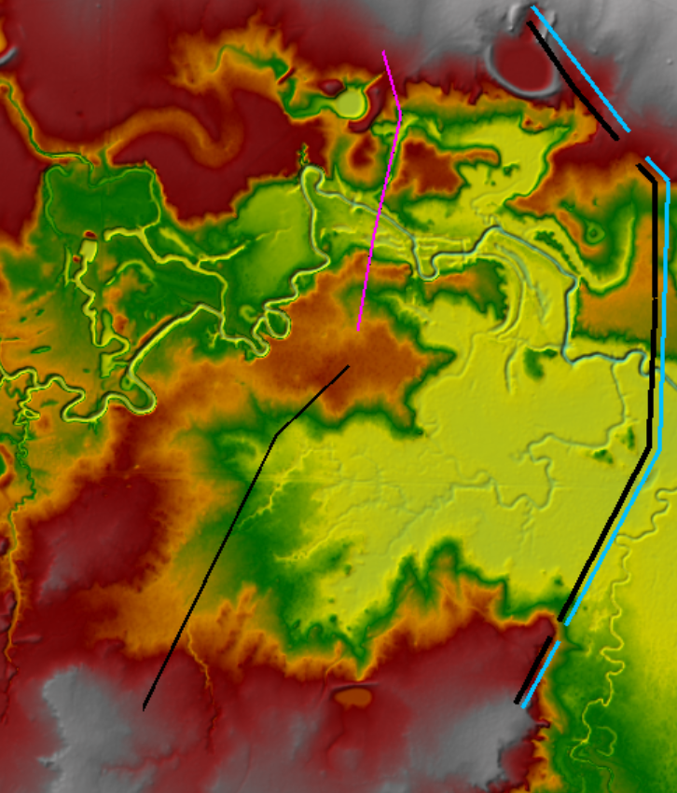
Figure 24: SA/2D Connection Outflow BVRC 701 at the Downstream End of Domain SBVR_701
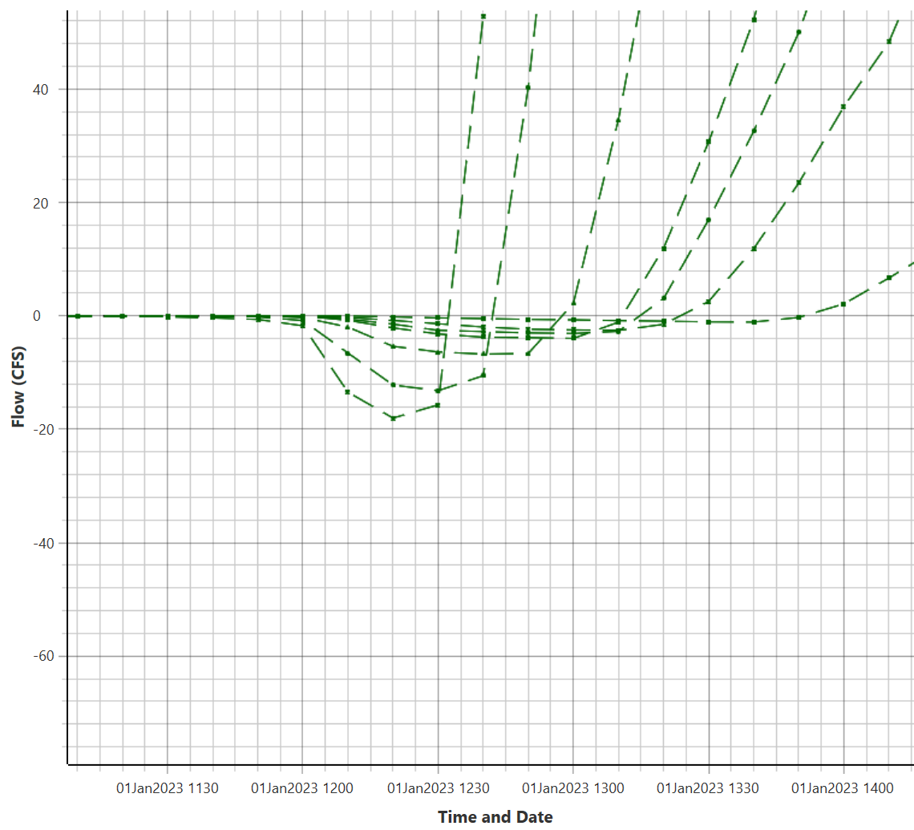
Figure 25: Minor Negative Discharges at SA/2D Connection Outflow BVRC 701

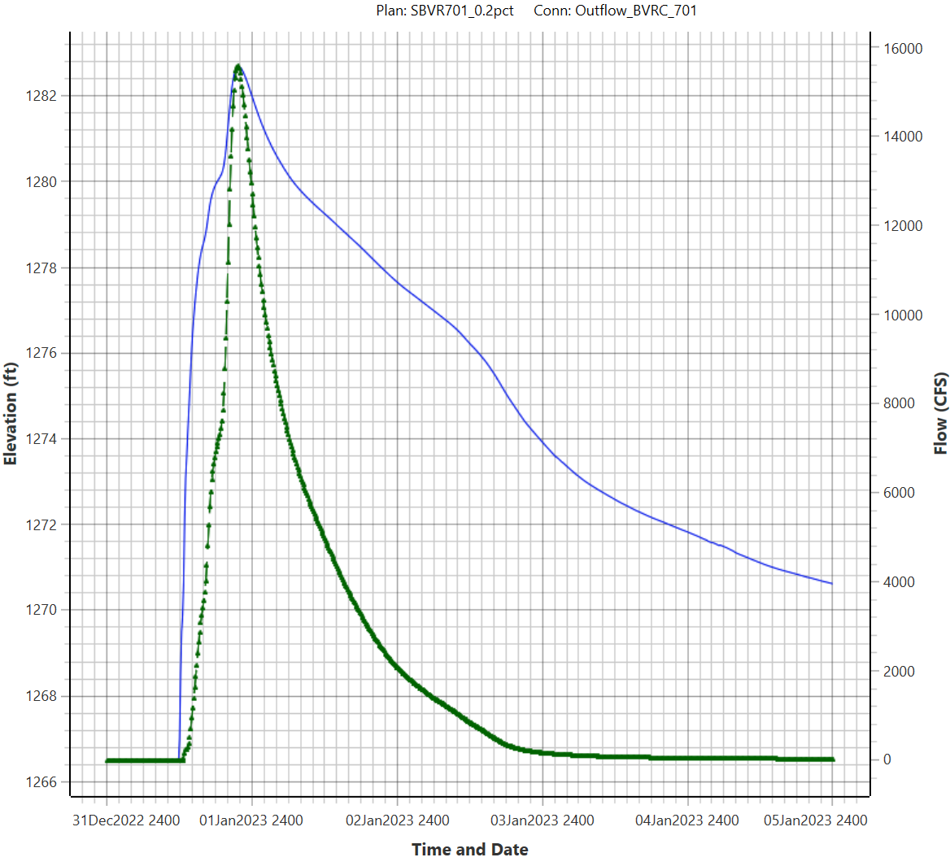
Figure 26: Stage (Blue) and Flow (green) Hydrographs at SA/2D Connection Outflow BVRC 701
The second place where negative discharges occurred in the BLE model is at SA/2D connection SBVR_702_PT1 in domain SBVR_702. This SA/2D connection is aligned with validation location PT1 in the domain (see Table 16) and is only used to pull discharges from the model for validation purposes. The connection is located just upstream from Santa Rosa Lake as shown on Figure 27. The pink line is the SA/2D connection, and the blue polygon is the extent of the lake at the beginning of the simulation. As the model starts, local runoff soon enters the lake and starts to increase the lake’s floodplain. Before runoff from upstream of the SA/2D connection can reach the connection, the lake backs up far enough to flood the connection and cause negative discharges as shown on Figure 28. These negative discharges are temporary and soon disappear as runoff from upstream makes it to the SA/2D connection. Because these negative discharges occur early in the model run and are soon resolved, they do not adversely affect the BLE model outcomes.
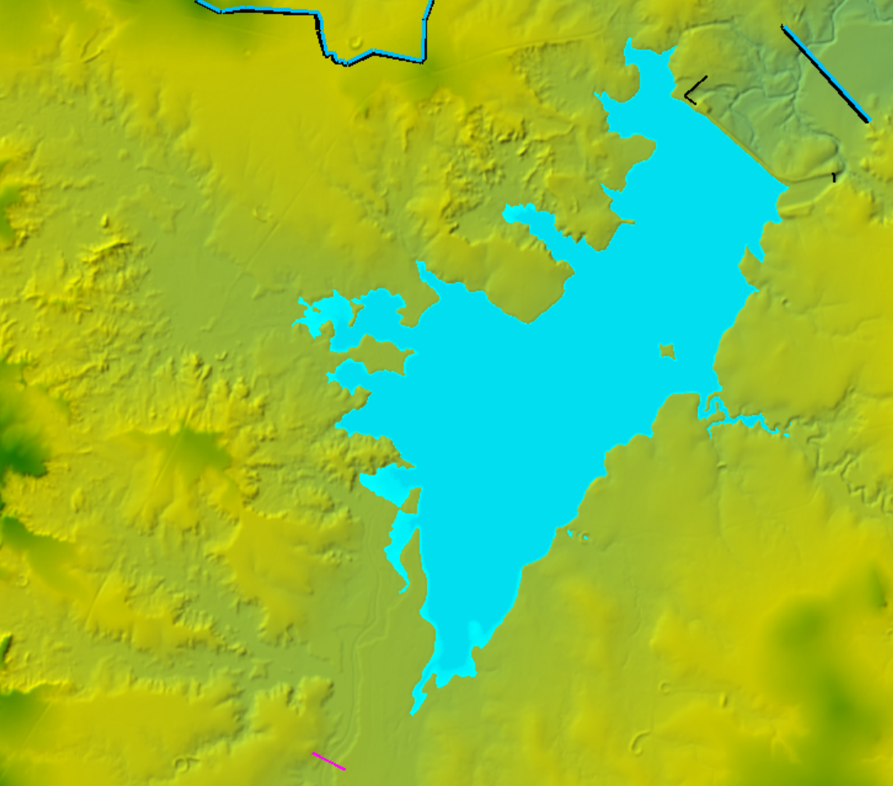
Figure 27: SA/2D Connection SBVR_702_PT1 Near Santa Rosa Lake
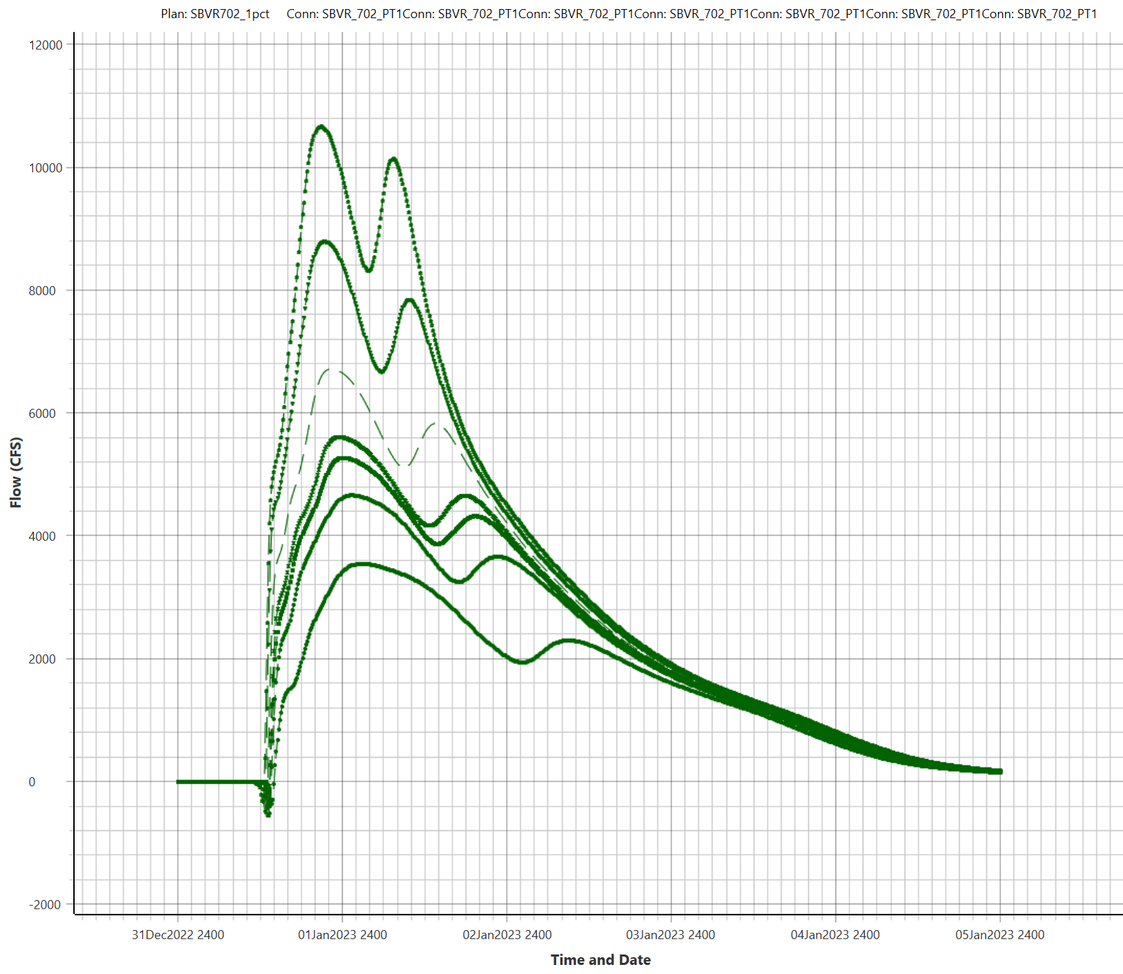
Figure 28: Flow Hydrographs at SA/2D Connection SBVR_702_PT1
Crossing Profiles at Lake Santa Rosa Spillway #1
Lake Santa Rosa and the Santa Rosa Dam are located in domain SBVR_702. Floodwaters leave the lake via two spillways. Spillway #1 is on the south side of the dam, and Spillway #2 is on the north side of the dam.
During the model run for this domain, the stage hydrographs for the 0.2% and the 1% plus events at the outlet structure for Spillway #1 crossed one another at the spillway outlet, which was modeled using SA/2D connection Outflow1_BVR_702. See Figure 29 for the crossing profiles. The stage hydrographs are shown in blue and the flow hydrographs are shown in green.
This issue affects only the 0.2% and the 1% plus events. No other profiles cross one another. At its maximum, the 1% plus stage is only 0.12 feet higher than the 0.2% stage. Several modeling scenarios were tested to eliminate the crossing profiles, but none of them resolved the crossing profiles. Although a shorter time step might eliminate the crossing profiles, the time step was not shortened in order to maintain a consistent time step in all of the BLE models for this watershed. Another reason the time step was not shortened is that it would have increased the model run times for minimal benefit, which was not desirable. Since these crossing profiles did not affect the flow hydrographs and since the 1% plus event is a statistical event that is not mapped, the crossing profiles were considered acceptable in this BLE model.
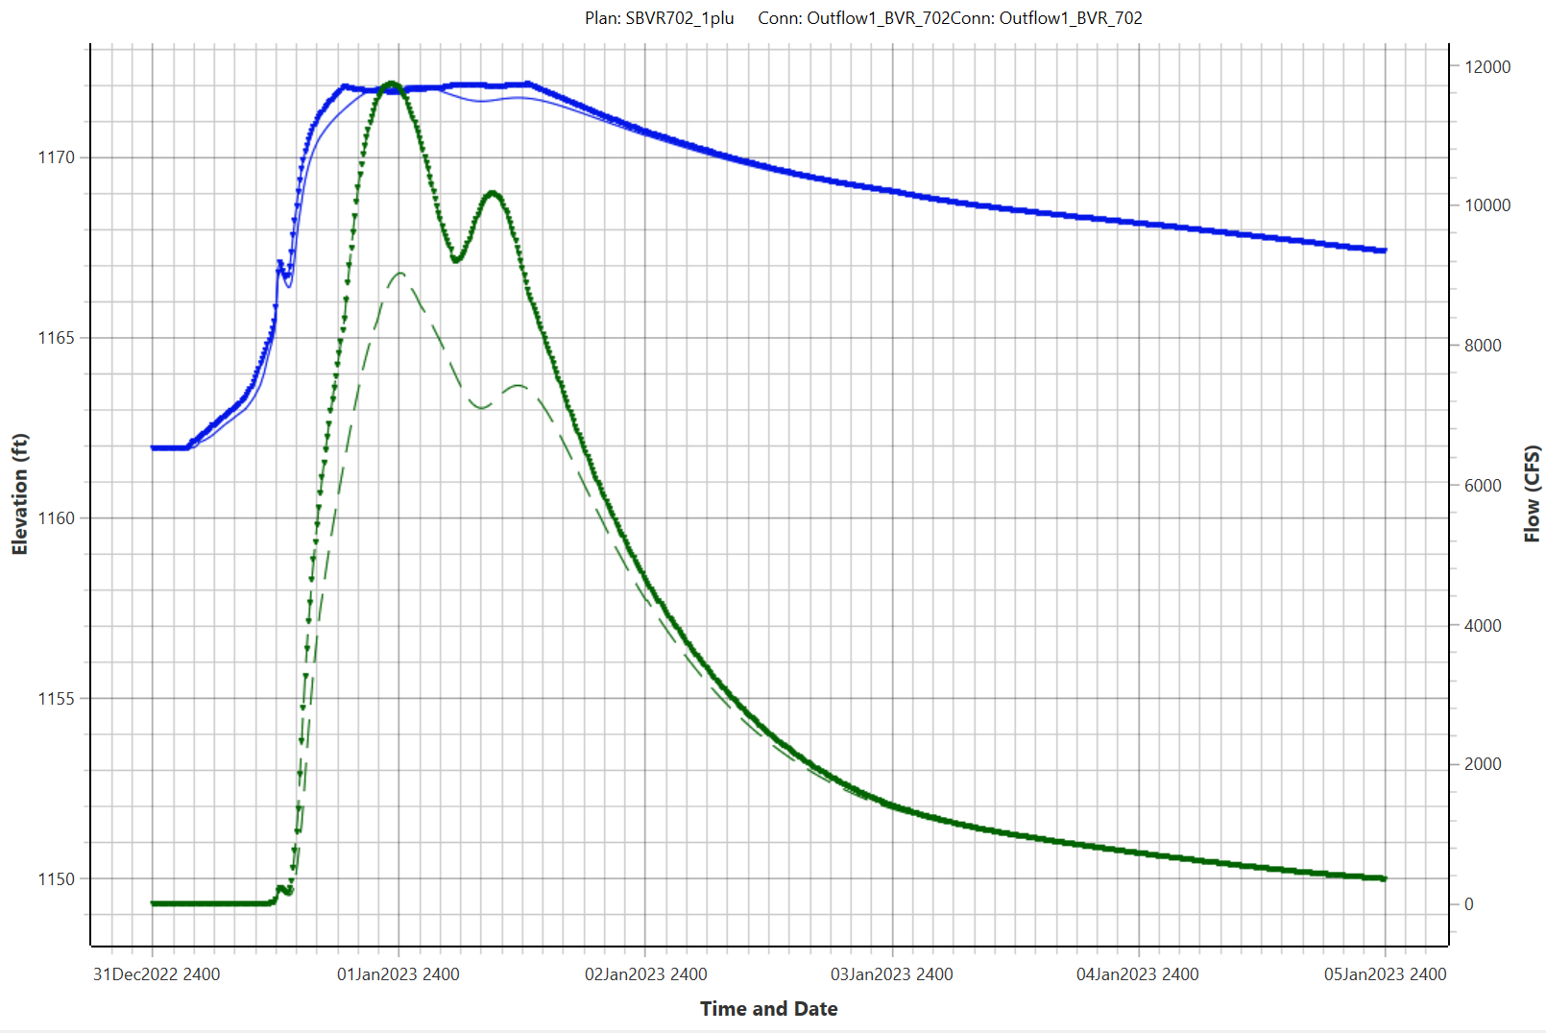
Figure 29: Stage and Flow Hydrographs at SA/2D Connection Outflow1_BVR_702

Results and Recommendations
The BLE floodplain mapping for the Southern Beaver watershed compared reasonably well with the effective Special Flood Hazard Area (SFHA) in most cases and provides an estimated 1% annual-chance floodplain in areas currently not mapped by FEMA. These results provide context for flood risk communication as part of the Discovery process and should be verified through community work map meetings before application to a regulatory product.
A map showing the BLE results for the Southern Beaver watershed has been included as Appendix A.
The BLE floodplains were compared with the effective floodplains in the Southern Beaver watershed. Digitized mapping was available in the National Flood Hazard Layer (NFHL) for the watershed in Wichita County. A comparison of the FEMA mapping with the BLE 1% boundaries revealed that the BLE floodplains exhibited generally good agreement with the effective mapping, as shown in Figure 30.
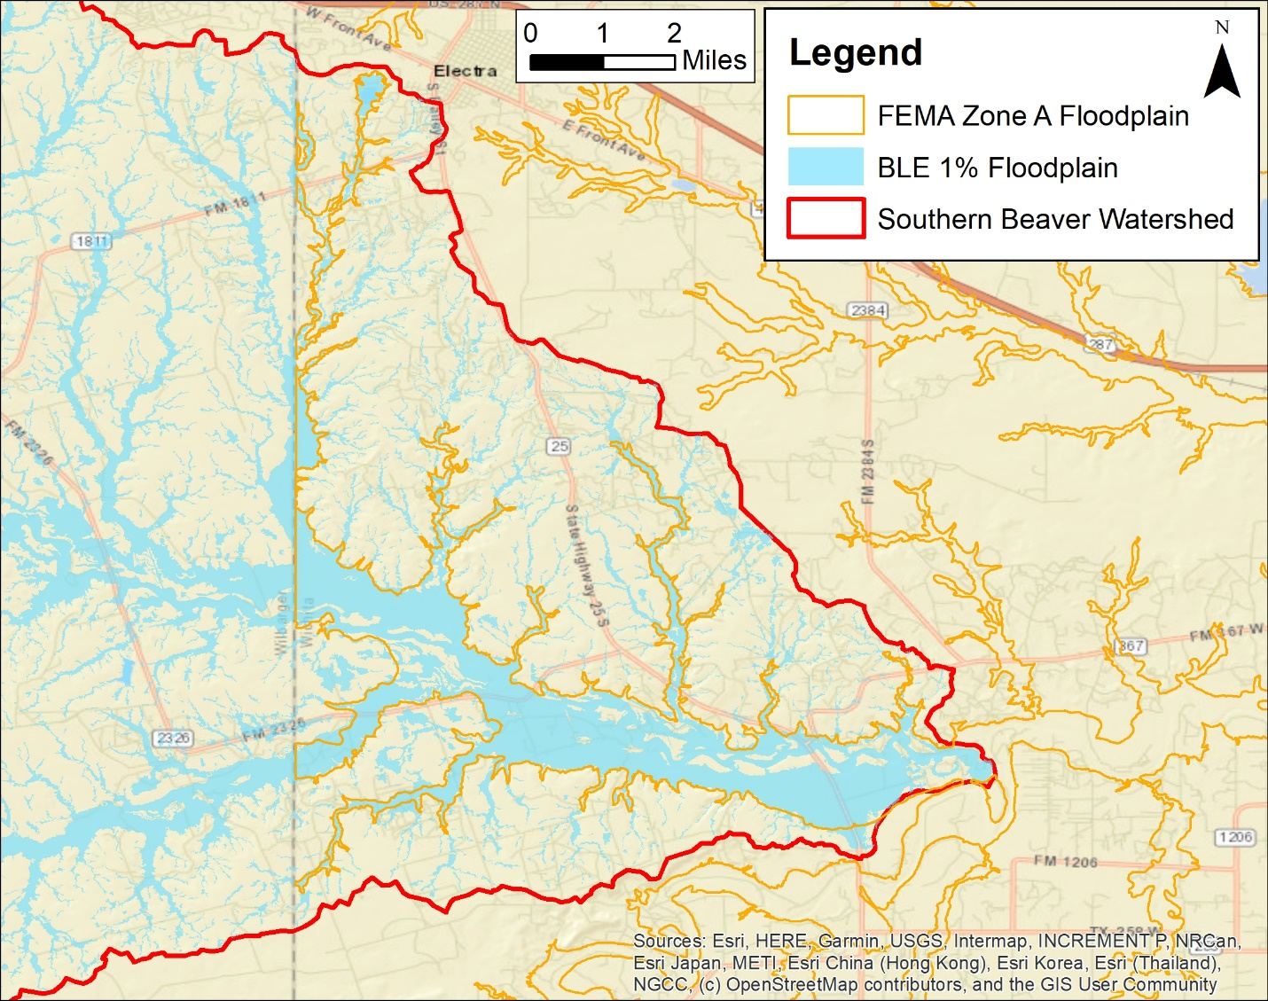
Figure 30: The Effective 1% Floodplain and the 1% BLE Floodplain in Wichita County, TX
Floodplain mapping for the Southern Beaver watershed was also available from a contractor called Fathom. The TWDB acquired cursory floodplain data from Fathom to fill gaps in areas where no floodplain mapping was available in Texas. The Fathom floodplain dataset included pluvial, fluvial, and coastal storm surges produced using models developed at a 30-meter resolution for the entire state of Texas. The 30-meter Fathom models incorporated LiDAR data provided by the TWDB and NOAA Atlas 14 rainfall data in all areas of the state. Fathom model results were mapped to a 3-meter resolution. Fluvial and pluvial cells with depths less than 0.5 feet were removed from the results of the mapping dataset. The use of this dataset should be limited to areas where no other data source has been identified or areas where flood hazard information is outdated or unreliable. Limited use of this dataset is recommended due to limitations with accuracy, resolution, and age of the underlying datasets.
The 2D BLE results for the Southern Beaver watershed were compared with the Fathom floodplain mapping. Figure 31 shows the 1% BLE mapping in blue with a transparency applied and the 1% Fathom mapping in black in the same area that is shown in Figure 30. In general, there was good agreement between the mapping from these two sources. However, there are examples of pluvial mapping in the figure that are more extensive in the BLE mapping than in the Fathom mapping.
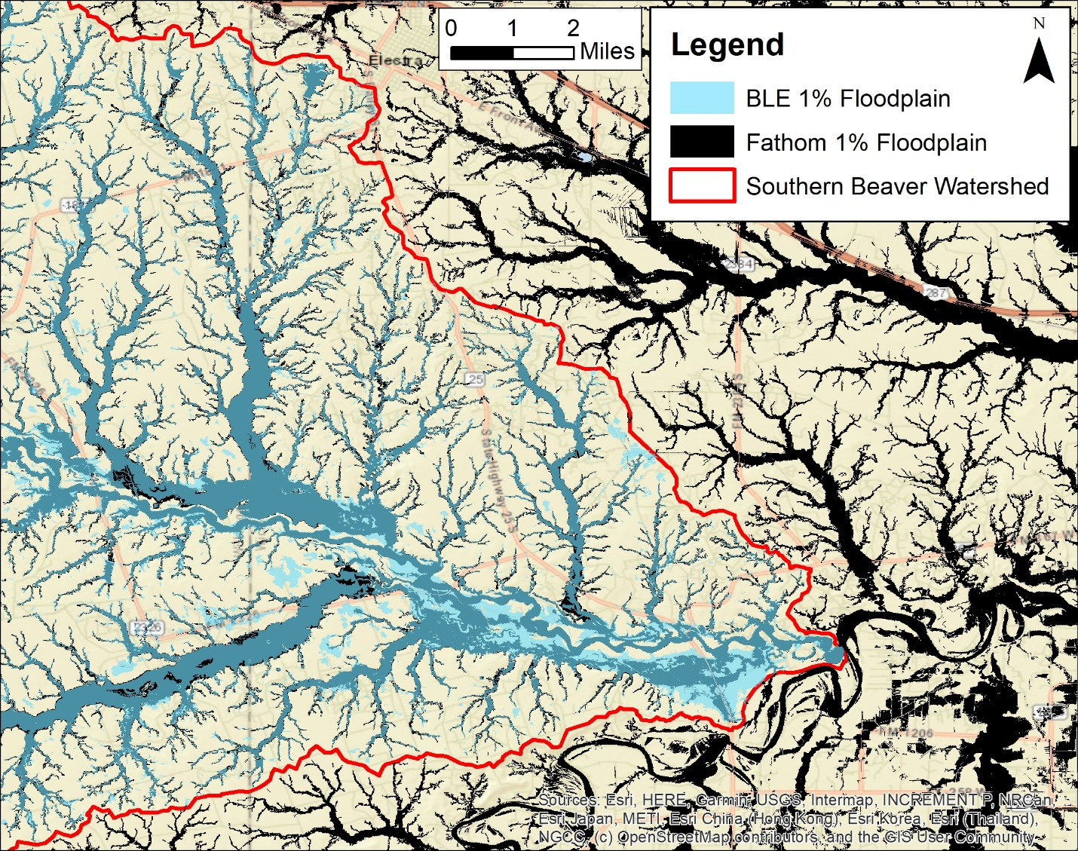
Figure 31: Comparison of 1% BLE Mapping with Fathom 1% Mapping
As part of the BLE assessment effort, a polygon file was prepared to detail areas where model refinements may be warranted. These areas may be found in the feature class S_AOMI_AR in the mapping database.

Quality Control
To guide its quality control (QC) reviews, AtkinsRéalis developed three custom QC checklists for its TWDB 2D BLE studies. The checklists were for the terrain processing, the modeling, and the mapping tasks. The terrain processing checklist included 17 items and the modeling checklist included 51 items. The mapping checklist included 20 checks for the spatial data and 244 checks for the attributes in the mapping database. These robust checklists documented the QC review process, capturing reviewer comments and originator feedback throughout the comment resolution process. Checklists were not considered final until reviewed and approved by project leadership.
A major component of the QC process was an automated check that identified locations where the 1% annual-chance WSELs were crossed by another frequency or by the 1% plus or 1% minus profile. Significant effort was made to reasonably resolve all of these instances.
An Independent Technical Review (ITR) was completed on all BLE deliverables by a representative of the TWDB. AtkinsRéalis resolved all ITR comments prior to uploading the project deliverables to the MIP.

CNMS Validation of Effective Zone A Special Flood Hazard Area
Most of the Zone A streams (33.6 miles) in the Southern Beaver watershed were classified as “UNVERIFIED” with a status type of “BEING STUDIED.” The remaining 29.9 miles of Zone A streams were classified as “VALID” with a status type of “BEING STUDIED.”
Initial Assessment A1 – Significant Topography Update Check
This check involved determining whether a topographic data source was available that was significantly better than that used for the effective Zone A modeling and mapping. For the Southern Beaver watershed, USGS 1:24,000-scale topographic maps were used for the effective Zone A analysis. The LiDAR data used in the BLE analysis was a significant improvement over the effective data. Therefore, the A1 check failed for all effective Zone A reaches.
Initial Assessment A2 – Check for Significant Hydrology Changes
This check involved first determining whether regression equations were used in the effective study. If they were, then it was determined whether new regression equations had become available since the date of the effective Zone A study. If newer regression equations existed for the area of interest, then an engineer determined whether these regression equations would significantly affect the 1% annual-chance flow. The effective hydrologic analysis was not based on a regression analysis, therefore the A2 check was set to pass.
Initial Assessment A3 – Check for Significant Development
This check involved using the National Urban Change Indicator (NUCI) dataset to assess increased urbanization in the HUC-12 watersheds with Zone A studies. If the percentage of urban area within the watershed containing the effective Zone A study was 15% or more, and had increased by 50% or more since the effective analysis, then the study would fail this check. Although the NUCI data provided year-to-year changes in urbanization, the NLCD also was needed to establish a baseline of urban land cover for this analysis. This watershed is generally rural with few villages, and there has not been significant development in the watershed. A significant development check for the study areas was carried out using the NUCI dataset, which did not meet the urban change criteria. Therefore, the A3 check was set to pass for all reaches.
Table 18: Zone A Initial Assessment Results
Assessment Check | Pass/Fail | Comments/Notes
A1 - Topography | Fail | The LiDAR terrain data is a significant improvement over the terrain data used to develop the effective mapping.
A2 - Hydrology | Pass | The effective hydrologic analysis was not regression based.
A3 - Development | Pass | No significant development has occurred in the study area.
Initial Assessment A4 – Check of Studies Backed by Technical Data
Zone A studies that passed all of the initial assessment checks described above were categorized as “Valid” in the CNMS Inventory when the effective Zone A study was supported by modeling or sound engineering judgment and all regulatory products were in agreement. If the effective Zone A study passed all initial assessment checks but was not supported by modeling, or if the original engineering method used was unsupported or undocumented, then a comparison of the BLE results and effective Zone A mapping was performed. There was no adequate documentation regarding how the engineering analysis supporting the effective study was performed. Therefore, the A4 check was set to fail for all reaches in this study.
Initial Assessment A5 – Comparison of BLE and Effective Zone A Floodplains
The BLE/effective Zone A comparison method leveraged the existing Floodplain Boundary Standard (FBS) certification procedures described in FEMA SID 113, but with a slight modification. This modified FBS comparison approach used the 1% plus and 1% minus flood extents and the horizontal and vertical tolerances described in the CNMS Technical Reference. For the comparison of the BLE mapping and effective Zone A mapping in the study area, the following vertical and horizontal tolerances were used to conduct the modified FBS procedure. These comparisons were made at points spaced at a 100-foot interval along the outer extents of the effective Zone A mapping.
Vertical Tolerance: Plus or minus 5 feet (one-half contour interval of assumed effective topographic source).
Horizontal Tolerance: Plus or minus 75 feet (standard horizontal tolerance for BLE comparison testing).
The terrain data used to complete Initial Assessment A5 was the terrain surface created from the LiDAR data that was acquired for the Southern Beaver BLE analysis.
The contour interval for the vertical tolerance was taken from the USGS 1:24,000-scale topographic maps of the Southern Beaver watershed.
The source of the effective Zone A mapping was FEMA’s NFHL and mapping that was digitized from FEMA’s paper FIRMs.
See Table 20 for a summary of the outcomes of Initial Assessment A5.

CNMS Validation Results
Based on the validation assessments and BLE comparisons described above, the CNMS inventory of the Zone A studies in the Southern Beaver watershed study area has been updated. The total miles in each of these categories are summarized in Table 19 and illustrated on Figure 32. The findings from Initial Assessment A5 are in Table 20.
Table 19: Zone A Validation Results
Validation Status | CNMS Validation Status | CNMS Project Start | CNMS Post-BLE Assessment
VALID | BEING STUDIED | 0 | 29.9
VALID | TO BE STUDIED | 0 | 0
UNVERIFIED | BEING STUDIED | 63.5 | 33.6
UNVERIFIED | TO BE STUDIED | 0 | 0

Table 20: BLE Comparison Results
HUC-12 Watershed |  | Total FBS Points | Fail | Pass | % Pass | BLE Comparison Pass? (>85%)
Watershed Name | HUC-12 ID
111302070101 | City of Crowell-Beaver Creek | 285 | 22 | 263 | 92.3% | Pass
111302070401 | Long Creek | 361 | 76 | 285 | 79.0% | Fail
111302070402 | Bluff Creek-Beaver Creek | 2,572 | 243 | 2,329 | 90.6% | Pass
111302070403 | Short Creek-Beaver Creek | 2,879 | 506 | 2,373 | 82.4% | Fail

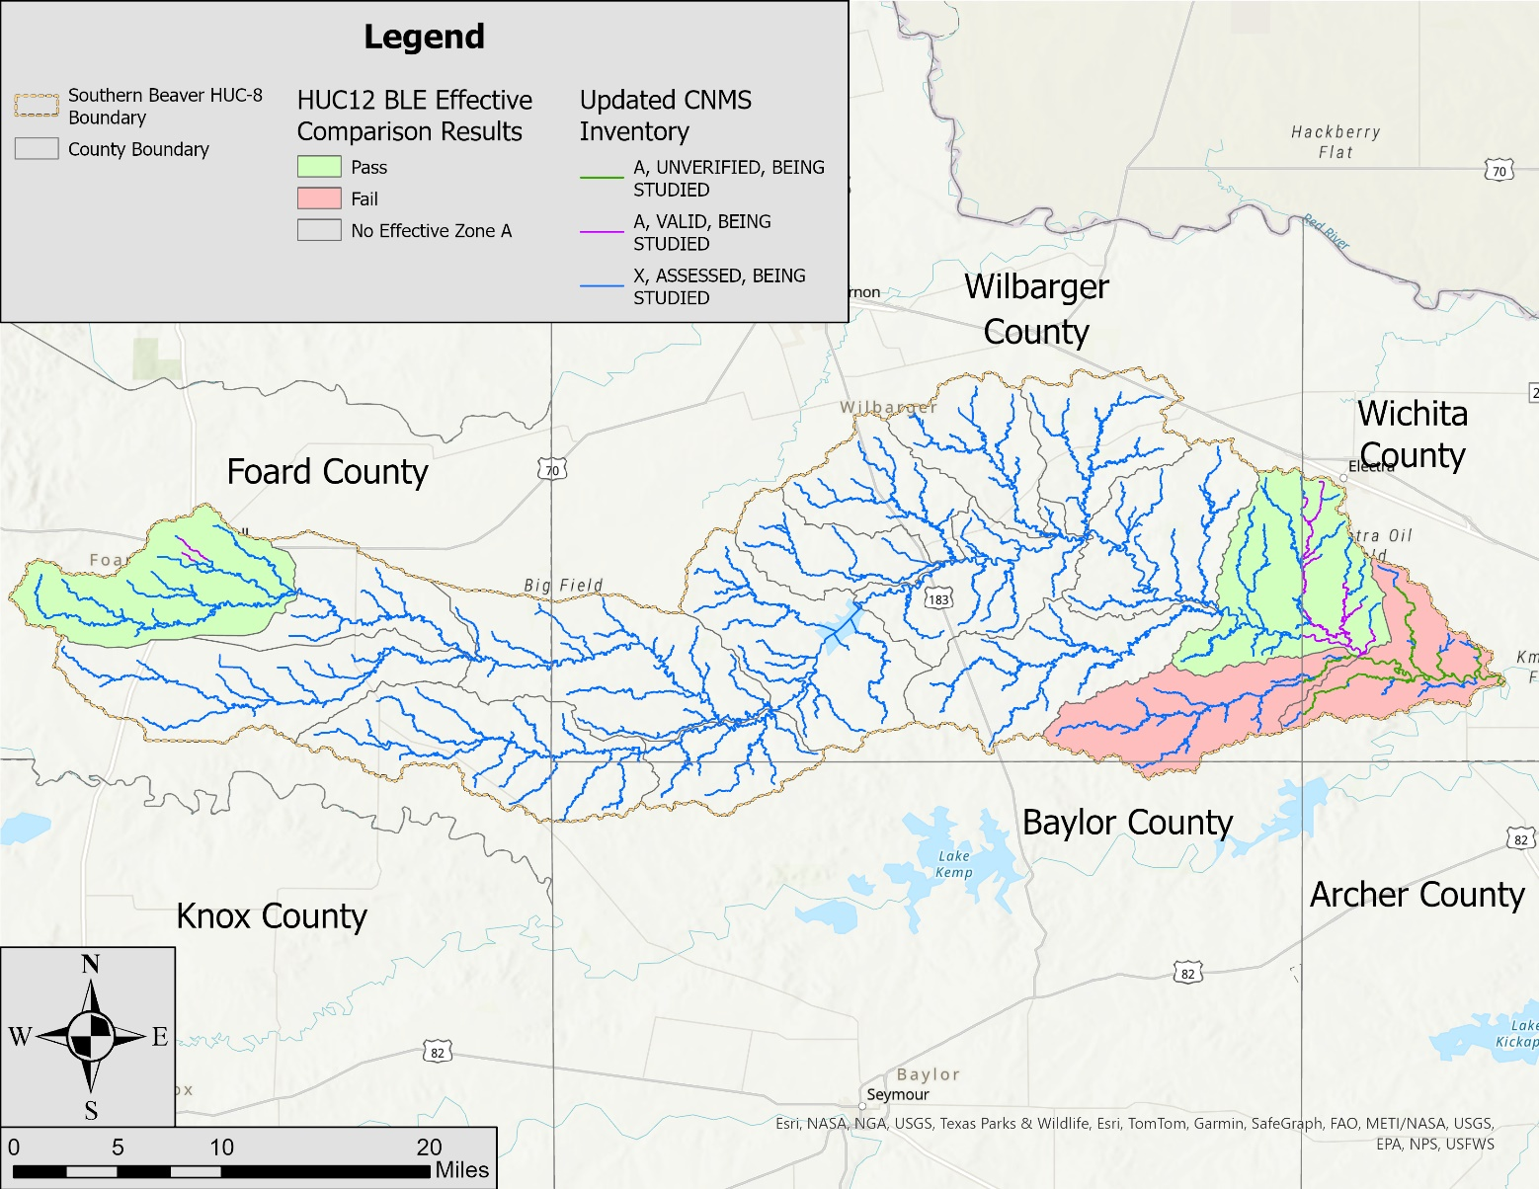
Figure 32: CNMS Validation Results

Flood Risk Analysis
A flood risk analysis was performed for the Southern Beaver watershed. This analysis was completed using Hazus Version 5.1. Flood losses were based on the 1% annual-chance depth grids from the BLE analysis.
Additional inputs for the analysis were as follows.
S_AOMI_Ar
AoMIs are Areas of Mitigation Interest. This polygon feature class is intended to be used as a communication tool to direct users to areas that warrant further investigation or research for possible mitigation. The intent of this coverage area is to allow a visualization and depiction of areas that may be refined in future local, state, regional, or federal modeling efforts.
Areas typically identified by this feature class include:
- Areas of significant land use change – The source of land use data for this BLE assessment was the 2019 NLCD. The land uses captured by this database were compared with the land uses shown in the aerial imagery available in Google Earth when the floodplain mapping was being developed. Areas where the land use had changed significantly since 2019 were documented in the feature class.
- Intersections of significant streams with major roadways – Since structures were not explicitly included in the BLE models, these areas were identified as areas where additional analysis may be useful for refining the outcomes of the BLE study.
Floodplain mapping tie-ins along the HUC-8 watershed boundary – Along the HUC-8 watershed boundaries where AtkinsRéalis completed BLE assessments for both watersheds, the floodplain mapping includes smooth tie-ins across the watershed boundaries. Along those HUC-8 watershed boundaries where AtkinsRéalis did not study both watersheds, the mapping tie-ins could not be smoothed since the BLE floodplain mapping in the neighboring watershed was not available. AoMIs were placed along these HUC-8 watershed boundaries to identify those tie-ins that potentially could be refined by a future modeling effort.
Outputs from the analysis were as follows.
S_FRACT_Ar
This is the flood risk assessment polygon feature class. It is the output for a flood level 2 analysis using Hazus Version 5.1, which is based on a 1% annual-chance depth grid. The calculated loss results from Hazus are stored in the polygon feature and are based on dasymetric census blocks. Dasymetric census blocks have had additional “undeveloped” land areas (primarily wetlands and forest) clipped out of the original census block boundaries based on USGS land use/land cover data. Loss values are reported in whole dollar amounts. See Table 21 below for a summary of the losses computed by Hazus. Note that the full replacement loss (total loss) column is limited to those structures in the 1% floodplain while the dollar exposure columns considered all structures in the watershed.
L_Source_Cit
The data sources used for S_AOMI_Ar are documented in the L_Source_Cit table.
Table 21: Hazus Results for the Southern Beaver Watershed
County | Full Replacement –  Total Loss | Dollar Exposure (Replacement  Value) - Buildings | Dollar Exposure (Replacement  Value) - Contents
Baylor County | $1,907,000,000 | $4,683,000,000 | $4,538,000,000
Foard County | $48,898,000,000 | $125,516,000,000 | $77,187,000,000
Wichita County | $1,178,000,000 | $63,545,000,000 | $42,685,000,000
Wilbarger County | $8,985,000,000 | $27,100,000,000 | $20,446,000,000
Total | $60,968,000,000 | $220,844,000,000 | $144,856,000,000

References
This section includes a bibliographic list of the documents referenced throughout this document or used during the preparation of the BLE analysis.
- Chow, Ven T. Open Channel Hydraulics. Caldwell, NJ: Blackburn, 1959. Development of Uniform Flow and Its Formulas, pages 109-113. Print.
- Federal Emergency Management Agency (FEMA). Base Level Engineering – Region 6 Submittal Guidance, Version 6. July 2021. PDF.
- Federal Emergency Management Agency (FEMA). Coordinated Needs Management Strategy (CNMS) Technical Reference. November 2021. Web. https://www.fema.gov/flood-maps/guidance-reports/guidelines-standards
- Federal Emergency Management Agency (FEMA). National Flood Hazard Layer (NFHL). Web. https://hazards-fema.maps.arcgis.com/apps/webappviewer/index.html?id=8b0adb51996444d4879338b5529aa9cd
- Natural Resources Conservation Service. Gridded Soil Survey Geographic Database (gSSURGO). 2021 version. Web. https://data.nal.usda.gov/dataset/gridded-soil-survey-geographic-database-gssurgo
- Sanja Perica, Sandra Pavlovic, Michael St. Laurent, Carl Trypaluk, Dale Unruh, Orlan Wilhite. NOAA Atlas 14 Volume 11 Version 2, Precipitation-Frequency Atlas of the United States, Texas. 2018. NOAA, National Weather Service, Silver Spring, MD.
- Texas Water Development Board (TWDB). Texas Two-Dimensional Base Level Engineering Guidelines, Version 1.0. May 21, 2022. PDF.
- United States Army Corps of Engineers (USACE). Hydrologic Engineering Center-River Analysis System (HEC-RAS), Version 6.3.1. September 30, 2022.
- United States Geological Survey (USGS). Multi-Resolution Land Characteristics Consortium. National Land Cover Database 2019. https://www.mrlc.gov/data/nlcd-2019-land-cover-conus
- United States Geological Survey (USGS). Panhandle LiDAR, 2018-05-20. Web. https://apps.nationalmap.gov/downloader/
- United States Geological Survey (USGS). Texas West Central LiDAR, 2018-05-27. Web. https://apps.nationalmap.gov/downloader/
- William H. Asquith, Meghan C. Roussel. Regression Equations for Estimation of Annual Peak-Streamflow Frequency for Undeveloped Watersheds in Texas Using an L-moment-Based, PRESS-Minimized, Residual-Adjusted Approach. USGS Scientific Investigations Report 2009-5087. June 2009.

Appendix A: Base Level Engineering Results
