

Base Level Engineering Report
Buchanan-Lyndon B Johnson Lakes (12090201)
January 31, 2025
Version 1.0

Report Prepared for: Report Prepared by:
Texas Water Development Board AtkinsRéalis USA, Inc.
1700 North Congress Avenue 11801 Domain Boulevard
Austin, TX 78701 Suite 500
Austin, TX 78758
Document History
Document Storage Location
K:/FY2022/22-06-0047S/Hydraulics – BLE|FY21|Buchanan-Lyndon B Johnson Lakes (12090201)
Revision History
Version No. | Version Date | Summary of Changes | Author
1.0 | January 31, 2025 | Initial Report for Estimated Base Flood Elevation Viewer | AtkinsRéalis USA, Inc.

FINAL REPORT FOR Buchanan-Lyndon B Johnson Lakes (12090201)
PREPARED FOR:



Prepared By:

AtkinsRéalis USA, Inc.



Table of Contents
Page
Executive Summary 1
1.0 Base Level Engineering (BLE) Methodology 3
1.1 Topographic Data 4
1.1.1 Development of the Seamless HUC-8 Digital Elevation Model (DEM) 4
1.1.2 Development of the Stream Networks and Drainage Basins 7
1.2 Hydrologic and Hydraulic Analysis 8
1.2.1 Total Precipitation 10
1.2.2 Infiltration Losses 10
1.2.3 2D Computational Mesh 13
1.2.4 Model Boundary Conditions 14
1.2.5 Reservoir Modeling 18
1.2.6 Computation Settings 28
1.2.7 Regression Analysis 28
1.2.8 Gage Analysis 30
1.2.9 Model Validation 30
1.3 Floodplain Delineation (10%, 1%, and 0.2% events) 44
2.0 Challenges 48
3.0 Results and Recommendations 54
3.1 Quality Control 57
3.2 CNMS Validation of Effective Zone A Special Flood Hazard Area 58
3.3 Flood Risk Analysis 62
4.0 References 64
Appendices:
A Base Level Engineering Results
B Supporting Documentation

List of Tables
Page
Table 1: Summary of Stream Miles 2
Table 2: Zone A Validation Results 2
Table 3: Topographic Data Sources 6
Table 4: Reported and Computed Drainage Areas at Each USGS Gage 8
Table 5: AMC II Curve Number Values 11
Table 6: AMC I Curve Number Values 12
Table 7: Manning’s n Values for Overland and Overbank Areas 13
Table 8: Upstream and Downstream Discharges and WSELs at the Outlet of Domain 0101_A1 16
Table 9: Upstream and Downstream Discharges and WSELs at the Outlet of Domain 0101_A2 17
Table 10: Upstream and Downstream Discharges and WSELs at the Outlet of Domain 0103_A4 17
Table 11: Upstream and Downstream Discharges and WSELs at the Outlet of Domain 0103_A5 17
Table 12: WHA RFA Frequency-Stage-Outflow Table for Lake Buchanan 21
Table 13: HEC-HMS Peak Outflow Data for Lake LBJ Outlet from the InFRM WHA 23
Table 14: RFA Stage-Frequency-Outflow Data for Lake LBJ from the InFRM WHA 24
Table 15: Summary of USGS Gage Stations across the Buchanan-LBJ lakes Watershed 30
Table 16: Summary of Parameter Adjustments Made in the Buchanan-LBJ Lakes Watershed 33
Table 17: Summary of the Model Validation Process for Domain 0101_A1 34
Table 18: Comparison of 1% BLE, Gage, and Effectives Flows in the Buchanan-LBJ Lakes Watershed 36
Table 19: Comparison of 1% Effective WSELs and 1% BLE WSELs 37
Table 20: 1% Peak Flow Validation Results for the Buchanan Watershed 39
Table 21: Inland Mapping Threshold Matrix 46
Table 22: InFRM Gage Analysis Summary for USGS Gage 08136700 50
Table 23: Zone A Initial Assessment Results 58
Table 24: Zone A Validation Results 59
Table 25: BLE Comparison Results 60
Table 26: Hazus Results for the Buchanan-LBJ Lakes Watershed 63

List of Figures
Figure 1: Buchanan-LBJ Lakes - 12090201 CNMS Validation Results 2
Figure 2: Buchanan-LBJ Lakes Watershed – HUC-8 12090201 4
Figure 3: Topographic Data Extents in the Buchanan-LBJ Lakes Watershed 5
Figure 4: HEC-RAS Terrain Modification at a Culvert Crossing to Allow Flow through a Roadway 7
Figure 5: Buchanan-LBJ Lakes Model Domains and Linkages 9
Figure 6: Extraction of Flow Hydrograph from the SA/2D Connection in the Upstream Domain 15
Figure 7: Application of Upstream Flow Hydrograph in the Downstream Domain 16
Figure 8. Model Configuration Near Lake Buchanan 20
Figure 9: Domain 0104_A6 Inflow Hydrographs for Colorado River 21
Figure 10. Lake LBJ model configuration 22
Figure 11: Wirtz Dam (Lake LBJ) SA/2D Connection Setup 24
Figure 12: 1% AEP Inflows applied to Lake LBJ 25
Figure 13: BLE Stage-Outflow Data for the 0.2 Event at Connection 0104_A6_Outfall 27
Figure 14: HEC-RAS Unsteady Computation Options and Tolerances 28
Figure 15: Regression Equations for the Buchanan-LBJ Lakes Watershed 29
Figure 16: Typical Antecedent Moisture Conditions in Texas 32
Figure 17: Computed Flow vs Drainage Area for Select 1% BLE, Regression, FIS, and Gage Flows 38
Figure 18: Example of Overlapping Mapping along a Model Domain Boundary 45
Figure 19: WSEL Difference Raster and Split Line for the Overlap Area 46
Figure 20: An Example of Cupping in 2D BLE Mapping 49
Figure 21: Crossing Hydrographs at the Outlet of the Middle Colorado HUC-8 Watershed 50
Figure 22: Layout of BC Line 3 in Domain 0102_A3 52
Figure 23: Crossing Stage Hydrographs at BC Line 3 in Domain 0102_A3 52
Figure 24: Comparison of the 1% BLE Mapping with the FEMA SFHA Mapping along Sandy Creek 54
Figure 25: Comparison of the 1% BLE Mapping with the FEMA SFHA Mapping along the Colorado River 55
Figure 26: Comparison of the 1% BLE Mapping with the Fathom Mapping 57
Figure 27: CNMS Validation Results 61

Executive Summary
The Texas Water Development Board (TWDB) contracted with AtkinsRéalis USA, Inc. (AtkinsRéalis) to complete two-dimensional (2D) Base Level Engineering (BLE) in the Buchanan-Lyndon B Johnson (LBJ) Lakes HUC-8 watershed (12090201). This watershed is located in Central Texas, northwest of Austin, between Goldthwaite and Horseshoe Bay, Texas. The watershed area is 1,274 square miles (mi²). Approximately 1,203 miles of stream centerlines were modeled. The information produced during this assessment is available on the U.S. Department of Homeland Security’s Federal Emergency Management Agency’s (FEMA) Mapping Information Platform (MIP) under case number 22-06-0047S.
The following guidance documents provided the methodologies for this project:
- Base Level Engineering – Region 6 Submittal Guidance (FEMA, January 2019)
- Base Level Engineering – Region 6 Submittal Guidance – Appendix A: 2-D Base Level Engineering Guidance (FEMA, January 2019)
- Texas Two-Dimensional Base Level Engineering Guidelines, Version 1.0 (TWDB, May 2022)
Light Detection And Ranging (LiDAR) topographic data available for download from the Texas Natural Resources Information System (TNRIS) were leveraged to build a 3D terrain surface for the watershed.
The hydrologic and hydraulic modeling was completed using the U.S. Army Corps of Engineers’ Hydrologic Engineering Center River Analysis System (HEC-RAS), Version 6.2. In accordance with FEMA’s Standard Identification Number (SID) 84, the 10%, 4%, 2%, 1%, 0.2%, 1% plus, and 1% minus annual-chance events were simulated. Precipitation data from the National Oceanic and Atmospheric Administration’s (NOAA) Atlas 14 were leveraged to develop the 24-hour rainfall distribution for each event. A rain-on-grid methodology was applied to distribute the rainfall across the extents of the 2D hydraulic model area. Infiltration losses were computed using the Natural Resources Conservation Service’s (NRCS) Curve Number (CN) loss rate method.
The Buchanan-LBJ Lakes watershed was divided into six HEC-RAS model domains — 0101_A1, 0101_A2, 0102_A3, 0103_A4, 0103_A5, and 0104_A6. Per TWDB guidance, a 200-foot by 200-foot nominal cell spacing was used for the 2D area and a finer 100-foot by 100-foot cell spacing was used along the breaklines and within the refinement regions. Breaklines were added to capture roadways, railroads, dam crests, and embankments to force the terrain surface to drain properly. Refinement regions were defined in and near urban areas, major reservoirs, and dam overflow areas to enhance the identification of the flood hazards in these higher-risk areas.
Model results were validated using stream gage data, regression flows, effective FEMA data, and outcomes from other studies in the project area.
Floodplain mapping was developed for the 10%, 1%, and 0.2% annual chance events. Raw mapping output from HEC-RAS was post-processed to delineate floodplains that aligned with the TWDB’s 2D BLE mapping standards.
A summary of FEMA’s Coordinated Needs Management Strategy (CNMS) data for the Buchanan-LBJ Lakes watershed is in Table 1 and Table 2 and shown on Figure 1.
Table 1: Summary of Stream Miles
Source | Stream Miles
Current Inventory - CNMS | 581.6
New Study Streams - CNMS | 620.9
Total (BLE) Stream Miles | 1,202.5

Table 2: Zone A Validation Results
Validation Status | CNMS Validation Status | CNMS Project Start | CNMS Post-BLE Assessment
VALID | NVUE COMPLIANT | 0 | 0
VALID | BEING STUDIED | 173.2 | 59.4
UNVERIFIED | BEING STUDIED | 9.9 | 396.6
UNVERIFIED | TO BE STUDIED | 272.4 | 0

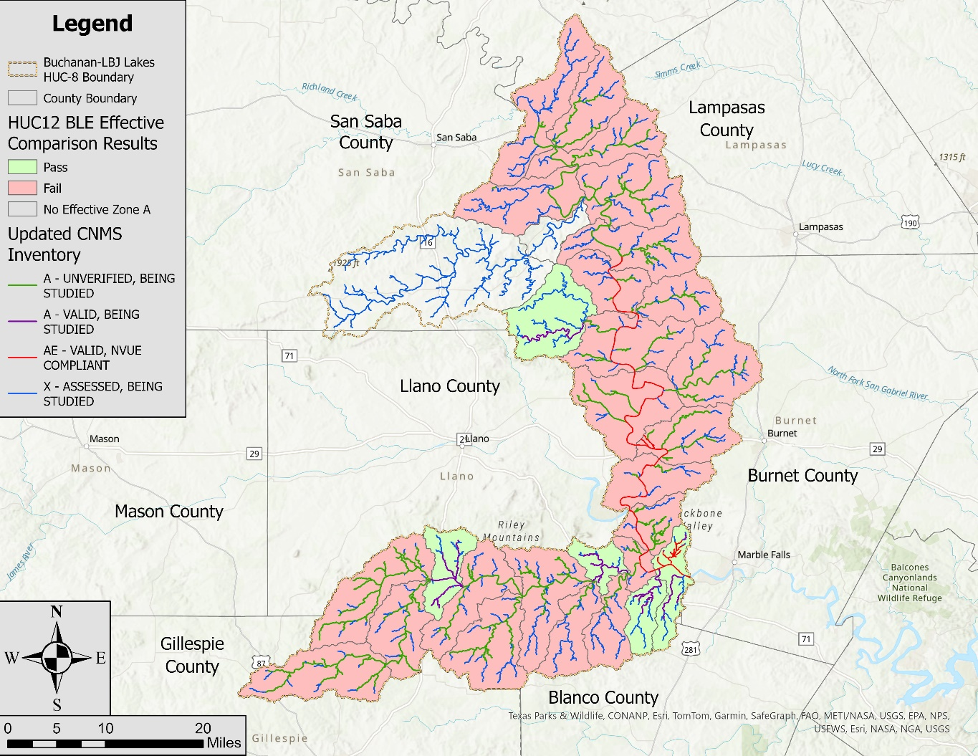
Figure 1: Buchanan-LBJ Lakes - 12090201 CNMS Validation Results

Base Level Engineering (BLE) Methodology
Recent innovations and increased efficiency in floodplain mapping have allowed FEMA to develop a process called BLE, which can be used to address current program challenges, including the validation of Zone A studies and the availability of flood risk data in the early stages of a Flood Risk Project. The BLE process involves using best available data and incorporating automated techniques with traditional model development procedures to produce regulatory-quality flood hazard boundaries for the 1% annual chance event, as well as estimates of flood hazard boundaries for multiple recurrence intervals. The cost for developing the data and estimates resulting from the BLE process are lower than standard flood production costs. The BLE results may be used for eventual production of regulatory and non-regulatory products.
As described in Title 42 of the Code of Federal Regulations, Chapter III, Section 4101(e), once every 5 years, FEMA must determine whether the information on its Flood Insurance Rate Maps (FIRMs) reflects the current risks in flood-prone areas. FEMA makes this determination of flood hazard data validity by examining flood study attributes and change characteristics, as specified in the Validation Checklist of the CNMS Technical Reference. The CNMS Validation Checklist provides a series of critical and secondary checks to determine the validity of flood hazard areas studied by detailed methods (e.g., Zone AE, AH, or AO). While the critical and secondary elements in CNMS provide a comprehensive method of evaluating the validity of Zone AE studies, a cost-effective approach for evaluating Zone A studies has been lacking.
In addition to the need for Zone A validation guidance, FEMA standards require flood risk data to be provided in the early stages of a flood risk project. FEMA Program SID 29 requires that during the Discovery process, data must be identified that illustrates potential changes in flood elevation and mapping that may result from the proposed project scope. If available data does not clearly illustrate the likely changes, then an analysis is required that estimates the likely changes. This data and any associated analyses should be shared, and the results should be discussed with stakeholders.
An important goal of the BLE process is the scalability of the results. Scalability means that the results of a BLE analysis cannot only be used for CNMS evaluations of Zone A studies, but can also be leveraged throughout the Risk MAP program. The data resulting from a BLE analysis can be updated as needed and used for the eventual production of regulatory and non-regulatory products, outreach and risk communication, and MT-1 processing. Leveraging this data outside the Risk Mapping, Assessment, and Planning (Risk MAP) program may also be valuable to external stakeholders.
The TWDB contracted with AtkinsRéalis to complete a BLE analysis for the Buchanan-LBJ Lakes watershed (HUC-8 12090201). The watershed is mostly rural and the land is predominantly used for farming and ranching. The watershed is located within Blanco, Burnet, Gillespie, Lampasas, Llano, Mills, and San Saba counties. Parts of the cities of Burnet, Cottonwood Shores, Granite Shoals, Highland Haven, Horseshoe Bay, Lometa, and Sunrise Beach Village and the town of Round Mountain reside in the watershed. From upstream to downstream, Lake Buchanan, Inks Lake, and Lake LBJ are major reservoirs in the watershed along the Colorado River. See Figure 2 for a map of the Buchanan-LBJ Lakes watershed.
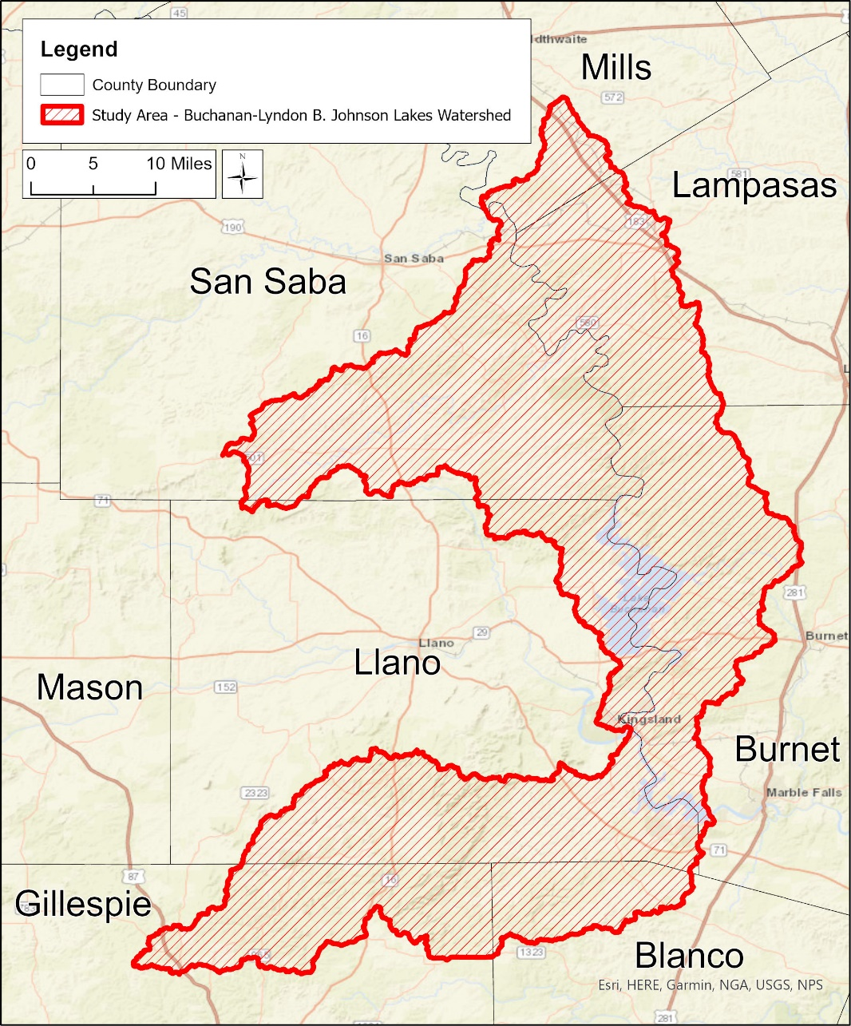
Figure 2: Buchanan-LBJ Lakes Watershed – HUC-8 12090201
The BLE assessment prepared a cursory engineering analysis for approximately 1.203 miles of stream reaches within the Buchanan-LBJ Lakes watershed, with a minimum drainage area tolerance of 1 mi². The selection and extent of the stream reaches studied were based on the number of stream miles meeting the minimum drainage area of 1 mi² and not the number of effective Zone A stream miles. Study reaches were extended above this 1-mi² threshold as appropriate so the entire effective Zone A floodplain received an updated analysis. The following sections summarize the BLE process and discuss the results, along with their recommended use.

Topographic Data

Development of the Seamless HUC-8 Digital Elevation Model (DEM)
The topographic datasets used to develop the terrain surface for the Buchanan-LBJ Lakes watershed were the Bandera & Lampasas Counties, Hurricane, North & Central Texas, and South Central Texas LiDAR collections. These datasets, in the form of Digital Elevation Models (DEMs), were downloaded directly from the TNRIS website. A description of these data sources is in Table 3.
Some of the topographic datasets overlapped one another. Therefore, a priority hierarchy was established to determine which dataset took precedent over the others in the overlap areas. Factors used to establish the hierarchy included the age of the terrain data and its accuracy. This hierarchy is as follows:
- Hurricane
- South Central Texas
- North & Central Texas
- Bandera & Lampasas Counties

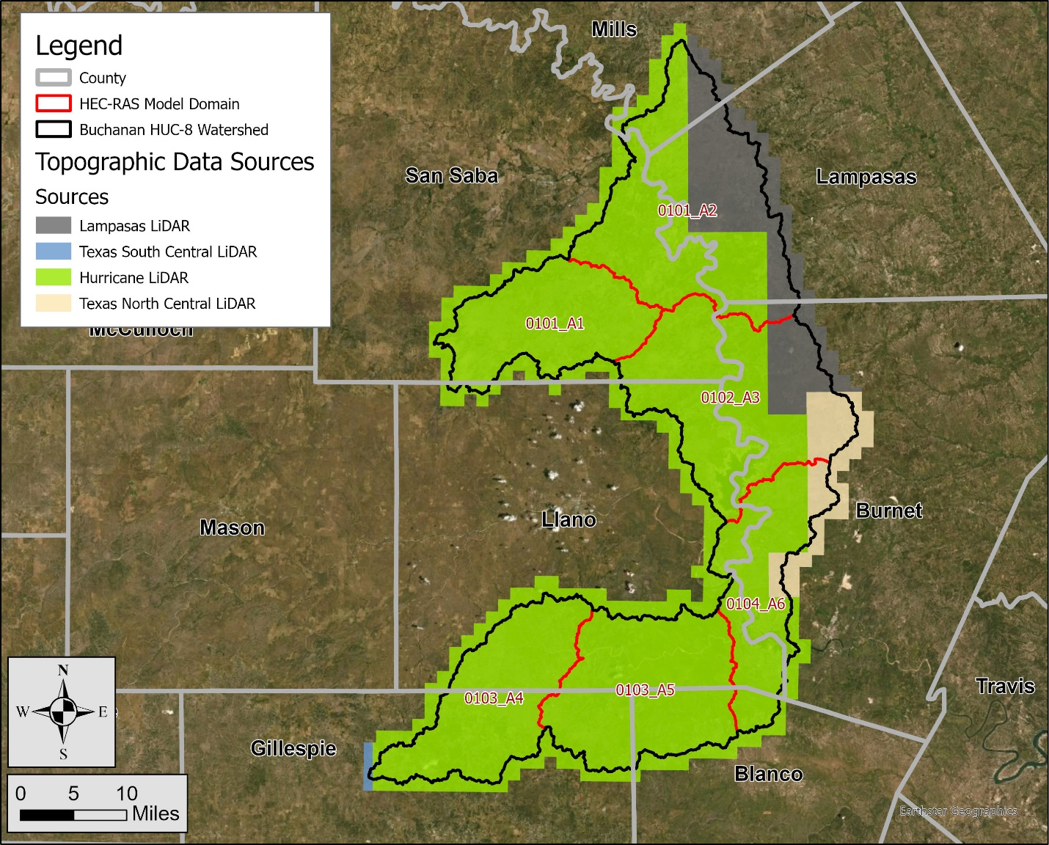
Figure 3: Topographic Data Extents in the Buchanan-LBJ Lakes Watershed
Table 3: Topographic Data Sources
County | Year Acquired | Vertical  Accuracy | Source | Approximate  Footprint (mi²)
Hurricane LiDAR  (Blanco, Burnet, Gillespie, Lampasas, Llano, Mills, and San Saba counties) | 2019 | 3.8 cm | USGS | 1337
South Central Texas LiDAR  (Gillespie County) | 2018 | 5.9 cm | USGS | 4
North & Central Texas LiDAR  (Burnet County) | 2020 | 3.9 cm | StratMap | 76
Bandera and Lampasas Counties LiDAR  (Burnet, Lampasas, and Mills counties) | 2014 | 4.4 cm | StratMap | 197
An overview of each topographic dataset follows. The vertical datum for each dataset was the North American Vertical Datum of 1988 (NAVD 88).
Dataset One – Hurricane LiDAR
The U.S. Geological Survey’s (USGS) Hurricane LiDAR dataset captured in 2019 contains data for 14,512 mi² across 45 counties in Texas. In the Buchanan-LBJ Lakes watershed, this dataset includes parts of Blanco, Burnet, Gillespie, Llano, Lampasas, Mills, and San Saba counties. The vertical accuracy (RMSEz, or root mean square error in the z direction) of this dataset, is 3.8 centimeters (cm). The native cell size of the data is 1 m².
Dataset Two – South Central Texas LiDAR
The USGS’s South Central Texas LiDAR dataset captured in 2018 contains data for 5,329 mi² across 6 counties in Texas. In the Buchanan-LBJ Lakes watershed, this dataset includes part of Gillespie County. The vertical accuracy (RMSEz) of this dataset is 5.9 cm. The native cell size of the data is 1 m².
Dataset Three – North & Central Texas LiDAR
The StratMap North & Central Texas LiDAR dataset captured in 2020 covers approximately 6,330 mi² across 21 counties in Texas. In the Buchanan-LBJ Lakes watershed, this dataset resides within Burnet County. The vertical accuracy (RMSEz) of this dataset is 3.9 cm. The native cell size of the data is 1 m².
Dataset Four – Bandera & Lampasas Counties LiDAR
The StratMap Bandera & Lampasas counties LiDAR dataset captured in 2014 covers approximately 3,054 mi² across 12 counties in Texas. In the Buchanan-LBJ Lakes watershed, this dataset resides within Burnet, Lampasas, and Mills counties. The vertical accuracy (RMSEz) of this dataset is 4.4 cm. The native cell size of the data is 1 m².
The above-mentioned LiDAR data sets were used to create a seamless set of tiled 5-foot DEMs for the Buchanan-LBJ Lakes watershed and a buffered area around the watershed. Each DEM tile measured 6,000 feet by 6,000 feet. This tile size was used because tiles this size can easily be resampled by other users to 1-, 2-, 3-, 5-, 10-, 20-, or 25-foot rasters, since 6,000 is evenly divisible by all of these numbers. A 1,000-meter buffer was included since the watershed divide was outside the HUC-8 watershed extents in some areas. A 5-foot cell size was used in accordance with the 10-foot cell size criterion outlined in FEMA’s Region 6 BLE guidance from 2019. After projecting the terrain into the Texas State Plane Zone 3 (Central) projection (North American Datum [NAD] 1983 [2011]) with units of U.S. feet, the tiles were mosaicked into one DEM. The source and extents of the original DEMs used to create the mosaicked DEM are shown on Figure 3.
No modifications were made to this terrain surface. The goal was to use this terrain ‘as is’ in the hydraulic modeling, floodplain mapping, and grid development tasks. Maintaining the source terrain data in an unmodified state avoids customized changes to the terrain dataset that future users may not be able to replicate. It also reduces the chance of future users applying an outdated version of the terrain. Any changes that were required in the hydraulic model phase were made in the HEC-RAS terrain, not in the processed tiles.

Development of the Stream Networks and Drainage Basins
A hydro-conditioned terrain surface was developed to define the stream networks and drainage basins. A 1,000-meter buffer was applied to the HUC-8 boundary to capture the watershed divide. A 5-meter mosaicked DEM was developed from the source LiDAR data in the same projection as the source data. Using a 5-meter DEM for hydrologic network development maintained sufficient accuracy and produced datasets that were smaller in size and easier to manipulate.
The process for terrain preparation and network and basin delineation is outlined below:
- The flow direction grid, flow accumulation grid, hydrologic stream network, and hydrologic basins were developed.
- Burn lines were defined as needed at roadway/railroad crossings or where reservoirs/ponds artificially diverted the flow path from the natural alignment. The bridge/culvert crossing burn lines developed in this task were subsequently incorporated into the HEC-RAS terrain as terrain modification features. Terrain modifications, when applied, allowed flow through roadways.
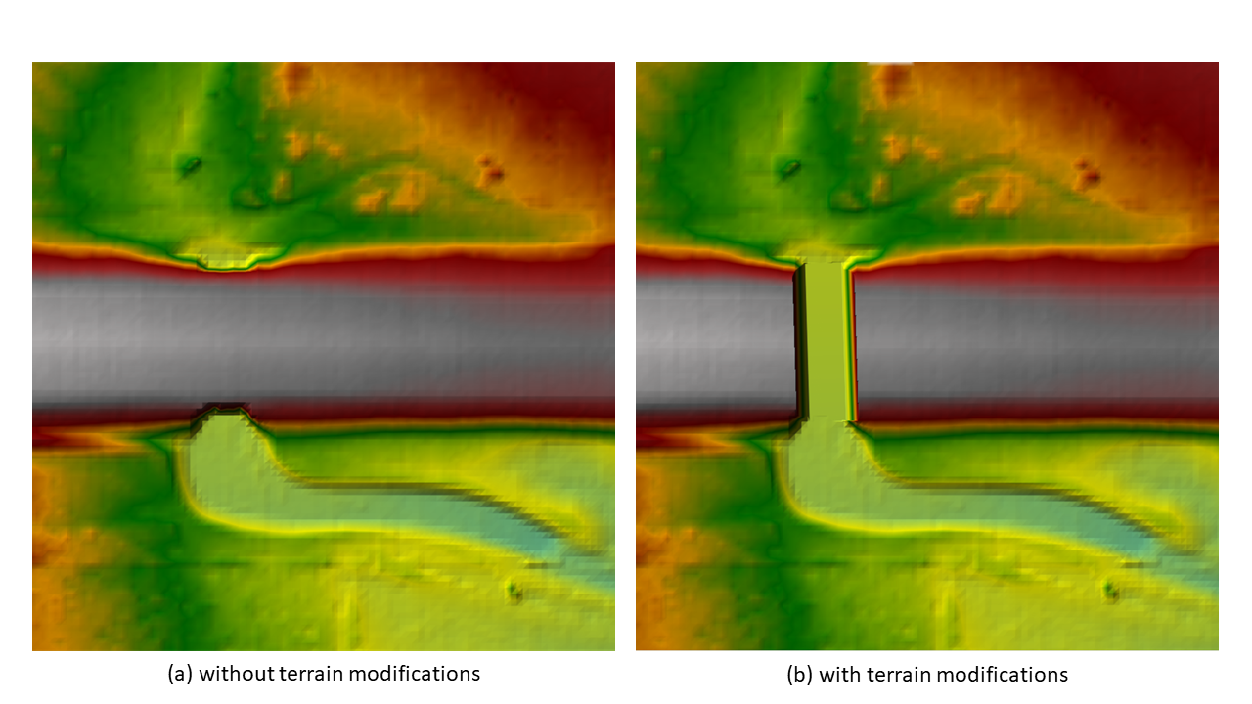
Figure 4: HEC-RAS Terrain Modification at a Culvert Crossing to Allow Flow through a Roadway
- The streamlines and watershed delineations were reviewed and burn lines were continually added and adjusted until the flow paths, basins, and computed drainage areas were reasonable and justifiable.
- A drainage area grid was computed along the flow paths.
- There are two USGS gages with drainage areas greater than 1 mi² in the watershed. The table below summarizes the differences between the reported and computed values for the drainage area. The differences are negligible.
Table 4: Reported and Computed Drainage Areas at Each USGS Gage
USGS Gages |  |  | Computed Values
Site No. | Site Name | Drainage Area (mi²) | Drainage Area (mi²) | Difference
08147000 | Colorado River nr San Saba, TX | 31,217 | 31,218 | 0.0%
08152000 | Sandy Ck nr Kingsland, TX | 346 | 346 | 0.0%
The following information has been placed in the terrain supplemental data folder:
- The computed watershed boundaries at the HUC-8, HUC-10, and HUC-12 levels developed during the terrain processing task.
- The 1-mi² stream network developed during the terrain processing task. These lines represent locations where the drainage area is 1 mi² or greater.
- Additional supporting layers such as roads, NHD waterbodies, and NHD flow lines.

Hydrologic and Hydraulic Analysis
A 2D BLE analysis of the Buchanan LBJ Lakes watershed was completed using HEC-RAS Version 6.2. The analysis applied a rain-on-grid methodology over a 3D terrain. Average basin rainfall was applied to the 2D computational mesh, and losses were computed using the spatially-varied infiltration capabilities of HEC-RAS. In accordance with SID 84, the 10%, 4%, 2%, 1%, 0.2%, 1% plus, and 1% minus annual-chance events were simulated.
Model Layout
The Buchanan-LBJ Lakes watershed was split into six model domains — 0101_A1, 0101_A2, 0102_A3, 0103_A4, 0103_A5, and 0104_A6, as shown on Figure 5. The first 4 numbers in the model domain name are the final 4 numbers in the name of the HUC-10 watershed number. A1, A2, etc. in the model domain name is just a linear naming convention for the domains. Per recommendation from the TWDB, the model domains (work areas) were no larger than roughly 300 mi², which is the size of a typical HUC-10 watershed. The primary reason for having a domain size equal to or smaller than a HUC-10 watershed was to satisfy the assumption that the rainfall across the domain was uniform. The initial model domain boundaries were derived from revised HUC-10 watershed delineations that were established using the LiDAR data. A buffer of 1,000 feet was applied to each HUC-10 watershed boundary to create overlapping domain boundaries. The purpose of the overlap areas was to facilitate clean floodplain and Base Flood Elevation (BFE) transitions between models, to capture the full extent of the floodplain within the watershed, and to minimize the impact of model boundary conditions on model results. At the confluences of model domains, the overlap areas along the main channel were increased in some locations to facilitate tie-ins between model domains.

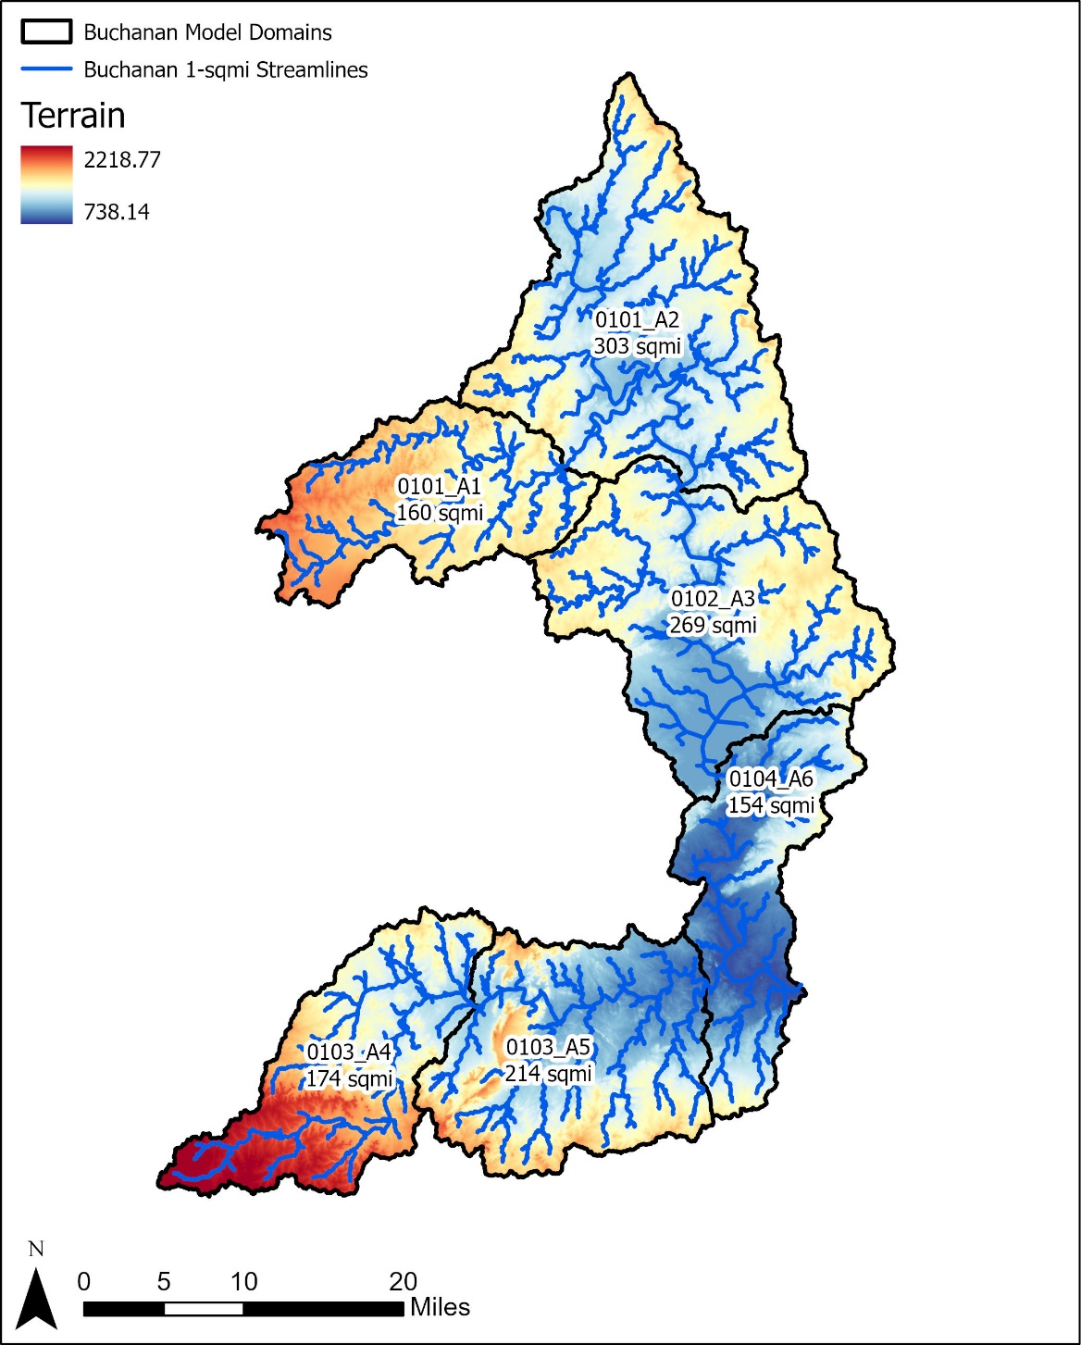
Figure 5: Buchanan-LBJ Lakes Model Domains and Linkages

Total Precipitation
Using NOAA’s Atlas 14 precipitation statistics, an area-averaged precipitation frequency table was computed for each event in each model domain. For all events, a 24-hour rainfall distribution was calculated using an NRCS nested temporal distribution. The NRCS rainfall distribution development methodology is documented in Title 210, Part 630, Chapter 4, Section 630.0407 of the National Engineering Handbook. To create the 24-hour rainfall distribution for an event, the model domain-averaged rainfall totals for the 5-minute, 10-minute, 15-minute, 30-minute, 1-hour, 2-hour, 3-hour, 6-hour, 12-hour, and 24-hour durations were calculated for that event. The ratio of each duration’s precipitation total to the 24-hour duration’s precipitation total was calculated to produce a preliminary symmetric rainfall distribution. These rain ratios were manipulated as described in Section 630.0407 to obtain the final 24-hour rainfall distribution for the event. This process was repeated for all events in the model domain. The results were exported to DSS (data storage system) files for input into the HEC-RAS models.
The 1% plus and 1% minus annual-chance rainfall totals were computed using the approach provided in subsection 2.2.3 of the TWDB’s 2D BLE Guidance Version 1.0 (May 2022). The 1% plus and 1% minus storms were based on the NRCS temporal distribution described in Section 630.0407 of the National Engineering Handbook (August 2019). Additional checks were performed to confirm the 1% plus and 1% minus hyetographs did not cross the hyetographs for other events. The precipitation data used in this study has been included in the supplemental data folder.

Infiltration Losses
The NRCS CN loss rate method was used to account for infiltration losses. A spatially varying infiltration layer for the study area was developed in HEC-RAS by using gridded soils and gridded land cover data sets.
To develop the soils dataset, the 2021 Gridded Soils Survey Geographic (gSSURGO) database was downloaded from NRCS’s website (https://data.nal.usda.gov/dataset/gridded-soil-survey-geographic-database-gssurgo). The SSURGO database contained hydrologic soil type information, which was used to develop the gridded soils layer in HEC-RAS.
To develop the land cover dataset, the 2019 National Land Cover Database (NLCD) was downloaded from the Multi-Resolution Land Characteristics Consortium (MRLC) website (https://www.mrlc.gov/data/nlcd-2019-land-cover-conus). The land cover dataset provided land use classification codes and the extent of each land use. This information was used to create the gridded land cover dataset.
The infiltration layer was created in HEC-RAS by combining the soils and land cover gridded datasets. The CN values required for the loss rate computations were obtained from Table 2.4 of the TWDB’s 2D Base Level Engineering Guidance Version 1.0 (May 2022) and are shown below in Table 5. An initial abstraction ratio of 0.2 was used to obtain the initial loss. During the model validation phase, the CN values were adjusted to bring the model results into alignment with the validation data (e.g., stream gage data, effective discharges, etc.). The CN values presented in Table 5 were based on average Antecedent Moisture Condition II (AMC II) and during validation, the values were revised by no more than ±10% of their initial values. In some cases, however, a 10% reduction of the AMC II CN values produced flows that continued to be too high to be considered valid. For these model domains, CN values corresponding to AMC I conditions were used to achieve model validation. See Table 6 for the AMC I CNs in the watershed.
Research completed for this project revealed that antecedent moisture conditions in Texas vary from AMC II in the east to AMC I in the west, and the Buchanan-LBJ Lakes watershed resides within the transition from AMC II to AMC I. Therefore, the application of AMC I conditions to support validation was appropriate. Including AMC I CN values in these domains produced flows that were able to be validated while avoiding adjustments to the AMC I CN values. See Section 1.2.9 for more information about the use of AMC I and AMC II CNs in the Buchanan-LBJ Lakes watershed.
Table 5: AMC II Curve Number Values
Land Use Grid Code | NLCD Land Use Description | CN for Each Hydrologic Soil Group
Land Use Grid Code | NLCD Land Use Description | A | B | C | D
11 | Open Water | 99 | 99 | 99 | 99
21 | Developed, Open Space | 49 | 69 | 79 | 84
22 | Developed, Low Intensity | 61 | 75 | 83 | 87
23 | Developed, Medium Intensity | 81 | 88 | 91 | 93
24 | Developed, High Intensity | 89 | 92 | 94 | 95
31 | Barren Land | 39 | 61 | 74 | 80
41 | Deciduous Forest | 30 | 55 | 70 | 77
42 | Evergreen Forest | 30 | 55 | 70 | 77
43 | Mixed Forest | 30 | 55 | 70 | 77
52 | Shrub Scrub | 30 | 48 | 65 | 73
71 | Herbaceous | 49 | 62 | 74 | 85
81 | Hay Pasture | 39 | 61 | 74 | 80
82 | Cultivated Crops | 51 | 67 | 76 | 80
90 | Woody Wetlands | 72 | 80 | 87 | 93
95 | Emergent Herbaceous Wetlands | 72 | 80 | 87 | 93

Table 6: AMC I Curve Number Values
Land Use Grid Code | NLCD Land Use Description | CN for Each Hydrologic Soil Group
Land Use Grid Code | NLCD Land Use Description | A | B | C | D
11 | Open Water | 98 | 98 | 98 | 98
21 | Developed, Open Space | 29 | 48 | 61 | 69
22 | Developed, Low Intensity | 40 | 56 | 67 | 74
23 | Developed, Medium Intensity | 64 | 75 | 81 | 85
24 | Developed, High Intensity | 77 | 83 | 87 | 89
31 | Barren Land | 21 | 40 | 54 | 63
41 | Deciduous Forest | 15 | 34 | 49 | 58
42 | Evergreen Forest | 15 | 34 | 49 | 58
43 | Mixed Forest | 15 | 34 | 49 | 58
52 | Shrub Scrub | 15 | 28 | 44 | 53
71 | Herbaceous | 29 | 41 | 54 | 70
81 | Hay Pasture | 21 | 40 | 54 | 63
82 | Cultivated Crops | 30 | 46 | 57 | 63
90 | Woody Wetlands | 52 | 63 | 74 | 85
95 | Emergent Herbaceous Wetlands | 52 | 63 | 74 | 85

Manning’s n values were defined within the infiltration layer. These values were used to compute the energy losses as the flow was routed through the 2D computational mesh in the HEC-RAS model. For this study, the overbank Manning’s roughness coefficients were obtained from Table 2.2 of the TWDB’s 2D Base Level Engineering Guidance Version 1.0 (May 2022) and are presented in Table 7. Manning’s n values for the main channel areas were refined by adding Manning’s n override regions. The extents of the override regions in the channels were established by adding a typical buffer of 100 feet to the streamlines. For larger streams, where the channel polygon widths were wider than 200 feet, the channel polygons were adjusted by reviewing the typical channel widths on the terrain surface and aerial photography. Manning’s n values in the main channels ranged from 0.040 to 0.050.

Table 7: Manning’s n Values for Overland and Overbank Areas
Land Use Grid Code | NLCD Land Use Description | Typical  N Value | N Value Range
11 | Open Water | 0.038 | 0.025–0.050
21 | Developed, Open Space | 0.040 | 0.030–0.050
22 | Developed, Low Intensity | 0.090 | 0.060–0.12
23 | Developed, Medium Intensity | 0.12 | 0.080–0.14
24 | Developed, High Intensity | 0.16 | 0.12–0.20
31 | Barren Land | 0.025 | 0.023–0.030
41 | Deciduous Forest | 0.15 | 0.10–0.20
42 | Evergreen Forest | 0.12 | 0.080–0.16
43 | Mixed Forest | 0.14 | 0.080–0.20
52 | Shrub Scrub | 0.115 | 0.070–0.16
71 | Herbaceous | 0.038 | 0.025–0.050
81 | Hay Pasture | 0.038 | 0.025–0.050
82 | Cultivated Crops | 0.035 | 0.020–0.050
90 | Woody Wetlands | 0.098 | 0.045–0.15
95 | Emergent Herbaceous Wetlands | 0.068 | 0.050–0.085

2D Computational Mesh
The 2D computational mesh is one of the key components of a rain-on-grid 2D model, and it has a significant impact on model outcomes. Per the TWDB’s 2D BLE guidelines, a 200-foot by 200-foot nominal cell spacing was used for the 2D area and a finer 100-foot by 100-foot cell spacing was used along the breaklines and within the refinement regions. Breaklines were included in the model to capture linear features in the topographic data that represented high ground or streamlines. Breaklines were added to capture roadways, railroads, dam crests, and embankments to force the terrain surface to drain properly. For main channel areas where flow depths and velocities are higher and in urban areas, refinement regions were added to enhance the identification of the flood hazards in these higher-risk areas.
The following list provides additional details of the mesh refinement that was performed:
- The stream centerlines defined during the hydro-enforcement task were applied as breaklines to align the mesh cells with the direction of flow. For undeveloped/rural areas, the 1 mi² stream centerlines were used to create the breaklines. For urban areas, the 0.5 mi² stream centerlines were used.
- Texas Department of Transportation (TxDOT) road lines (https://gis-txdot.opendata.arcgis.com/) were used as breaklines.
- Breaklines were placed on the spillways and crests of significant reservoirs.
- Polygons computed by buffering the streamlines were used to establish channel refinement regions. The buffers were 200 feet wide for small streams and increased for wider streams with larger drainage areas.
- Refinement regions were defined in urban areas, major reservoirs, and dam overflow areas.
- Breaklines were split into multi-parts at all intersections using the planarize tool in ArcGIS Pro.
- Since the model runtime increases as more breaklines and refinement regions are added, all breaklines and refinement regions were reviewed to confirm that they improved the quality of the model. Those that did not improve the quality were removed.
- The 2D perimeter, refinement regions, and breaklines were smoothed and cleaned using Geographic Information Systems (GIS) software to minimize mesh generation errors.
- As discussed in Section 1.1.2, the bridge/culvert crossing burn lines developed for this study were incorporated into the HEC-RAS terrain as terrain modification features to allow flow through roadways.

Model Boundary Conditions
The BLE analysis included four types of model boundary conditions—precipitation, flow hydrograph, stage, and normal depth. The following is a summary of where each type of boundary condition was applied.
Precipitation Boundary Conditions
As described previously, basin-averaged NOAA Atlas 14 precipitation depths were calculated for each model domain and were temporally distributed using an NRCS distribution. The precipitation hyetographs were applied to the 2D area using a precipitation boundary condition for the rain-on-grid analysis.
Flow Hydrograph Boundary Conditions
Flow hydrograph boundary conditions were added at major stream inflow locations. In this study, a direct-flow approach was used to transfer flows from upstream watersheds to downstream watersheds. In the direct-inflow method, the precipitation and upstream inflows assume the same annual-chance event is occurring simultaneously. So, for each event, the outflows from the upstream watersheds were directly applied as inflows to the model of interest without adjustments to the timing of the peaks.
Storage Area-2D (SA/2D) connections were added near the main channel outflow location in the upstream HEC-RAS model to compute the outflow from the upstream model. A flow boundary condition line was then added in the downstream model at a location that coincided with the SA/2D line to maintain consistency. The breaklines were enforced at the SA/2D connections and flow boundary condition lines to align the cell faces with the boundary. The purpose of adding SA/2D connections was to limit the impact of the boundary conditions on the inflow applied to the downstream models and to clearly document the flow transfer locations and hydrographs, as this information is stored in the DSS output files. The lengths of the inflow boundary condition lines for the downstream model were shortened to a length between the widths of the 1% and 10% floodplain limits to mimic the distribution of the inflow in the upstream model.
Stage Hydrograph Boundary Conditions
Stage hydrographs were applied at the main stem outflow locations to account for the downstream backwater elevations. This approach served two purposes. First, it facilitated the tie-ins of the water surface elevations at the model domain boundaries, which were required to be within 0.5 feet. Second, the application of the stage hydrograph boundaries accounted for the timing of the tailwater conditions in the downstream model. In short, the stage hydrograph in the upstream model was obtained from the downstream model at the upstream main channel’s outflow location.
Figure 6 and Figure 7 show an example of the iterative process used to extract and apply a stage hydrograph at the transition of two model domains (which overlap) in the Jim Ned watershed. These figures show the location used to obtain the stage hydrograph between domains 0801_A2 (upstream domain) and 0802_A3 (downstream domain). A stage hydrograph was iteratively extracted from the downstream model results and applied to the upstream model as a boundary condition. This boundary condition was based upon the hydrograph results calculated from a SA/2D connection in the upstream model applied as a discharge in the downstream model. The iterative process was necessary to balance the upstream model’s peak outflow within 5% of the downstream model’s peak inflow while also achieving a WSEL tie-in of 0.5 foot or less at the transition location.
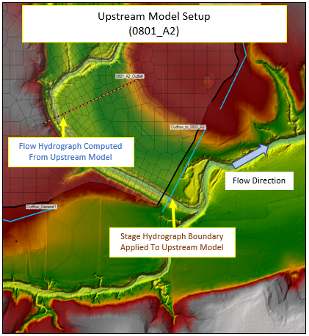
Figure 6: Extraction of Flow Hydrograph from the SA/2D Connection in the Upstream Domain
for Use in the Downstream Domain
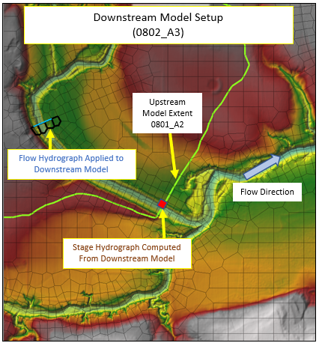
Figure 7: Application of Upstream Flow Hydrograph in the Downstream Domain
See Table 8 through Table 11 for a summary of the upstream and downstream peak discharges and WSELs at the downstream end of each domain in the Buchanan-LBJ Lakes watershed. These tables have been included to demonstrate that at the downstream end of each model domain, the peak discharges are within 5% of one another and the WSELs are within 0.5 feet for each profile.
Tables were not produced for domains 0102_A3 and 0104_A6 because the downstream end of these outlets are at Lake Buchanan and Lake LBJ, respectively. Because of the dams, there is no expectation that the discharges and the WSELs meet the tie-in criteria.
Table 8: Upstream and Downstream Discharges and WSELs at the Outlet of Domain 0101_A1
Profile (AEP) | Upstream Outflow (cfs) | Downstream Inflow (cfs) | Difference  (%) | Upstream  WSEL (ft) | Downstream  WSEL (ft) | Difference (ft)
10% | 12,600 | 12,566 | 0.28% | 1,236.93 | 1,236.80 | 0.13
4% | 23,535 | 23,467 | 0.29% | 1,239.62 | 1,239.46 | 0.16
2% | 33,756 | 33,653 | 0.31% | 1,241.75 | 1,241.61 | 0.14
1% | 46,757 | 46,597 | 0.34% | 1,244.01 | 1,243.91 | 0.10
0.2% | 93,752 | 91,975 | 1.91% | 1,250.08 | 1,249.95 | 0.13
1% minus | 28,588 | 29,219 | 2.18% | 1,240.86 | 1,240.71 | 0.15
1% plus | 68,550 | 68,079 | 0.69% | 1,247.17 | 1,247.03 | 0.14

Table 9: Upstream and Downstream Discharges and WSELs at the Outlet of Domain 0101_A2
Profile (AEP) | Upstream Outflow (cfs) | Downstream Inflow (cfs) | Difference  (%) | Upstream  WSEL (ft) | Downstream  WSEL (ft) | Difference (ft)
10% | 77,527 | 77,345 | 0.24% | 1,051.67 | 1,051.65 | 0.03
4% | 124,527 | 124,305 | 0.18% | 1,059.56 | 1,059.54 | 0.02
2% | 165,926 | 165,691 | 0.14% | 1,065.15 | 1,065.12 | 0.03
1% | 217,661 | 217,953 | 0.13% | 1,071.18 | 1,071.16 | 0.02
0.2% | 411,220 | 416,022 | 1.16% | 1,088.46 | 1,088.43 | 0.03
1% minus | 146,696 | 146,523 | 0.12% | 1,062.62 | 1,062.63 | 0.01
1% plus | 316,698 | 318,730 | 0.64% | 1,080.80 | 1,080.77 | 0.03

Table 10: Upstream and Downstream Discharges and WSELs at the Outlet of Domain 0103_A4
Profile (AEP) | Upstream Outflow (cfs) | Downstream Inflow (cfs) | Difference  (%) | Upstream  WSEL (ft) | Downstream  WSEL (ft) | Difference (ft)
10% | 18,003 | 18,003 | 0.00% | 1,095.39 | 1095.365 | 0.03
4% | 37,829 | 37,829 | 0.00% | 1,098.44 | 1,098.41 | 0.03
2% | 60,008 | 60,008 | 0.00% | 1,101.13 | 1,101.10 | 0.03
1% | 88,928 | 88,928 | 0.00% | 1,104.11 | 1,104.07 | 0.04
0.2% | 192,656 | 192,656 | 0.00% | 1,112.35 | 1,112.38 | 0.03
1% minus | 52,080 | 52,080 | 0.00% | 1,100.22 | 1,100.19 | 0.03
1% plus | 130,437 | 130,437 | 0.00% | 1,107.80 | 1,107.79 | 0.01

Table 11: Upstream and Downstream Discharges and WSELs at the Outlet of Domain 0103_A5
Profile (AEP) | Upstream Outflow (cfs) | Downstream Inflow (cfs) | Difference  (%) | Upstream  WSEL (ft) | Downstream  WSEL (ft) | Difference (ft)
10% | 26,420 | 26,406 | 0.06% | 837.61 | 837.61 | 0.00
4% | 56,047 | 56,147 | 0.18% | 842.68 | 842.68 | 0.00
2% | 89,298 | 89,382 | 0.09% | 845.97 | 845.97 | 0.00
1% | 132,352 | 132,050 | 0.23% | 850.06 | 849.72 | 0.34
0.2% | 274,992 | 273,121 | 0.68% | 860.96 | 860.53 | 0.43
1% minus | 76,731 | 76,955 | 0.29% | 844.38 | 844.38 | 0.00
1% plus | 193,290 | 192,225 | 0.55% | 855.26 | 854.86 | 0.40
Normal Depth Boundary Conditions
Since each 2D model domain extent included a buffer to the watershed boundary, normal depth boundary conditions were applied along each 2D area perimeter to avoid ponding along the perimeter. At the main channel outflow or tributary inflow locations where other boundary conditions were already present, a normal depth boundary was not applied.

Reservoir Modeling
The two most significant reservoirs in this watershed are Lake Buchanan and Lake LBJ. Both reservoirs reside along the Colorado River. The dam at the downstream end of Lake LBJ forms the boundary between the Buchanan-LBJ Lakes and Austin-Travis Lakes HUC-8 watersheds. The modeling approaches for the reservoirs are discussed in this subsection.
General Overview
While the BLE analysis of the Buchanan-LBJ Lakes watershed was being completed by AtkinsRéalis, the Interagency Flood Risk Management team (InFRM) had been working on a Watershed Hydrology Assessment (WHA) of the Lower Colorado River Basin, which included the AtkinsRéalis BLE study area. The TWDB acquired a draft version of the WHA and shared it with AtkinsRéalis. The WHA included Reservoir Frequency Analyses (RFA) for Lake Buchanan and Lake LBJ. These RFAs derived scalable hydrograph shapes at the reservoir outlets using simulated historical storm events from 1935 (Lake LBJ) and 1936 (Lake Buchanan). Frequency-stage-outflow data for each reservoir were computed for the 50%, 20%, 10%, 4%, 2%, 1%, 0.4%, and 0.2% events. The modeling used to support this effort was not available. Although the reservoirs were constructed after these historical storm events, the WHA modeling assumed the reservoirs were in-place.

In addition to the RFAs, the WHA included flow frequency analyses for the USGS streamflow gages in the AtkinsRéalis BLE study area. These analyses applied a Bulletin 17C methodology to the annual peak flows observed at the gages to estimate peak flows for the 50%, 20%, 10%, 4%, 2%, 1%, 0.5%, and 0.2% events. Although there were not many USGS gages in the study area, there was a gage upstream of Lake Buchanan.

In October 2022, the TWDB received additional reservoir modeling data from the InFRM WHA team and shared this information with AtkinsRéalis. This package included scalable hydrograph shapes at the outlets of Lake Buchanan and Lake LBJ. It also included a summary of flow-frequency output data at the outlet of Lake LBJ derived from an HEC-HMS model. The TWDB was not able to acquire this model from the InFRM team.

Before the hydrograph shapes and HEC-HMS model summary were acquired, AtkinsRéalis had developed its own hydrographs at the reservoir outlets during its BLE efforts. For each reservoir, AtkinsRéalis reviewed the WHA to determine whether the flow-frequency data from the RFA or the gage analyses should be used. Since no hydrograph shapes were available in the WHA, AtkinsRéalis developed its own hydrograph shapes. These shapes were developed using a balanced hydrograph approach that leveraged flow data from USGS gage 08147000 (Colorado River near San Saba, TX) for major events in 1997, 2000, 2004, and 2018. This gage was located upstream of Lake Buchanan, downstream of the confluence with the San Saba River.

Following receipt of the InFRM hydrograph shapes in October 2022, the TWDB asked AtkinsRéalis to review them to determine whether they should be incorporated into AtkinsRéalis’ BLE models. This investigation
yielded the following key findings:

- In general, the WHA hydrographs and the AtkinsRéalis hydrographs produced WSELs and floodplain extents that were similar.

- Within a reservoir storage area, the WSEL in the reservoir was dependent on the volume of water that entered the reservoir.

- WSELs and floodplain extents downstream of the reservoirs were more sensitive to the peak flow rate than the hydrograph shape.

- The WHA hydrographs generally had longer durations than AtkinsRéalis’ hydrographs. These longer durations led to longer run times with limited effects on BLE outcomes.

AtkinsRéalis met with the TWDB and its Independent Technical Review (ITR) team to review these findings and clarify the modeling approach for each reservoir. Please see below for details for each reservoir.

Lake Buchanan
The lake and its dam, Buchanan Dam, are owned and operated by the Lower Colorado River Authority for flood control, water supply, hydropower generation, and recreational purposes. Construction of the dam was completed in 1938. The dam is a concrete arch and gravity structure. The elevation at the top of the arches is 1025.5 feet above mean sea level. The crest of the uncontrolled spillway is at 1020.5 feet above mean sea level. There are 37 flood-control gates for controlled releases from the lake.
The reservoir and dam are located in BLE model domain 0102_A3. The model domains were split near the Buchanan Dam’s crest such that the entire reservoir was located in domain 0102_A3, and the reach downstream of the dam was located in domain 0102_A6. Figure 8 shows the layout of these model domains and Lake Buchanan.
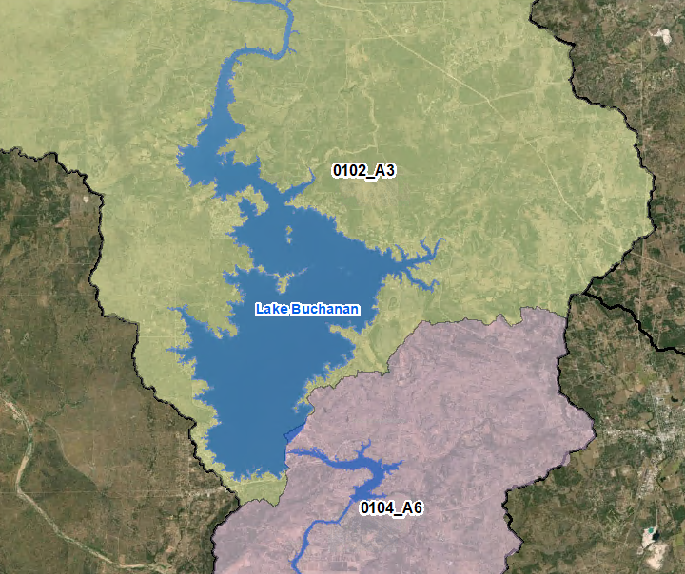
Figure 8. Model Configuration Near Lake Buchanan
The Colorado River flows through the lake. Downstream of the reservoir outlet, the Llano River enters the Colorado River. At this confluence, the 1% flows in the Llano River are higher than the 1% flows in the Colorado River.
The AtkinsRéalis 1% hydrograph shape was compared to the WHA hydrograph shape. The WHA hydrograph was derived from the 1936 storm and had a peak flow of 211,836 cfs. The AtkinsRéalis peak 1% flow, taken from the WHA RFA since no gage data were available, was 219,670 cfs. The WHA hydrograph volume was a little bigger than AtkinsRéalis’ volume.
Inks Lake is just downstream of Lake Buchanan. The AtkinsRéalis and WHA approaches produced similar floodplain extents in the lake. The WSELs were within 0.5 feet.
Downstream of Inks Lake, the floodplain extents were similar and the WSELs were within 1 foot.
AtkinsRéalis recommended using its balanced hydrograph shape and the WHA RFA frequency-stage-outflow table to establish the hydrographs at the reservoir outlet. This approach was approved by the TWDB and its ITR team. The WHA RFA table is summarized in Table 12. This table is from page 58 of the RFA, which has been included in Appendix B.

Table 12: WHA RFA Frequency-Stage-Outflow Table for Lake Buchanan
Event | Stage Elevation (ft, NGVD) | Spillway Release (cfs) | Gate Release (cfs) | Total Release (cfs)
10% | 1,021.00 | 45,400 | 0 | 45,400
4% | 1,021.23 | 115,860 | 0 | 115,860
2% | 1,021.44 | 155,235 | 0 | 155,235
1% | 1,021.60 | 219,670 | 0 | 219,670
0.2% | 1,022.05 | 412,980 | 0 | 412,980
1% plus* | In RAS*** | 361,357 | 0 | 361,357
1% minus** | In RAS*** | 133,538 | 0 | 133,538
* Discharge is the 1% discharge * the average standard error. See Subsection 1.2.7 for more information.
** Discharge is the 1% discharge / the average standard error. See Subsection 1.2.7 for more information.
*** Stages for the 1% plus and 1% minus events interpolated by RAS during model run using discharges for those events.
The hydrographs that established the inflows into domain 0104_A6 are shown on Figure 9. The calculations used to build these hydrographs are documented in the spreadsheet (BuchananLBJ_OutflowHyd_RatingCrv.xlsx) in the supplemental data folder.
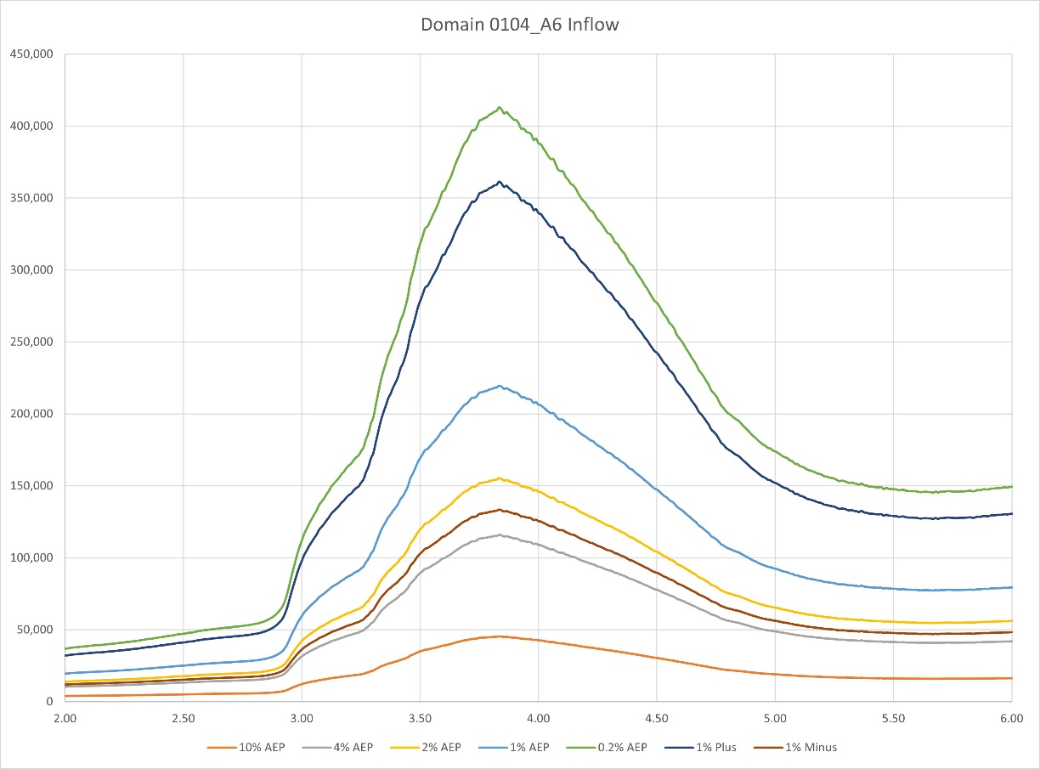
Figure 9: Domain 0104_A6 Inflow Hydrographs for Colorado River
Lake LBJ
The Colorado River flows through Lake LBJ. Lake outflow enters the upstream end of the Austin-Travis Lakes HUC-8 watershed.

The dam at the outlet of Lake LBJ is the Alvin J. Wirtz Dam (Wirtz Dam). The lake and the dam are owned and operated by the LCRA primarily for hydroelectric power. Construction of the dam was completed in 1951. The dam is a concrete and earthfill structure. The top-of-dam elevation is 838 feet above mean sea level. The spillway, controlled by 9 tainter gates each 50 feet high by 30 feet wide, has a crest elevation of 796 feet above mean sea level.

Lake LBJ is located in domain 0104_A6 of the BLE model. Downstream of Wirtz Dam is domain 0501_A1 in the Austin-Travis Lakes watershed BLE model. Figure 7 shows the layout of the model domains in the vicinity of Wirtz Dam.

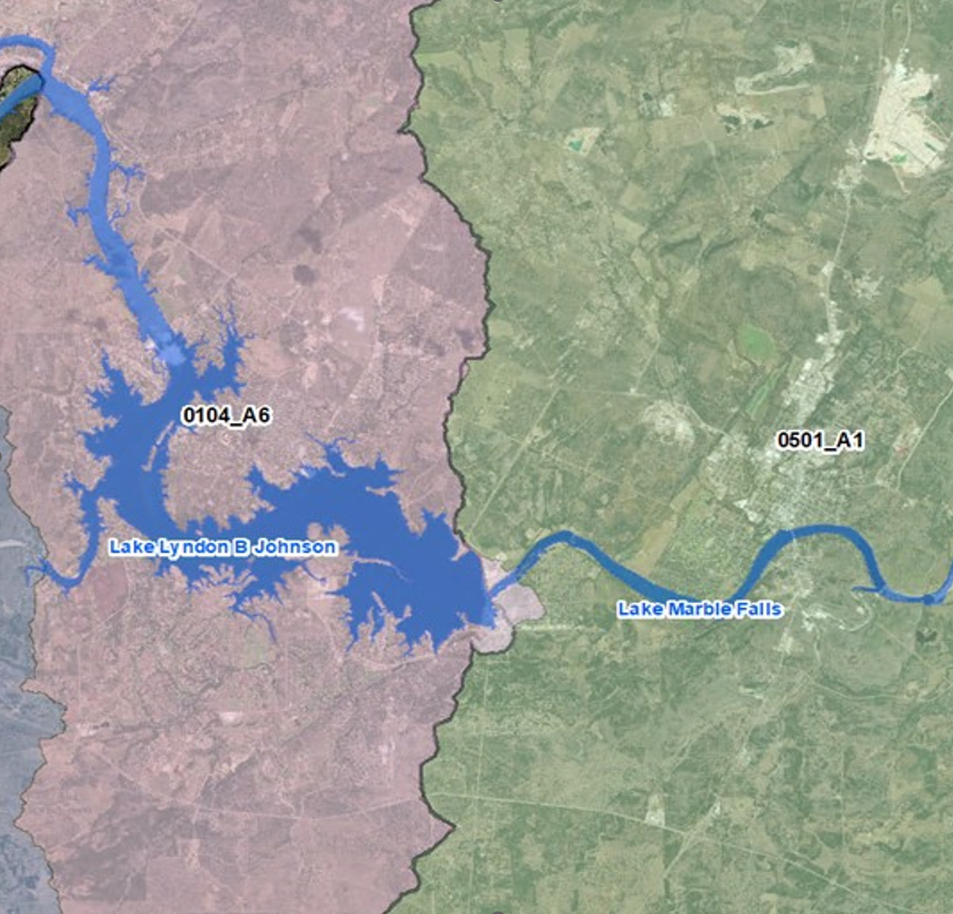

Figure 10. Lake LBJ model configuration

The October 2022 data from the InFRM team included a frequency-flow table at the reservoir outlet derived from an HEC-HMS model of the 1935 storm. The peak 1% flow in this model was 375,000 cfs. This information also included a hydrograph shape that was based on this 1% flow.

The RFA in the WHA also computed a frequency-flow table for the reservoir. The peak 1% flow rate in the RFA was 190,335 cfs.

AtkinsRéalis concluded the HEC-HMS flow was more reasonable since AtkinsRéalis’ BLE model computed a 1% inflow of 432,000 cfs into Lake LBJ, which is more in-line with the 375,000 cfs computed by the HEC-HMS model at the outlet versus the RFA’s 1% discharge of 190,335 cfs. This conclusion was further supported by the FIS, which documented a 1% effective discharge of 330,000 cfs at the lake outlet.

AtkinsRéalis compared its 1% hydrograph shape to the 1% hydrograph from the HEC-HMS model. The AtkinsRéalis and WHA peak flows were identical (375,000 cfs). The AtkinsRéalis hydrograph volume was larger than the WHA volume.

AtkinsRéalis compared the BLE outcomes using the two hydrographs. The floodplain extents downstream of the lake were similar. The WSELs were within 0.5 feet.

AtkinsRéalis compared the BLE outcomes using the peak flow rates of 190,335 cfs from the RFA and 375,000 cfs from the HEC-HMS model. The AtkinsRéalis hydrograph shape was used. Unsurprisingly, this led to significant differences in the floodplain extents downstream of the lake. The WSELs were different by more than 10 feet.

AtkinsRéalis recommended using its balanced hydrograph shape and the HEC-HMS frequency-flow table to establish the hydrographs at the reservoir outlet. This table is shown in Table 13. Because reservoir stage data were available in the RFA but not in the HEC-HMS model, AtkinsRéalis recommended using the RFA stage-outflow data in the RFA to set the stages in at the SA/2D connection at the downstream end of Lake LBJ in the BLE HEC-RAS model. This approach was approved by the TWDB and its ITR team. The HEC-HMS frequency-flow table is shown in Table 13 and the RFA stage-outflow table is shown in Table 14.

Table 13: HEC-HMS Peak Outflow Data for Lake LBJ Outlet from the InFRM WHA
Event | Peak Flow (cfs)
10% | 71,000
4% | 149,000
2% | 242,000
1% | 375,000
0.2% | 650,000
1% plus | 618,000
1% minus | 227,549

Table 14: RFA Stage-Frequency-Outflow Data for Lake LBJ from the InFRM WHA
Event | Stage Elevation  (ft, NGVD) | Spillway Release (cfs) | Gate Release (cfs) | Total Release (cfs)
10% | 826.60 | 70,975 | 0 | 70,975
4% | 827.93 | 102,195 | 0 | 102,195
2% | 828.31 | 147,270 | 0 | 147,270
1% | 828.70 | 190,335 | 0 | 190,335
0.2% | 830.00 | 328,990 | 0 | 328,990
1% plus* | In RAS*** | 618,000 | 0 | 618,000
1% minus** | In RAS*** | 227,549 | 0 | 227,549
* Discharge is the 1% discharge * the average standard error. See Subsection 1.2.7 for more information.
** Discharge is the 1% discharge / the average standard error. See Subsection 1.2.7 for more information.
*** Stages for 1% plus and 1% minus events interpolated by RAS during model run using discharges for those events.
Wirtz Dam in domain 0104_A6 was modeled as a hydraulic structure by adding a SA/2D connection in the HEC-RAS model. The InFRM RFA stage-outflow rating curve was applied at the SA/2D connection. The elevations in the InFRM study were referenced to NGVD 1929. A datum conversion of +0.298 feet was applied to convert the elevations to NAVD 1988. The Wirtz Dam structure setup is shown in Figure 11.
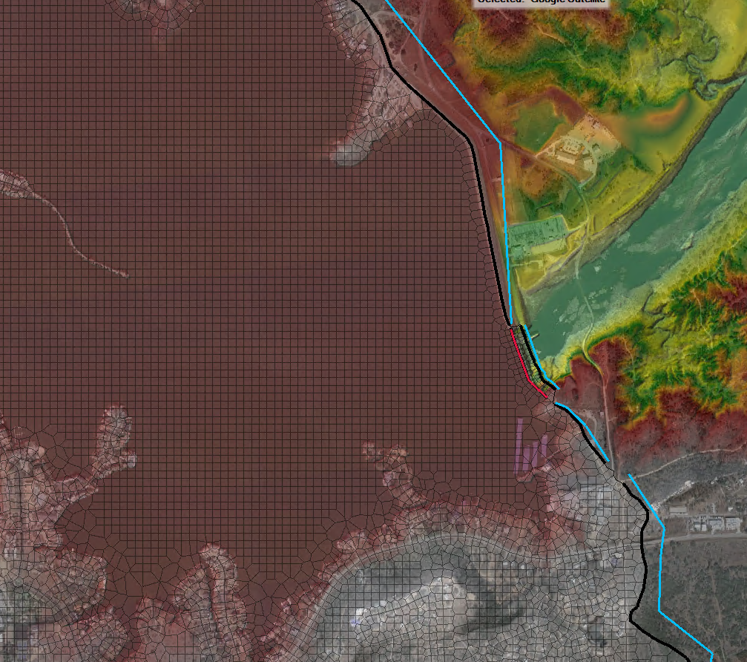
Wirtz Dam
Domain 0501_A1
Domain 0104_A6
Figure 11: Wirtz Dam (Lake LBJ) SA/2D Connection Setup
Model Results for Lake LBJ
Lake LBJ is located just downstream of the confluence of the Colorado River with the Llano River. There were three sources of inflow into the lake – the Colorado River, the Llano River, and local runoff from domain 0103_A5. In this area, the Llano River peak flows dominated those from the Colorado River and domain 0103_A5. See Figure 12 for details.
AtkinsRéalis completed a BLE assessment for the TWDB for the Llano River HUC-8 watershed (12090204). The Llano River watershed drains 4,526 mi². Near the downstream end of the Llano River is USGS gage 08151500 (Llano River at Llano, TX). The WHA flow-frequency analysis for this gage computed a 1% flow of 425,000 cfs. The 1% BLE flow at the USGS gage was 446,164 cfs and roughly 442,000 cfs at the Llano River outlet. The outflow hydrographs from the Llano BLE model were used to establish the inflows for domain 0104_A6, which includes Lake LBJ.
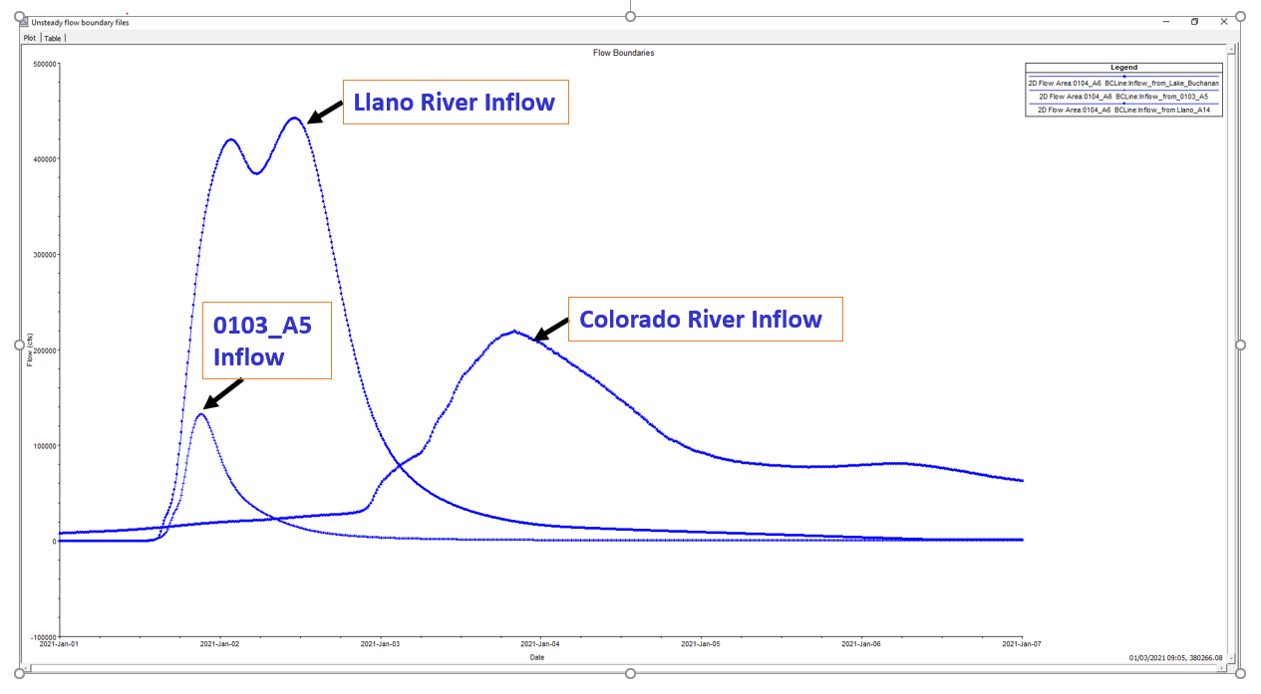
Figure 12: 1% AEP Inflows applied to Lake LBJ
The 1% BLE discharge along the Colorado River at the outlet of Lake Buchanan and into domain 0104_A6 was leveraged from the WHA’s RFA of Lake Buchanan. See above for details. This flow rate was 219,670 cfs. The drainage area at the outlet of Lake Buchanan is more than 31,700 mi², but this watershed is highly regulated by dams. Due to this large contributing area and the effects of the dams, the Colorado River 1% hydrograph peaks later than the Llano River 1% hydrograph.
The Sandy Creek inflow from domain 0103_A5 had a 1% BLE flow of 132,518 cfs. This creek drains 388 mi². This creek also peaks before the Llano River.
The 1% BLE outflow from Lake LBJ was 457,263 cfs, which was much higher than the 1% discharges in other studies (e.g., the WHA). A contributing factor to this high discharge was the application of uniform 1% rainfall over the entire watershed. AtkinsRéalis applied a decoupled approach on the Colorado River at the outlet of Buchanan Dam to reset the inflows into Lake LBJ by leveraging the WHA’s RFA of Lake Buchanan. This lowered the 1% discharge out of Lake Buchanan to 219,670 cfs.
The Llano River watershed is largely unregulated. The North Llano and South Llano HUC-8 watersheds (12090202 and 12090203, respectively) drain into the Llano River HUC-8 watershed. Overall, the Llano River drains more than 4,500 mi². The BLE assessment for the Llano River watershed assumed that the 1% storm occurred over the entire watershed. In each domain, Atlas 14 rainfall totals were used; no areal-reduction factors were applied, which was reasonable since the domains were relatively small (less than 300 mi²). This led to generally good BLE results in the Llano River watershed. However, along the main stem of the Llano River, as one moves downstream, the application of unreduced rainfall in each domain produced runoff volumes that became higher and higher. A way to reduce these volumes for the downstream reaches of the Llano River’s main stem would be to apply an elliptical rainfall distribution over the Llano River or a Joint Probability Analysis in the Llano River watershed, but such an analysis was beyond the scope of the BLE project. Although AtkinsRéalis was able to validate the peak flow on the Llano River at USGS gage 08151500 (Llano River at Llano, TX), the validation of the river’s hydrograph volumes using historical storms or other sources was outside the scope of this BLE study.
Inflow hydrograph volumes dictate the computed peak stages and outflows at reservoirs, and the hydrograph volumes for the downstream reach of the Llano River main stem, which drains into Lake LBJ, are likely overestimated in the BLE model due to the application of uniform rainfall over the entire watershed. It should be noted that the application of uniform rainfall leads to an overestimation of volumes only on the main stems of large rivers (i.e., those with drainage areas greater than 1,000 mi²).
Flow Hydrograph Instabilities During the 0.2% Event
The Llano River, Colorado River, and Sandy River inflows include high peak flows and volumes and result in a combined 0.2% BLE outflow of 1,159,323 cfs from Wirtz Dam. The large volume of water in the lake led to some instabilities in the lake during the 0.2% run; however, no instabilities were present in the 1% and more frequent events. The model produced an “extrapolated elevation beyond rating curve” error at the lake during the 0.2% and 1% plus runs. The model was adjusted to attempt to resolve the instabilities, but they persisted. Additional review of the model results revealed that the instabilities were not affecting the model outcomes. For example, the 0.2% headwater hydrograph, shown below in the top curve in Figure 13, is stable. In addition, domain 0501_A1, located immediately downstream of Wirtz Dam in the Austin-Travis Lakes watershed, has been de-coupled from the outflows from domain 0104_A6 in the Buchanan-LBJ Lakes watershed. Therefore, the high outflows calculated at Wirtz Dam are not transferred into the Austin-Travis Lakes watershed. Instead, the inflows into the watershed were derived from the HEC-HMS model, since the 1% flow in that model (375,000 cfs) was similar to the FEMA effective 1% flow (330,000 cfs).

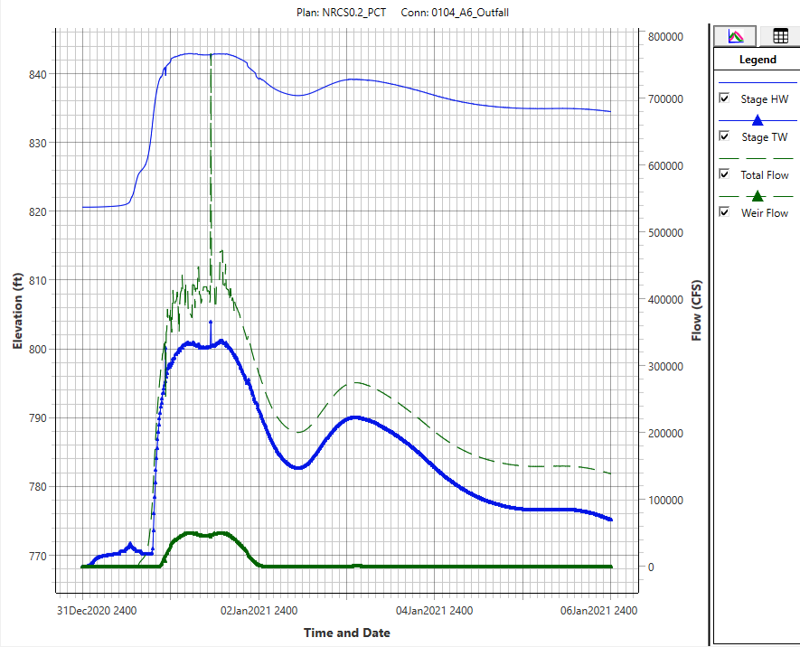
Figure 13: BLE Stage-Outflow Data for the 0.2 Event at Connection 0104_A6_Outfall
Because of these high volumes, the BLE WSELs in Lake LBJ and in the vicinity of the lake are of limited value. Fortunately, there is extensive effective FEMA mapping available for Lake LBJ and all major tributaries entering the lake. The FEMA floodplain mapping should take precedence over the BLE mapping in this area.
High Water Surface Elevations at the Wirtz Dam (Lake LBJ) and Buchanan Dam (Buchanan Lake)
As discussed above, the BLE models overpredicted the volumes that entered the lakes. These high volumes initially produced WSELs that exceeded the highest WSELs in the dam rating tables available in the RFAs in the InFRM WHA. After coordination with the TWDB, AtkinsRéalis made the following revisions to the modeling approach for the dams:
- Delete the SA/2D connection for each dam and clip the model domain extent to align with the dam.
- Insert a new downstream boundary condition at the dam. Instead of a rating curve, a stage hydrograph boundary was used. The peak stage for the stage hydrograph was based on the InFRM RFA. AtkinsRéalis developed the shape for the stage hydrograph using a normal depth boundary for the 1% plan and scaled it to match the InFRM peak stages.
- Increase the mesh sizes near the downstream end of the model to lower the water surface elevations upstream of the dam.
- Modify the terrain near the dam outlet (under the water surface) to align the BFE lines to the dam outlet and to further lower the water surface elevations.
These modifications lowered the water surface elevations at the dams to realistic levels and better aligned the stages out of the dam with the stages in the RFA.

Computation Settings
The computation settings applied in the HEC-RAS models are listed below:
- The Diffusion Wave equation was used.
- A 6-day simulation time was generally applied to capture the peaks and tails of the hydrographs.
- An advanced time step control based on the Courant number was applied as shown below in Figure 14. This option was chosen to decrease run times while generally maintaining Courant number values less than 1.
- Typical model run times with this advanced time step control setting were approximately 2 hours per simulation.
- The mapping and hydrograph output intervals were 10 minutes.
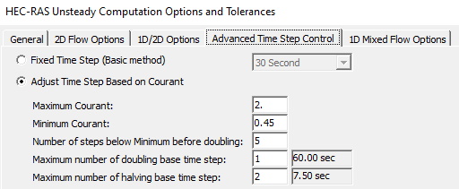
Figure 14: HEC-RAS Unsteady Computation Options and Tolerances
For Domain 0104_A6 the minimum time setup in the advanced time step control was lower to approximately 1 second to obtain smooth hydrographs at the Lake LBJ Dam SA/2D connection.

Regression Analysis
Regression flows were used for model validation where gage data was not available. The flow direction and flow accumulation grids created during the hydro-enforcement task were used to develop regression input parameter grids and regression peak flow grids for locations with drainage areas of 1 mi² or larger. The peak flows were computed using the regression equations documented in Regression Equations for Estimation of Annual Peak-Streamflow Frequency for Undeveloped Watersheds in Texas Using an L-moment-Based, PRESS-Minimized, Residual-Adjusted Approach (Asquith and Roussel 2009).
The contributing drainage area (A), mean-annual precipitation (P), dimensionless channel slope (S), and the basin-averaged OmegaEM parameter (Ω) were the input parameters for the regression equations. The regression equations are shown in Table 3 in the regression report (Asquith and Roussel 2009) and below on Figure 15.
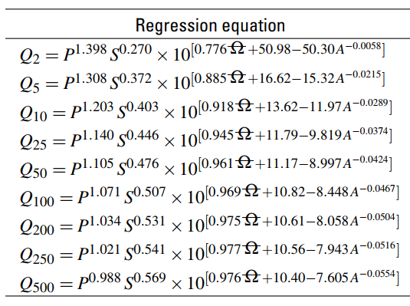
Figure 15: Regression Equations for the Buchanan-LBJ Lakes Watershed
The lower and upper limits of the slope in the regression analysis were 0.00023 and 0.0703, respectively. The computed flows are sensitive to the channel slope and unreasonable flows tend to be computed when slopes are outside the range used in the regression analysis. Therefore, when the channel slope was less than 0.00023, 0.00023 foot per mile was used in place of the computed value. Similarly, when the channel slope exceeded 0.0703, 0.0703 was used in place of the computed value.
The average standard error of prediction (SEP) for the 1% annual-chance event was 64.8%, according to the PRESS statistic in Table 3 of the regression report (Asquith and Roussel 2009). The 1% plus and 1% minus gridded flows were computed using the SEP as shown in the equations below. The 1% minus flows were not computed by multiplying the 1% flow by 1 minus SEP to avoid unreasonably low flows when the standard errors were large.

$$Q_{1\%Plus}=Q_{1\%}*1.648$$
$$Q_{1\%Minus}=\frac{Q_{1\%}}{1.648}$$
The flows resulting from the regression analysis were not used downstream of flow-regulating reservoirs or for streams with inflows from other HUC-8 watersheds.

Gage Analysis
The Buchanan-LBJ Lakes watershed was being studied as part of the InFRM team’s WHA for the Lower Colorado River Basin. The WHA analyzed USGS gages 08147000 (Colorado River near San Saba, TX) and 08152000 (Sandy Creek near Kingsland, TX) using the methodology in USGS Bulletin 17C. This InFRM gage analysis was leveraged to support flow validation in the Buchanan-LBJ Lakes BLE model.
Table 15: Summary of USGS Gage Stations across the Buchanan-LBJ lakes Watershed
Site No. | Site Name | Computed Drainage Area (mi²) | Was Gage Analysis Performed? | Source of Gage Analysis | Reason Why Gage Analysis Was Not Performed to Support BLE Validation
08147000 | Colorado Rv nr San Saba, TX | 31,218 | Yes | InFRM  WHA | N/A
08152000 | Sandy Ck nr Kingsland, TX | 346.1 | Yes | InFRM  WHA | N/A

A description of the analysis, its assumptions, and its results is included on pages 91 through 95, 146, 106, 107, and 152 of Chapter 5 of the InFRM’s draft WHA report. A copy of these pages has been included in Appendix B of this report.
No additional gage analysis was performed for this BLE study.

Model Validation
The Buchanan-LBJ Lakes BLE hydraulic models were validated using peak flow information available in the draft InFRM WHA and the effective FIS report. For the streams where no InFRM or FIS flow information was available, the regression analysis previously discussed was used to validate the HEC-RAS models.
Validation checks were made at 69 locations throughout the Buchanan-LBJ Lakes watershed. The locations may be grouped as follows:
- One validation location compared the 1% BLE flow with the 1% minus, 1%, and 1% plus gage flows from the InFRM WHA and the 1% minus, 1%, and 1% plus regression flows.
- One validation location compared the 1% BLE flow with the 1% minus, 1%, and 1% plus gage flows.
- Two validation locations compared the 1% BLE flow with the 1% effective flow and the 1% minus, 1%, and 1% plus regression flows.
- Two validation locations compared the 1% BLE flow with the 1% effective flow.
- Sixty-three validation locations compared the 1% BLE flows with the 1% minus, 1%, and 1% plus regression flows.
The validation locations were scattered throughout the watershed in locations that provided a comprehensive coverage of drainage areas and stream characteristics. Validation points were added where gage and effective flow information were available. The drainage areas of the validation points ranged from approximately 1 mi² to 36,750 mi².
At the 2 validation points where the InFRM WHA completed a gage flow-frequency analysis, the 1% BLE flow was between the gage’s 1% minus and 1% plus flows at one location and above the 1% plus discharge at the other location. At the 68 validation points where regression flows were computed, the BLE 1% flows were between the 1% minus and 1% plus regression flow at 55 locations, and they were outside of this range at 13 locations.
At the 4 validation locations in domain 0104_A6 where 1% effective flows were available, the 1% BLE flows were 50% lower, 2% lower, 35% higher, and 54% higher than the effective flows. Note that locations where the 1% BLE flows were within 25% of the 1% effective flows passed the validation check. The 1% BLE, regression, effective, and gage flows at all validation points are presented in Table 20.

The first step of the validation effort was to review the initial BLE results. When the initial BLE flows fell outside the 1% plus and 1% minus range of the gage or regression flows, the Manning’s n and CN values were adjusted iteratively until the computed flows at as many validation points as possible were within the 1% plus and 1% minus range of the gage or regression flows. The Manning’s n values were revised as needed provided they remained within the ranges specified in Table 7. The AMC II CNs were adjusted by no more than ±10% of their initial values. If the computed flows were within the 1% plus and 1% minus range (i.e., valid), then the adjusted AMC II CNs and Manning’s n values were used in the final model.

In all domains, these adjustments to the Manning’s n and AMC II CN values did not reduce the flows enough to produce valid flows at an acceptable number of validation locations. In these domains, the Manning’s n values were reset to their initial values and the CN values were determined by assuming a weighted average of 70% of the AMC I values and 30% of the AMC II values. According to Engineering Technical Note No. 210-18-TX5, published by the Soil Conservation Service (SCS) in October 1990, antecedent moisture conditions in Texas vary from AMC II in the east to AMC I in the west. Since the Buchanan-LBJ Lakes watershed resides within the transition zone from AMC II to AMC I, it was reasonable to assume a blend of AMC I and AMC II conditions were present in the watershed for validation purposes. See Figure 16 and Appendix B for a map from the SCS report showing the average antecedent moisture conditions across Texas.
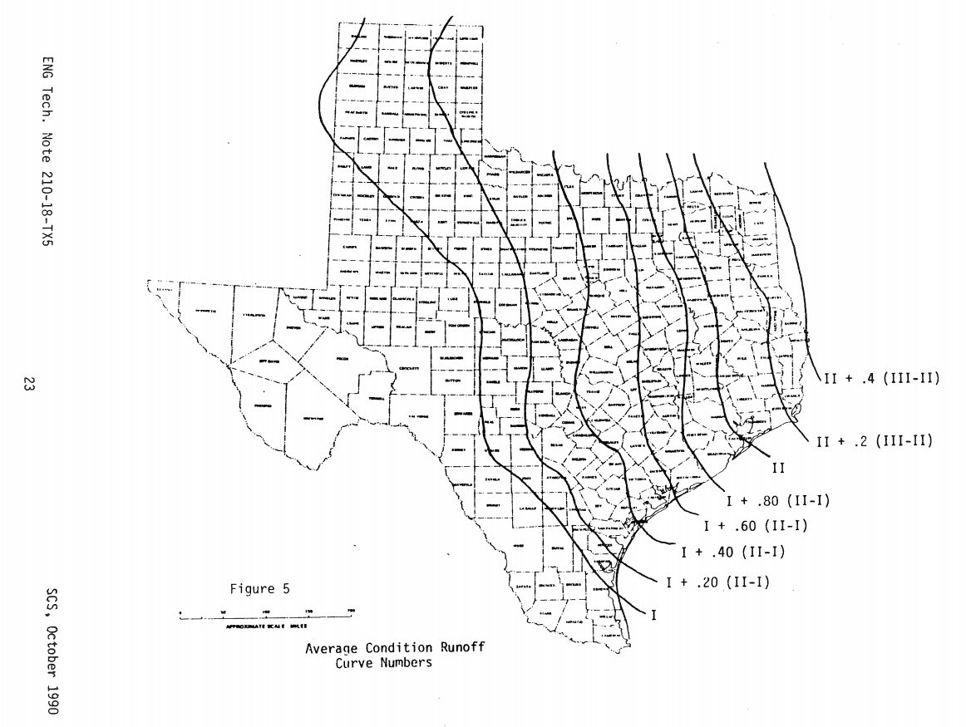
Figure 16: Typical Antecedent Moisture Conditions in Texas
After these adjustments to the CN values, the flows continued to be too high. In response, the Manning’s n values were increased in the overland areas to their maximum values as documented in Table 7. In addition, the channel Manning’s n value in domain 0101_A2 was increased to 0.050. These adjustments increased the number of locations where valid 1% BLE flows were computed to an acceptable level (55 out of 69).
A summary of the parameters adjustment during the validation tasks is shown in Table 16.

Table 16: Summary of Parameter Adjustments Made in the Buchanan-LBJ Lakes Watershed
Model Domain | CN Adjustment | Overland n Adjustment | Channel n Adjustment | Number of Validation Locations | Pass | Fail
0101_A1 | Weighted – 70% AMC I + 30% AMC II | Max | None | 12 | 8 | 4
0101_A2 | Weighted – 70% AMC I + 30% AMC II | Max | Increased to 0.05 | 12 | 8 | 4
0102_A3 | Weighted – 70% AMC I + 30% AMC II | Max | None | 5 | 3 | 2
0103_A4 | Weighted – 70% AMC I + 30% AMC II | Max | None | 14 | 14 | 0
0103_A5 | Weighted – 70% AMC I + 30% AMC II | Max | None | 16 | 16 | 0
0104_A6 | Weighted – 70% AMC I + 30% AMC II | Max | None | 10 | 7 | 3
 |  |  | Total | 69 | 55 | 13

During the validation process, domain-wide parameter adjustments were applied to the CN values and the Manning’s n values to maximize the number of streams where the 1% BLE flows fell between the 1% minus and 1% plus regressions/gage flows. No particular area or tributary in a domain was considered a priority over the others when these adjustments were made. As a result, in areas where the stream/‌watershed characteristics were significantly different from the rest of the domain, some of the 1% BLE flows might fall outside of the 1% minus and 1% plus bounds. Other factors that contributed to the 1% BLE flows falling outside of the 1% minus and 1% plus bounds included differences in the regression, effective, gage, and 2D BLE analysis methodologies; the use of updated topographic data in the BLE analysis; and the higher NOAA Atlas 14 rainfall totals that were used in the BLE analysis.
The model validation process for domain 0101_A1 is described here. Iterative results from this process are presented in Table 17. This description is representative; a similar process was applied to all domains in the Buchanan-LBJ Lakes watershed. In Table 17, the flows in green are within the 1% plus and 1% minus regression range, and the values in red are outside this range.
For Iteration 1, baseline AMC II CN values and Manning’s n values were assumed. The Iteration 1 results showed that all of the computed 1% BLE flows were higher than the 1% plus regression flows. To reduce the computed flows, Iteration 2 lowered the CN values by assuming a weighted average of 70% of the AMC I CN values and 30% of the AMC II CN values. These revisions produced 1% BLE flows that fell between the 1% minus and 1% plus regression flows at 7 of 12 locations. For Iteration 3, the CNs values were unrevised from Iteration 2 and the Manning’s n values were increased as documented in Table 12. This iteration produced 1% BLE flows that fell between the 1% minus and 1% plus regression flows at 8 of 12 locations.
Table 17: Summary of the Model Validation Process for Domain 0101_A1
Validation Location | Name | Drainage Area (mi²) | Regression |  |  | Iteration 1 | Iteration 2 | Iteration 3
Validation Location | Name | Drainage Area (mi²) | 1%-  (cfs) | 1%  (cfs) | 1%+  (cfs) | AMC II CN and Baseline n  (cfs) | Weighted CN  (70% AMC I + 30% AMC II) + Baseline n  (cfs) | Weighted CN (70% AMC I + 30% AMC II) + Adjusted n  (cfs)
Point 1 | Unnamed | 1.0 | 468 | 771 | 1,270 | 1,371 | 1,058 | 887
Point 2 | Buffalo Creek | 7.6 | 1,899 | 3,130 | 5,157 | 9,794 | 7,453 | 6,367
Point 3 | Jackson Branch | 12.4 | 2,909 | 4,793 | 7,899 | 9,888 | 7,447 | 6,567
Point 4 | Buffalo Creek | 35.6 | 4,505 | 7,424 | 12,234 | 20,913 | 16,432 | 15,634
Point 5 | Unnamed | 3.8 | 1,672 | 2,756 | 4,542 | 4,325 | 3,283 | 2,756
Point 6 | Cherokee Creek | 33.6 | 7,622 | 12,562 | 20,702 | 24,016 | 18,707 | 16,313
Point 7 | Salt Branch | 11.3 | 3,559 | 5,865 | 9,665 | 10,523 | 7,548 | 6,395
Point 8 | Bee Branch | 6.3 | 2,206 | 3,636 | 5,992 | 6,287 | 5,023 | 4,333
Point 9 | Unnamed | 10.7 | 2,617 | 4,313 | 7,108 | 7,370 | 5,456 | 4,954
Point 10 | Cherokee Creek | 108.7 | 13,893 | 22,895 | 37,731 | 53,508 | 42,398 | 39,408
Point 11 | Cherokee Creek | 135.8 | 15,624 | 25,748 | 42,433 | 57,213 | 45,680 | 42,916
0101_A1  Outfall | Cherokee Creek | 159.9 | 17,315 | 28,535 | 47,025 | 61,366 | 49,297 | 46,514

Gage 08147000 Colorado River near San Saba, TX is located at the upstream end of the HUC-8 watershed boundary, downstream of the confluence of the Colorado River and the San Saba River. The InFRM WHA performed two flow-frequency analyses for this gage: one using gage data that started with water year 1963 and an alternate analysis with the gage’s entire period of record (1916 – 2020).
The Pettitt test identified a change point in water year 1961. The Twin Buttes Reservoir, upstream of the watershed along the Concho River, was constructed in 1963, and the E.V. Spence Reservoir, upstream of the watershed along the Colorado River, was constructed in 1969. The WHA concluded that these two reservoirs could potentially affect the peak discharges in the Buchanan-LBJ Lake watershed. For this reason, the primary flow-frequency analysis considered peak discharges only from water years 1963 to 2020. The WHA performed the alternate analysis, which considered all peak discharges at the gage, to highlight the effects of gage data from before 1963. The WHA noted that the results of the primary analysis better reflect current conditions at the gage and are the recommended results.
The 1% peak flows from the gage analyses were 80,900 cfs (primary) and 158,000 cfs (alternate). The 1% BLE flow computed at the gage was 236,163 cfs. The 1% BLE flow at the gage was driven by the 1% BLE inflow of approximately 240,000 cfs from the Middle Colorado HUC-8 watershed (12090106) upstream of the Buchanan-LBJ Lakes watershed.
The 1% BLE outflow on the Colorado River at Inks Lake Dam was 218,078 cfs, which was 35% higher than the 1% effective FIS flow. The primary reason for this difference was that the InFRM study reported a 1% outflow of 219,670 cfs for the dam, which was used as the inflow for domain 0104_A6.
In domain 0104_A6, the most downstream domain in this watershed, the Llano River dominated the peak flow rates, not the Colorado River. The 1% BLE inflow from the Llano River HUC-8 (1290204) was approximately 442,000 cfs, which was validated using the InFRM flow-frequency analysis of gage 08151500 (Llano River at Llano TX). Due to significantly higher inflows into domain 0104_A6, the Colorado River outflow at Wirtz Dam was 292,444 cfs. This 1% BLE flow rate was 54% higher than the effective flow rate. In the HEC-HMS model provided by the InFRM team as discussed in Subsection 1.2.5, the 1% peak outflow rate was 375,000 cfs, so the computed flow rate was between the InFRM (RFA) estimate of 190,335 cfs and the 1% discharge from the HEC-HMS model.
Outside of the Colorado River, the only other place where FEMA effective discharges were available in the Buchanan-LBJ Lakes watershed was in the Elm Creek watershed. Elm Creek drains an area of approximately 5.3 mi². The creek enters Lake LBJ at Granite Shoals, Texas. This watershed was studied in 1990 using NUDALLAS for the hydrologic modeling and HEC-2 for the hydraulic modeling. NUDALLAS is a simple rainfall-runoff model developed by the USACE’s Fort Worth District. HEC-2 is an old hydraulic model developed by the HEC that is a pre-cursor to HEC-RAS. In 2012, the results of this study were re-delineated using LiDAR data captured in 2006.
Most of the discharges from the Elm Creek study that were documented in the FIS for Burnet County are for drainage areas less than 1 mi². Because those drainage areas were so small, the 1% BLE discharges were not compared with the FIS 1% discharges. The BLE 1% discharges were compared with representative effective discharges along Elm Creek. See Table 18 for this comparison. At one location, the BLE discharge was 54% smaller than the effective discharge. At the other location, the BLE discharge was 2% smaller than the effective discharge. Reasons for why the BLE and effective discharges differ along Elm Creek include the age of the effective study, the differences between the rudimentary NUDALLAS modeling in the effective study and the rain-on-grid approach in the BLE study, and the differences in rainfall inputs.

See Table 18 for a summary of how the 1% BLE flows compared with the WHA flow-frequency analysis and the 1% effective data.

Table 18: Comparison of 1% BLE, Gage, and Effectives Flows in the Buchanan-LBJ Lakes Watershed
Gage ID | Location | Area (mi²) | BLE 1% Flow | InFRM Bulletin 17C Analysis  Gage Flows (cfs) |  |  | FIS 1% Flow (cfs) | % Difference
 |  |  |  | 1% Minus | 1% | 1% Plus | FIS 1% Flow (cfs) | BLE Vs. Gage | BLE Vs. FIS
08147000 | Colorado River near San Saba, TX | 31,218 | 236,163 | 57,400 | 80,900 | 145,000 | n/a | 192 | -
 |  |  |  | 115,000 | 158,000 | 254,000 | n/a | 49 | -
n/a | Colorado River at Inks Lake Dam (Outflow) | 31,950 | 218,078 | - | - | - | 161,410 | - | 35
n/a | Colorado River at LBJ Dam (Outflow) | 36,752 | 292,444 | - | - | - | 190,335 |  | 54
08152000 | Sandy Creek near Kingsland, TX | 346.1 | 126,364 | 67,900 | 123,000 | 514,000 | n/a | 3 | -
n/a | Elm Creek below confluence with Stream E6 | 3.4 | 2,133 | - | - | - | 4,250 | - | -50
n/a | Elm Creek at Lake Lyndon B. Johnson | 5.4 | 6,300 | - | - | - | 6,450 | - | 2

A comparison between the 1% BLE WSELs and select effective 1% WSELs in the watershed is presented in Table 19. The effective 1% WSELs were estimated using BFEs available in the RMSI digitized floodplain mapping dataset. The 1% BLE WSELs were similar to those in the effective study. Variations can be attributed to the differences in the topographic data and methodologies that were used to compute the BLE and effective WSELs.
Table 19: Comparison of 1% Effective WSELs and 1% BLE WSELs
Location | Effective 1% WSEL (feet) | BLE 1% WSEL (feet) | Difference (Eff. – BLE) (feet)
W FM 2147 at Slickrock Creek | 848.3 | 851.1 | -2.8
E Castlewood Dr | 856.9 | 857.1 | -0.2
W FM 1431 | 882.3 | 884.6 | -2.3
Elm Creek at Riggs Rd | 881.8 | 881.6 | 0.2
Elm Creek at Little Elm Rd | 891.7 | 892.3 | -0.6
See Table 20 and Figure 17 on the following pages for a summary of the 1% validation results at the validation points in the Buchanan-LBJ Lakes watershed.
The model overview and results spreadsheet (Buchanan_Model_Overview_and_Results.xlsx) has been placed in the task documentation folder of this submittal. The validation locations are included in the HEC-RAS models and may also be found on the validation location maps in the model overview and results spreadsheet for each domain.

Figure 17: Computed Flow vs Drainage Area for Select 1% BLE, Regression, FIS, and Gage Flows
Table 20: 1% Peak Flow Validation Results for the Buchanan Watershed
Point ID | Validation Point Name | Drainage Area (mi²) | Regression 1%- Flow (cfs) | Regression 1% Flow (cfs) | Regression 1%+ Flow (cfs) | BLE  1% Flow (cfs) | Gage 1%- Flow (cfs) | Gage 1% Flow (cfs) | Gage 1%+ Flow (cfs) | FIS 1% Flow (cfs)
Domain 0101_A1
Point 1 | Unnamed | 1.0 | 468 | 771 | 1,270 | 887 | - | - | - | -
Point 2 | Buffalo Creek | 7.6 | 1,899 | 3,130 | 5,157 | 6,367 | - | - | - | -
Point 3 | Jackson Branch | 12.4 | 2,909 | 4,793 | 7,899 | 6,567 | - | - | - | -
Point 4 | Buffalo Creek | 35.6 | 4,505 | 7,424 | 12,234 | 15,634 | - | - | - | -
Point 5 | Unnamed | 3.8 | 1,672 | 2,756 | 4,542 | 2,756 | - | - | - | -
Point 6 | Cherokee Creek | 33.6 | 7,622 | 12,562 | 20,702 | 16,313 | - | - | - | -
Point 7 | Salt Branch | 11.3 | 3,559 | 5,865 | 9,665 | 6,395 | - | - | - | -
Point 8 | Bee Branch | 6.3 | 2,206 | 3,636 | 5,992 | 4,333 | - | - | - | -
Point 9 | Unnamed | 10.7 | 2,617 | 4,313 | 7,108 | 4,954 | - | - | - | -
Point 10 | Cherokee Creek | 108.7 | 13,893 | 22,895 | 37,731 | 39,408 | - | - | - | -
Point 11 | Cherokee Creek | 135.8 | 15,624 | 25,748 | 42,433 | 42,916 | - | - | - | -
0101_A1  Outfall | Cherokee Creek | 159.9 | 17,315 | 28,535 | 47,025 | 46,514 | - | - | - | -
Domain 0101_A2
USGS Gage | 08147000 | 31218 | - | - | - | 236,163 | 115,000 | 158,000 | 254,000 | -
Pt 1 | Yancey Creek | 29.4 | 6,647 | 10,954 | 18,052 | 16,361 | - | - | - | -
Pt 2 | Unnamed | 2.5 | 914 | 1,507 | 2,484 | 1,148 | - | - | - | -
Pt 3 | Rough Creek | 17.8 | 3,252 | 3,540 | 8,833 | 10,873 | - | - | - | -
Pt 4 | Salt Creek | 22.5 | 4,267 | 7,032 | 11,589 | 10,796 | - | - | - | -
Pt 5 | Elliott | 26.8 | 4,186 | 6,899 | 11,370 | 7,075 | - | - | - | -
Pt 6 | Rough Creek | 5.9 | 1,406 | 2,317 | 3,818 | 4,484 | - | - | - | -
Pt 7 | Lynch Creek | 7.4 | 2,086 | 3,437 | 5,665 | 3,034 | - | - | - | -
Pt 8 | Antelope Creek | 6.9 | 2,221 | 3,661 | 6,033 | 4,387 | - | - | - | -
Pt 9 | Burnt Branch | 6.5 | 2,203 | 3,631 | 5,984 | 5,129 | - | - | - | -
Pt 10 | Lynch Creek | 39.0 | 6,414 | 10,570 | 17,420 | 20,040 | - | - | - | -
Pt 11 | North Antelope Creek | 8.1 | 1,959 | 3,228 | 5,320 | 3,619 | - | - | - | -
Domain 0102_A3
Point 1 | Redrock Creek | 1.0 | 630 | 1,039 | 1,712 | 1,047 | - | - | - | -
Point 2 | North Fork Morgan Creek | 7.4 | 3,452 | 5,689 | 9,376 | 9,708 | - | - | - | -
Point 3 | Beaver Creek | 12.8 | 6,342 | 10,451 | 17,224 | 12,913 | - | - | - | -
Point 4 | Deer Creek | 28.0 | 9,070 | 14,947 | 24,632 | 24,461 | - | - | - | -
Point 5 | Fall Creek | 54.2 | 11,031 | 18,179 | 29,959 | 35,908 | - | - | - | -
Domain 0103_A4
Point 1 | Crabapple Creek | 62.7 | 15,870 | 26,154 | 43,101 | 42,753 | - | - | - | -
Point 2 | Unnamed | 1.0 | 1,293 | 2,130 | 3,511 | 1,676 | - | - | - | -
Point 3 | Walnut Spring Creek | 8.3 | 4,213 | 6,944 | 11,443 | 5,416 | - | - | - | -
Point 4 | Sandy Creek | 31.7 | 12,549 | 20,681 | 34,083 | 26,053 | - | - | - | -
Point 5 | Sandy Creek | 53.4 | 16,031 | 26,421 | 43,541 | 36,418 | - | - | - | -
Point 6 | Hondo Creek | 8.6 | 4,152 | 6,843 | 11,277 | 8,234 | - | - | - | -
Point 7 | Willow Branch | 5.6 | 2,881 | 4,748 | 7,824 | 5,235 | - | - | - | -
Point 8 | Sandy Creek | 149.9 | 31,847 | 52,485 | 86,495 | 81,261 | - | - | - | -
Point 9 | Crabapple Creek | 92.9 | 23,088 | 38,050 | 62,706 | 53,612 | - | - | - | -
Point 10 | Keener Branch | 8.5 | 4,910 | 8,092 | 13,335 | 9,573 | - | - | - | -
Point 11 | Polander Creek | 7.9 | 4,387 | 7,229 | 11,913 | 9,183 | - | - | - | -
Point 12 | Crabapple Creek | 23.6 | 8,153 | 13,437 | 22,144 | 19,940 | - | - | - | -
Point 13 | Crabapple Creek | 32.7 | 10,389 | 17,121 | 28,216 | 27,585 | - | - | - | -
0402_A4  Outfall | Sandy Creek | 173.9 | 34,686 | 57,163 | 94,204 | 88,928 | - | - | - | -
Domain 0103_A5
Point 1 | Legion Creek | 10.1 | 7,212 | 11,885 | 19,586 | 8,372 | - | - | - | -
Point 2 | Legion Creek | 18.4 | 8,134 | 13,404 | 22,090 | 12,128 | - | - | - | -
Point 3 | Coal Creek | 18.1 | 11,539 | 19,017 | 31,340 | 13,447 | - | - | - | -
Point 4 | Coal Creek | 20.5 | 11,055 | 18,219 | 30,025 | 14,189 | - | - | - | -
Point 5 | Coal Creek | 49.9 | 17,441 | 28,744 | 47,369 | 28,807 | - | - | - | -
Point 6 | Comanche Creek | 10.3 | 6,491 | 10,696 | 17,628 | 9,355 | - | - | - | -
Point 7 | Comanche Creek | 19.1 | 8,696 | 14,331 | 23,618 | 13,023 | - | - | - | -
Point 8 | White Creek | 13.6 | 7,758 | 12,786 | 21,071 | 8,822 | - | - | - | -
Point 9 | White Creek | 19.6 | 8,978 | 14,798 | 24,384 | 12,297 | - | - | - | -
Point 10 | White Creek | 25.6 | 10,222 | 16,846 | 27,762 | 14,886 | - | - | - | -
Point 11 | Walnut Creek | 18.2 | 8,770 | 14,454 | 23,820 | 10,810 | - | - | - | -
Point 12 | Walnut Creek | 26.5 | 10,622 | 17,506 | 28,849 | 14,432 | - | - | - | -
Point 13 | Barnett Branch | 9.1 | 5,079 | 8,371 | 13,795 | 6,470 | - | - | - | -
Point 14 | Sandy Creek | 200.7 | 37,803 | 62,300 | 102,671 | 97,434 | - | - | - | -
Point 15 | Sandy Creek | 346.1 | 49,543 | 81,647 | 134,553 | 129,097 | 67,900 | 123,000 | 514,000 | -
Outflow  0104_A6 | Sandy Creek | 388.0 | 51,845 | 85,441 | 140,806 | 132,088 | - | - | - | -
Domain 0104_A6
FIS1 | Elm Creek below confluence with Stream E6 | 3.4 | 1,440 | 2,328 | 3,910 | 2,133 | - | - | - | 4,250
FIS2 | Elm Creek at Lake Lyndon B. Johnson | 5.4 | 2,001 | 3,298 | 5,435 | 6,300 | - | - | - | 6,450
FIS3 | Inks Lake Dam | 31,950 | - | - | - | 218,078 | - | - | - | 161,410
Pt1 | Pecan Creek | 5.6 | 3,803 | 6,267 | 10,329 | 7,567 | - | - | - | -
Pt2 | Slickrock Creek | 6.7 | 3,986 | 6,269 | 10,826 | 7,748 | - | - | - | -
Pt3 | Unnamed | 17.7 | 8,570 | 14,124 | 23,277 | 19,291 | - | - | - | -
Pt4 | Spring Creek | 12.1 | 6,935 | 11,429 | 18,835 | 16,823 | - | - | - | -
Pt5 | Clear Creek | 10.5 | 4,509 | 7,432 | 12,247 | 11,634 | - | - | - | -
Pt6 | Spring Creek | 8.2 | 5,663 | 9,333 | 15,381 | 11,205 | - | - | - | -
0104_A6  Outfall | Colorado River/Wirtz Dam | 36,752 | - | - | - | 292,444 | - | - | - | 190,335

Floodplain Delineation (10%, 1%, and 0.2% events)
Floodplains were delineated throughout the entire watershed for the 10%, 1%, and 0.2% annual-chance events. The 1% and 0.2% floodplains may be found in the FLD_HZD_AR feature class in the flood risk database. The 10% floodplain may be found in the TENPCT_FP feature class in the database.
The floodplains were derived from the raw modeled grids using the maximum water surface elevation and depth values in each cell of the mesh. These grids were exported from HEC-RAS as rasters in TIF format with an interpolated rendering that slopes values at the center and along the faces/edges of the computational mesh cells. Using GIS software, the TIF rasters were post-processed into 10%, 1%, and 0.2% annual-chance floodplains.
The following general steps were completed to delineate the floodplains:
- Export the depth rasters and WSEL rasters for the 10%, 1%, and 0.2% ACEs from the HEC-RAS models using a sloping water surface elevation render mode to a GIS environment. When exporting the model results, the “Raster based on terrain” parameter in HEC-RAS was changed from “Terrain.HydroEnforced” to “Terrain.” This change was made so the original terrain surface was used to develop the floodplain mapping, not the hydro-enforced terrain surface. Using the hydro-enforced terrain would have led to mapping that would have incorrectly shown the roadway as being overtopped where the hydro-enforced culverts had been added.
- For each ACE, merge the raw WSEL rasters into a single raster that covers the entire watershed. Do the same for the depth rasters. Where the floodplain mapping needed to tie-in across two model domains, the model domain boundaries overlapped. Tie-in locations were identified in these overlap areas using split line shapefiles. Three split line shapefiles were created, one for each of the mapped events (i.e., 10%, 1%, and 0.2%). Split line alignments for each event were determined by creating difference rasters that subtracted the WSEL rasters from one another in the model domain overlap areas. Split lines were then drawn around the entire perimeter of each model domain through areas where the WSELs in the difference rasters were within 0.5 feet of each other. See the split line shapefiles in the Supplement Data folder to understand where the mapping tie-ins are located.
- To understand how a split line is placed, consider Figure 18, which shows two floodplains that overlap along a model domain boundary. The split line must be placed where the WSELs are within 0.5 feet of one another in the overlap area. To determine where the WSELs meet this criterion, a WSEL difference raster was created.
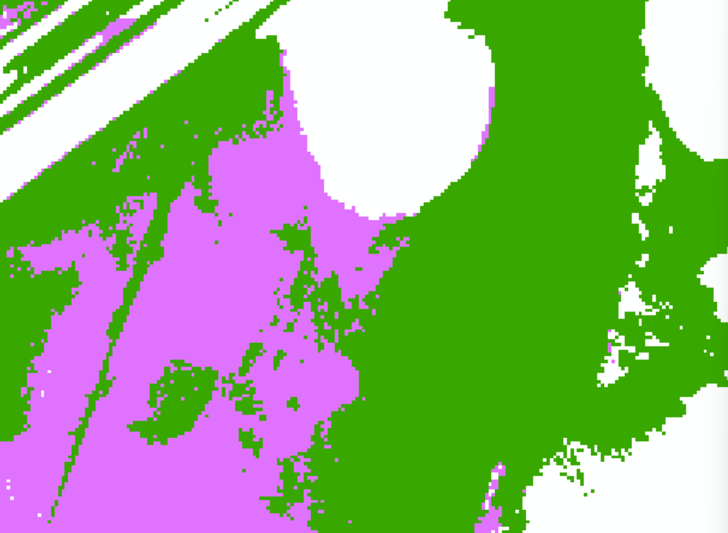
Figure 18: Example of Overlapping Mapping along a Model Domain Boundary
Figure 19 shows what the difference raster looks like for the area in Figure 18. Light green means the WSELs are within 0.5 feet of each other and red means they are not. The blue-black line is the split line. It has been aligned so that it crosses the difference raster where the raster is light green. To the south of this line, the purple raster in Figure 18 is the source of the floodplain mapping. To the north of the split line, the dark green raster is the source of the floodplain mapping. Along the split line is where the source of the mapping transitions from the purple mapping to the dark green mapping.
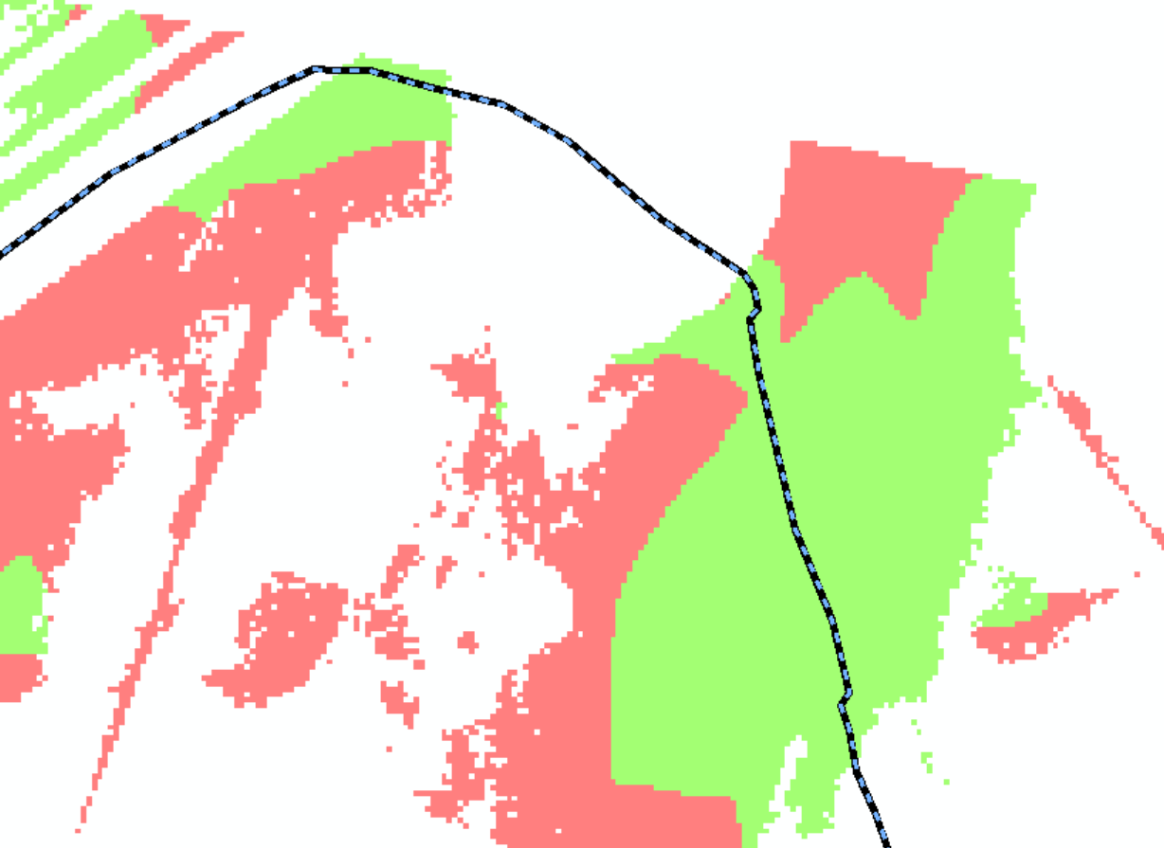
Figure 19: WSEL Difference Raster and Split Line for the Overlap Area
- The merged raw raster grids included connected and disconnected areas of potential flood hazard. To reduce the extent of these disconnected flood areas, process the rasters to filter and remove disconnected small, shallow areas of flooding. To do this, apply the TWDB’s mapping threshold matrix to remove shallow depths, small areas of flood risk, and disconnected areas. According to Figure 3.1 in TWDB’s 2D BLE guidelines, the watershed falls in the Inland Areas of Texas. Therefore, disconnected areas were removed if they met both of the criteria in Table 21.
Table 21: Inland Mapping Threshold Matrix
Area (acres) | Depth (feet)
Less than 0.33 | Remove all flooding
0.33 to 0.50 | Less than 0.33
0.50 to 1.0 | Less than 0.25
1.0 to 2.0 | Less than 0.10

- Fill the holes (i.e., islands) in the rasters using the Elevation Void Fill routine. For the 1% and 0.2% ACEs, holes in the rasters less than 2 acres were filled. For the 10% ACE, holes in the raster less than 0.5 acres were filled. Application of the Elevation Void Fill routine occasionally produces WSELs that are below the ground elevation. In cases where this phenomenon occurred, the WSELs were not revised from their subterranean values, but the depths at these locations were set to 0.1 feet.
- Convert each WSEL raster to a floodplain polygon.
- Many ponding areas were present throughout the watershed. Due to the large mesh cells used in the 2D modeling, the extent of the smaller ponds was not always mapped properly in the model output. To properly identify the flood hazard in these areas, transfer the ponding extents available in the National Hydrography Dataset into the 1% and 0.2% floodplain polygons. Do not transfer them into the 10% floodplain polygon.
- If any dams are present that have been catalogued by the National Inventory of Dams and include a normal pool storage of 200 acre-feet or more, review the spillway mapping along each dam. If the 1% and/or the 0.2% model output did not include any flooding along the spillway, manually revise the floodplain polygon(s) to flood the spillway.
- Add waterbodies of lake and reservoir inundation areas of 20 acres or greater to the WTR-LN and FLD_HAZ_AR feature classes. The National Inventory of Dams was used to identify dams with inundation areas greater than 20 acres. The areas of inundation were computed by measuring the areas of the normal pools visible on the aerial photography.
- Clean up each polygon by simplifying it and smoothing it. The intent of the simplify and smooth processes is to eliminate unnecessary/erroneous vertices, remove rough edges, and reduce the size and complexity of the raw floodplain polygons. Apply professional judgement to determine the appropriate tolerance for simplifying and smoothing the floodplain polygons. Set initial thresholds to 5 feet for simplifying and 25 feet for smoothing.
- Merge the 1%, and 0.2% ACE polygons into one feature class. Keep the 10% ACE polygon as a separate feature class.
- The extents of the final depth and WSEL grids must match the extents of the flood inundation polygons. Because of the clipping and smoothing procedures applied to the floodplain polygons, they will no longer match the extents of the rasters. Clip the depth and WSEL grids to each respective flood frequency inundation polygon to align the extents of the rasters with the extents of the floodplain polygons.
- Clip the rasters and the floodplain polygons using the HUC-8 watershed boundary.

Challenges
A handful of challenges were encountered during the Buchanan-LBJ Lakes BLE analysis. These challenges and their solutions are catalogued in the following subsections.
Balancing Flows between Small and Large Streams
The BLE models developed for the Buchanan-LBJ Lakes watershed are watershed-wide models. Each domain is similar in size to a HUC-10 watershed. As a result, streams with both large and small drainage areas are in the same model and cannot be isolated from one another. One of the main challenges of the BLE analysis was adjusting the model input parameters so that valid flows were produced along streams with both large and small drainage areas. For example, when the CN values were revised to increase flows that were too low along the smaller tributaries, this adjustment would occasionally lower the flows along the more-significant streams to a point below the lower end of that which was considered valid, and vice versa. To address this challenge, a range of acceptable CN values and Manning’s n values was established for the watershed. The parameters were adjusted only within this set range so that the model results did not skew too heavily in favor of the larger streams or the smaller streams. Balancing the validation needs between the small and large streams was further enhanced by assigning an equal weight to all validation locations and choosing validation locations such that a representative coverage of drainage areas and stream characteristics was included.
Modeling of Hydraulic Structures
Although detailed modeling of hydraulic structures was outside the scope of this BLE analysis,
completely ignoring the structures would have produced invalid model results. Therefore, hydraulic structures were modeled using a simplified approach. This included adding breaklines along dam crests, elevated roadways, and railroads to force the terrain surface to drain properly. Bridge and culvert openings were represented by hydro-enforcing burn lines that were roughly equal in width to the bridge and culvert opening sizes. The addition of breaklines at the dam crests throughout AtkinsRéalis’ BLE study area typically resulted in an overestimation of the 1% BLE floodplain extents and WSELs on the upstream side of the dam. On the downstream side of the dams, the floodplains and flows tended to be underestimated.
Cupping
Within HEC-RAS, the RAS Mapper interface provides three render modes for visualization of floodplains: Horizontal, Sloping, and Hybrid. Currently, the results of only the horizontal and sloping render modes can be exported. While the horizontal render mode produces “bathtubs” of isolated ponding per cell, the sloping render mode produces “cupping.” Cupping is a ramp-up of the depth in the overbanks occurring most often in areas of significant topographic relief. USACE’s HEC is aware of this issue, which is an error caused by the WSEL projecting to the adjacent cell’s average elevation. However, the timeframe for a solution to this error by the HEC is unknown. Since the TWDB mapping process is based on the sloping render mode output, this cupping effect can be identified in the final mapping products produced, as shown by the pink areas in Figure 20. The areas of cupping will not be removed or cleaned beyond the extents of the mapping clean-up process discussed herein. There is significant topographic relief throughout the Buchanan-LBJ Lakes watershed. Therefore, cupping is prevalent throughout the BLE mapping.
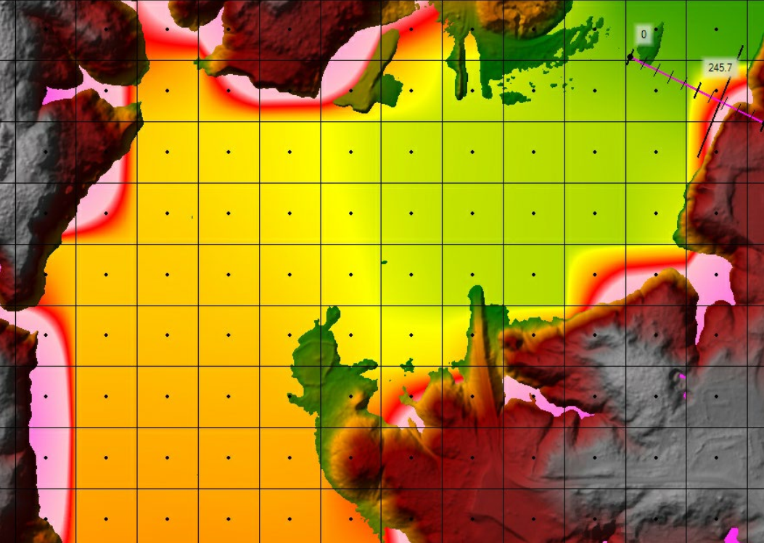
Figure 20: An Example of Cupping in 2D BLE Mapping

Crossing Profiles in the Inflow Hydrographs from the Middle Colorado HUC-8 Watershed
Upstream of the Buchanan-LBJ Lakes HUC-8 watershed is the Middle Colorado HUC-8 watershed. AtkinsRéalis completed BLE assessments for the TWDB in both watersheds.
The most downstream domain in the Middle Colorado watershed is 0606_A9. This domain drains into domain 0101_A1 in the Buchanan-LBJ Lakes watershed. The hydrographs for the 1% plus and the 0.2% events that exit domain 0606_A9 cross one another. See Figure 21 for details.
The Colorado River flows through the Middle Colorado watershed. Where the river enters the watershed is the O.H. Ivie Reservoir. The peak flows that exit the reservoir and continue along the Colorado River were based on the InFRM’s WHA gage analysis of USGS gage 08136700 (Colorado River near Stacy, TX). The 1% plus discharge computed by the gage analysis is higher than the 0.2% discharge as shown in Table 22.

Table 22: InFRM Gage Analysis Summary for USGS Gage 08136700
InFRM WHA Gage Analysis
AEP | USGS gage 08136700 (Colorado River near Stacy)
10% | 5,540
4% | 12,000
2% | 19,600
1% | 30,300
0.2% | 71,500
1% plus | 160,000
1% minus | 11,700
The 0.2% point rainfall totals in the Middle Colorado watershed are higher than the 1% plus rainfall totals. Runoff from the local rainfall enters the river before the peak flows out of the reservoir arrive. As a result, earlier in the model simulation, the 0.2% discharges are higher than the 1% plus discharges. Later in the model run, once the peak flows arrive from the reservoir, these profiles cross and the 1% plus discharges are higher than the 0.2% discharges, as shown in Figure 21.

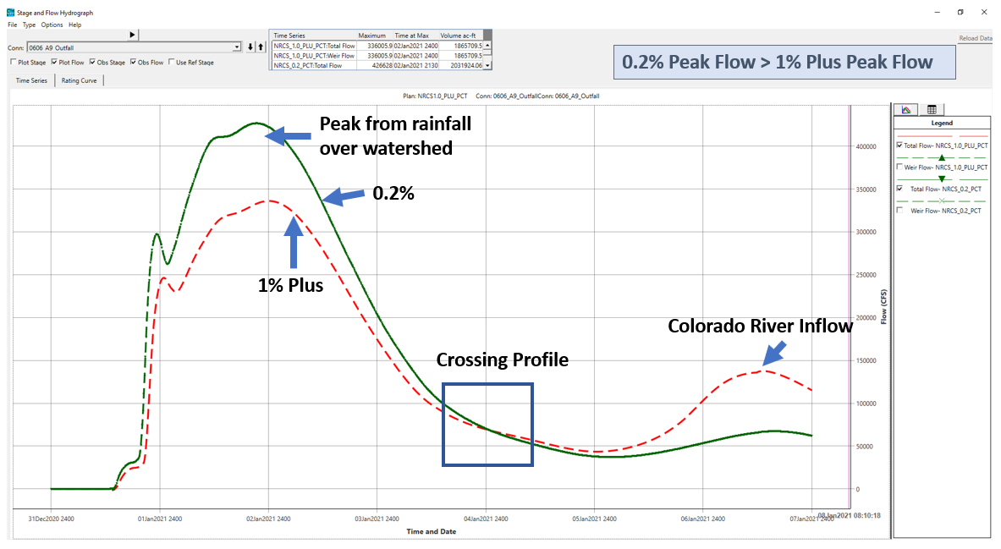
Figure 21: Crossing Hydrographs at the Outlet of the Middle Colorado HUC-8 Watershed
This phenomenon occurs along the length of the Colorado River in the Middle Colorado watershed. As a result, the hydrographs for the Colorado River for the 1% plus and 0.2% events that enter the Buchanan-LBJ Lakes watershed also cross, leading to crossing profiles in the Buchanan-LBJ Lakes watershed as well in domains 0101_A2 and 0102_A3. At the downstream end of domain 0102_A3 is Lake Buchanan, which drains into domain 0104_A6. Because of Buchanan Dam, at the downstream end of Lake Buchanan, the discharges from domain 0101_A3 into domain 0104_A6 have been decoupled from one another. Therefore, downstream of Buchanan Dam, the profiles for the 1% plus and 0.2% events no longer cross one another.
High Water Surface Elevations at the Wirtz Dam (Lake LBJ) and Buchanan Dam (Buchanan Lake)
Subsection 1.2.5 discusses the modeling approaches for Lake LBJ (Wirtz Dam) and Lake Buchanan (Buchanan Dam). Due to reasons described there, the BLE models overpredicted the runoff volumes that entered the lakes. See this subsection for details about this issue and for a description of how the dams were modeled to accommodate these large runoff volumes.
Crossing Profiles in the Perimeter BC Lines
When establishing the extents of each model domain, a buffer of 1,000 feet was applied to each HUC-10 watershed boundary to create overlapping domain boundaries. The purpose of these overlap areas was to facilitate clean floodplain and BFE transitions between domains, to capture the full extent of the floodplain within the watershed, and to minimize the impact of model boundary conditions on model results.
BC lines were placed around the perimeter of the buffered domain. Breakout areas where runoff left the domain received their own BC lines. For the rest of the domain, long BC lines were placed along the perimeter of the domain. Because of the buffering of the domain and the rain-on-grid approach applied in the model, some rainfall fell outside of the HUC-10 watershed ridgeline, in the area between the ridgeline and the edge of the buffered domain. This runoff needed to leave the domain or else it would have ponded up against the domain boundary. To allow this runoff to leave, long BC lines were placed around the perimeter of each domain. These BC lines assumed a normal depth boundary condition with a slope of 0.01 feet/foot.
At some of these perimeter BC lines, the stage hydrographs cross near the beginning of the model run. An example of where this occurred is in domain 0102_A3 along the perimeter BC line called BC Line 3. See Figure 22 for the orientation of BC Line 3 in the domain. See Figure 23 for the stage hydrographs at this BC line. Note that the profiles are crossing toward the beginning of the simulation.

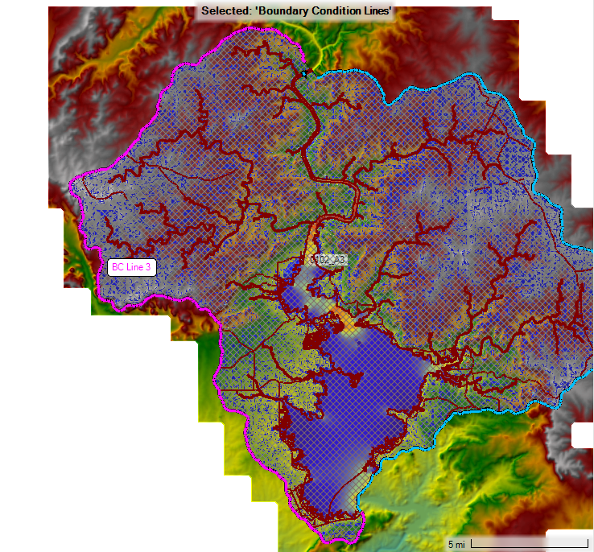
Figure 22: Layout of BC Line 3 in Domain 0102_A3
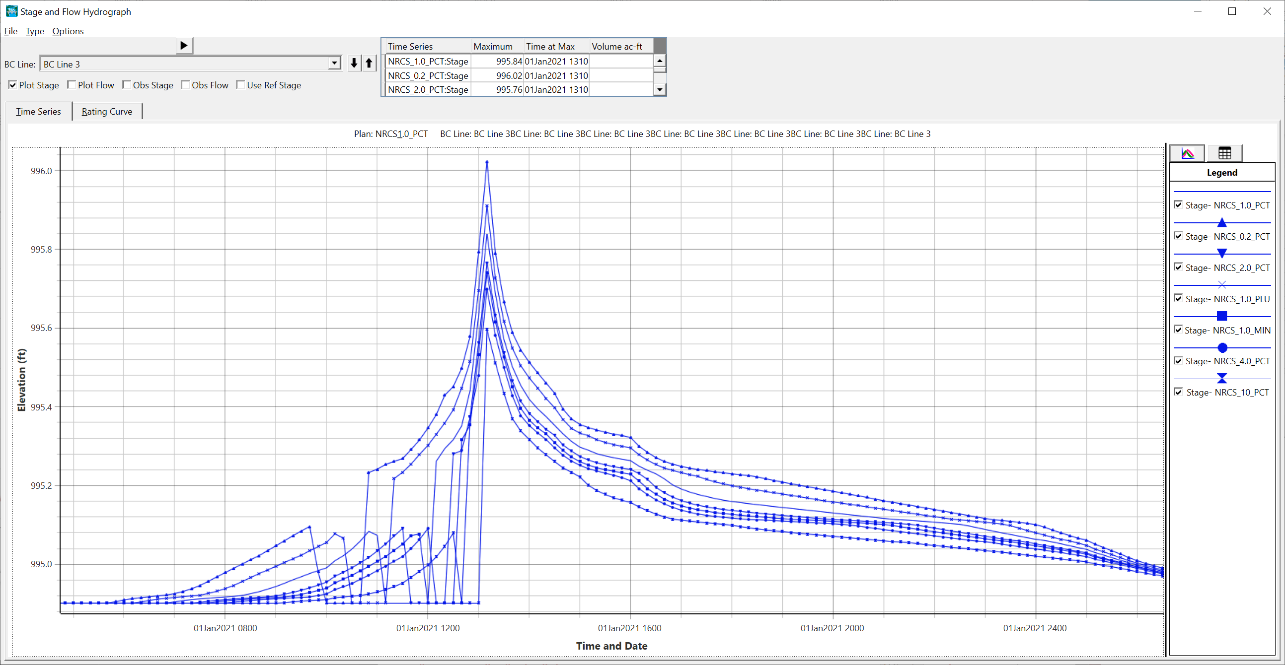
Figure 23: Crossing Stage Hydrographs at BC Line 3 in Domain 0102_A3
These profiles are crossing due to model instabilities when the rain first starts to fall during the simulation. Rainfall totals during this part of the run are only a few hundredth of an inch. In addition, the BC line is long (over 40 miles) and the stage hydrograph is only able to report a single WSEL at each time step even though the elevation along the BC line varies significantly across the line. Note that WSELs are computed at each cell face along the BC line, but HEC-RAS consolidates them into a single stage at each time step for the stage hydrograph.
These crossing profiles are acceptable because the stages in the stage hydrographs are not used to support any BLE outcomes. The BC lines with these stage hydrographs exist only to allow rain that falls outside of the HUC-10 watershed to leave the model without ponding.
High Flow Velocities in Limited Streams
In isolated locations in domains 0103_A4 and 0103_A5, the flow velocities for some streams were between 8 and 13 feet per second even though the stream channel beds were relatively flat. Only a handful of streams experienced these high velocities. The mesh was revised along the streams to attempt to lower the velocities, but the high velocities persisted. Fortunately, these high velocities only minimally affect the computed WSELs.
Use of InFRM WHA Data in This BLE Study
As described throughout this report, this BLE study leveraged data from a draft copy of the InFRM’s WHA of the Lower Colorado River Basin. AtkinsRéalis received the draft WHA gage analysis, the RFAs, and the reservoir HEC-HMS modeling output between November 2021 and October 2022. In August 2023, the final HEC-HMS model of the entire study area was made available, although information from this model was not included in the BLE study since it was received too late in the modeling workflow to be included.
The draft and final WHA outcomes may differ from each other. Future updates to the Buchanan-LBJ Lakes BLE study should review the final WHA to determine whether the WHA data used in the BLE study should be updated. This review should also consider whether any WHA data not already in the BLE study should be included in the analysis.

Results and Recommendations
The BLE floodplain mapping for the Buchanan-LBJ Lakes watershed compared reasonably well with the effective Special Flood Hazard Area (SFHA) in most cases, and provides an estimated 1% annual-chance floodplain in areas currently not mapped by FEMA. These results provide context for flood risk communication as part of the Discovery process and should be verified through community work map meetings before application to a regulatory product.
A map showing the BLE results for the Buchanan-LBJ Lakes watershed has been included as Appendix A.
The BLE floodplains were compared with the effective floodplains in the Buchanan-LBJ Lakes watershed. Overall, the BLE and FEMA mapping along the tributaries that enter the Colorado River matched well. See Figure 24 for a comparison between the BLE and FEMA mapping along Sandy Creek near State Highway 16. Along the creek, the floodplains are very similar. Along the tributaries to the creek, the BLE mapping tends to be narrower, but that is not surprising since the BLE models do not include any structures, and the combination of steep slopes with the 100-foot cell size in the model mesh tends to narrow the BLE floodplains.

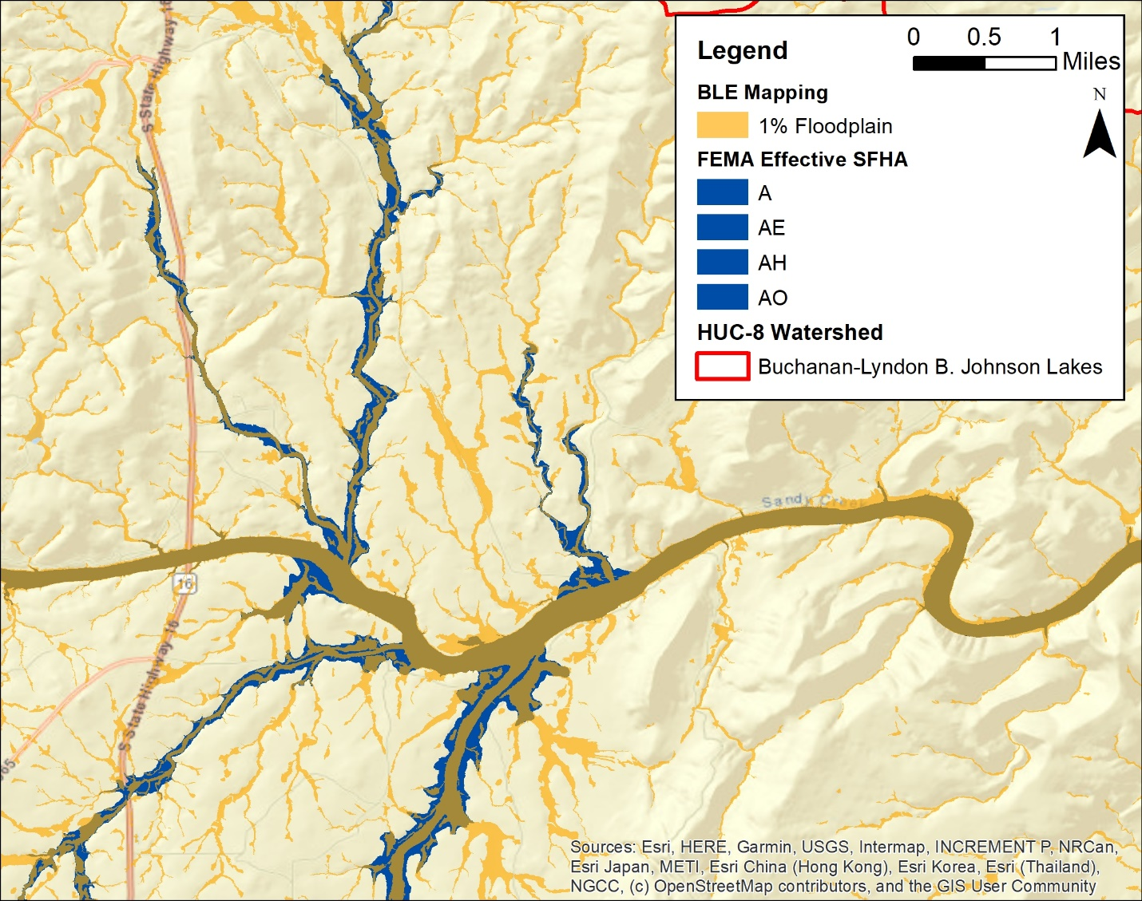
Figure 24: Comparison of the 1% BLE Mapping with the FEMA SFHA Mapping along Sandy Creek
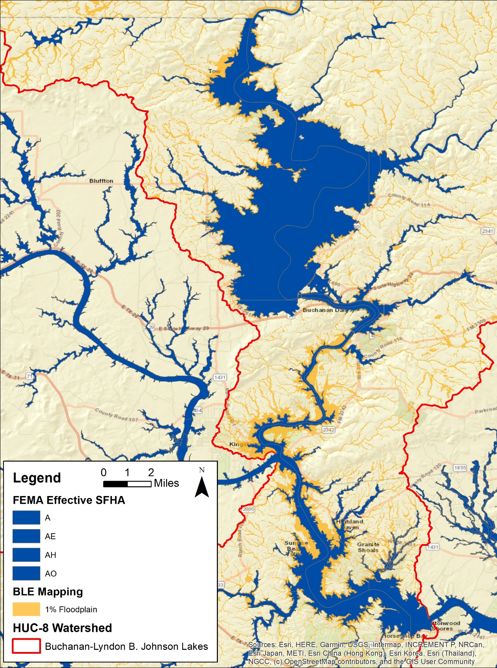
Figure 25: Comparison of the 1% BLE Mapping with the FEMA SFHA Mapping along the Colorado River
The BLE floodplains were also compared with the effective floodplains along the Colorado River, including Lake Buchanan and Lake LBJ. Figure 25 shows the Colorado River from Lake Buchanan through Lake LBJ. In the lakes and along the river, the BLE mapping is more extensive than the FEMA mapping. As discussed in Subsection 1.2.5, the BLE models overpredicted the runoff volumes that entered the lakes, which explains why the BLE mapping is more extensive than the FEMA mapping in this area.
Floodplain mapping for the Buchanan-LBJ Lakes watershed was also available from a contractor called Fathom. The TWDB acquired cursory floodplain data from Fathom to fill gaps in areas where no floodplain mapping was available in Texas. The Fathom floodplain dataset included pluvial, fluvial, and coastal storm surges produced using models developed at a 30-meter resolution for the entire state of Texas. The 30-meter Fathom models incorporated LiDAR data provided by the TWDB and NOAA Atlas 14 rainfall data in all areas of the state. Fathom model results were mapped to a 3-meter resolution. Fluvial and pluvial cells with depths less than 0.5 feet were removed from the results of the mapping dataset. The use of this dataset should be limited to areas where no other data source has been identified or areas where flood hazard information is outdated or unreliable. Limited use of this dataset is recommended due to limitations with accuracy, resolution, and age of the underlying datasets.
The 2D BLE results for the Buchanan-LBJ Lakes watershed were compared with the Fathom floodplain mapping. Figure 26 shows the 1% BLE mapping and the 1% Fathom mapping in the same area that is shown in Figure 24. In general, there was good agreement between the mapping from these two sources.

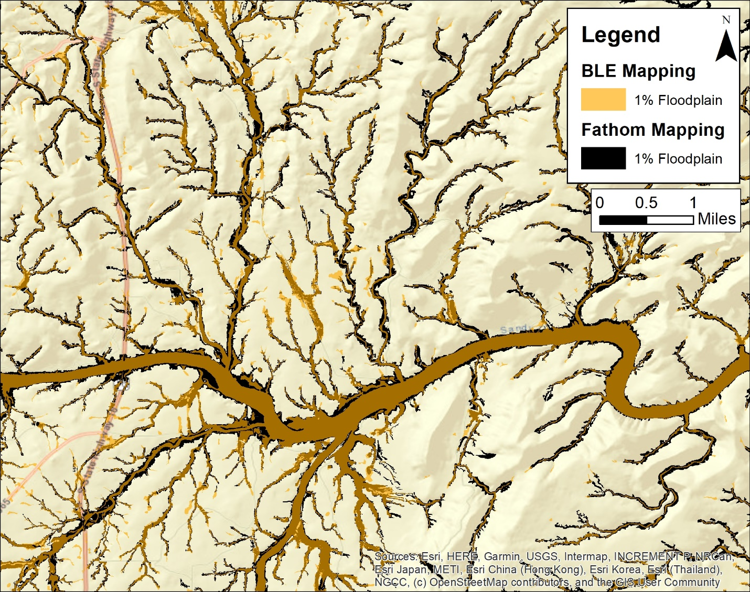
Figure 26: Comparison of the 1% BLE Mapping with the Fathom Mapping
Finally, as part of the BLE assessment effort, a point file was prepared to detail areas where model refinements may be warranted. These areas may be found in the feature class S_AOMI_AR in the mapping database.

Quality Control
To guide its quality control (QC) reviews, AtkinsRéalis developed three custom QC checklists for its TWDB 2D BLE studies. The checklists were for the terrain processing, the modeling, and the mapping tasks. The terrain processing checklist included 17 items and the modeling checklist included 51 items. The mapping checklist included 20 checks for the spatial data and 244 checks for the attributes in the mapping database. These robust checklists documented the QC review process, capturing reviewer comments and originator feedback throughout the comment resolution process. Checklists were not considered final until reviewed and approved by project leadership.
A major component of the QC process was an automated check that identified locations where the 1% annual-chance WSELs were crossed by another frequency or by the 1% plus or 1% minus profile. Significant effort was made to reasonably resolve all of these instances.
An ITR was completed on all BLE deliverables by a representative of the TWDB. AtkinsRéalis resolved all ITR comments prior to uploading the project deliverables to the MIP.

CNMS Validation of Effective Zone A Special Flood Hazard Area
Most of the Zone A streams in the Buchanan-LBJ Lakes watershed were classified as “UNVERIFIED” with a status type of “BEING STUDIED” (378.9 miles). The rest of the Zone A streams (116.0 miles) were classified as “VALID” with a status type of “BEING STUDIED.”
Initial Assessment A1 – Significant Topography Update Check
This check involved determining whether a topographic data source was available that was significantly better than that used for the effective Zone A modeling and mapping. For the Buchanan-LBJ Lakes watershed, USGS 1:24,000-scale topographic maps were used for the effective Zone A analysis. The LiDAR data used in the BLE analysis was a significant improvement over the effective data. Therefore, the A1 check failed for all effective Zone A reaches.
Initial Assessment A2 – Check for Significant Hydrology Changes
This check involved first determining whether regression equations were used in the effective study. If they were, then it was determined whether new regression equations had become available since the date of the effective Zone A study. If newer regression equations existed for the area of interest, then an engineer determined whether these regression equations would significantly affect the 1% annual-chance flow. The effective hydrologic analysis was not based on a regression analysis, therefore the A2 check was set to pass.
Initial Assessment A3 – Check for Significant Development
This check involved using the National Urban Change Indicator (NUCI) dataset to assess increased urbanization in the HUC-12 watersheds with Zone A studies. If the percentage of urban area within the watershed containing the effective Zone A study was 15% or more, and had increased by 50% or more since the effective analysis, then the study would fail this check. Although the NUCI data provided year-to-year changes in urbanization, the NLCD also was needed to establish a baseline of urban land cover for this analysis. This watershed is generally rural with few villages, and there has not been significant development in the watershed. A significant development check for the study areas was carried out using the NUCI dataset, which did not meet the urban change criteria. Therefore, the A3 check was set to pass for all reaches.
Table 23: Zone A Initial Assessment Results
Assessment Check | Pass/Fail | Comments/Notes
A1 - Topography | Fail | The LiDAR terrain data is a significant improvement over the terrain data used to develop the effective mapping.
A2 - Hydrology | Pass | The effective hydrologic analysis was not regression based.
A3 - Development | Pass | No significant development has occurred in the study area.

Initial Assessment A4 – Check of Studies Backed by Technical Data
Zone A studies that passed all of the initial assessment checks described above were categorized as “Valid” in the CNMS Inventory when the effective Zone A study was supported by modeling or sound engineering judgment and all regulatory products were in agreement. If the effective Zone A study passed all initial assessment checks but was not supported by modeling, or if the original engineering method used was unsupported or undocumented, then a comparison of the BLE results and effective Zone A mapping was performed. There was no adequate documentation regarding how the engineering analysis supporting the effective study was performed. Therefore, the A4 check was set to fail for all reaches in this study.
Initial Assessment A5 – Comparison of BLE and Effective Zone A Floodplains
The BLE/effective Zone A comparison method leveraged the existing Floodplain Boundary Standard (FBS) certification procedures described in FEMA SID 113, but with a slight modification. This modified FBS comparison approach used the 1% plus and 1% minus flood extents and the horizontal and vertical tolerances described in the CNMS Technical Reference. For the comparison of the BLE mapping and effective Zone A mapping in the study area, the following vertical and horizontal tolerances were used to conduct the modified FBS procedure. These comparisons were made at points spaced at a 100-foot interval along the outer extents of the effective Zone A mapping.
Vertical Tolerance: Plus or minus 5 or 10 feet (one-half contour interval of assumed effective topographic source). See the shapefile USGS_24k_Index.shp in the Supplemental data folder to see how the vertical tolerance varied throughout the watershed.
Horizontal Tolerance: Plus or minus 75 feet (standard horizontal tolerance for BLE comparison testing).
The terrain data used to complete Initial Assessment A5 was the terrain surface created from the LiDAR data that was acquired for the Buchanan-LBJ Lakes BLE analysis.
The contour interval for the vertical tolerance was taken from the USGS 1:24,000-scale topographic maps of the Buchanan-LBJ Lakes watershed.
The source of the effective Zone A mapping was FEMA’s NFHL and mapping that was digitized from FEMA’s paper FIRMs.
See Table 25 for a summary of the outcomes of Initial Assessment A5.
CNMS Validation Results
Based on the validation assessments and BLE comparisons described above, the CNMS inventory of the Zone A studies in the Buchanan-LBJ Lakes watershed has been updated. The total miles in each of these categories is summarized in Table 24 and illustrated on Figure 27. The findings from initial Assessment A5 are in Table 25.

Table 24: Zone A Validation Results
Validation Status | CNMS Validation Status | CNMS Project Start | CNMS Post-BLE Assessment
VALID | NVUE COMPLIANT | 0 | 0
VALID | BEING STUDIED | 173.2 | 59.4
UNVERIFIED | BEING STUDIED | 9.9 | 396.6
UNVERIFIED | TO BE STUDIED | 272.4 | 0

Table 25: BLE Comparison Results
HUC-12 Watershed |  | Total FBS Points | Fail | Pass | % Pass | BLE Comparison Pass? (>90%)
Watershed Name | HUC-12 ID
Elliott Creek-Colorado River | 120902010101 | 633 | 239 | 394 | 62.2% | No
Antelope Creek-Colorado River | 120902010102 | 1,774 | 298 | 1,476 | 83.2% | No
Salt Creek-Colorado River | 120902010103 | 2,139 | 703 | 1,436 | 67.1% | No
Rough Creek-Colorado River | 120902010104 | 1,199 | 805 | 394 | 32.9% | No
Lynch Creek-Colorado River | 120902010110 | 2,697 | 997 | 1,700 | 63.0% | No
Yancey Creek-Colorado River | 120902010111 | 2,566 | 1,263 | 1,303 | 50.8% | No
Spicewood Creek-Colorado River | 120902010201 | 392 | 60 | 332 | 84.7% | No
Deer Creek | 120902010202 | 1,105 | 246 | 859 | 77.7% | No
Headwaters Fall Creek | 120902010203 | 1,381 | 93 | 1,288 | 93.3% | Yes
Fall Creek-Lake Buchanan | 120902010204 | 1,896 | 417 | 1,479 | 78.0% | No
South Fork Morgan Creek-Lake Buchanan | 120902010205 | 2,626 | 468 | 2,158 | 82.2% | No
Lake Buchanan | 120902010206 | 1,419 | 205 | 1,214 | 85.6% | No
Upper Crabapple Creek | 120902010301 | 3,587 | 1,087 | 2,500 | 69.7% | No
Lower Crabapple Creek | 120902010302 | 3,112 | 769 | 2,343 | 75.3% | No
Headwaters Sandy Creek | 120902010303 | 5,938 | 711 | 5,227 | 88.0% | No
Hondo Creek-Sandy Creek | 120902010304 | 2,348 | 229 | 2,119 | 90.3% | Yes
Legion Creek-Sandy Creek | 120902010305 | 2,591 | 381 | 2,210 | 85.3% | No
Coal Creek | 120902010306 | 3,146 | 905 | 2,241 | 71.2% | No
Comanche Creek-Sandy Creek | 120902010307 | 3,460 | 450 | 3,010 | 87.0% | No
White Creek | 120902010308 | 989 | 119 | 870 | 88.0% | No
Upshaw Creek-Sandy Creek | 120902010309 | 1,918 | 129 | 1,789 | 93.3% | Yes
West Walnut Creek-Walnut Creek | 120902010310 | 1,306 | 224 | 1,082 | 82.9% | No
Clear Creek-Inks Lake | 120902010401 | 2,733 | 423 | 2,310 | 84.5% | No
Peters Creek-Lake Lyndon B Johnson | 120902010402 | 490 | 96 | 394 | 80.4% | No
Mill Creek-Lake Lyndon B Johnson | 120902010403 | 2,347 | 656 | 1,691 | 72.1% | No
Spring Branch-Lake Lyndon B Johnson | 120902010404 | 535 | 212 | 323 | 60.4% | No
Pecan Creek-Lake Lyndon B Johnson | 120902010405 | 217 | 1 | 216 | 99.5% | Yes
Slickrock Creek-Lake Lyndon B Johnson | 120902010406 | 771 | 20 | 751 | 97.4% | Yes

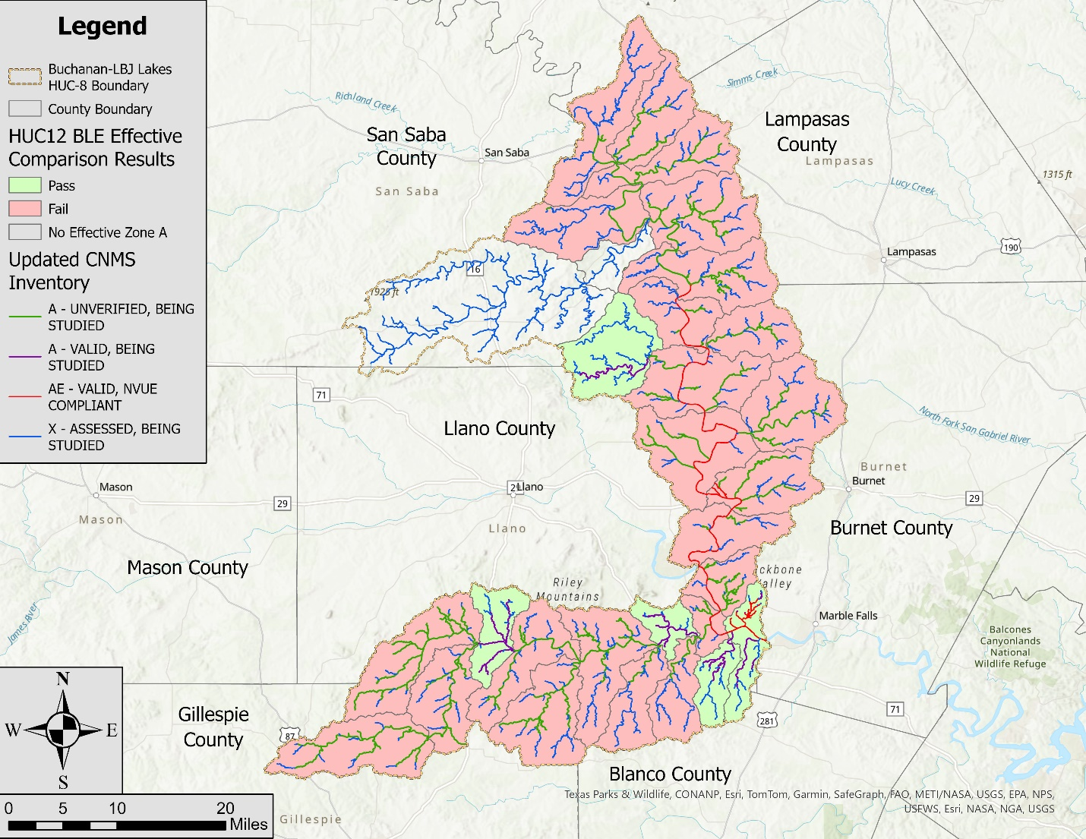
Figure 27: CNMS Validation Results

Flood Risk Analysis
A flood risk analysis was performed for the Buchanan-LBJ Lakes watershed. This analysis was completed using Hazus Version 5.1. Flood losses were based on the 1% annual-chance depth grids from the BLE analysis.
Additional inputs for the analysis were as follows.
S_AOMI_Ar
AoMIs are Areas of Mitigation Interest. This polygon feature class is intended to be used as a communication tool to direct users to areas that warrant further investigation or research for possible mitigation. The intent of this coverage area is to allow a visualization and depiction of areas that may be refined in future local, state, regional, or federal modeling efforts.
Areas typically identified by this feature class include:
- Areas of significant land use change – The source of land use data for this BLE assessment was the 2019 NLCD. The land uses captured by this database were compared with the land uses shown in the aerial imagery available in Google Earth when the floodplain mapping was being developed. Areas where the land use had changed significantly since 2019 were documented in the feature class.
- Intersections of significant streams with major roadways – Since structures were not explicitly included in the BLE models, these areas were identified as areas where additional analysis may be useful for refining the outcomes of the BLE study.
- Floodplain mapping tie-ins along the HUC-8 watershed boundary – Along the HUC-8 watershed boundaries where AtkinsRéalis completed BLE assessments for both watersheds, the floodplain mapping includes smooth tie-ins across the watershed boundaries. Along those HUC-8 watershed boundaries where AtkinsRéalis did not study both watersheds, the mapping tie-ins could not be smoothed since the BLE floodplain mapping in the neighboring watershed was not available. AoMIs were placed along these HUC-8 watershed boundaries to identify those tie-ins that potentially could be refined by a future modeling effort.
Outputs from the analysis were as follows.
S_FRACT_Ar
This is the flood risk assessment polygon feature class. It is the output for a flood level 2 analysis using Hazus Version 5.1, which is based on a 1% annual-chance depth grid. The calculated loss results from Hazus are stored in the polygon feature and are based on dasymetric census blocks. Dasymetric census blocks have had additional “undeveloped” land areas (primarily wetlands and forest) clipped out of the original census block boundaries based on USGS land use/land cover data. Loss values are reported in whole dollar amounts. See Table 26 below for a summary of the losses computed by Hazus.
L_Source_Cit
The data sources used for S_AOMI_AR are documented in the L_Source_Cit table.
Table 26: Hazus Results for the Buchanan-LBJ Lakes Watershed
County | Full Replacement –  Total Loss | Dollar Exposure (Replacement  Value) - Buildings | Dollar Exposure (Replacement  Value) - Contents
Blanco County | $5,426,000 | $38,890,000 | $23,884,000
Burnet County | $547,079,000 | $1,185,818,000 | $641,247,000
Gillespie County | $6,612,000 | $108,311,000 | $62,931,000
Lampasas County | $19,565,000 | $114,200,000 | $33,574,000
Llano County | $988,378,000 | $1,919,331,000 | $1,050,699,000
Mills County | $1,473,000 | $44,716,000 | $44,298,000
San Saba County | $20,458,000 | $88,214,000 | $48,738,000
Total | $1,588,991,000 | $3,499,480,000 | $1,905,371,000

References
This section includes a bibliographic list of the documents referenced throughout this document or used during the preparation of the BLE analysis.
- Chow, Ven T. Open Channel Hydraulics. Caldwell, NJ: Blackburn, 1959. Development of Uniform Flow and Its Formulas, pages 109-113. Print.
- Federal Emergency Management Agency (FEMA). Base Level Engineering – Region 6 Submittal Guidance. January 2019. Main report and Appendix A. PDF.
- Federal Emergency Management Agency (FEMA). Coordinated Needs Management Strategy (CNMS) Technical Reference. November 2021. Web. https://www.fema.gov/flood-maps/guidance-reports/guidelines-standards
- Federal Emergency Management Agency (FEMA). Flood Insurance Study for Burnet County, Texas and Incorporated Areas. November 1, 2019. PDF.
- Federal Emergency Management Agency (FEMA). National Flood Hazard Layer (NFHL). Web. https://hazards-fema.maps.arcgis.com/apps/webappviewer/index.html?id=8b0adb51996444d4879338b5529aa9cd
- Interagency Flood Risk Management (InFRM) Team. Watershed Hydrology Assessment for the Lower Colorado River Basin. DRAFT PDF. Chapter 5, pages 96, 97, and 152. 2021-08-13.
- Natural Resources Conservation Service. Gridded Soil Survey Geographic Database (gSSURGO). 2021 version. Web. https://data.nal.usda.gov/dataset/gridded-soil-survey-geographic-database-gssurgo
- Natural Resources Conservation Service. National Engineering Handbook, Title 210, Section 630, Chapter 4. August 2019 Version. Web. https://directives.sc.egov.usda.gov/OpenNonWebContent.aspx?content=43924.wba
- Sanja Perica, Sandra Pavlovic, Michael St. Laurent, Carl Trypaluk, Dale Unruh, Orlan Wilhite. NOAA Atlas 14 Volume 11 Version 2, Precipitation-Frequency Atlas of the United States, Texas. 2018. NOAA, National Weather Service, Silver Spring, MD.
- Soil Conservation Service. Engineering Technical Note No. 210-18-TX5. October, 1990.
- Texas Water Development Board (TWDB). Texas Two-Dimensional Base Level Engineering Guidelines, Version 1.0. May 21, 2022. PDF.
- United States Army Corps of Engineers (USACE). Hydrologic Engineering Center-River Analysis System (HEC-RAS), Version 6.2. March 11, 2022.
- United States Geological Survey (USGS). Lower Colorado San Bernard LiDAR, 2018-06-17. Web. https://data.tnris.org/collection?c=b246f8f7-9c79-4c89-91f7-9c7f44955fca#5.37/29.889/-99.969
- United States Geological Survey (USGS). Multi-Resolution Land Characteristics Consortium. National Land Cover Database 2019. https://www.mrlc.gov/data/nlcd-2019-land-cover-conus
- William H. Asquith, Meghan C. Roussel. Regression Equations for Estimation of Annual Peak-Streamflow Frequency for Undeveloped Watersheds in Texas Using an L-moment-Based, PRESS-Minimized, Residual-Adjusted Approach. USGS Scientific Investigations Report 2009-5087. June 2009.

Appendix A: Base Level Engineering Results
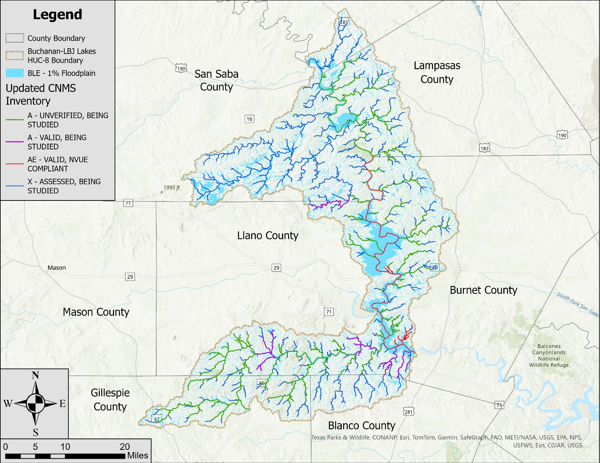
Appendix B: Supporting Documentation
The following information may be found in Appendix B. These documents provide further details regarding the methodology and outcomes of the BLE analysis for the Buchanan-LBJ Lakes watershed.
- Page 23 from Engineering Technical Note No. 210-18-TX5 titled Estimating Runoff For Conservation Practices – This is an excerpt showing a map of Average Runoff Conditions (ARC) across Texas. The term Antecedent Runoff Condition (ARC) used in the older literature is analogous to Antecedent Moisture Condition (AMC), which is the term that is commonly accepted today.
- Pages 91 through 95, 146, 106, 107, and 152 from Chapter 5 of the InFRM team’s draft Watershed Hydrology Assessment for the Lower Colorado River Basin. This is an excerpt from a draft copy of this report. This excerpt includes the gage analysis for USGS gage 08147000 (Colorado River near San Saba, TX) and USGS gage 08152000 (Sandy Creek near Kingsland, TX).
- Pages 58 through 63 from the Colorado RFA draft report. This is an excerpt from a draft copy of this report. This excerpt includes the data for the Lake Buchanan and Lake LBJ Reservoirs. The HEC-HMS Peak Outflow analysis for Lake LBJ is shown in the table below.
Return Int (yrs) | ACE (%) | Estimated Peak Outflow (cfs)
500 | 0.2 | 650,000
200 | 0.5 | 480,000
100 | 1 | 375,000
50 | 2 | 242,000
25 | 4 | 149,000
10 | 10 | 71,000
5 | 20 | 48,000

