





Report Prepared for:
Base Level Engineering Report
Upper Nueces (12110103)
CASE NUMBER: 22-06-0047S

February 29, 2024


Gauge Engineering
11750 Katy Freeway, Suite 400 Houston, TX 77079

Watearth
2215 Post Road Ste. 1056,
Austin, TX 78704

Report Prepared by:
Stantec
1905 Aldrich St Suite 300
Austin, TX 78723-3544

Cardinal Strategies
2770 Capital Street
Wylie, TX 75098

TWDB (Texas Water Development Board)
1700 Congress Avenue
Austin, TX 78701

Document History
Document Location
K:/FY2022/22-06-0047S

Revision History
Version Number | Version Date | Summary of Changes | Author
1.0 | May 2023 | Draft Deliverable to TWDB | Project team
1.1 | June 2023 | Disclaimer; regional hydrology; additional appendices | Stantec
1.2 | February 2024 | Final deliverable to TWDB | Stantec

Contents
Acronyms 7
Executive Summary 8
Modeling Approach - Overview, Limitations and Disclaimer 10
1 Introduction and Project Scope 12
2 Topographic and Watershed Data 15
2.1 Terrain Data Development 15
2.2 Final Seamless DEM 17
2.3 Watershed Data Development 17
2.4 Final Arc Hydro Data Model 18
2.4.1 Arc Hydro Data Model (Geodatabase and Rasters) 18
2.4.2 Hydrography Data (Geodatabase) 18
3 Hydrology 19
3.1 Precipitation-Frequency Estimates 23
3.2 Infiltration Parameters 25
3.3 Regional Hydrology and Basin Properties 26
3.4 Hydrologic Calibration 29
4 Hydraulics 30
4.1 2D Computational Mesh and Settings 31
4.1.1 Model Computational Settings 31
4.2 Breaklines and Refinement Regions 32
4.2.1 Breaklines 33
4.2.2 Mesh Refinement Regions 34
4.3 Manning’s n Surface Roughness 36
4.4 Terrain Modifications 37
4.5 Synthetic Inflow Hydrographs for Model Integration and Calibration 37
4.6 HUC10 Level Model Integration 40
4.6.1 Montell Creek – Nueces River (1211010104) and Model 301 (at the Indian Creek – Nueces River (1211010301) Boundary) 44
4.6.2 West Nueces River (1211010104) and Model 301 (at the Indian Creek - Nueces River (1211010103) Boundary) 45
4.6.3 Model 301 and Model 302 (flow transfer within the Sand Creek - Nueces River (1211010302) watershed) Boundary 46
4.6.4 Lower Turkey Creek (1211010406) and Model 302 (connection at the Sand Creek - Nueces River (1211010302) Boundary) 48
4.6.5 Model 302 and Model 303 Boundary 50
4.7 Calibration and Validation 52
4.8 Modeled Results 56
4.9 Challenges and Recommendations 57
5 Quality Control 58
6 Floodplain Delineation (10%, 1% and 0.2% events) 59
6.1 Internal Mapping Tie-ins 59
6.2 Hazus 60
6.3 Special Considerations 60
6.4 Results and Recommendations 61
7 CNMS Validation of Effective Zone A Special Flood Hazard Area (SFHA) 62
7.1 Deliverables 67
References 68
Appendix A – PeakFQ Output File 69
Appendix B – Supplemental Hydrology Data 70
Appendix C – Comparison of flow leveraging methods for Upper Nueces, Middle Nueces, and upper Frio BLE’s 76
Appendix D – Statement from the Nueces River Authority 97
Appendix E – FEMA Model Review and Recommendations with Stantec Responses 98

List of Figures
Figure 0-1. Task Order 1 HUC 8 Watersheds 9
Figure 0-2 Upper Nueces (12110103) and Middle Nueces (12110105) - HUC10 Basins and USGS Gage Locations 11
Figure 1-1. Upper Nueces (12110103)– HUC10 Basins 14
Figure 2-1. Extent and coverage of LiDAR Data as it relates to project watershed. 16
Figure 3-1: Example of temporal distribution curves for first-quartile events with 24-hour duration. Taken from NOAA Atlas 14 Volume 11. Accessed 12/13/2021. 19
Figure 3-2: Incremental unit hyetograph used to create timeseries of precipitation rasters. 20
Figure 3-3. Approximate geographic boundaries for NRCS (SCS) rainfall distributions. Taken from TR-55, Figure B-2 (USDA NRCS 1986). 20
Figure 3-4. Texas Temporal Distribution Regions: Interior Highlands (1), Central Plains (2), and Gulf Coast (3) 22
Figure 3-5. Comparison of NOAA Atlas 14 1st quartile temporal distributions and SCS Type II and Type III temporal distributions. 22
Figure 3-6. Total precipitation (inches) for baseline 1% event across Upper Nueces watershed 24
Figure 3-73-7. Gage locations in Upper and Middle Nueces watersheds and contributing area 27
Figure 3-83-8. Hydrographs from Nueces River flood in 1935 showing peak flow loss in system from Uvalde to Cotulla and Three Rivers, Texas (via Dalrymple et al. 1937) 28
Figure 3-93-9. Known location of stream losses to groundwater in the Nueces River (provided by Nueces River Authority) 29
Figure 4-1. HEC-RAS Unsteady Computation Options and Tolerances 32
Figure 4-2. Overview of HUC8 Scale Breaklines for Upper Nueces 33
Figure 4-3. Example of Refinement Region Polygon 34
Figure 4-4. Overview of HUC8 Scale Mesh Refinement Regions for Upper Nueces 35
Figure 4-5. Example of localized original terrain (left) and terrain after resampling and addition of modification layer (right) 37
Figure 4-6. Example Synthetic Hydrograph versus a full-volume inflow hydrograph 38
Figure 4-7. Overview of HUC8 with HUC10 Watershed Connectivity 40
Figure 4-8. SA/2D Normal Depth sensitivity and placement example 41
Figure 4-9. Overview of Adjusted Model Domains 42
Figure 4-10. 1211010104 and Model 301 Boundary Plan View 44
Figure 4-11. 1211010204 (TWDB) and Model 301 Boundary Plan View 45
Figure 4-12. Model 301 and Model 302 Boundary Plan View 46
Figure 4-13. Lower Turkey Creek 1211010406 and Model 302 Boundary Plan View 48
Figure 4-14. Model 302 and Model 303 Boundary Plan View 50
Figure 4-15. Task Order 1 HUC8 watershed overview with Edward’s Aquifer zones 53
Figure 4-16. USGS Gages in Nueces Headwaters 54
Figure 6-1. HUC 12110103 and HUC 12110105 Tie in Location 60
Figure 7-1. CNMS Validation Results 67
Figure B.0-1. Comparison of Atlas 14 and normalized model cumulative precipitation. 74
List of Tables
Table 0-1: Summary of Stream Miles 8
Table 0-2: Zone A Validation Results 8
Table 1-1. BLE Task Configuration 12
Table 2-1. LiDAR Data Sources 15
Table 3-1: Total number of precipitation cases and number (and Percent) of cases in each Atlas 14 Quartile for Selected Durations for Interior Highlands (1), Central Plains (2), and Gulf Coast (3) regions. 24
Table 3-2. SCS Hydrologic Soil Groups and Infiltration Parameters (Source: USACE 2021) 25
Table 3-3. Land Use - Soils - CN Matrix for Computing Initial Curve Numbers (SOURCE: USGS 2015) 26
Table 3-4. Summary of Peak Flows in the Nueces River Basin from historic storm events (See Figure 3-7) for gage locations) 27
Table 4-1. HUC10 Mesh Parameters 31
Table 4-2. Summary of Mesh Refinement Features for Upper Nueces 32
Table 4-3. Manning's n Values Applied in Models for Upper Nueces (Source: NRCS 2016) 36
Table 4-4. Comparison of Modeled Flows to Gage Analysis in Upper and Middle Nueces Watersheds 39
Table 4-5. HUC10 Model Integration Summary 43
Table 4-6. 1211010104 and Model 301 Continuity – all modeled events – Connection 1 44
Table 4-7. 1211010104 and Model 301 Continuity – all modeled events – Connection 2 45
Table 4-8. 1211010204 and Model 301 Continuity – all modeled events 46
Table 4-9. Model 301 and Model 302 Continuity – all modeled events – Connection 1 47
Table 4-10. Model 301 and Model 302 Continuity – all modeled events – Connection 2 47
Table 4-11. Model 301 and Model 302 Continuity – all modeled events – Connection 3 47
Table 4-12. 1211010406 and Model 302 Continuity – all modeled events – Connection 1 48
Table 4-13. 1211010406 and Model 302 Continuity – all modeled events – Connection 2 49
Table 4-14. 1211010406 and Model 302 Continuity – all modeled events – Connection 3 49
Table 4-15. 1211010406 and Model 302 Continuity – all modeled events – Connection 4 49
Table 4-16. 1211010406 and Model 302 Continuity – all modeled events – Connection 5 50
Table 4-17. 1211010302 and 1211010303 Continuity – all modeled events – Connection 1 51
Table 4-18. 1211010303 and 1211010502 Continuity – all modeled events – Connection 2 51
Table 4-19. 1%-Annual-chance Flood Event Calibration Results Summary for Nueces Headwaters 55
Table 4-20. 1% Annual-chance Flood Event – Modeled Peak Flow Comparison to USGS Regional Regression Estimates (equations and parameters via USGS 2009) 55
Table 4-21. 10%-Annual-chance Flood Results Summary for Nueces Headwaters 56
Table 4-22. 1%-Annual-chance Flood Results Summary for Nueces Headwaters 56
Table 4-23. 0.2%-Annual-chance Flood Results Summary for Nueces Headwaters 56
Table 7-1: Zone A Initial Assessment Results 62
Table 7-2: Zone A Validation Results 63
Table 7-3: BLE Comparison Results 64

Acronyms
AAL | Average Annualized Loss
BLE | Base Level Engineering
CN | Curve Number
CNMS | Coordinated Needs Management Strategy
DEM | Digital Elevation Map
FEMA | Federal Emergency Management Agency
GIS | Geographic Information System
HAZUS | Hazards United States
HC | Hydraulic Connector
H&H | Hydrology and Hydraulics
LiDAR | Light Detection and Ranging
NAVD | North American Vertical Datum
NHD | National Hydrography Dataset
NID | National Inventory of Dams
NLCD | National Land Cover Database
NRCS | Natural Resources Conservation Service
SCS | Soil Conservation Service
SFHA | Special Flood Hazard Area
TNRIS | Texas Natural Resource Information Systems
TWDB | Texas Water Development Board
USACE | United States Army Corps of Engineers
USGS | United States Geological Survey
QA/QC | Quality Assurance/Quality Control

Executive Summary
The Texas Water Development Board’s (TWDB) statewide floodplain modeling and mapping project is part of the TWDB’s effort to understand and evaluate regional flood risks to drive statewide efforts in the creation of effective flood mitigation strategies in Texas. Stantec Consulting Services Inc. (Stantec) is working with TWDB to develop Base Level Engineering (BLE) floodplain modeling and mapping studies with a multi-year contract that will include two-dimensional (2D) riverine model development, floodplain and flood hazard mapping, and Coordinated Needs Management Strategy (CNMS) data development for FEMA Region 6. This report summarizes the BLE hydrologic and hydraulic (H&H) analyses performed by Stantec for the Upper Nueces watershed, as part of Task Order #1 under Contract No. 2101792546. A summary of the study parameters and results for Upper Nueces watershed is provided below in Table 0-1, Table 0-2, and Figure 0-1.

Table 0-1: Summary of Stream Miles
Source | Stream Miles
Current Inventory – CNMS (S_Studies_Ln) | 1085 mi
New Study Streams – CNMS  (S_Unmapped_Ln)  Informed by NHD 1:100 | 497 mi
Total (BLE) Stream Miles | 1582 mi

Table 0-2: Zone A Validation Results
Validation Status | CNMS Validation Status | CNMS Project Start | CNMS Post-BLE Assessment | Total Miles
VALID | NVUE COMPLIANT | 0 | 0 | 0
UNKNOWN | Deferred, To Be Assessed and  To Be Studied | 0 | 0 | 0
UNVERIFIED | TO BE STUDIED | 1085 | 1085 | 1085

TWDB contracted Stantec under Task Order #1 to complete a BLE analysis for six, HUC8-scale watersheds in the Nueces and Frio River Basins, west of San Antonio, in the Edward’s Aquifer region:
- Nueces Headwaters - # 12110101
- Upper Nueces - #12110103
- Turkey - #12110104
- Middles Nueces - #12110105
- Upper Frio - #12110106
- Hondo - #12110107

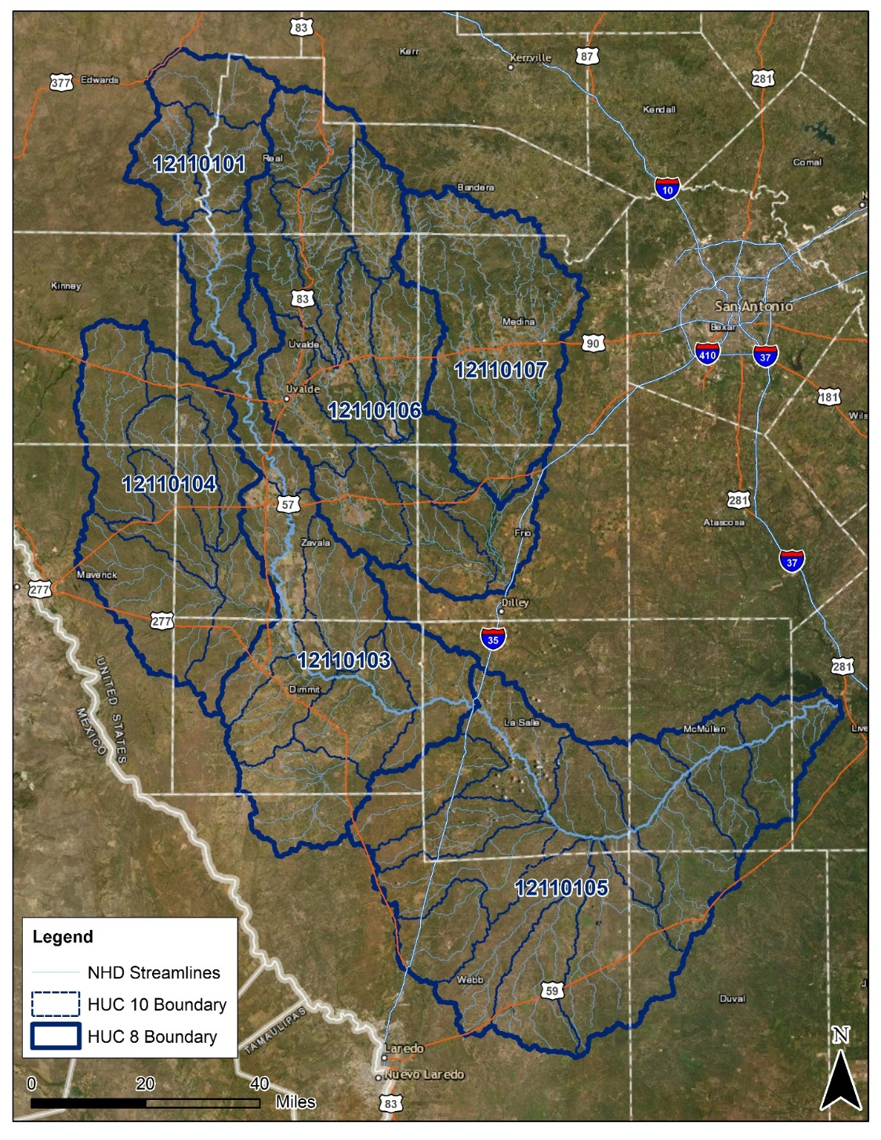
Figure 0-1. Task Order 1 HUC 8 Watersheds

Results of this study affect the counties of Edwards, Kinney, Real, Uvalde, Zavala, Maverick, Medina, Kerr, Bandera, Frio, Dimmit, La Salle, McMullen, Webb, Duval, and Live Oak. The BLE Analysis under this Task Order was Divided into five tasks covered in this report:
- Task 1 – Terrain Development (Section 2)
- Task 2 – Hydrologic and Hydraulic Analysis (Section 3 and 4)
- Task 3 – Floodplain Mapping (Section 6)
- Task 4 – HAZUS Estimation (Level 2)
- Task 5 – CNMS (Section 7)

Modeling Approach - Overview, Limitations and Disclaimer
Base Level Engineering (BLE) watershed analyses use automated modeling and high-resolution terrain data to produce both credible and approximate, hydrologic and hydraulic estimates for thousands of miles of streams in a single model. Due to watershed complexities such as documented interactions between ground and surface water, and due to limitations of the current version of the Hydrologic Engineering Center’s River Analysis System (HEC-RAS) modeling software to simulate such conditions, certain modeling approaches implemented for this BLE analysis vary from typical TWDB and FEMA BLE modeling methods.
These alternative modeling approaches were utilized to produce estimated Base Flood Elevations (eBFEs) and approximate flood depths that compare reasonably well to flood frequency analyses performed at United States Geological Survey (USGS) gages, while reducing model complexity and improving usability. While the results of this analysis and the modeling approach employed therein satisfy the objective of approximate flood hazard mapping (BLE), the limitations of the methodology should be noted.
Detailed documentation describing the modeling approach and its limitations has been provided in Section 4.5. End-users of the corresponding hydraulic models should review this documentation to understand the alternative methodology used in this study. End-users are advised to seek professional review prior to use or adaptation of these models.
Upper and Middle Nueces – Groundwater-Surface Water Interaction and Modeling Approach Overview
Results from USGS Bulletin 17C flood frequency analyses performed for gages in the Upper and Middle Nueces basins showed a significant reduction in the 100-year peak discharge estimates in the Nueces River (Figure 0-1) moving downstream from USGS gage 08192000 (486,500 cfs) to gage 08193000 (30,320 cfs). Peak flow volume loss of this nature is demonstrated in historic gage records for many flood events and is discussed in Section 3.3. This type of volume loss along a stream is indicative of this portion of the Nueces River being a losing stream. A losing stream is defined by the USGS as a stream that loses water to the groundwater system. This phenomenon has been verified in this portion of the Nueces River with historical storm data, USGS hydrologic studies, ongoing Watershed Hydrology Assessment (WHA) conducted by USACE and anecdotal information from the local river authority. Detailed background and summary of the hydrologic nuances of the basin are discussed in the Hydrology section of this report.
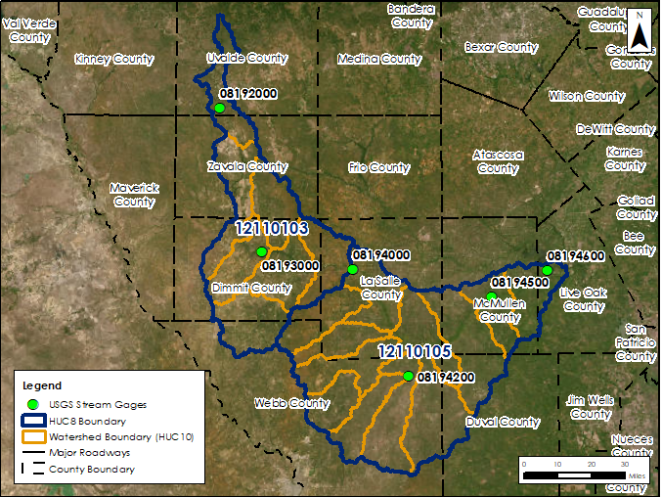
Figure 0-2 Upper Nueces (12110103) and Middle Nueces (12110105) - HUC10 Basins and USGS Gage Locations
Preliminary rain-on-grid models that were developed with Region 6 BLE approach guidelines (detailed methodology described in the report), were adjusted in an attempt to calibrate to the 08192000 and 08930000 gages for the 100-year storm event. However, it proved impossible to reduce the peak flow by over 90% (per the gage analysis) through adjusting traditional calibration parameters.
An alternative modeling approach was developed to remove excess volume from the Nueces River using a synthetic inflow hydrograph. The methodology for the synthetic hydrograph development and application, as well as the results of the methodology, are described in detail in the hydraulics section of this report.
The intent of this BLE assessment, consistent with FEMA Region 6 guidelines for BLE efforts is, “to provide communities technically credible flood hazard information in a cost efficient and timely manner.” This study is in line with BLE FEMA Region 6 guidance, “is very much driven by the use of automated methods and very little ground survey.” It was determined that more detailed evaluation of the complex hydrology was outside the scope of BLE and could be completed for a future, enhanced level of study. Additional future recommendations for this watershed are discussed in Section 4.9.

Introduction and Project Scope
The Texas Water Development Board (TWDB) contracted Stantec under Task Order #1 to complete a Base Level Engineering (BLE) analysis for six, HUC8-scale watersheds in the Nueces and Frio River Basins, west of San Antonio, in the Edward’s Aquifer region:
- Nueces Headwaters - #12110101
- Upper Nueces - #12110103
- Turkey - #12110104
- Middles Nueces - #12110105
- Upper Frio - #12110106
- Hondo - #12110107
Results of this study affect the counties of Edwards, Kinney, Real, Uvalde, Zavala, Maverick, Medina, Kerr, Bandera, Frio, Dimmit, La Salle, McMullen, Webb, Duval, and Live Oak.
The BLE process involves using best available data and incorporating automated techniques with traditional hydrologic and hydraulic model development procedures to produce regulatory quality flood hazard boundaries for the 1-percent-annual-chance event as well as estimates of flood hazard boundaries for multiple recurrence intervals. The BLE analysis under this Task Order was divided into six tasks, most of which are covered in this report:
- Task 1 – Terrain Development (Section 2)
- Task 2 – Hydrologic and Hydraulic Analysis (Section 3 and 4)
- Task 3 – Floodplain Mapping (Section 6)
- Task 4 – HAZUS Estimation (Level 2)
- Task 5 – CNMS (Section 7)
- Task 6 – Project Management (includes community outreach)
A breakdown of each task is summarized in Table 1-1.
Table 1-1. BLE Task Configuration
Task ID | Task | Task Phase ID | Task Phase
1 | Terrain Data Development | 1.1 | Phase1: Seamless HUC8 DEM
1 | Terrain Data Development | 1.2 | Phase2: Streams and sub-watersheds
1 | Terrain Data Development | 1.3 | Phase3: Incremental deliverables, report, internal QA/QC
1 | Terrain Data Development | 1.4 | Phase4: Independent QA/QC (Respond/Resolve comments only)
2 | Hydrology and Hydraulic Analyses | 2.1 | Phase1: Draft HECRAS Model
2 | Hydrology and Hydraulic Analyses | 2.2 | Phase2: Model Adjustments/Calibration
2 | Hydrology and Hydraulic Analyses | 2.3 | Phase3: Multi-frequency Runs
2 | Hydrology and Hydraulic Analyses | 2.4 | Phase4: Incremental deliverables, report, internal QA/QC
2 | Hydrology and Hydraulic Analyses | 2.5 | Phase5: Independent QA/QC (Respond/Resolve comments only)
3 | Floodplain Mapping & Grids | 3.1 | Phase1: Mapping/Grid products and Geodatabase
3 | Floodplain Mapping & Grids | 3.2 | Phase2: Incremental deliverables, report, internal QA/QC
3 | Floodplain Mapping & Grids | 3.3 | Phase3: Independent QA/QC (Respond/Resolve comments only)
4 | Hazus Estimation (Level2) | 4.1 | Phase1: Loss Estimation and Geodatabase
4 | Hazus Estimation (Level2) | 4.2 | Phase2: Incremental deliverables, report, internal QA/QC
4 | Hazus Estimation (Level2) | 4.3 | Phase3: Independent QA/QC (Respond/Resolve comments only)
5 | CNMS | 5.1 | Phase1: Round1 CNMS
5 | CNMS | 5.2 | Phase2: Independent QA/QC (Respond/Resolve comments only)
5 | CNMS | 5.3 | Phase3: Round2 CNMS
5 | CNMS | 5.4 | Phase4: Independent QA/QC (Respond/Resolve comments only)
6 | Project Management | 6.1 | Project Kickoff & Community Outreach
6 | Project Management | 6.2 | TWDB Coordination/Invoicing/Reporting
6 | Project Management | 6.3 | FEMA/USGS Coordination and Project Closeout

The BLE results from this study may be used for eventual production of regulatory and non-regulatory products. This report describes the BLE analysis performed for Upper Nueces watershed (Figure 1-1) which includes coverage of portions of Dimmit, La Salle, Uvalde, Webb, and Zavala counties.
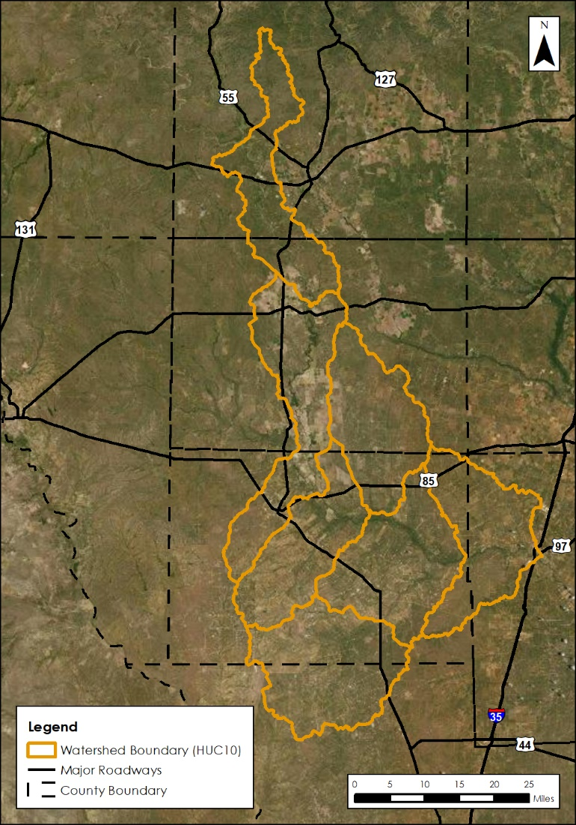
Figure 1-1. Upper Nueces (12110103)– HUC10 Basins
The Base Level Engineering assessment for the Upper Nueces watershed prepared cursory engineering analysis for approximately 844 miles of stream reaches with a minimum drainage area tolerance of one square mile; the stream selection was not based number of effective Zone A stream miles. The following sections will summarize the BLE process and will discuss the results along with their recommended use.

Topographic and Watershed Data

Terrain Data Development
The primary sources for Upper Nueces terrain data were the Lower Colorado San Bernard (2018), South Texas (2018), and South-Central Texas (2018) LiDAR projects obtained from the Texas Natural Resource Information System (TNRIS), along with South Texas Lidar and South-Central Texas Lidar Collections. The individual Digital Elevation Model (DEM) tiles from the data sources were used to create one seamless DEM mosaic for the Upper Nueces Watershed. This HUC8 watershed was covered by three data sources.
The final seamless DEM was developed by cataloging the tiles and then mosaicking them into one DEM while maintaining UTM Zone 14 meters NAVD88 meters and raster cell size 1 by 1; this was done for each individual data source applicable to the project watershed. The full DEM was then projected into the NAD83 Texas South Central FIPS 4204 (US Foot) horizontal projected coordinate system and clipped to a buffer (minimum of 500 ft.) based on the NHD HUC8 boundary. The raster values from the clipped output were converted from meters to feet.
In instances where the watershed was covered by multiple overlapping data sources, the mosaicking process prioritized using the most recent data source within the overlapping area. Otherwise, a Blend option was used is areas where tiles may overlap with one another.
Table 2-1. LiDAR Data Sources
LiDAR Collection  Name | County¹ | Age/Year | Accuracy² | Source & Contact | Approximate Footprint (Sq Mi)³
Lower Colorado San Bernard 2018 | Dimmit, Uvalde, and Zavala | 02/2018 – 04/2018 | Horizontal: +/-42.8cm at 95% confidence level  Vertical:  NVA: 4.5cm RMSEz  NVA (DEM): 4.9cm RMSEz  VVA (DEM): 17cm 95th Percentile | Texas Natural Resources Information System (TNRIS) | 17,942
South Texas 2018 | La Salle and Webb | 01/2018 - 02/2019 | Horizontal: +/-29.4cm at 95% confidence level  Vertical:  NVA: 9.0cm RMSEz  NVA (DEM): 8.9cm RMSEz  VVA (DEM): 28cm 95th Percentile | Texas Natural Resources Information System (TNRIS) | 22,229
South Central Texas 2018 | Dimmit, La Salle, and Zavala | 01/2018 - 01/2018 | Horizontal: +/-98.1cm at 95% confidence level  Vertical:  NVA: 5.9cm RMSEz  NVA (DEM): 11.6cm RMSEz  VVA (DEM): 12.3cm 95th Percentile | Texas Natural Resources Information System (TNRIS) | 5,329
¹Counties listed are only those applicable to current project watershed.
²Accuracy derived from original Lidar project report.
³Area reported reflects coverage of entire lidar project beyond the current project watershed.

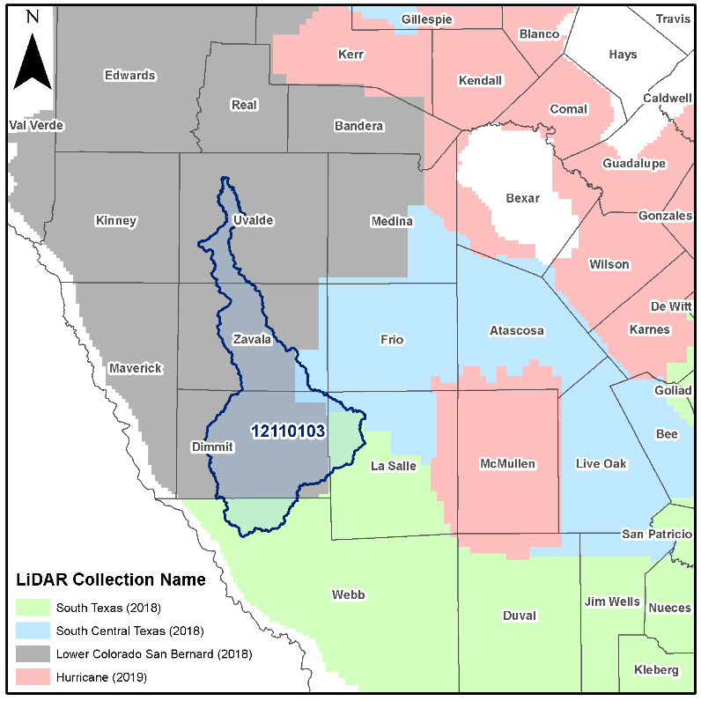
Figure 2-1. Extent and coverage of LiDAR Data as it relates to project watershed.

Final Seamless DEM
The final DEM developed covers the project watershed, has been re-projected into the local State Plane (NAD83) horizontal coordinate system, and has raster cells values adjusted from meters to feet.
Projection: NAD83 Texas South Central FIPS 4204 (US Foot)
Linear: US Feet
Horizontal Datum: NAD83
Vertical Datum: NAVD88
Vertical Units: US Survey Feet

Raster Information:
Pixel Depth: 32 bit
Number of Bands: 1
Cell Size: 3.2808333, 3.2808333 (feet)
Format: TIFF

Watershed Data Development
The primary data source for this phase was the seamless DEM developed in the first phase. The seamless DEM was the basis for subsequent processing using the Arc Hydro toolset. The Arc Hydro processing steps outlined below create output that collectively creates the Arc Hydro data model for this watershed.

- Fill Sinks
- Flow Direction
- Flow Accumulation
- Stream Definition (1 sq. mile threshold used)
- Stream Segmentation
- Catchment Grid Delineation
- Catchment Polygon Processing
- Drainage Line Processing
- Adjoin Catchment Processing

The final data products from this phase include a geodatabase developed using Arc Hydro tools, a collection of rasters developed using Arc Hydro tools, a geodatabase containing the drainage lines within the study watershed, and a new HUC8 watershed boundary.

The one issue that arose during the Arc Hydro data development in this phase was several missing outputs for a small section in the downstream area of the watershed, approximately 43 miles upstream along the Nueces River from the watershed drainage outlet. This area contains numerous flow paths and damming structures which are believed to be contributing variables to the lack out output from the automated Arc Hydro processing. For this watershed, a much smaller Arc Hydro data model was developed to supplement the drainage lines; this area was also supplemented by the NHD flowlines that had their centroid within the missing area. In addition to this area, a catchment along Turkey Creek on the border of 12110103 and 12110104 was re-delineated in the supplemental data to improve consistency with NHD HUC8 boundary.

Final Arc Hydro Data Model
The final watershed data is composed of an Arc Hydro data model and hydrography data. The Arc Hydro data model contains vector, raster, and tabular data outputs from using the various Arc Hydro processing tools. The hydrography data contains streams that represent drainage of at least 1 square mile, updated HUC8 watershed boundary, and a comparison between the NHD HUC8 watershed boundary and the project watershed delineation.

Arc Hydro Data Model (Geodatabase and Rasters)
- Geodatabase (.gdb)
  - ArcHydro (feature dataset)
    - Adjoint Catchment – An adjoint catchment is the total upstream area (if any) draining into a single catchment.
    - Catchment – Polygon feature class created from the catchment grid.
    - DrainageLine – Streamline line feature class derived from stream link grid.
  - APUNIQUEID – A table created and managed through Arc Hydro tools; contains the last hydro identifier assigned to a new feature within the geodatabase.
- Rasters (.tif)
  - Catchment Grid (Cat) – Drainage areas for segments in the stream link grid or sinks in the sink link grid.
  - Flow Accumulation Grid (Fac) – Created from the flow direction grid; each cell value represents the total quantity of upstream cells draining to that cell.
  - Flow Direction Grid (Fdr) – Represents the direction of flow from a given cell; 8 different directional values are possible based on the eight-direction (D8) flow model.
  - Fill Sinks Grid (Fil) – Gridded DEM with sinks or depressions removed.
  - Stream Grid (Str) – A stream grid with cells from a flow accumulation grid that exceed a user defined cell count and/or area threshold.
  - Stream Link Grid (StrLnk) – A stream grid with unique values for every link between two stream junctions.

Hydrography Data (Geodatabase)
- Drainage Lines – Drainage lines from the Arc Hydro data modeling within the study HUC8.
- Watershed – A watershed delineation developed through Arc Hydro and based on the elevations within the Seamless DEM created in Task 1 Phase 1.
- Watershed Comparison – A comparison of the watershed feature and the NHD WBD HUC8 boundary.

Hydrology
The Hydrologic Engineering Center’s River Analysis System (HEC-RAS) Version 6.3 has the capability to utilize spatially varying precipitation, improving the hydrologic representation of the study area. Gridded precipitation data from NOAA Atlas 14 were added to HEC-RAS model using the Unsteady Flow Boundary Conditions editor, from the Meteorological Data tab. The gridded precipitation data was temporally distributed using the NOAA Atlas 14 Volume 11, Region 2, 1st quartile, 50% event hyetographs (Figure 3-1) to create 6-minute, 24-hour duration time series of gridded precipitation (Figure 3-2). Rasters of these hyetographs were generated on a HUC-8 level and converted to DSS files for import into HEC-RAS.
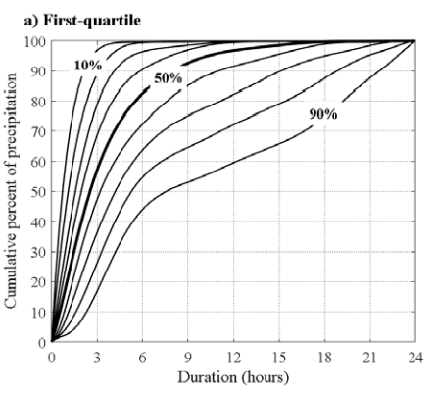
Figure 3-1: Example of temporal distribution curves for first-quartile events with 24-hour duration. Taken from NOAA Atlas 14 Volume 11. Accessed 12/13/2021.

Figure 3-2: Incremental unit hyetograph used to create timeseries of precipitation rasters.
Traditionally, total precipitation depths have been disaggregated using the temporal distributions prescribed in Technical Release 55 (TR-55; USDA NRCS 1986), which are commonly referred to as SCS rainfall distributions. The SCS storms are synthetic rainfall distributions that were developed to maximize rainfall intensities and produce conservative peak discharges for design level analyses (USDA NRCS 1986). They were developed nearly 40 years ago and therefore do not account for any changes of shifts in global weather patterns, moisture sources, or physics governing extreme precipitation in the region under consideration. Additionally, they were developed to be representative of any site in the United States (see Figure 3-3). For additional detail on the selection and application of the NOAA Atlas 14 temporal distributions refer to Appendix B – Supplemental Hydrology Data
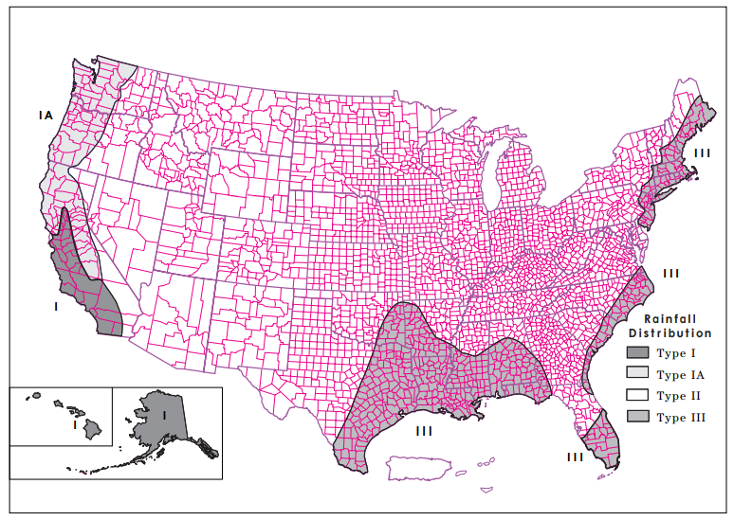
Figure 3-3. Approximate geographic boundaries for NRCS (SCS) rainfall distributions. Taken from TR-55, Figure B-2 (USDA NRCS 1986).
Stantec utilized temporal distributions presented in NA14 Volume 11 because they are provided with the precipitation-frequency information and are more representative of current temporal storm patterns in Texas. The temporal distributions in NA14 Volume 11 were developed through a thorough analysis of historic storms within the region and contain 30+ additional years of storm data since the publication of TR-55. The temporal distributions presented in the NA14 report are synthetic rainfall distributions, but they are based upon thousands of historic storms, which makes them more representative of the physical processes that drive extreme precipitation in Texas. These historic storms provide a better representation of extreme storms in the region.
Figure 3-4 presents the three Texas regions for which temporal distributions were developed as part of NA14 Volume 11. The HUC-8 watersheds modeled by Stantec are all contained within Region 2 (see Figure 3-4). The NA14 analysis divides the historic storms into four categories, which are defined by the quartile in which the greatest percentage of precipitation occurred (Perica et al. 2018). For Region 2, nearly 50% of all historic storms were categorized as first quartile storms, meaning the majority of precipitation fell in the first 6 hours of a 24-hour storm (see Table A.5.1 in Perica et al. 2018). The second, third and fourth quartile storms all contained fewer than 20% of the historic storms, thus justifying the use of the first quartile temporal distributions.
The storms for each quartile are further distilled into temporal distributions for nine deciles (10% to 90%). To achieve this, cumulative precipitation amounts were converted to percentages of the total precipitation amount at one-hour time increments. All storms for a specific duration were then combined and probabilities of occurrence of precipitation totals were computed at each hour (Perica et al. 2018). Stantec utilized the 50% temporal distribution, which represents the median of all the storms. The decision to use the 50% temporal distribution was made to provide a temporal distribution that is not overly conservative and will not erroneously overestimate the floodplain.
Figure 3-5 presents an example of the set of temporal distribution curves for Region 2, first quartile storms of 24-hour duration. Figure 3-5 also presents the SCS temporal distributions specific to the state of Texas (i.e., Type II or Type III, see Figure 1). For both Type II and Type III temporal patterns, over 50% of the total precipitation occurs between the 11th and 13th hours of the storm. As can be seen in Figure 3-5 this is not what is seen in historic storms in the region. The SCS storms are maximized and do not necessarily represent any changes to the physics of extreme precipitation over the past 30+ years. NA14 storms are based upon observed historic storms, thus will represent realistic conditions for all three regions in Texas.
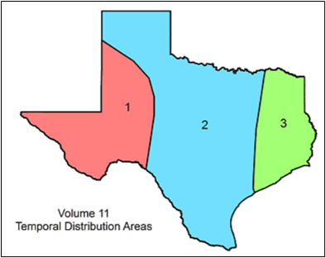
Figure 3-4. Texas Temporal Distribution Regions: Interior Highlands (1), Central Plains (2), and Gulf Coast (3)
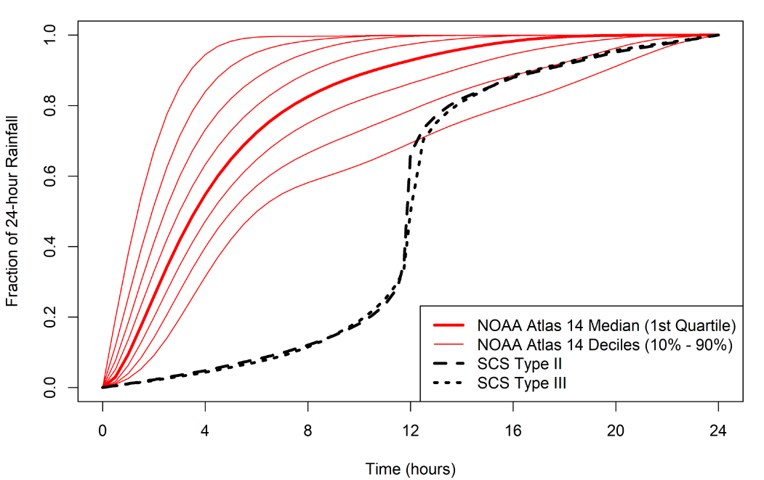
Figure 3-5. Comparison of NOAA Atlas 14 1st quartile temporal distributions and SCS Type II and Type III temporal distributions.

Precipitation-Frequency Estimates
Precipitation-frequency estimates for this study were obtained from NOAA Atlas 14 in Geographic Information system (GIS) compatible format (NOAA 2017). Specifically, precipitation depths for 10-year, 25-year, 50-year, 100-year, 500-year, 100-year plus and 100-year minus recurrence intervals were used for this study. These data are provided as 1/12-degree spatial-resolution raster data clipped to the state of Texas boundary and were subsequently cropped to cover the extent of the Upper Nueces watershed. The 1%-plus and 1%-minus storm events are not directly provided by Atlas 14 but were calculated using Atlas 14-provided the 90% confidence interval around the baseline 1% event. The plus and minus events represent the 68% confidence interval, and assuming a normal distribution, can be calculated as follows:
$\hat{σ}=\frac{X_{95}–X_{05}}{Z_{95}–Z_{05}}$ (1)

$CI_{68}=(X-\hat{σ}, X+ \hat{σ})$ (2)

In equation 1, $\hat{σ}$ represents the standard deviation of an assumed normal distribution around the NOAA Atlas 14 frequency estimates; X₉₅ and X₀₅ represent the upper and lower estimates of the 90% confidence interval, respectively; and Z₉₅ and Z₀₅ represent the corresponding z-scores of the upper and lower estimates, respectively (i.e., Z₉₅ = 1.645; Z₀₅ = -1.645). In equation 2, the 68% confidence interval is approximated by applying one standard deviation above and below the baseline 1-in-100 (1%) annual-chance event. Figure 3-6 shows a map of the baseline 1-in-100 (1%) annual-chance event rainfall totals for the Upper Nueces Headwaters watershed.

The NOAA Atlas 14 precipitation-frequency grids only provide total depth. To utilize the grids within HEC-RAS, they must be temporally disaggregated across the provided events duration. To accomplish this, the NOAA Atlas 14 Volume 11, Region 2, 1st quartile 50% event distribution was applied at each grid cell for the duration of the event to create a 6-minute event time series (Figure 3-2). The first quartile event shape was selected because it represents the shape of 49% of historical events for Region 2 (Table 3-1, Figure 3-5). The 50% event represents the median temporal distribution for all first quartile events, meaning that 50% of the analyzed events had either more intense or less intense distributions (Figure 3-5). The 50% event was selected as a balanced option, not too conservative but also not erroneously overestimating the floodplain. The use of spatially varying precipitation was used to capture the heterogeneity of event magnitude across an individual HUC08 (Figure 3-6). Accurately representing this spatial variability will ultimately provide a more accurate depiction of total rainfall amount at any point within a watershed.
An aerial reduction factor was not applied to this HUC8 study. Rather, the spatial rainfall grid as detailed above, was applied to the terrain grid and the focus was placed on calibration to individual gages.
An overview of the precipitation dataset development can be found in Appendix B – Supplemental Hydrology Data.

Table 3-1: Total number of precipitation cases and number (and Percent) of cases in each Atlas 14 Quartile for Selected Durations for Interior Highlands (1), Central Plains (2), and Gulf Coast (3) regions.
Duration | Region | All Cases | 1st Quartile Cases | 2nd Quartile Cases | 3rd Quartile Cases | 4th Quartile Cases
6-hour | 1 | 1,530 | 916 (60%) | 353 (23%) | 174 (11%) | 87 (6%)
6-hour | 2 | 6,206 | 2,574 (41%) | 2,002 (32%) | 1,073 (17%) | 557 (9%)
6-hour | 3 | 2,331 | 735 (32%) | 806 (35%) | 525 (23%) | 265 (11%)
12-hour | 1 | 1,559 | 983 (63%) | 277 (18%) | 190 (12%) | 109 (7%)
12-hour | 2 | 6,318 | 3,124 (49%) | 1,570 (25%) | 1,029 (16%) | 595 (9%)
12-hour | 3 | 2,306 | 883 (38%) | 656 (28%) | 477 (21%) | 290 (13%)
24-hour | 1 | 1,516 | 892 (59%) | 223 (15%) | 188 (12%) | 213 (14%)
24-hour | 2 | 6,153 | 3,027 (49%) | 1,196 (19%) | 1,099 (18%) | 831 (14%)
24-hour | 3 | 2,243 | 866 (39%) | 507 (23%) | 472 (21%) | 398 (18%)
96-hour | 1 | 1,409 | 656 (47%) | 290 (21%) | 262 (19%) | 201 (14%)
96-hour | 2 | 5,886 | 2,753 (47%) | 1,283 (22 %) | 1,001 (17%) | 849 (14%)
96-hour | 3 | 2,093 | 894 (43%) | 443 (21%) | 399 (19%) | 357 (17%)

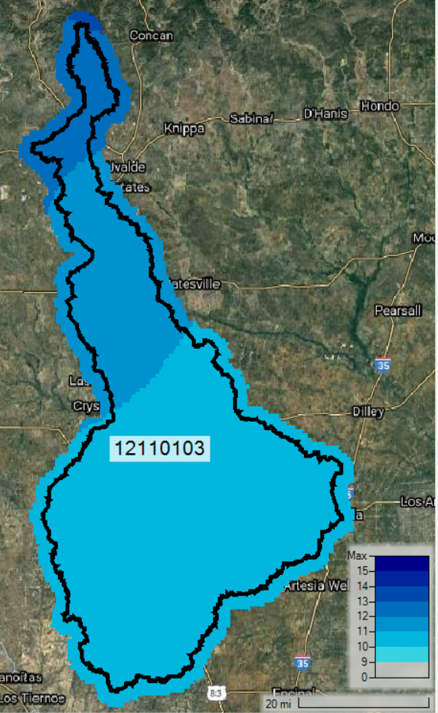
Figure 3-6. Total precipitation (inches) for baseline 1% event across Upper Nueces watershed

Infiltration Parameters
The infiltration layer containing attributes for Soil Conservation Survey (SCS; now the Natural Resources Conservation Survey (NRCS)) curve numbers (CN), abstraction ratio, and minimum infiltration rate (Table 3-2) was developed in ArcGIS using the National Land Cover Database (NLCD) and NRCS soil data from the USGS Soils Survey Geographic Database (SSURGO) (SSURGO 2020; MRCL 2019). The overall technical development process for the base CN data is described in a process flow chart included in Appendix B – Supplemental Hydrology Data.
Table 3-2. SCS Hydrologic Soil Groups and Infiltration Parameters (Source: USACE 2021)
Hydrologic Soil Group | Range of Loss Rates (in./hour) (SCS 1986) | Base Model Loss Rates (in./hour) *
A – deep sand, deep loess, aggregated silts | 0.30 – 0.45 | 0.30
B – shallow loess, sandy lam | 0.15 – 0.30 | 0.23
C – clay loams, shallow sandy loam, soils low in organic content, and soils usually high in clay | 0.05 – 0.15 | 0.10
D – Soils that swell significantly when wet, heavy plastic clays, and certain saline soils | 0.00 – 0.05 | 0.05
*Base minimum infiltration rate chosen based on engineering judgement per regional experience

A land-use – soils – CN table (Table 3-3) was used to determine CN values for the study area. This table was acquired from a USGS study in the Upper Colorado River Basin but is a composite of published data (USGS 2015). Provided that the table in the HEC-RAS manual requires assumptions or investigation outside the scope of a BLE study, it is believed these reported values more accurately represent the study area. This table was setup to calculate a base infiltration raster layer which was input and processed in each hydraulic model; initial abstraction for the base layer was set to an abstraction ratio of 0.2 based on HEC-RAS 2D user’s manual (USACE 2021). The base infiltration layer was processed in HEC-RAS RASMapper to create a spatially distributed raster dataset of the infiltration parameters. The base infiltration parameters, CN and abstraction ratio, were adjusted to calibrate the HEC-RAS hydraulic model response to the Bulletin 17C gages analysis for the 1% annual-chance storm event where adequate gages records were available. Additional discussion on model calibration is discussed in Section 4.7.

Table 3-3. Land Use - Soils - CN Matrix for Computing Initial Curve Numbers (SOURCE: USGS 2015)
LU_GridCode | NLCD LU Description | Hydrologic Soil Group |  |  |  | TR-55 Land Use Cover Type
LU_GridCode | NLCD LU Description | A | B | C | D | TR-55 Land Use Cover Type
11 | Open Water | 100 | 100 | 100 | 100 | -
21 | Developed Open Space | 49 | 69 | 79 | 84 | Open Space – Fair Condition (grass cover 50 – 75%)
22 | Developed Low Intensity | 77 | 86 | 91 | 94 | Newly graded areas
23 | Developed Medium Intensity | 89 | 92 | 94 | 95 | Urban Districts – commercial and business
24 | Developed High Intensity | 98 | 98 | 98 | 98 | Impervious areas: paved
31 | Barren Land | 77 | 86 | 91 | 94 | Fallow – bare soil
41 | Deciduous Forest | 32* | 48 | 57 | 63 | Oak- aspen – fair hydrologic condition  *Woods – grass combination, good hydrologic condition
42 | Evergreen Forest | 39* | 58 | 73 | 80 | Pinyon – juniper – fair hydrologic condition  *Pasture – good hydrologic condition
43 | Mixed Forest | 46 | 60 | 68 | 74 | Woods/ Woods – grass combination – hydrologic condition ranging poor - good
52 | Shrub Scrub | 49 | 69 | 79 | 84 | Pasture, grassland, or range – fair hydrologic condition
71 | Herbaceous | 64 | 71 | 81 | 89 | Herbaceous – fair hydrologic condition
81 | Hay Pasture | 49 | 69 | 79 | 84 | Pasture, grassland, or range – fair hydrologic condition
82 | Cultivated Crops | 71 | 80 | 87 | 90 | Row Crops – poor hydrologic condition
90 | Woody Wetlands | 88 | 89 | 90 | 91 | Within range of impervious cover (wetlands), herbaceous and woods.
95 | Emergent Herbaceous Wetlands | 89 | 90 | 91 | 92 | Within range of impervious cover (wetlands), herbaceous and woods.
All values derived from tables 2-2a -d in USDA Urban Hydrology for Small Watersheds (TR-55) unless indicated.
Note: values for emergent and woody wetlands are not explicitly defined in TR-55. Values listed are derived from Appendix table 4b in TR-55.

Regional Hydrology and Basin Properties
Topographic and hydrologic characteristics in the headwaters of the Nueces River basin vary greatly from the upper and middle portions of the basin. The headwaters are primarily Texas hill country with steep, hilly terrain and shallow soils that abruptly transition to broad plains with meandering streams, permeable gravel lobes, and coarse bed material in the Upper and Middle Nueces watersheds. This topographic variance, coupled with underlying major and minor aquifers, contributes to significant streamflow losses which have been well-documented through storm events in USGS gage data (Table 3-4, Figure 3-8) and discussed in scientific reports (Dalrymple et al. 1937; Massey and Reeves 1983; Dietsch and Wehmeyer 2012). Further, results from a draft USACE Interagency Flood Risk Management (InFRM) study support the findings of hydrologic losses in this system. The InFRM report is anticipated to be published in late 2023 and should be referenced in future hydraulic studies of Upper and Middle Nueces watersheds.
Table 3-4. Summary of Peak Flows in the Nueces River Basin from historic storm events (See Figure 3-7) for gage locations)

Event Start Date | Peak Flow at Gages (CFS)
Event Start Date | USGS 08190000  (at Laguna, TX) | USGS 08190500 (near Brackettville, TX) | USGS 08192000 (below Uvalde, TX) | USGS 08193000 (near Asherton, TX) | USGS 08194000 (at Cotulla, TX) | USGS 8194500 (near Tilden, TX)
June 14, 1935 | 213,000 | 550,000 | 616,000 | N/A (no reading) | 82,600 | N/A (no reading)
Sep. 24, 1955 | 307,000 | 150,000 | 189,000 | 15,100 | 10,900 | 3,570
Sep. 20, 1964 | 108,000 | 246,000 | 188,000 | 12,900 | 11,900 | 10,700
Oct. 13, 1973 | 150,000 | 52,700 | 144,000 | 15,900 | 13,400 | 10,500
Dec. 31, 1984 | 537,005 | 24,600 | 44,600 | 7,210 | 5,140 | 2,650
Oct. 28, 1996 | 142,000 | 230,000 | 201,000 | 11,000 | 8,410 | 2,670
Aug. 23, 1998 | 81,500 | 46,400 | 83,200 | 19,100 | 17,600 | 13,000
Oct. 9, 2018 | 71,500 | 11,100 | 105,000 | 14,200 | 13,200 | 10,600

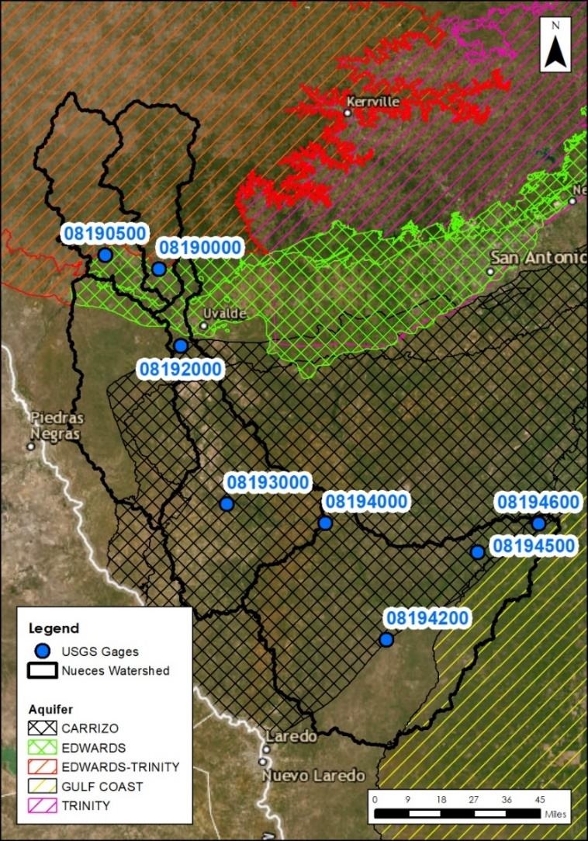
Figure 3-73-7. Gage locations in Upper and Middle Nueces watersheds and contributing area
High peak flow events have been documented in the Nueces Headwaters since the 1935 Texas floods (Dalrymple et al. 1937). However, peak discharge events can virtually disappear in the topography transition (as exemplified in events summarized in Table 3-4) downstream of Uvalde, Texas. Figure 3-8 shows a graphical example of flow losses in the Nueces system specific to the 1935 flood. This type of volume loss moving downstream is indicative of a losing stream.
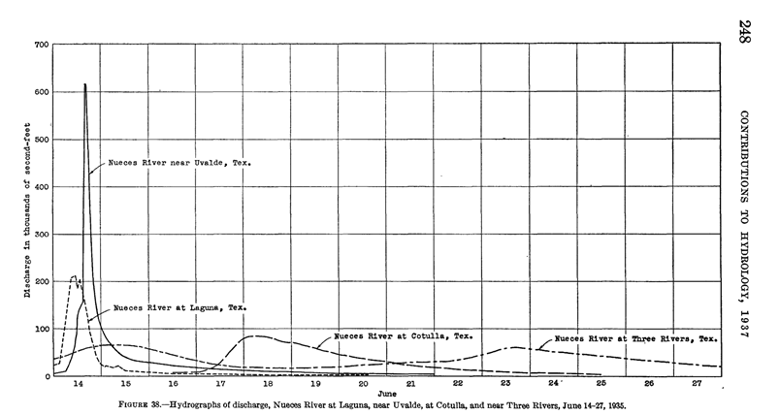
Figure 3-83-8. Hydrographs from Nueces River flood in 1935 showing peak flow loss in system from Uvalde to Cotulla and Three Rivers, Texas (via Dalrymple et al. 1937)
The draft InFRM report uses the 1997 water-year event to showcase this phenomenon, where more than 90% of flow was lost between USGS gage 08192000 and Asherton (USGS gage 08193000) decreasing from 201,000 cfs to 11,000 cfs, respectively. A 1983 study by Massey and Reeves found that average storm runoff losses ranged from 32 to 59 percent in the basin between USGS gage 08194000 (near Cotulla) and USGS gage 08194500 (near Tilden). Water losses along the stretch averaged 174,000 acre-feet per year for the study period (Massey and Reeves 1983).
A recent watershed model for the middle Nueces River (extending from above the Carrizo-Wilcox outcrop near Uvalde, TX to Lake Corpus Christi) estimated that approximately 92-93 percent of annual rainfall was lost to evapotranspiration, 5-6 percent was lost to groundwater recharge to formations such as the Carrizo-Wilcox, and approximately 1-2 percent resulted in surface runoff (Dietsch and Wehmeyer 2012). The Nueces River Authority provided both visual and documented confirmation of substantial losses in both the Nueces River stretching from just north of HWY-90 to south of HWY-57 (Figure 3-9) and the adjacent Frio watershed to the west.
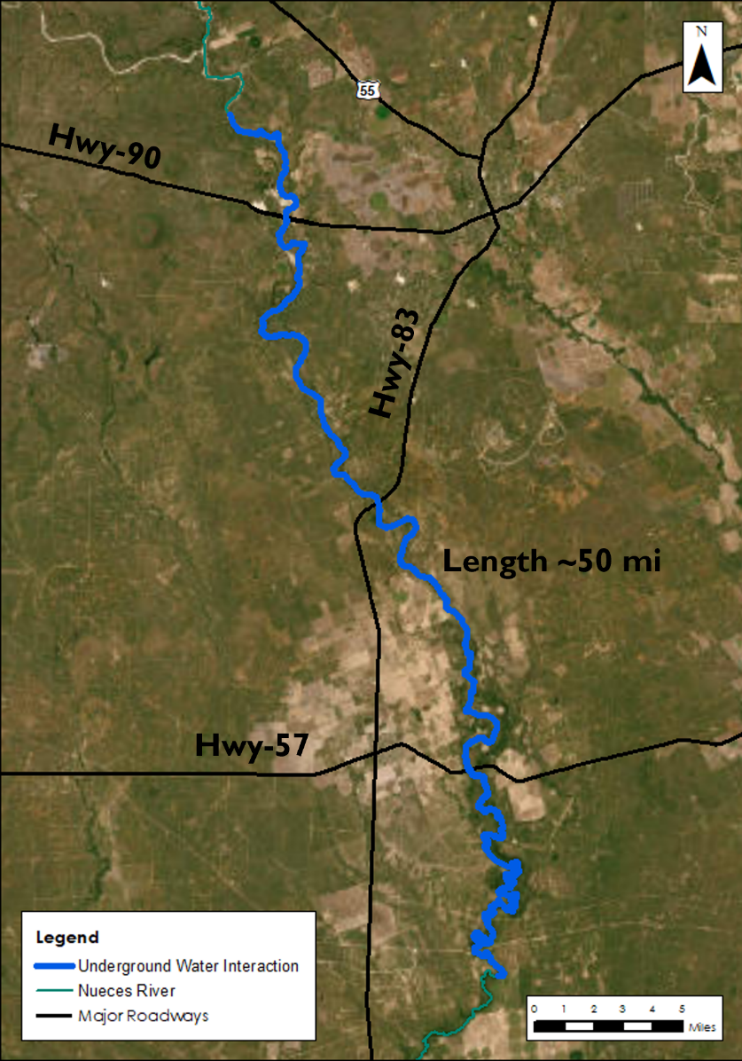
Figure 3-93-9. Known location of stream losses to groundwater in the Nueces River (provided by Nueces River Authority)
The Nueces River Authority staff has reviewed the hydraulic model discussed in this report with the modeling team. The Nueces River Authority confirms the presence of significant volume losses within the channel in the Nueces and Frio Rivers. Due to unknown causes, the losses seem to be increasing over time. A statement from the Nueces River Authority has been included in Appendix D – Statement from the Nueces River Authority.

Hydrologic Calibration
Due to the influence of groundwater interaction and evapotranspiration on the hydrology in this region, hydrologic calibration was conducted by applying synthetic hydrographs for the 2D hydraulic models of this watershed. The synthetic hydrograph method is described in detail in Chapter 4 and was only applied after traditional hydrologic calibration parameters were adjusted within acceptable bounds and modeled results were not reflective of mainstem Bulletin 17C flow estimates. Generally, hydrologic parameters were revised on a case-to-case basis as a result of hydraulic model comparison of the 1-in-100 (1%) annual-chance comparison to historic USGS gage data on an individual model (HUC10) scale. See Section 4.7 for more details.

Hydraulics
The hydraulic approach for the Upper Nueces watershed’s BLE analysis initially consisted of developing HUC10-scale two-dimensional (2D) hydraulic models with the Hydrologic Engineering Center’s River Analysis System (HEC-RAS) program version 6.3. Hydraulic routing was performed with an unsteady-state analysis by applying NOAA Atlas 14 spatially varying rainfall data to the final model mesh, which is comprised of the terrain model (described in Section 2.1) and the hydrologic inputs (described in Section 3). The models were refined based on USGS historic gages records to simulate predictions of WSEL and inundation extent during the 10%, 4%, 2%, 1%, +1%, -1% and 0.2% annual-chance events.

The Upper Nueces Watershed consisted of seven HUC10 catchments which were the original basis of the model domains. The seven HUC10 catchments are:
- Indian Creek – Nueces River - 1211010301
- Sand Creek – Nueces River - 1211010302
- Soldier Slough Creek – Nueces River - 1211010303
- Tortuga Creek - 1211010304
- Headwaters San Roque Creek – 1211010305
- Appurceon Creek – Nueces River – 1211010306
- Espio Creek – Nueces River - 1211010307

The seven HUC10 catchments were combined into three models and will be referred to throughout this report as model 301, 302 and 303. The models were combined due to topography and vast floodplains which made maintaining WSEL continuity at model connection points with the USGS HUC10 delineation challenging. Each model consists of a portion and variation of the seven USGS catchments as follows (depicted in the following sections in Figure 4-8):

- Model 301
  - Indian Creek – Nueces River - 1211010301
  - Sand Creek – Nueces River - 1211010302 (northern half)
- Model 302
  - Sand Creek – Nueces River - 1211010302 (southern half)
  - Soldier Slough Creek – Nueces River - 1211010303
  - Tortuga Creek – 1211010304
  - Appurceon Creek – Nueces River – 1211010306 (north west)
- Model 303
  - Headwaters San Roque Creek – 1211010305
  - Appurceon Creek – Nueces River – 1211010306 (south east)
  - Espio Creek – Nueces River - 1211010307

The models were coupled through outflow and inflow boundary conditions for calibration and derivation of a unified floodplain which is described in Section 4.6. Each HUC10 model was developed for consistency applying the same parameters and procedures described in this chapter. Unique variances from these procedures are noted and described in Sections 4.2 to 4.4 as applicable to each model.

2D Computational Mesh and Settings
The base computational mesh for the models in the Upper Nueces watershed was developed at a 200ft x 200ft (40,000 ft²) grid cell size. Breaklines and refinement regions were implemented to create higher mesh resolution for channels with contributing area of at least 1 square mile and in areas of significant terrain elevation change, both of which are described in the following section. ESRI’s ArcHydro GIS extension was used to develop drainage catchments for the entire HUC8 using the finalized terrain. The HUC10 model perimeters, originally defined by the HUC10 watershed boundaries, were adjusted to reflect the drainage catchments. The total number of mesh elements and average cell size varied per HUC10 model; spatial parameters of each HUC10 model are summarized in Table 4-1.
Table 4-1. HUC10 Mesh Parameters
Model Name | Size of Study Area (mi²) | Number of Mesh Elements (grid cells) | Average cell size (ft²)
Model 301 | 441.29 | 1,207,277 | 10,179
Model 302 | 785.53 | 815,576 | 26,853
Model 303 | 717.81 | 664,356 | 30,119

Model Computational Settings
Models were run using the Diffusion Wave equation set for 2D flow for each frequency event discussed in this report. Diffusion Wave computational method was selected rather than the Shallow Water equations due to hydraulic structures, such as bridges, culverts and dams, not being modeled in detail as part of this BLE study. The Full Momentum equation is typically selected to better account for energy losses in and around structures (USACE 2021). More information on the application of Diffusion Wave Equations versus the Shallow Water equations can be found in the HEC-RAS version 6.3 2D user’s manual.
A computational timestep was determined from a sensitivity analysis for Courant conditions and model computational time. Courant values of less than or equal to 2 are considered ideal, with 5 considered the maximum acceptable for simulations applying Diffusion Wave computational methods (USACE 2021). The default 2D flow options were applied for the multi-frequency runs as shown in Figure 4-1. Timesteps of individual models were adjusted as needed from the base timestep of 30-seconds to maintain a Courant value near 2. Final computational timesteps ranged from 10-seconds to 30-seconds for the various models.
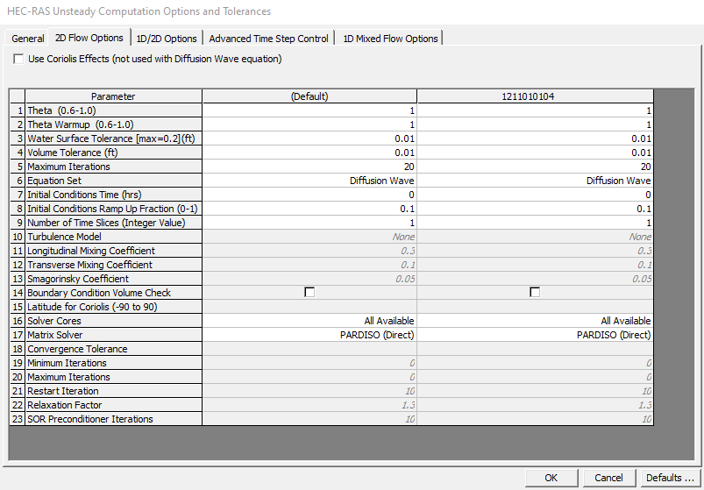
Figure 4-1. HEC-RAS Unsteady Computation Options and Tolerances

Breaklines and Refinement Regions
Breaklines and refinement regions were enforced in the model mesh at half the base cell resolution. Refinement regions for smaller tributaries were enforced at higher resolution (minimum cell size of 50 ft x 50 ft) on a case-by-case basis per engineering judgement. The spatial properties of breaklines and refinement regions for each Upper Nueces model are summarized in Table 4-2. The development of these features is described in the following sections.
Table 4-2. Summary of Mesh Refinement Features for Upper Nueces
Model Name | Breaklines (linear ft) | Total area of Refinement Regions (acres)
Model 301 | 833,882 | 31,554
Model 302 | 2,320,848 | 131,706
Model 303 | 774,043 | 40,589

Breaklines
Breaklines were enforced in the models’ computational meshes for state and federal roadways and dams found in the National Inventory of Dams (NID). Additional breaklines were added using engineering judgement after inspection of individual models to better represent areas such as agricultural ponds, dams, embankments, or other changes in elevation found to be hydraulically significant to a model domain. Breaklines were specifically added in the main reach adjacent to urbanized areas, or individual structures, to capture channel bank geometry correctly in the mesh. An overview of the breaklines for the Nueces Headwaters is shown in Figure 4-2.
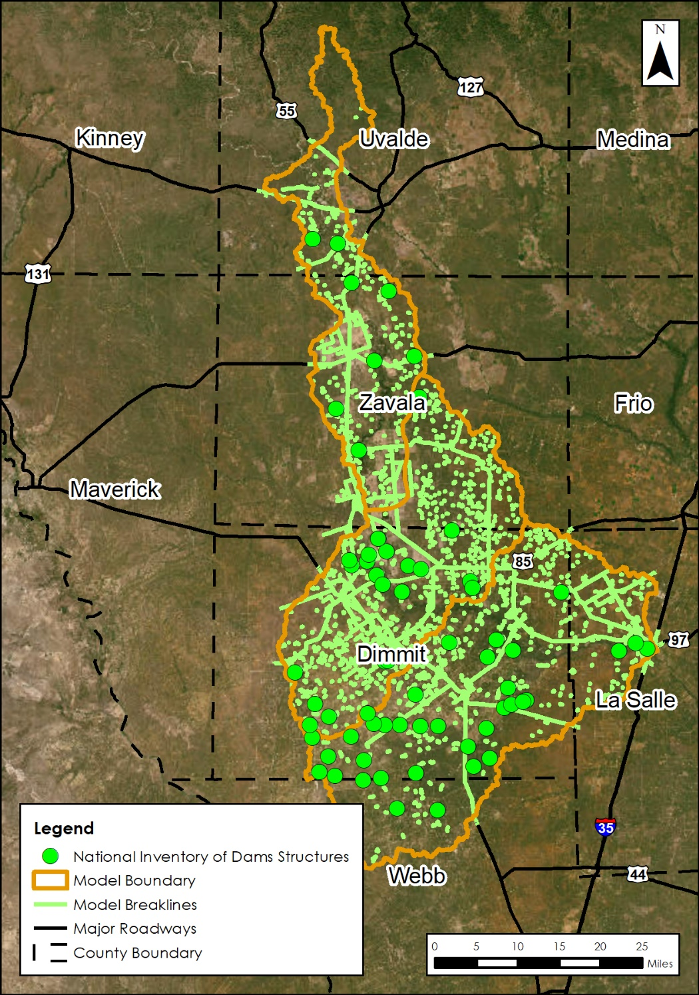
Figure 4-2. Overview of HUC8 Scale Breaklines for Upper Nueces

Mesh Refinement Regions
A mesh refinement region was enforced to provide a more detailed drainage pathway in the computational mesh. A refinement region polygon was developed for each model to represent bank full flow (Figure 4-3).
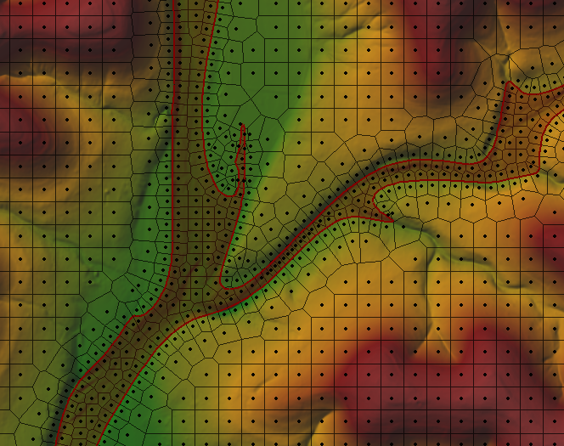
Figure 4-3. Example of Refinement Region Polygon
The polygon was developed by simulating a 2-year NOAA atlas 14 rainfall event in each model using the base 200 ft resolution mesh. The 2-year event was simulated without breaklines, infiltration, or Manning’s roughness implemented in the model. The inundation boundary from the 2-year event was exported from RASMapper for post-processing and smoothing in ArcGIS. The processed polygon was then imported into the model geometry as a refinement region in the HEC-RAS geometry with 100 ft near and far cell spacing. An overview of the refinement regions for Upper Nueces is shown in Figure 4-4.
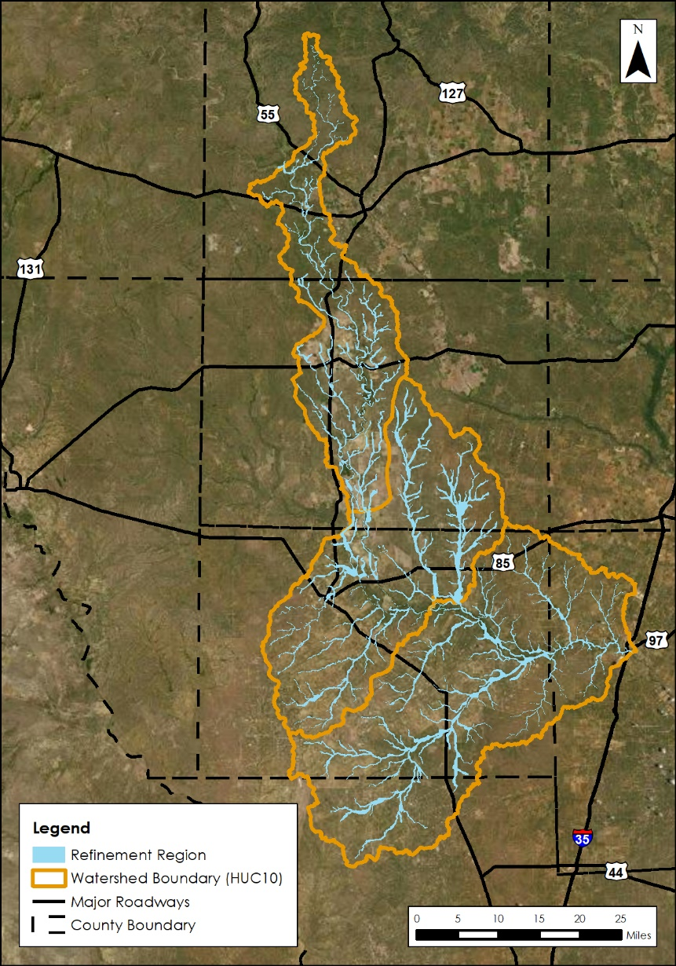
Figure 4-4. Overview of HUC8 Scale Mesh Refinement Regions for Upper Nueces

Manning’s n Surface Roughness
The 2019 National Land Cover Database (NLCD) Land Use Classification raster was used to develop the Manning’s n roughness coefficients for the study area. Manning’s n values for a given land-cover were taken from a table reported by NRCS in 2016, developed for Kansas (Table 4.3). This table was selected provided the values are within the range of values provided by the HEC-RAS 2D manual and appear to compare well with aerial imagery. Manning’s n was adjusted to represent the high-stage preferential flow path and set to range between 0.045-0.065. The high-stage flow path was viewed as the minimum between a 500’ buffer from the stream centerline or the 2-year floodplain extent.
Table 4-3. Manning's n Values Applied in Models for Upper Nueces (Source: NRCS 2016)
Land Use Classification | Allowable Range of n values | Normal n value for 2D Analyses (NRCS 2016)
Open Water^{1,2} | 0.025 – 0.050 | 0.040
Developed, Open Space² | 0.030 – 0.050 | 0.040
Developed, Low Intensity² | 0.080 – 0.120 | 0.100
Developed, Medium Intensity² | 0.060 – 0.140 | 0.080
Developed, High Intensity² | 0.120 – 0.200 | 0.150
Barren Land¹ | 0.023 – 0.300 | 0.025
Deciduous Forest² | 0.100 – 0.160 | 0.160
Evergreen Forest¹ | 0.100 – 0.160 | 0.160
Mixed Forest² | 0.100 – 0.160 | 0.160
Scrub/Shrub^{1,2} | 0.070 – 0.160 | 0.100
Grassland/Herbaceous^{1,2} | 0.025 – 0.050 | 0.035
Pasture/Hay^{1,2} | 0.025 – 0.050 | 0.030
Cultivated Crops^{1,2} | 0.025 – 0.050 | 0.035
Woody Wetlands^{1,2} | 0.045 – 0.150 | 0.120
Emergent Herbaceous Wetland^{1,2} | 0.050 – 0.085 | 0.070
Citations for historic n value ranges:
¹Open-Channel Hydraulics, by Chow, Ven Te, 1959;
²HEC‐RAS River Analysis System 2D Modeling User’s Manual, Version 6.3, 2021

Manning’s n override regions were enforced in the models within the channels to spatially correspond to the channel mesh refinement regions as discussed in Section 4.2.2. Initial Manning’s override n-values were set to 0.055 – 0.065 based on aerial examination of historic imagery showing consistent absence or presence of channel debris. If necessary, channel Manning’s values were revised on a HUC10 model basis for calibration purposes. Manning’s n adjustment for the Upper Nueces models is discussed further in Section 4.7.

Terrain Modifications
Terrain modifications were made through the HEC-RAS layer modifications feature in RASMapper Version 6.3. Direct modifications were not made to the original terrain. A modifications layer was added to each model terrain to apply Hydraulic Connectors (HCs) which allow flow to be conveyed through structures, such as roadway culverts, that the original DEM otherwise impedes. After adding a modifications layer with all final HCs, the terrain was resampled in RASMapper to include the HC drainage pathways (Figure 4-5).
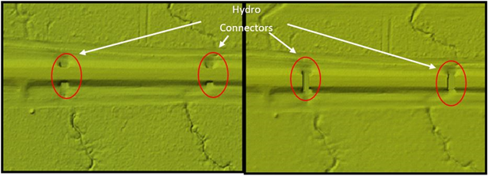
Figure 4-5. Example of localized original terrain (left) and terrain after resampling and addition of modification layer (right)

Synthetic Inflow Hydrographs for Model Integration and Calibration
The HUC8 Upper Middle Nueces models are in a portion of the Nueces River basin where documented, high-volume runoff losses occur (discussed in Section 3.3). The hypothesized source of these streamflow losses is attributed to a combination of the groundwater interaction and evapotranspiration.
As such, transferring the modeled flow from upstream to downstream models resulted in flow rates exceeding the Bulletin 17C 95% confidence interval for the 100-yr event in the Upper and Middle Nueces watersheds (specifically the models consisting of HUC10 12110103_02-07). The magnitude of runoff loss is underscored in Table 4-4, which shows that that only applying precipitation (neglecting all upstream inflow) to the model areas caused peak flow results in exceedance of the Bulletin 17C median (Table 4-4). This is likely due to both the compounding effects of applying rainfall at the same time across 6 HUC8’s (approximately 15,000 sq-mi, consisting of many models). Additionally, the presence of documented hydrologic features in the basin that contribute to volume loss in the system during flood events are difficult to incorporate into the 2D hydraulic model.
To simulate the volume loss in the BLE models, while sustaining the 0.5-ft water-surface elevation tie-in threshold, flow from upstream model hydrographs would not be leveraged within the downstream model. A synthetic inflow hydrograph was used for the purpose of making a floodplain tie-in with the upstream model. The concept of the synthetic hydrograph is to create a quickly occurring, peak wave to make a WSE tie-in with the upstream model, wherein the synthetic wave is over and dissipated before the peak runoff wave arrives. The synthetic hydrograph created is a 4-hour, centrally peaking event that rises and falls at a rate of 25% (Figure 4-6). The peak flow of the synthetic hydrograph is initially selected by taking the peak flow from the upstream model’s SA2D line. For models where this does not produce a tie-in, the HEC-RAS hydrograph multiplier option is used to appropriately increase or decrease the synthetic inflow hydrograph as needed for water surface elevation tie-in. The results of the modeled flow with an applied synthetic flow hydrograph, compared to the modeled results with the full-leveraged flow from upstream watersheds are summarized in Table 4-4. This approach ultimately transferred an attenuated, narrow-peak hydrograph to tie in water surface elevations at model boundaries within 0.5 ft, while also transferring reduced volume. Applying this approach resulted in modeled flows better aligned to the results of the Bulletin 17C analysis (Table 4-4). The table includes references to gages on the Nueces River, upstream of this HUC8.
Figure 4-6. Example Synthetic Hydrograph versus a full-volume inflow hydrograph
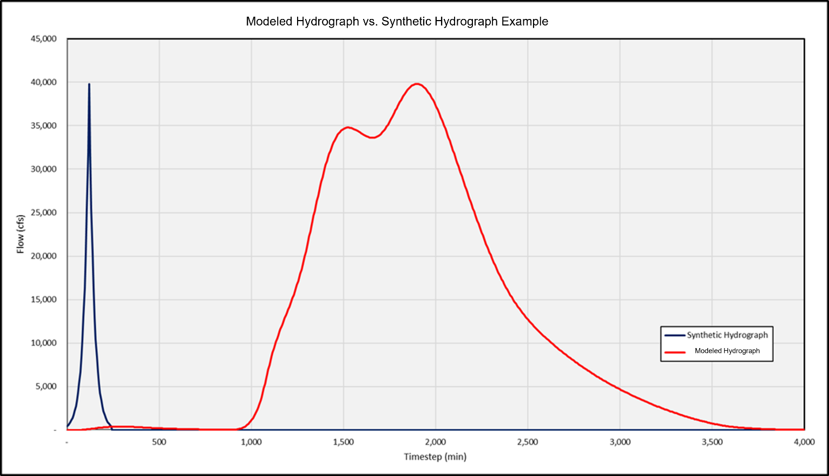

Table 4-4. Comparison of Modeled Flows to Gage Analysis in Upper and Middle Nueces Watersheds

USGS Gage | Contributing Area (Sq. Mi) | Historic Record Bulletin 17C Flood Frequency Analysis -  1%-Annual-chance flow (CFS) |  |  | 1% Modeled Flows (CFS)
USGS Gage | Contributing Area (Sq. Mi) | Median | Lower 5% Confidence Limit | Upper 95% Confidence Limit | Rain-on-Grid* only (no upstream inflow) | Fully leveraged flows | Synthetic Hydrographs
08192000- Nueces River below Uvalde, TX | 1,861 | 486,500 | 270,000 | 1,170,000 | N/A (volume loss recorded downstream of gage) | 456,066 | N/A (volume loss recorded downstream of gage)
08193000-Nueces River near Asherton, TX | 4,082 | 30,320 | 22,580 | 130,300 | 34,191 | 615,169 | 89,278
08194000 –Nueces River at Cotulla, TX | 5,171 | 41,770 | 29,560 | 69,360 | 91,700 | 524,543 | 59,314
08194500- Nueces River near Tilden, TX | 8,093 | 95,790 | 60,060 | 189,300 | 26,078 | 456,110 | 122,458
*Note that the rain-on-grid modeled values are a function of the location of the gage on the mainstem within the model (i.e. upstream or near the model outlet). When assessing the rain-on-grid only flows at the model outlets, the CFS/sq-mil was greater than or equal to the CFS/square mile of the median Bulletin 17C analysis corresponding to the gage located within the model.

A sensitivity analysis was performed to compare the synthetic hydrograph approach to modeled flow with only rain-on-grid applied to the models (Table 4-4). Multiple alternative methods were tested HEC-RAS version 6.3 to simulate the volume loss from the system; however, capabilities of the software cannot currently represent the physical process of surface water-groundwater interaction in 2D rain-on-grid models. The sensitivity analysis and full comparison of alternative methods can be found in Appendix C – Comparison of flow leveraging methods for Upper Nueces, Middle Nueces, and upper Frio BLE’s.
FEMA performed a review of the models using the synthetic hydrograph approach within this BLE study for reasonableness. FEMA’s review concluded that the models and modeling approach for this watershed is “in general, reasonable and in agreement with standard practice and with applicable FEMA guidance and standards. However, the development and use of the synthetic inflow hydrograph approach is not a typical or standard method. Stantec developed and employed the synthetic inflow hydrograph approach to address the atypical hydrologic and hydraulic conditions found within the 11 Middle Nueces HUC10 based model domains. These atypical hydrologic and hydraulic conditions are evidenced by stream flows that decrease in the downstream direction.” For the full FEMA review of the Upper and Middle Nueces models, as well as Stantec responses, see Appendix E – FEMA Model Review and Recommendations with Stantec Responses.
It should be noted that limitations of the synthetic hydrograph modeling approach may include: 1) a skewed timing of the Nueces River’s peak flood inundation wave anywhere downstream of where a synthetic hydrograph has been used, 2) potential for skewed floodplain extents in tributaries at their converge with the Nueces River due to the skewed timing mentioned above, and 2) volume loss discrepancy wherein the majority of runoff loss occurs at locations other than where the loss is applied using the synthetic hydrograph approach (at the model tie-ins). An overview of challenges and recommendations for future modeling iterations of this watershed is included in Section 4.9.

HUC10 Level Model Integration
A diagram showing inter-basin connectivity and boundary condition locations for Upper Nueces watershed is included in Figure 4-6. The HUC10 models were coupled using Storage Area (SA)/2D connectors in the upstream model to transfer flow into the receiving downstream model in the form of inflow hydrograph boundary conditions. Some models were calibrated using a synthetic hydrograph for flow transfer.
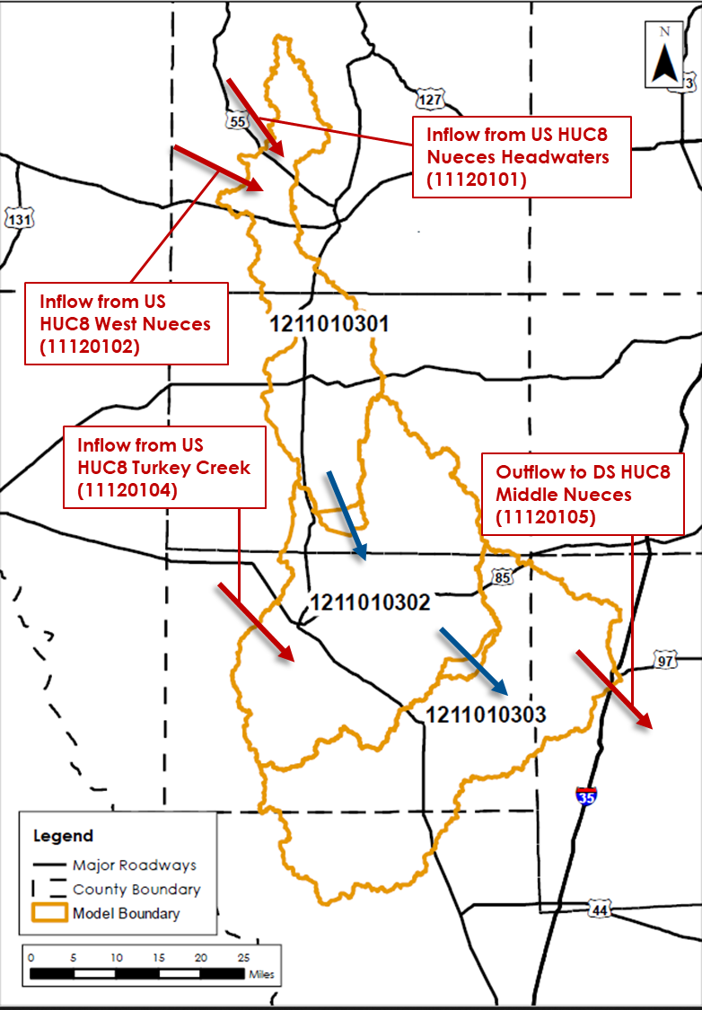
Figure 4-7. Overview of HUC8 with HUC10 Watershed Connectivity
The SA/2D connectors in the upstream model were placed perpendicular to channel flow a distance upstream of the channel outlet to avoid influence of the downstream normal depth boundary conditions. The upstream SA/2D location was isolated based on a normal depth sensitivity analysis where the placement distance from the downstream boundary condition was determined by the location of channel WSEL convergence for runs of varying normal depth BC values (Figure 4-7).
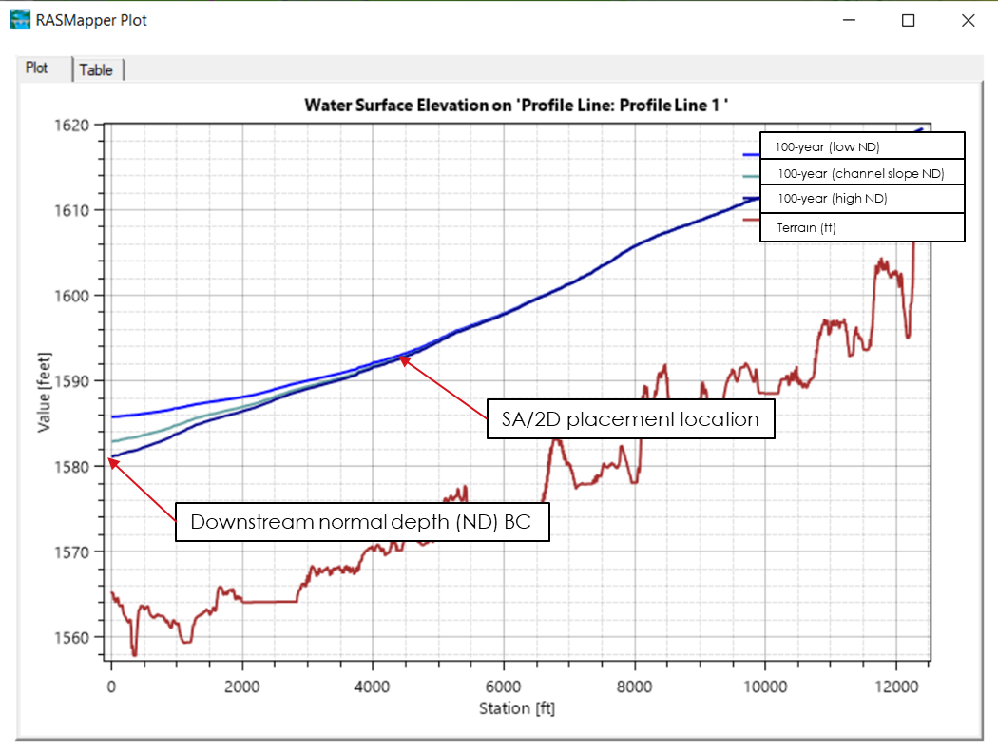
Figure 4-8. SA/2D Normal Depth sensitivity and placement example
The upstream and downstream model meshes were modified from the USGS HUC10 delineation to overlap at the location of the SA/2D connection. To optimize the hydraulic performance of the connection, the SA/2D placement varied per model based on unique features such as terrain slope, channel dimensions, instream flow obstructions (dams, railroad crossings, low water crossings etc.) and normal depth sensitivity. Therefore, model overlap size varied per model and connection location. Final model meshes for the Upper Nueces watershed models are shown in Figure 4-8. In locations where the models overlap, the downstream model’s water surface elevation and flow in the receiving model represent the overlapped area.
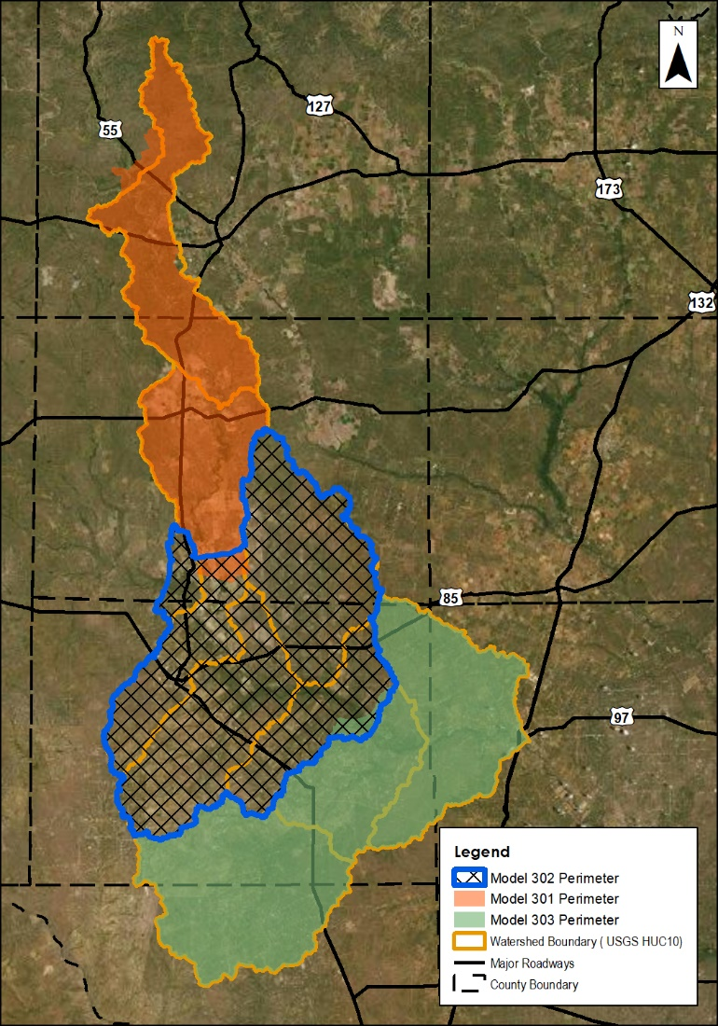
Figure 4-9. Overview of Adjusted Model Domains
The SA/2D connections were evaluated to ensure continuity of both water surface elevation (within 0.5-ft) and flow between upstream and downstream models, during the 1-in-100 (1%) annual-chance event only. The continuity of water surface elevation and flow was assessed, but not calibrated to, for the other simulated annual-chance events and the results are also included in the following sections. The continuity metrics are summarized in Table 4-5. for the Upper Nueces models. Application of a stage hydrograph versus a flow hydrograph boundary condition was also evaluated independently for each connection. Flow hydographs were found to transfer flow with greater accuracy than stage hydrographs in reaches with flat overbank terrain and low channel slope (promoting pooling), reaches with “braided” stream formations and variable terrain elevation across the floodplain cross-section, and reaches with a proximal instream flow obstructions such as an upstream dam. Flow hydrographs were applied to connect the three Upper Nueces models. The boundary conditions for each model are summarized in
Table 4-5 and described in more detail in the following sections.
Table 4-5. HUC10 Model Integration Summary
Upstream Model Name | Downstream HUC10 Model Name | Number of SA/2D Connectors | Distance from SA/2D Connector to DS BC (ft) | 100-Year Flow Difference (%) | 100-Year Stage Difference (ft)
External  Montell Creek-Nueces River (1211010104) | Model 301 | 2 | N/A¹ | 0.0 | 0.2
External  Montell Creek-Nueces River (1211010104) | Model 301 | 2 | N/A¹ | 0.0 | 0.4
External  West Nueces River (1211010204) | Model 301 | 1 | N/A² | 0.0 | 0.2
Model 301 | Model 302 | 3 | 14,150 | Synthetic Flow Hydrograph | 0.3
Model 301 | Model 302 | 3 | 14,150 | Synthetic Flow Hydrograph | 0.1
Model 301 | Model 302 | 3 | 14,150 | Synthetic Flow Hydrograph | 0.2
External  Lower Turkey Creek (1211010406) | Model 302 | 5 | N/A³ | Synthetic Flow Hydrograph | 0.1
 |  |  |  | 0.0 | 0.1
 |  |  |  | 0.0 | 0.1
 |  |  |  | Synthetic Flow Hydrograph | 0.0
 |  |  |  | 0.0 | 0.8⁵
Model 302 | Model 303 | 2 | 13,000 | Synthetic Flow Hydrograph | 0.5
Model 302 | Model 303 | 2 | 10,500 | Synthetic Flow Hydrograph | 0.3
Model 303 | External  HUC8 Middle Nueces (12110105) | 1⁴ | 9,948 | Synthetic Flow Hydrograph | 0.3
¹Refer to BLE report for HUC8 12110101.
²West Nueces River connection was provided by the TWDB.
³Refer to BLE report for HUC8 12110104.
⁴Description for this connection can be found in BLE report for HUC 12110105.
⁵Water Surface Elevation difference of greater than 0.5ft. However, upon grid comparison in RasMapper these differences were found to be less than 0.5ft within the overlap area.

Montell Creek – Nueces River (1211010104) and Model 301 (at the Indian Creek – Nueces River (1211010301) Boundary)
The downstream boundary of the Montell Creek Nueces River model used two SA/2D connectors to connect with the Model 301. The second inflow is very minor compared to the overall inflow. Both of these connections used an inflow hydrograph at the boundary condition line. Just downstream of these inflows is a very constricted channel the flow passes through. This causes high velocities compared to the rest of the model and required the computational time step for the 1211010301 model be reduced to 15 seconds to keep courant values in this area below 5. The resulting model meshes and hydraulic continuity results are summarized in Figure 4-9, Figure 4-10, Table 4-6, and Table 4-7.
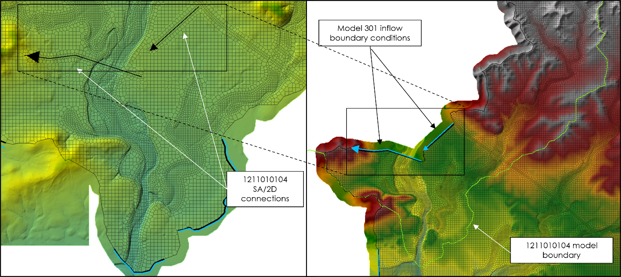
Figure 4-10. 1211010104 and Model 301 Boundary Plan View
Table 4-6. 1211010104 and Model 301 Continuity – all modeled events – Connection 1
Annual-chance Event | HUC101 (Upstream) |  | HUC103 (Downstream) |  | Absolute Difference
Annual-chance Event | Max WSEL (ft) | Peak Flow (Cfs) | Max WSEL (ft) | Peak Flow (Cfs) | Max WSEL (ft) | Peak Flow (Cfs)
10YR | 1,007.5 | 148,386 | 1,007.4 | 148,386 | 0.1 | 0
25YR | 1,012.0 | 232,434 | 1,012.0 | 232,434 | 0.0 | 0
50YR | 1,015.4 | 311,149 | 1,015.3 | 311,149 | 0.1 | 0
100YR | 1,018.7 | 406,606 | 1,018.5 | 406,606 | 0.2 | 0
500YR | 1,025.2 | 653,730 | 1,024.9 | 653,730 | 0.3 | 0
100YR- | 1,014.3 | 282,873 | 1,014.2 | 282,873 | 0.1 | 0
100YR+ | 1,022.1 | 528,408 | 1,022.0 | 528,408 | 0.1 | 0

Table 4-7. 1211010104 and Model 301 Continuity – all modeled events – Connection 2
Annual-chance Event | HUC101 (Upstream) |  | HUC103 (Downstream) |  | Absolute Difference
Annual-chance Event | Max WSEL (ft) | Peak Flow (Cfs) | Max WSEL (ft) | Peak Flow (Cfs) | Max WSEL (ft) | Peak Flow (Cfs)
10YR | 1,023.6 | 71 | 1,023.2 | 71 | 0.4 | 0
25YR | 1,023.7 | 108 | 1,023.3 | 108 | 0.4 | 0
50YR | 1,023.7 | 143 | 1,023.3 | 143 | 0.4 | 0
100YR | 1,024.2 | 998 | 1,023.8 | 998 | 0.4 | 0
500YR | 1,029.0 | 61,911¹ | 1,028.8 | 61,911 ¹ | 0.2 | 0
100YR- | 1,023.7 | 134 | 1,023.3 | 134 | 0.4 | 0
100YR+ | 1,026.6 | 17,802 ¹ | 1,026.3 | 17,802 ¹ | 0.3 | 0
¹ Significant increase in modeled flows for 500YR and 100YR+ events at this continuity are due to the nature of the secondary channel. Smaller storm events do not result in water surface elevations that overflow into the secondary channel and therefore result in much lower reported flows at this continuity.

West Nueces River (1211010104) and Model 301 (at the Indian Creek - Nueces River (1211010103) Boundary)
The West Nueces River inflow was provided by TWDB as a flow hydrograph for a 48-hour event. To complete the receding limb of the flow hydrograph, a decay function was used for the remainder of 121101010301 model plan time. The flow was input along a single SA/2D connection. The TWDB Manning’s n-value override region was used and extended approximately one mile further downstream with an n-value of 0.03. On the up- and downstream ends of this Manning’s override region, the override regions were phased back to the default value of 0.055 by slowly increasing the override region value by 0.005 approximately every 1,000 feet to avoid unrealistic hydraulic changes. The resulting model meshes and hydraulic continuity results are summarized in Figure 4-10, and Table 4-8.
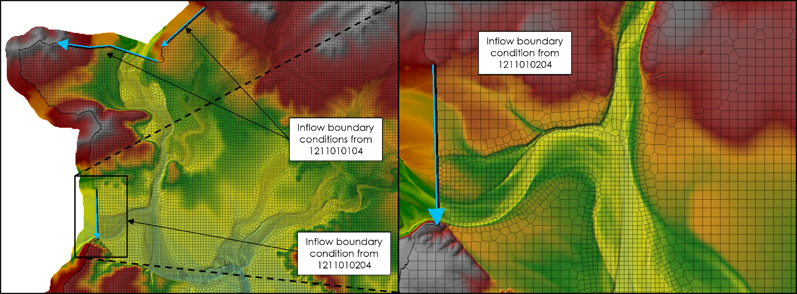
Figure 4-11. 1211010204 (TWDB) and Model 301 Boundary Plan View
Table 4-8. 1211010204 and Model 301 Continuity – all modeled events
Annual-chance Event | HUC104 (Upstream) |  | HUC103 (Downstream) |  | Absolute Difference
Annual-chance Event | Max WSEL (ft) | Peak Flow (Cfs) | Max WSEL (ft) | Peak Flow (Cfs) | Max WSEL (ft) | Peak Flow (Cfs)
10YR | 979.5 | 106,298 | 978.3 | 106,262 | 1.2 | 36
25YR | 982.2 | 180,711 | 981.4 | 180,709 | 0.8 | 2
50YR | 984.3 | 255,399 | 983.8 | 255,399 | 0.5 | 0
100YR | 986.7 | 354,348 | 986.5 | 354,345 | 0.2 | 3
500YR | 993.1 | 688,165 | 993.8 | 688,165 | 0.7 | 0
100YR- | 982.0 | 174,291 | 981.2 | 174,242 | 0.8 | 49
100YR+ | 991.3 | 587,378 | 991.7 | 587,378 | 0.4 | 0
*Minor flow differences exist due to the existing TWDB model for HUC8_102 used a hydrograph output interval of 15min whereas this study of HUC8_103 used a hydrograph output interval of 6min.

Model 301 and Model 302 (flow transfer within the Sand Creek - Nueces River (1211010302) watershed) Boundary
Model 301 transfers flow to model 302 almost 3-miles upstream of the model 301 downstream boundary condition due to the breadth of the floodplain in this area. Flow is transferred at 3 locations via SA/2D connectors (shown in the figure below). Due to the complexities of the Nueces River hydrology downstream of the Edward’s Aquifer, combined with impacts of flow regulation in the watershed and compounding effects of rainfall across the large study area, the full upstream flow from Model 301 was not leveraged in the downstream model 302. This was done in order to calibrate the model based on the results of downstream statistical gage analyses. A synthetic flow hydrograph, as described in Section 4.5, was implemented to maintain WSEL continuity between the two models. The continuity metrics of each flow transfer location are summarized in the three tables below. The resulting model meshes and hydraulic continuity results are summarized in Figure 4-11, Table 4-9, Table 4-10, and Table 4-11.
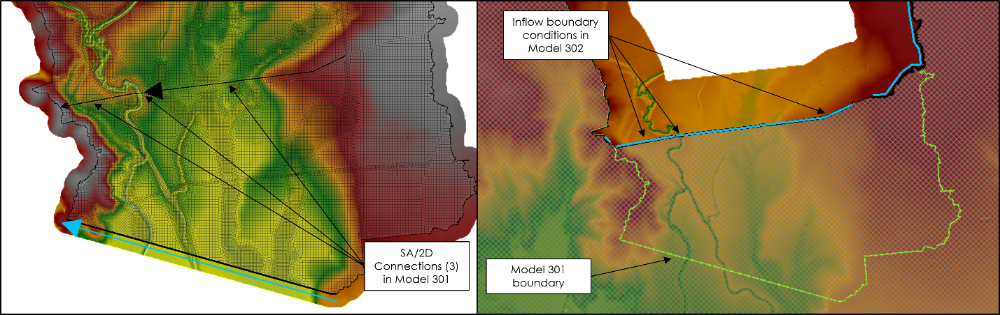
Figure 4-12. Model 301 and Model 302 Boundary Plan View
Table 4-9. Model 301 and Model 302 Continuity – all modeled events – Connection 1
Annual-chance Event | HUC301_1 (Upstream) | HUC302 (Downstream) | Difference  (upstream minus downstream)
Annual-chance Event | Max WSEL (ft) | Max WSEL (ft) | Max WSEL (ft)
10YR | 586.2 | 586.2 | 0.0
25YR | 586.6 | 586.8 | 0.2
50YR | 587.3 | 587.5 | 0.2
100YR | 588.5 | 588.8 | 0.3
500YR | 592.5 | 592.6 | 0.1
100YR- | 587.1 | 586.9 | 0.2
100YR+ | 591.4 | 591.6 | 0.2

Table 4-10. Model 301 and Model 302 Continuity – all modeled events – Connection 2
Annual-chance Event | HUC301_2 (Upstream) | HUC302 (Downstream) | Difference  (upstream minus downstream)
Annual-chance Event | Max WSEL (ft) | Max WSEL (ft) | Max WSEL (ft)
10YR | 586.0 | 585.9 | 0.1
25YR | 586.3 | 586.4 | 0.1
50YR | 587.2 | 587.5 | 0.3
100YR | 588.6 | 588.7 | 0.1
500YR | 592.4 | 592.4 | 0.0
100YR- | 587.2 | 586.9 | 0.3
100YR+ | 591.3 | 591.7 | 0.4

Table 4-11. Model 301 and Model 302 Continuity – all modeled events – Connection 3
Annual-chance Event | HUC301_3 (Upstream) | HUC302 (Downstream) | Difference  (upstream minus downstream)
Annual-chance Event | Max WSEL (ft) | Max WSEL (ft) | Max WSEL (ft)
10YR | 583.0 | 582.9 | 0.1
25YR | 584.9 | 585.2 | 0.3
50YR | 586.5 | 586.9 | 0.4
100YR | 588.3 | 588.1 | 0.2
500YR | 592.2 | 592.2 | 0.0
100YR- | 586.1 | 585.9 | 0.2
100YR+ | 591.1 | 591.4 | 0.3

Lower Turkey Creek (1211010406) and Model 302 (connection at the Sand Creek - Nueces River (1211010302) Boundary)
Model 302 receives flow from the northeast at the outlet of Turkey Creek HUC8 (104) watershed. The flow transfer occurs upstream of the HUC 103 boundary and within the Turkey Creek watershed using 5- SA/2D connectors in the Lower Turkey Creek (1211010406) watershed (shown in the figure below). As described above in Section 4.5, a synthetic flow hydrograph is applied as an inflow BC in model 302 at the flow transfer locations. WSEL continuity between the watersheds is summarized in the tables below for each of the 5 flow transfer locations. The resulting model meshes and hydraulic continuity results are summarized in Figure 4-12, Table 4-12, Table 4-13, Table 4-14, Table 4-15, and Table 4-16.
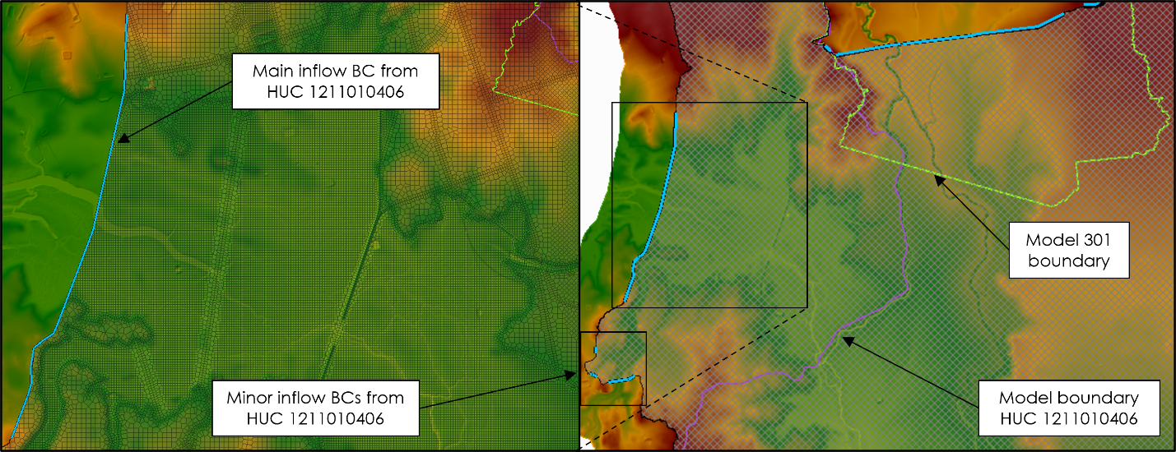
Figure 4-13. Lower Turkey Creek 1211010406 and Model 302 Boundary Plan View
Table 4-12. 1211010406 and Model 302 Continuity – all modeled events – Connection 1
Annual-chance Event | HUC406_1 (Upstream) | HUC302 (Downstream) | Difference  (upstream minus downstream)
Annual-chance Event | Max WSEL (ft) | Max WSEL (ft) | Max WSEL (ft)
10YR | 552.1 | 552.2 | 0.1
25YR | 555.5 | 555.5 | 0.0
50YR | 557.3 | 557.2 | 0.1
100YR | 559.5 | 559.6 | 0.1
500YR | 564.7 | 564.7 | 0.0
100YR- | 556.8 | 556.7 | 0.1
100YR+ | 561.2 | 561.5 | 0.3

Table 4-13. 1211010406 and Model 302 Continuity – all modeled events – Connection 2
Annual-chance Event | HUC406_2 (Upstream) | HUC302 (Downstream) | Difference  (upstream minus downstream)
Annual-chance Event | Max WSEL (ft) | Max WSEL (ft) | Max WSEL (ft)
10YR | 570.4 | 570.4 | 0.0
25YR | 570.4 | 570.1 | 0.3
50YR | 570.5 | 570.5 | 0.0
100YR | 570.8 | 570.7 | 0.1
500YR | 571.0 | 571.0 | 0.0
100YR- | 570.4 | 570.1 | 0.3
100YR+ | 570.7 | 570.7 | 0.0

Table 4-14. 1211010406 and Model 302 Continuity – all modeled events – Connection 3
Annual-chance Event | HUC406_3 (Upstream) | HUC302 (Downstream) | Difference  (upstream minus downstream)
Annual-chance Event | Max WSEL (ft) | Max WSEL (ft) | Max WSEL (ft)
10YR | 571.1 | 571.1 | 0.0
25YR | 571.2 | 570.8 | 0.4
50YR | 571.4 | 571.2 | 0.2
100YR | 571.8 | 571.9 | 0.1
500YR | 572.3 | 572.3 | 0.0
100YR- | 571.3 | 570.9 | 0.4
100YR+ | 571.8 | 571.7 | 0.1

Table 4-15. 1211010406 and Model 302 Continuity – all modeled events – Connection 4
Annual-chance Event | HUC406_4 (Upstream) | HUC302 (Downstream) | Difference  (upstream minus downstream)
Annual-chance Event | Max WSEL (ft) | Max WSEL (ft) | Max WSEL (ft)
10YR | 566.2 | 566.2 | 0.0
25YR | 567.8 | 567.4 | 0.4
50YR | 568.8 | 568.5 | 0.3
100YR | 569.8 | 569.8 | 0.0
500YR | 572.6 | 572.5 | 0.1
100YR- | 568.4 | 568.7 | 0.3
100YR+ | 571.4 | 571.5 | 0.1
Table 4-16. 1211010406 and Model 302 Continuity – all modeled events – Connection 5
Annual-chance Event | HUC406_5 (Upstream) | HUC302 (Downstream) | Difference  (upstream minus downstream)
Annual-chance Event | Max WSEL (ft) | Max WSEL (ft) | Max WSEL (ft)
10YR | 567.3 | 567.3 | 0.0
25YR | 567.4 | 567.0 | 0.4
50YR | 567.4 | 567.2 | 0.2
100YR | 567.5 | 567.5 | 0.0
500YR | 571.0 | 571.1 | 0.1
100YR- | 567.4 | 567.2 | 0.2
100YR+ | 569.0 | 569.1 | 0.1

Model 302 and Model 303 Boundary
Flow was transferred from model 302 to model 303 approximately 2-2.5-miles upstream of the model 302 downstream boundary. The flow transfer occurs in upstream Nueces River model by applying 2 SA/2D connectors in the 302 model (shown in the figure below). As described above in section 4.5.1, a synthetic flow hydrograph is applied as an inflow BC in the 303 model at the flow transfer locations with the highest flow volume (locations 1 and 4). The resulting model meshes and hydraulic continuity results are summarized in Figure 4-13, Table 4-17, and Table 4-18.
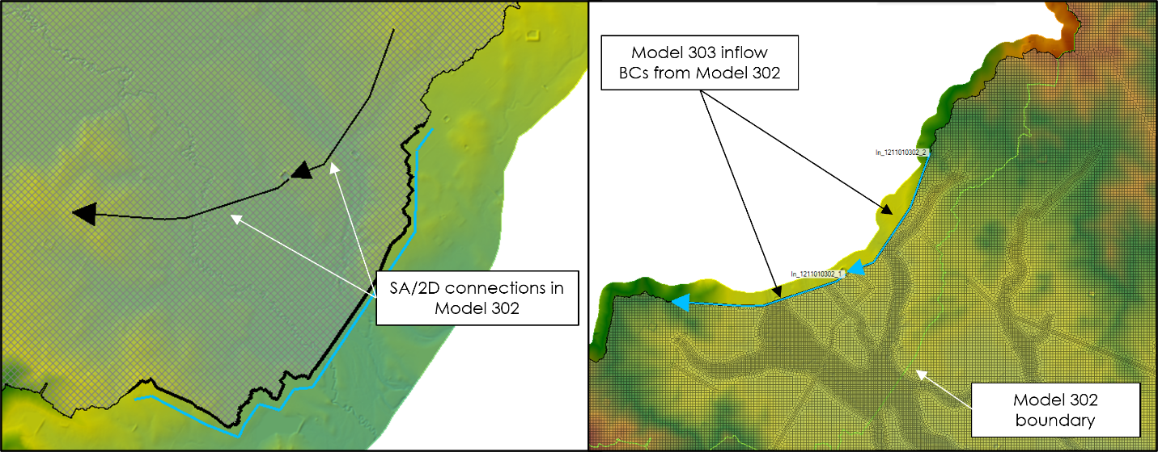
Figure 4-14. Model 302 and Model 303 Boundary Plan View

Table 4-17. 1211010302 and 1211010303 Continuity – all modeled events – Connection 1
Annual-chance Event | HUC302 (Upstream) | HUC303 (Downstream) | Difference  (upstream minus downstream)
Annual-chance Event | Max WSEL (ft) | Max WSEL (ft) | Max WSEL (ft)
10YR | 453.1 | 453.1 | 0.0
25YR | 454.4 | 454.1 | 0.3
50YR | 455.9 | 455.5 | 0.4
100YR | 458.6 | 458.6 | 0.0
500YR | 463.5 | 463.4 | 0.1
100YR+ | 455.3 | 455.0 | 0.3
100YR- | 460.3 | 459.8 | 0.5

Table 4-18. 1211010303 and 1211010502 Continuity – all modeled events – Connection 2
Annual-chance Event | HUC303 (Upstream) | HUC105 (Downstream) | Difference  (upstream minus downstream)
Annual-chance Event | Max WSEL (ft) | Max WSEL (ft) | Max WSEL (ft)
10YR | 452.9 | 452.9 | 0.0
25YR | 455.6 | 455.6 | 0.0
50YR | 457.6 | 457.5 | 0.1
100YR | 460.3 | 460.2 | 0.1
500YR | 464.6 | 464.5 | 0.1
100YR+ | 456.9 | 456.8 | 0.1
100YR- | 461.8 | 461.5 | 0.3

Calibration and Validation
Model parameter adjustment and calibration in the Task Order #1 BLE study was performed for models encompassing USGS gages with a minimum of 10 years of record. Model adjustments were based on estimates of a 1-in-100 (1%) annual-chance median peak flow values from a Bulletin 17C statistical analysis, and not considering hydrograph timing and flow volume. No model adjustments were made based on USGS regional regression estimates, but regression estimates were assessed to contextualize modeled results in watersheds lacking adequate gage records.
HUC8 watersheds in this Task Order coincide with the Edward’s Aquifer recharge and contributing zone and the Carrizo-Wilcox Aquifer underlies majority of the Frio, Upper and Middles Nueces HUC 8 watersheds (Figure 4-14). Coinciding with the aquifer creates a unique hydrologic rainfall-runoff response and groundwater-surface water interaction that is not reflected in the base CN derivation described in Section 3.2. Therefore, adjustment of infiltration parameters of Task Order #1 models for calibration was highly variable depending on vicinity of the model to aquifers and the recharge zones. Adjustment of CN’s in the Edward’s Aquifer region is a practice consistent with recent studies in Central Texas near the aquifer (Hydraulic Calibration of Watersheds by AECOM for Upper Brushy Creek WCID, Round Rock, Texas). Hydrologic losses due to the Carrizo-Wilcox influence and Karst geography in the Upper and Middle Nueces River HUC8 watersheds are well documented and being quantified by a concurrent InFRM study by USACE.
The Upper Nueces watershed (12110103) is likely impacted by the upstream Edward’s Aquifer recharge zone and direct concision with the Carrizo-Wilcox aquifer (discussed in more detail in Section 3.3). Since typical adjustments to CN’s, Manning’s values, and similar infiltration parameters, the primary calibration measure applied in the mainstem Upstream Nueces River models was by utilizing synthetic hydrographs to reduce the inflow leveraged from upstream models to better reflect the impacts of the upstream recharge and infiltration of the aquifer.

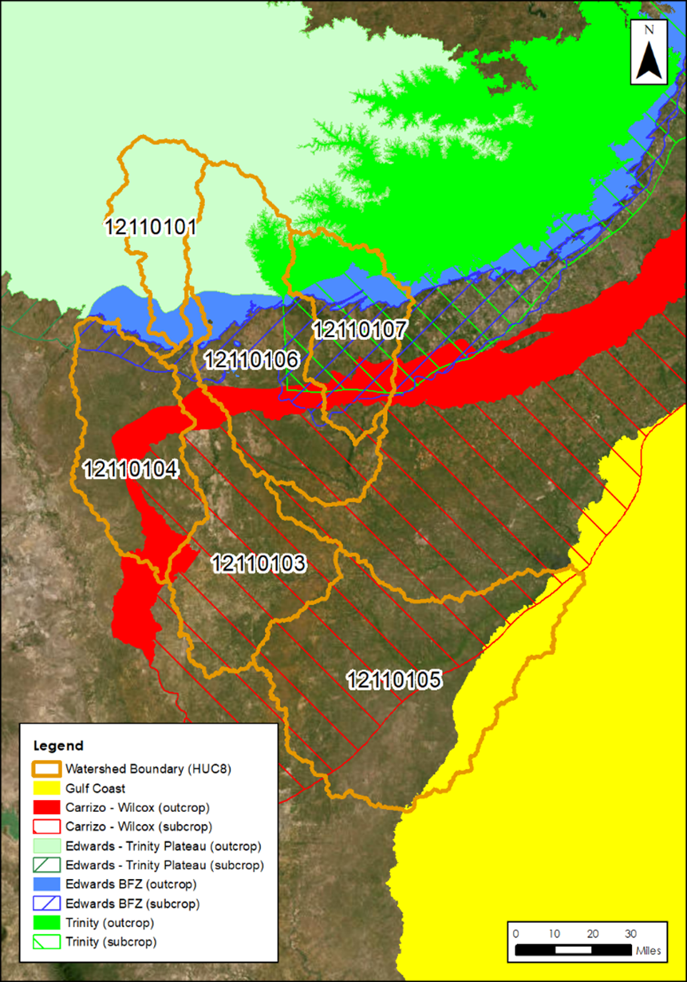
Figure 4-15. Task Order 1 HUC8 watershed overview with Edward’s Aquifer zones
Model calibration was performed at USGS gage locations with at least 10 years of discharge record. Calibration was based on estimates of 1-in-100 (1%) annual-chance peak flow values from a Bulletin 17C statistical flood frequency analysis performed with the USGS program PeakFQ and applying 2021 Texas regional skew factors at gages with adequate record (England et. al 2018; Cleveland and Fang 2021). HUC8 watersheds in Task Order #1 that do not have adequate historic data were calibrated using a regional factor derived from the calibration of models with adequate USGS gage records. The Upper Nueces watershed has four active USGS gages: Nueces Rv bl Uvalde, TX (08192000) and Nueces Rv nr Crystal City, TX (08192550), Nueces River near Asherton, TX (08193000) and Nueces River near Cotulla, TX (08194000). Gage 08192550 only records gage height and was not used to calibrate the models in this watershed, but modeled results were reported at this gage in Section 4.7. There was sufficient historic data for the Bulletin 17C statistical analysis at gage 08192000, 08193000, and 01894000 to be used for model calibration and validation. Gage locations in the Upper Nueces watershed are shown in Figure 4-15 and calibration results are summarized in Table 4-19. Results compare reasonably well with a draft Interagency Flood Risk Management (InFRM) report on the Nueces River Basin from January 2022, included within the supplemental data folder.
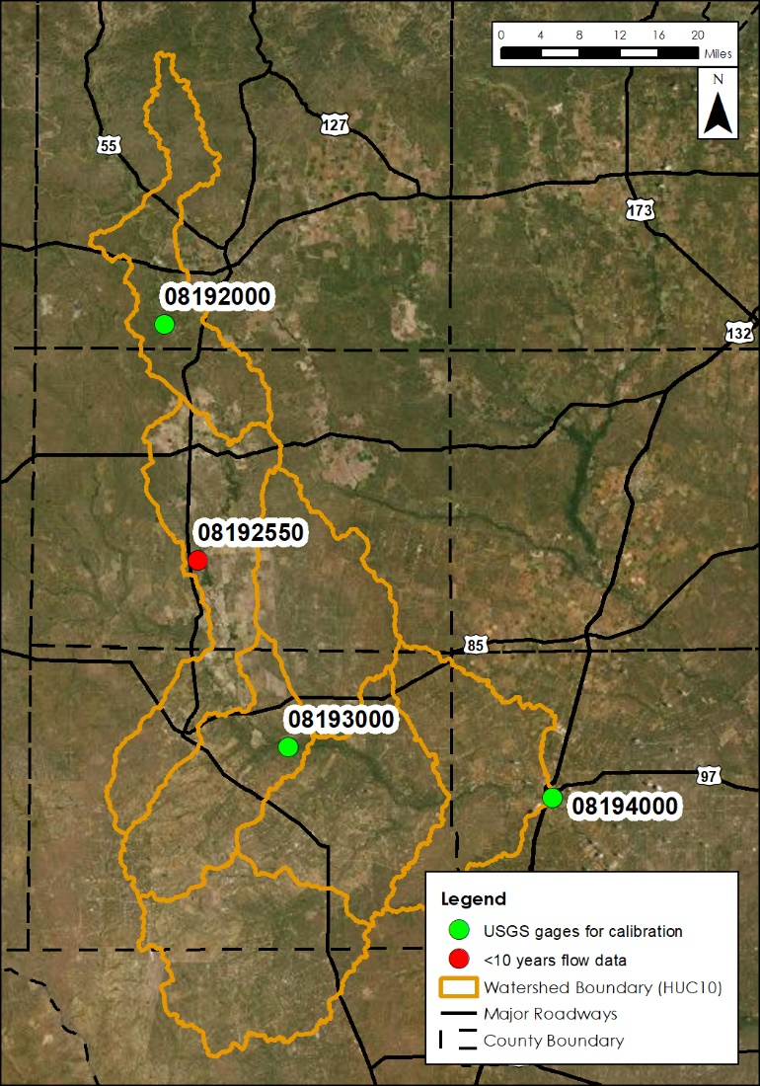
Figure 4-16. USGS Gages in Nueces Headwaters
As discussed previously in Section 4.5, inflow into model 302 and model 303 were only partially leveraged at some flow transfer locations to reduce modeled mainstem flows on the Nueces River in accordance with the regulated flow, Bulletin 17C 1% estimate at gage 08193000 and 08194000. Additionally, the base curve numbers in model 303 were reduced by 20% across the model domain to calibrate the model in accordance with the regulated flow, Bulletin 17C 1% estimate at gage 08194000. Final comparison of the modeled peak flow to the flood frequency analysis at the gage location is summarized in Table 4-19.
Table 4-19. 1%-Annual-chance Flood Event Calibration Results Summary for Nueces Headwaters
USGS Gage | Contributing Area (Sq. Mi) | Historic Record Bulletin 17C Flood Frequency Analysis -  1%-Annual-chance flow (CFS) |  |  | Modeled Peak Flow (1%) | Percent Difference (Modeled v. Historic Median)
USGS Gage | Contributing Area (Sq. Mi) | Median | Lower 5% Confidence Limit | Upper 95% Confidence Limit | Modeled Peak Flow (1%) | Percent Difference (Modeled v. Historic Median)
08192000 | 1,861 | 486,500 | 270,000 | 1,170,000 | 456,066 | 6 %
08193000 | 4,082 | 30,320 | 15,090 | 130,300 | 86,664 | 185 %
08194000 | 5,171 | 41,770 | 29,560 | 69,360 | 59,814 | 43 %

The model response was also compared to calculated flow estimates derived from USGS regional regression equations corresponding to the USGS gage locations in the HUC8 watershed (Table 4-20) and FEMA effective data where available. The modeled flows were higher than the median regression estimates but are within the upper 90% and lower 10% confidence bounds which were calculated with regional equations with Texas parameters derived from the 2009 USGS report by Asquith and Roussel (USGS 2009).
Table 4-20. 1% Annual-chance Flood Event – Modeled Peak Flow Comparison to USGS Regional Regression Estimates (equations and parameters via USGS 2009)
USGS Gage | 1% AEP Peak Flows (CFS)
USGS Gage | Modeled Peak Flow | Regression Estimate | Regression Estimate – 5% Lower CL | Regression Estimate – 95% Upper CL
08192000 | 456,066 | 110,550 | 36,600 | 333,900
08193000 | 86,664 | 212,180 | 70,260 | 640,770
08194000 | 59,814 | 275,000 | 90,810 | 828,210

The modeled WSEL and floodplain extents were compared to effective FEMA data, where existing. Currently, National Flood Hazard Layer (NFHL) regulatory data is available for Majority of the Upper Nueces watershed. Specifically, the following HUC10 watersheds have existing NFHL data: 1211010301, 1211010302, 1211010303, 1211010304, 1211010305, 1211010306, and 1211010307. The NFHL designations are Zone A and Zone X in this watershed with no published Base Flood Elevation (BFE) data.
The effective NFHL was imported as a map layer in RASMapper and inundation extent was compared from the modeled max depth 1% annual chance flood event. The modeled results in the tributary watersheds are spatially correlated with the NFHL Zone A estimates, but the modeled results for headwater tributaries generally show expanded inundation extent, specifically in the upstream portion of the watershed. The modeled results on the mainstem Nueces are highly correlated with the spatial inundation extent of the NFHL Floodplain Quilt Zone A estimates, specifically in the downstream portion of the watershed near the outlet.
Generally, in areas of variance with the NFHL flood extents along the main channel, the modeled results are narrower which is likely due to more accurate modeling of the channel and overbank terrain. Since the models are calibrated to gages on the mainstem, this narrower extent is not an indication of underrepresentation of modeled flow.

Modeled Results
A summary of modeled peak flow and WSEL results for the 10%, 1% and 0.2%-annual-chance events are summarized in Table 4-21, Table 4-22, and Table 4-23 for USGS and NWS gages in the watershed. Floodplain delineation for these events is described in Section 6 and exhibits corresponding to modeled results are included in Appendix C – Comparison of flow leveraging methods for Upper Nueces, Middle Nueces, and upper Frio BLE’s.
Table 4-21. 10%-Annual-chance Flood Results Summary for Nueces Headwaters
HUC10 Model Name and Number | Gage Description | Peak Flow (CFS) | WSEL¹ (ft)
08192000 | USGS | 158,801 | 825.4
08193000 | USGS | 25,480 | 500.8
08194000 | USGS | 15,415 | 384.4
¹Note vertical datum of modeled WSEL NAVD88

Table 4-22. 1%-Annual-chance Flood Results Summary for Nueces Headwaters
HUC10 Model Name and Number | Gage Description | Peak Flow (CFS) | WSEL¹ (ft)
08192000 | USGS | 456,049 | 835.8
08193000 | USGS | 86,664 | 504.1
08194000 | USGS | 59,814 | 391.1
¹Note vertical datum of modeled WSEL NAVD88

Table 4-23. 0.2%-Annual-chance Flood Results Summary for Nueces Headwaters
HUC10 Model Name and Number | Gage Description | Peak Flow (CFS) | WSEL¹ (ft)
08192000 | USGS | 869,486 | 843.7
08193000 | USGS | 162,674 | 506.1
08194000 | USGS | 137,250 | 398.3
¹Note vertical datum of modeled WSEL NAVD88

Challenges and Recommendations
The primary challenge in modeling this watershed was accurately representing the physical processes of the losing stream between gage 08192000 and 08210000. The chosen synthetic hydrograph application to remove water volume from the system was applied as a “proxy” for removing volume from the stream that is lost to groundwater. However, this solution neglects timing of the upstream inflow. It is recommended that the volume losses be further studied in order to better reflect the watershed losses and timing with potential additional surface water-groundwater modeling outside of HEC-RAS.
It's recommended that a sensitivity analysis of the impact of each of the following factors may be considered to better understand flood hazard extents that are outside the scope of this Base Level Engineering effort:
- Evaluating channel losses or storage losses from any irrigation diversions in watershed
- Further analyze most appropriate storm precipitation quartile for region
- Applying InFRM WHA study flows (currently in draft)
- Evaluating losses to aquifer recharge, modified infiltration parameters
- Comparison of the impacts of rainfall temporal distribution on runoff volume and mapping extents (e.g., middle-loaded precipitation to the front-loaded precipitation)
- De-coupling approach to modeling the Middle Nueces watershed (mainstem v. tributary models)
An additional challenge was the braided channel structure and flat terrain that occurs in the downstream portion of the Upper Nueces. This type of watershed characteristic makes it very challenging to tie-in models within the required 0.5-ft tolerance. This ultimately resulted in the combining of HUC 10 models and needing multiple BC lines to accurately capture the hydrograph at tie-in locations.
Future model upgrades should incorporate structures by utilizing as-builts, surveyed data, or effective models within the study area. They should also consider further refining significant regulation features, namely along the Nueces River and significant tributaries by implementing bathymetry data into the model terrain.

Quality Control
Following the initial BLE analysis in each watershed, the flood hazard area delineations were reviewed for areas where the inundation that impacted either critical public infrastructure or private property. Revisions were made, if necessary, to reflect potential flooding risk on these properties more accurately.
Quality Assurance/Quality Control (QA/QC) review necessitated some manual editing including adding/moving computational points, breaklines, hydraulic connectors, and mesh refinement regions. The areas in or adjacent to channelized areas or significant ponding were the focus of this review.

Floodplain Delineation (10%, 1% and 0.2% events)
Floodplain Delineation was developed using the Texas Water Development Board Matrix Tool and running a set of ArcGIS Cartography tools against the output results from the Matrix Tool. The tool inputs the raw depth grids produced from HEC-RAS and removes small islands that have any of the following parameters. Areas that are less than 0.33 acres or between 0.33-0.5 acres with an average depth less than 0.5 feet or areas between 0.5 – 1 acre averaging a depth less than 0.25 feet or between 1 – 2 acres averaging less than 0.1 feet. Lake, reservoir, and/or ponding areas of approximately 20 acres or greater were incorporated into the final mapping.
The Matrix Tool was also applied to fill the islands less than or equal to 0.33 acres in the vector floodplains. After the Matrix Tool is run, post-processing was performed to fill any additional islands of 2 aces or less for 0.2% and 1% floodplains while 10% floodplain received an 0.5 acre fill. In order for the flooding product extents to match, a 0.1ft was applied to the Depth Grid resulting in a 0.1ft depth low value. The Depth Grid was then used to extract the Water Surface Elevation Grid to have 1:1 match per FEMA standards. Additional post processing steps were applied using ArcGIS Simplifying and Smoothing tools to the 0.2% and 1% floodplain polygons using a 5-foot threshold for simplifying and 25-foot tolerance for smoothing. Per Guidance, the 10% floodplains did not go through the post processing step. This is to keep the 10% flood extents as close to the model export as possible. Disconnected floodplain extents are maintained through the post-process as preferred by Texas Water Development Board.

Internal Mapping Tie-ins
The hydraulic models in this task order were setup for upstream and downstream overlap in sequential models to maintain flow continuity of the mainstem between models. There are three overlap areas and three tie-ins at each overlap, one per event type. As shown in table 6-1 below, out of those nine main stem tie-ins three were able to achieve a mapping tie-in within +/-0.5 ft of WSEL difference for the 10-year, 100-year, and 500-year storms per FEMA Region 6 requirements. The remaining six tied-in with up to a +/-0.8 ft of WSEL difference. However, along the model perimeters where there are auxiliary flooding or spill locations, often model overlaps do not exist. In many of these instances, AOMI areas are used to identify tie-in issues that were unable to be resolved due to a lack of model overlap.
Within the downstream portion of Upper Nueces Watershed along Nueces River near City of Cotulla, floodplain mapping from Middle Nueces watershed (12110105) model was used to tie-in the Upper Nueces Watershed mapping products (Figure 6-1).
Table 6-1: Internal Mapping Tie-In WSEL Differences
Upper Nueces Models | Storm Event | Main Stem Tie-In Range
1211010301 and 1211010302 | 10-year | +/-0.8 ft WSEL difference
1211010301 and 1211010302 | 100-year | +/-0.8 ft WSEL difference
1211010301 and 1211010302 | 500-year | +/-0.5 ft WSEL difference
1211010302 and 1211010303 | 10-year | +/-0.8 ft WSEL difference
1211010302 and 1211010303 | 100-year | +/-0.5 ft WSEL difference
1211010302 and 1211010303 | 500-year | +/-0.8 ft WSEL difference
1211010303 and 1211010502 | 10-year | +/-0.8 ft WSEL difference
1211010303 and 1211010502 | 100-year | +/-0.5 ft WSEL difference
1211010303 and 1211010502 | 500-year | +/-0.8 ft WSEL difference

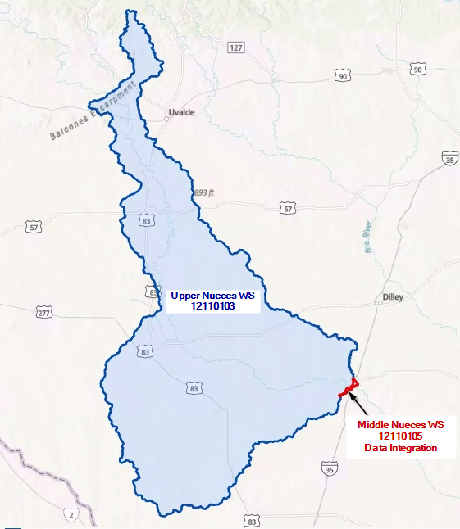
Figure 6-1. HUC 12110103 and HUC 12110105 Tie in Location

Hazus
As a part of the Base Level Engineering assessment effort, Hazus was run using version 6.0 and resampled 10ft cell size 1% Depth Grid. Hazus 6.0 uses parcel data to map the results but, attributes data by census block number. S_FRAC_Ar was populated with the 1% Hazus results. Data that intersects the HUC8 boundary is left as is, no clipping was performed. All census/parcel data completely outside of the HUC8 boundary was removed.

Special Considerations
Unique challenges to modeling this watershed were discussed in Chapter 4. In addition, the following items should be considered in reviewing the mapping products, and for potential future studies in the watershed:
- There are no detailed study areas/lines (DTL_STUD_AR & DTL_STUD_LN) within Upper Nueces Watershed, only approximate zones as provided from the National Flood Hazard Layer (NFHL) and TWDB Floodplain Quilt.
- Significant artificial depth increases at floodplain fringes occur in some areas of the mapping products because of RASMapper raster generation. In the sloping rendering mode, RASMapper attempts to interpolate between adjacent cells to “slope” the water surface, but in doing so, steep canyon walls or bluffs on the floodplain fringe can artificially cause the water surface to be interpolated upstream, resulting in significant areas of inundation where there should really be no inundation. This erroneous mapping result is referred to herein as “cupping”.
- In the Upper Nueces watershed products, stream centerlines are contained within the 1% floodplain. However, in areas where there are road crossings and embankments, there is no streamline containment because the floodplain is not overtopping.
  - There is a shapefile provided within the Supplemental Folder that categorizes whether the stream segment outside the 1% floodplain was fixed (Y) to be within the boundary or a ROAD/Embankment was present and no containment was possible.

Results and Recommendations
The BLE results for the Upper Nueces watershed produced an SFHA that compares reasonably well with the effective SFHA (if digitally available) in most cases and provides an additional estimated SFHA in areas that do not currently have an SFHA mapped. These results provide context for flood risk communication as part of the Discovery process and should be verified through community work map meetings before being applied to a regulatory product.

CNMS Validation of Effective Zone A Special Flood Hazard Area (SFHA)
A large portion of the Zone A studies (1085.3 miles) in the Nueces Headwaters watershed were classified in CNMS with a validation status of “UNVERIFIED” and status type of “TO BE STUDIED.” The following is a summary of the results of the CNMS validation assessment for the effective Zone A studies in the study area. Initial Assessment checks A1-A5 were evaluated for the CNMS inventory of Zone A studies.
Initial Assessment A1 – Significant Topography Update Check
This check involves determining whether a topographic data source is available that is significantly better than what was used for the effective Zone A modeling and mapping. For the Nueces Headwaters watershed study area, the effective Zone A topographic data leveraged a variety of sources, but primarily based upon USGS 24K map products.
The effective topo used for the effective Zone A in HUC8 12110103 does not meet vertical accuracy requirements of SID 43. There is new topo available that does meet SID 43 from Texas Natural Resources Information System (TNRIS). Therefore, all effective Zone A studies in HUC8 12110103 fail A1.
Initial Assessment A2 – Check for Significant Hydrology Changes
This check involves first determining whether regression equations were used in the effective study. If they were then it was determined if new regression equations have become available from the USGS since the date of the effective Zone A study. If newer regression equations exist for the area of interest, then an engineer must determine whether these regression equations would significantly affect the 1-percent-annual chance flow.
Hydrology methods are unknown for the effective Zone A studies in HUC8 12110103. Therefore, all effective Zone A studies in HUC8 12110103 pass A2.
Initial Assessment A3 – Check for Significant Development
This check involves using the National Urban Change Indicator (NUCI) dataset to assess increased urbanization in the watershed of the Zone A study. If the percentage of urban area within the HUC-12 watershed containing the effective Zone A study is 15% or more, and has increased by 50% or more since the effective analysis, the study would fail this check. Although the NUCI data provide year-to-year changes in urbanization, the NLCD also is needed to establish a baseline of urban land cover for this analysis.
National Land Cover Data and National Urban Change Indicator were analyzed, and urbanization increase for HUC8 12110103 was deemed insignificant for all effective Zone A reaches. Therefore, all effective Zone A reaches pass this check.
Table 7-1: Zone A Initial Assessment Results
Assessment Check | Pass/Fail | Comments/Notes
A1 - Topography | Fail | Old topo does not meet SID 43, new topo does
A2 - Hydrology | Pass | Hydrology methods are unknown for all reaches
A3 - Development | Pass | Urbanization increase is insignificant

Initial Assessment A4 – Check of Studies Backed by Technical Data
Zone A studies that pass all initial assessment checks described above may be categorized as “Valid” in the CNMS Inventory only if the effective Zone A study is supported by modeling or sound engineering judgment and all regulatory products are in agreement. If the effective Zone A study passes all initial assessment checks, but is not supported by modeling, or if the original engineering method used is unsupported or undocumented, a comparison of the BLE results and effective Zone A’s is performed.
All zone A reaches in HUC8 12110103 have no information available on their hydraulic model and are therefore not considered to be model backed. All zone A reaches in HUC8 12110103 fail A4.
Initial Assessment A5 – Comparison of BLE and Effective Zone A Floodplains
The BLE /effective Zone A comparison method leverages the existing Floodplain Boundary Standard (FBS) certification procedures described in FEMA SID 113, but with a slight modification. This modified FBS comparison approach uses the 1-percent plus and 1-percent minus flood profiles and horizontal and vertical tolerances described in the First Order Approximation - Methodology, Validation, and Scalability Guidance Procedures (Version 1.5). For the comparison of BLE and effective Zone A in the study area, the following vertical and horizontal tolerances were used to conduct the modified FBS procedure. Points were sampled on the effective floodplain boundary at 200 ft intervals for comparison.
Vertical Tolerance: +/- 0.5 feet (one-half contour interval of assumed effective topographic source).
Horizontal Tolerance: +/-75 feet (standard horizontal tolerance for BLE comparison testing).

All effective Zone A studies in HUC8 12110103 failed the BLE comparison check. The National Risk Index risk deciles were grouped to represent risk classes and used to evaluate the threshold of points needed to assign a passing A5 score for each HUC12. Results are listed in Table 7-3.
CNMS Validation Results
Based on the validation assessments and BLE comparison results described above, the CNMS inventory of Zone A studies in Nueces Headwaters watershed study area has been updated, total miles in each of these categories are summarized in Table 7-2 and illustrated in Figure 7-1 below.

Table 7-2: Zone A Validation Results
Validation Status | Status Type | Total Mileage
Valid | NVUE Compliant | 0
Unverified | To Be Studied | 1085

Table 7-3: BLE Comparison Results
HUC-12 Watershed |  | Total FBS Points | Fail | Pass | % Pass | BLE Comparison Pass? (>85%) | Priority Score
Watershed Name | HUC12 ID
Lower Tortuga Creek | 121101030403 | 638 | 405 | 233 | 37% | >95% | FAIL
Galveneno Creek-Arroyo Negro | 121101030405 | 1374 | 953 | 421 | 31% | >95% | FAIL
Tierra Blanca Creek | 121101030502 | 2164 | 990 | 1174 | 54% | >90% | FAIL
Beinhorn Lake-San Roque Creek | 121101030506 | 663 | 396 | 267 | 40% | >95% | FAIL
Headwaters Appurceon Creek | 121101030601 | 1108 | 680 | 428 | 39% | >95% | FAIL
San Roque Lake-San Roque Creek | 121101030605 | 1266 | 677 | 589 | 47% | >95% | FAIL
Cambalache Creek-Nueces River | 121101030203 | 729 | 551 | 178 | 24% | >95% | FAIL
Salt Creek | 121101030206 | 405 | 270 | 135 | 33% | >95% | FAIL
Penitas Creek-Carrizo Creek | 121101030205 | 2024 | 1400 | 624 | 31% | >95% | FAIL
Upper El Moro Creek | 121101030303 | 941 | 506 | 435 | 46% | >95% | FAIL
Headwaters Espejo Rosita Creek | 121101030501 | 2143 | 889 | 1254 | 59% | >90% | FAIL
Canyon Creek-Velenzuela Creek | 121101030503 | 2238 | 1166 | 1072 | 48% | >95% | FAIL
Bermuda Lake-Nueces River | 121101030305 | 723 | 438 | 285 | 39% | >95% | FAIL
Stagg Hollow-Nueces River | 121101030306 | 689 | 464 | 225 | 33% | >95% | FAIL
Nueces Hill-Nueces River | 121101030102 | 1364 | 735 | 629 | 46% | >95% | FAIL
Elm Creek-Nueces River | 121101030103 | 1250 | 630 | 620 | 50% | >95% | FAIL
Little Indian Creek-Indian Creek | 121101030101 | 2261 | 1478 | 783 | 35% | >95% | FAIL
Mustang Creek-Nueces River | 121101030104 | 1755 | 918 | 837 | 48% | >95% | FAIL
Sand Ridge Creek-Nueces River | 121101030105 | 872 | 553 | 319 | 37% | >95% | FAIL
Evans Lake-Nueces River | 121101030201 | 1242 | 1054 | 188 | 15% | >95% | FAIL
Cambalache Tank-Nueces River | 121101030202 | 691 | 626 | 65 | 9% | >95% | FAIL
Burro Creek-San Roque Creek | 121101030604 | 1337 | 666 | 671 | 50% | >95% | FAIL
Headwaters Espio Creek | 121101030702 | 933 | 461 | 472 | 51% | >95% | FAIL
Sauz Mocho Creek-Nueces River | 121101030606 | 1189 | 674 | 515 | 43% | >95% | FAIL
Sage Creek-Nueces River | 121101030701 | 1267 | 726 | 541 | 43% | >95% | FAIL
Sage Creek-Espio Creek | 121101030703 | 336 | 198 | 138 | 41% | >95% | FAIL
Salt Creek-Nueces River | 121101030705 | 50 | 29 | 21 | 42% | >95% | FAIL
Alligator Slough-Nueces River | 121101030204 | 826 | 732 | 94 | 11% | >95% | FAIL
Old Tresquilla Tank | 121101030302 | 791 | 412 | 379 | 48% | >95% | FAIL
Line Oak Slough-Nueces River | 121101030207 | 1281 | 792 | 489 | 38% | >95% | FAIL
El Barrosa Creek | 121101030301 | 792 | 516 | 276 | 35% | >95% | FAIL
Loma Vista Creek-Arroyo Negro | 121101030404 | 1175 | 771 | 404 | 34% | >95% | FAIL
Lower El Moro Creek | 121101030304 | 2121 | 1341 | 780 | 37% | >95% | FAIL
Llano Tank-Bonito Creek | 121101030504 | 1590 | 852 | 738 | 46% | >95% | FAIL
Upper Tortuga Creek | 121101030401 | 1439 | 1137 | 302 | 21% | >95% | FAIL
Velenzuela Creek-San Roque Creek | 121101030505 | 997 | 486 | 511 | 51% | >95% | FAIL
Middle Tortuga Creek | 121101030402 | 788 | 486 | 302 | 38% | >95% | FAIL
Las Tablas Creek | 121101030507 | 495 | 211 | 284 | 57% | >95% | FAIL
Arroyo Negro-Nueces River | 121101030602 | 1050 | 673 | 377 | 36% | >95% | FAIL
Headwaters Sauz Mocho Creek | 121101030603 | 743 | 427 | 316 | 43% | >95% | FAIL

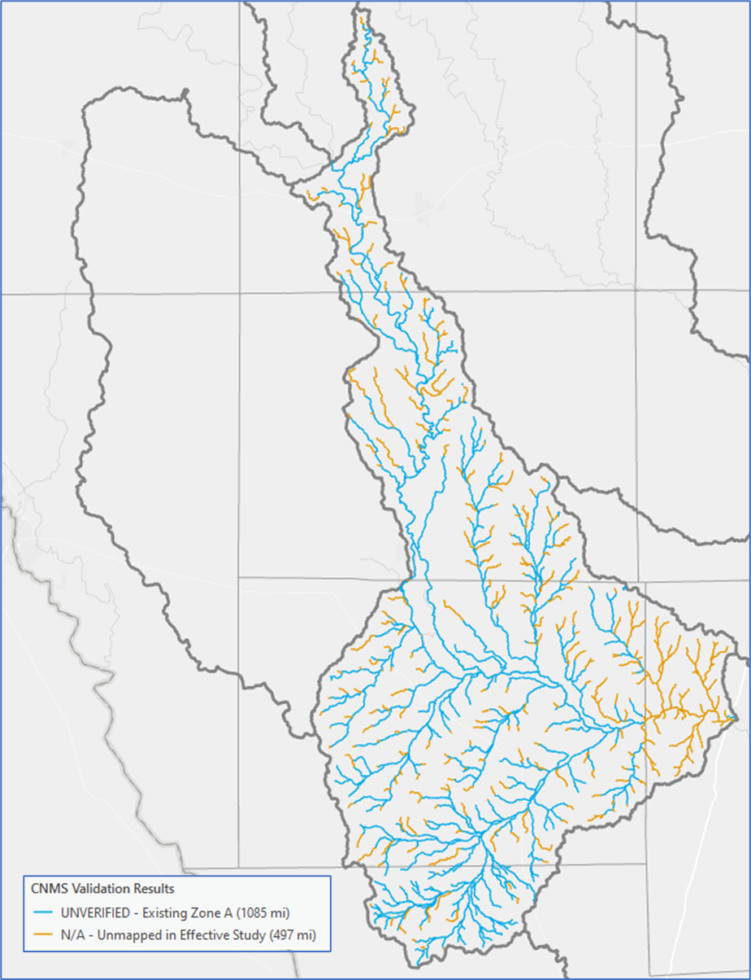
Figure 7-1. CNMS Validation Results

Deliverables
- Coordinated Needs Management Strategy (CNMS) Geodatabase
  - Contains all CNMS relationship and feature classes, including S_Studies_Ln and S_Unmapped_Ln (intentionally empty), for reaches in HUC8 12110103.

References

Chow, Ven T. "Development of Uniform Flow and Its Formulas." Open Channel Hydraulics. Caldwell, NJ: Blackburn, 1959. 109-113. Print.
Cleveland, Theodore G; Fang, Nick, 2021, “texas-skew-update-2021", https://doi.org/10.18738/T8/SVLCOQ, Texas Data Repository, V6
England, J.F., Jr., Cohn, T.A., Faber, B.A., Stedinger, J.R., Thomas, W.O., Jr., Veilleux, A.G., Kiang, J.E., and Mason, R.R., Jr., 2018, Guidelines for determining flood flow frequency--Bulletin 17C: U.S. Geological Survey Techniques and Methods, book 4, chap. B5, 148 p., https://doi.org/10.3133/tm4B5.
ESRI ArcMap (2018). ArcGIS v. 10.5.1
FEMA, “Guidance for Flood Risk Analysis and Mapping – First Order Approximation”, November 2014. (http://www.fema.gov/media-library-data/1420849667914-c1656173985d814d0e62f80818505969/FOA_Guidance_Nov_2014.pdf).
FEMA Region 6, “Base Level Engineering Submittal Guidance”, June 2017. (https://rmd.msc.fema.gov/Regions/VI/Ph0_Investment/1/Base%20Level%20Engineering/Submittal%20Guidance/20170615_BLE%20Submittal%20Guidance_R6.pdf).
Multi-Resolution Land Characteristics Consortium (MRCL). National Land Cover Database (NLCD) 2019 Land Cover (CONUS). Online at: https://www.mrlc.gov/data/nlcd-2019-land-cover-conus
NOAA. (2017). “NOAA Atlas 14 Precipitation Frequency Estimates in GIS Compatible Format”. Webpage last modified April 21, 2017. Downloadable online at: PF in GIS Format - PFDS/HDSC/OWP (noaa.gov)
NOAA. (2018). NOAA Atlas 14 Precipitation-Frequency Atlas of the United States. Volume 11 Version 2.0: Texas. Online at: NOAA Atlas 14 (weather.gov)
NRCS. (2016). Manning’s n Values for Various Land Covers to Use for Dam Breach Analysis by NRCS in Kansas. Online at: Microsoft Word - Manning’s n-values for Kansas Dam Breach Analyses - Adopted 071216.docx (rashms.com)
Soil Survey Staff, Natural Resources Conservation Service, United States Department of Agriculture. Soil Survey Geographic (SSURGO) Database. Available online at https://sdmdataaccess.sc.egov.usda.gov. Accessed [July/07/2021]
USGS. (2015). Documentation of Input Datasets for the Soil-Water Balance Groundwater Recharge Model for the Upper Colorado River Basin. Fred D. Tillman. Online at: cover v 3.5.1 (usgs.gov)

USACE. (2021). River Analysis System, HEC-RAS, v. 6.3.0
USACE Hydrologic Engineering Center (USACE HEC). HEC-RAS 2D User’s Manual. 2021. https://www.hec.usace.army.mil/confluence/rasdocs/r2dum/latest

Appendix A – PeakFQ Output File

1
Program PeakFq U. S. GEOLOGICAL SURVEY Seq.002.000
Version 7.3 Annual peak flow frequency analysis Run Date / Time
10/25/2019 11/12/2021 16:16

--- PROCESSING OPTIONS ---

Plot option = Graphics device
Basin char output = None
Print option = Yes
Debug print = No
Input peaks listing = Long
Input peaks format = WATSTORE peak file

Input files used:
peaks (ascii) - C:\Users\snarkhede\Documents\PROJECTS\TWDB\Gage Analysis\With Skew\HUC103\1211010301\08192000\08192000_PEAK.TXT
specifications - C:\Users\snarkhede\Documents\PROJECTS\TWDB\Gage Analysis\With Skew\HUC103\1211010301\08192000\PKFQWPSF.TMP
Output file(s):
main - C:\Users\snarkhede\Documents\PROJECTS\TWDB\Gage Analysis\With Skew\HUC103\1211010301\08192000\08192000_PEAK.PRT

*** User responsible for assessment and interpretation of the following analysis ***

1

Program PeakFq U. S. GEOLOGICAL SURVEY Seq.001.001
Version 7.3 Annual peak flow frequency analysis Run Date / Time
10/25/2019 11/12/2021 16:16

Station - 08192000 Nueces Rv bl Uvalde, TX

TABLE 1 - INPUT DATA SUMMARY

Number of peaks in record = 93
Peaks not used in analysis = 0
Gaged peaks in analysis = 93
Historic peaks in analysis = 0
Beginning Year = 1928
Ending Year = 2020
Historical Period Length = 93
Skew option = WEIGHTED
Regional skew = -0.428
Standard error = 0.465
Mean Square error = 0.216
Gage base discharge = 0.0
User supplied high outlier threshold = --
User supplied PILF (LO) criterion = --
Plotting position parameter = 0.00
Type of analysis EMA
PILF (LO) Test Method MGBT
Perceptible Ranges:
Start Year End Year Lower Bound Upper Bound
1928 2020 0.0 INF DEFAULT
Interval Data = None Specified

TABLE 2 - DIAGNOSTIC MESSAGE AND PILF RESULTS

*WCF107I-ACCEPTED GEN SKEW OUTSIDE MAP LIMITS. -0.428 -0.400 0.800
WCF002J-CALCS COMPLETED. RETURN CODE = 2
EMA002W-CONFIDENCE INTERVALS ARE NOT EXACT IF HISTORIC PERIOD > 0

MULTIPLE GRUBBS-BECK TEST RESULTS

MULTIPLE GRUBBS-BECK PILF THRESHOLD 4490.0
NUMBER OF PILFS IDENTIFIED 35
CLASSIFICATION OF PILFS:
NUMBER OF ZERO FLOWS 1
NUMBER OF CENSORED FLOWS 0
NUMBER OF GAGED PEAKS 34
GAGED PEAKS AND CORRESPONDING P-VALUES
0.1 (0.0002)
6.2 (0.1637)
8.3 (0.0857)
14.0 (0.0969)
19.0 (0.0750)
25.0 (0.0593)
37.0 (0.0824)
45.0 (0.0632)
46.0 (0.0227)
51.0 (0.0105)
55.0 (0.0038)
56.0 (0.0008)
60.0 (0.0002)
63.2 (0.0000)
70.0 (0.0000)
74.0 (0.0000)
83.0 (0.0000)
125.0 (0.0000)
153.0 (0.0000)
189.0 (0.0000)
212.0 (0.0000)
246.0 (0.0000)
330.0 (0.0000)
384.0 (0.0000)
626.0 (0.0000)
728.0 (0.0000)
1440.0 (0.0004)
1790.0 (0.0013)
1960.0 (0.0011)
2380.0 (0.0036)
2390.0 (0.0012)
3010.0 (0.0065)
3090.0 (0.0031)
3370.0 (0.0031)

Kendall's Tau Parameters

MEDIAN No. of
TAU P-VALUE SLOPE PEAKS
---------------------------------------
GAGED PEAKS -0.102 0.149 -19.508 92

1

Program PeakFq U. S. GEOLOGICAL SURVEY Seq.001.002
Version 7.3 Annual peak flow frequency analysis Run Date / Time
10/25/2019 11/12/2021 16:16

Station - 08192000 Nueces Rv bl Uvalde, TX

TABLE 3 - ANNUAL FREQUENCY CURVE PARAMETERS -- LOG-PEARSON TYPE III

LOGARITHMIC
-------------------------------
STANDARD
MEAN DEVIATION SKEW
-------------------------------
EMA WITHOUT REG SKEW 3.8477 0.9888 -0.742
EMA WITH REG SKEW 3.8810 0.9295 -0.516

EMA ESTIMATE OF MSE OF SKEW WITHOUT REG SKEW 0.1013
EMA ESTIMATE OF MSE OF SKEW W/GAGED PEAKS ONLY (AT-SITE) 0.1013

TABLE 4 - ANNUAL FREQUENCY CURVE -- DISCHARGES AT SELECTED EXCEEDANCE PROBABILITIES

ANNUAL <- EMA ESTIMATE -> <- FOR EMA ESTIMATE WITH REG SKEW ->
EXCEEDANCE WITH WITHOUT LOG VARIANCE <-CONFIDENCE LIMITS->
PROBABILITY REG SKEW REG SKEW OF EST. 5.0% LOWER 95.0% UPPER

0.9500 169.2 109.8 0.1596 9.4 471.4
0.9000 447.0 337.4 0.0954 44.8 980.1
0.8000 1352. 1177. 0.0481 258.6 2369.0
0.6667 3552. 3400. 0.0244 1179.0 5423.0
0.5000 9133. 9309. 0.0129 4903.0 13120.0
0.4292 13240. 13700. 0.0107 8089.0 18950.0
0.2000 47570. 49530. 0.0099 33100.0 71940.0
0.1000 102100. 102500. 0.0132 68710.0 170700.0
0.0400 214900. 200900. 0.0194 135400.0 417600.0
0.0200 334700. 294300. 0.0254 198600.0 725000.0
0.0100 486500. 401100. 0.0327 270000.0 1170000.0
0.0050 671700. 518700. 0.0413 347400.0 1792000.0
0.0020 969100. 686000. 0.0548 455300.0 2984000.0

*Note: If Station Skew option is selected then EMA ESTIMATE WITH REG SKEW will
display values for and be equal to EMA ESTIMATE WITHOUT REG SKEW.
1

Program PeakFq U. S. GEOLOGICAL SURVEY Seq.001.003
Version 7.3 Annual peak flow frequency analysis Run Date / Time
10/25/2019 11/12/2021 16:16

Station - 08192000 Nueces Rv bl Uvalde, TX

TABLE 5 - INPUT DATA LISTING

WATER PEAK PEAKFQ FLOW INTERVALS (WHERE LOWER BOUND NOT = UPPER BOUND)
YEAR VALUE CODES LOWER BOUND UPPER BOUND REMARKS
1928 10000.0
1929 14500.0
1930 68200.0
1931 27000.0
1932 207000.0
1933 246.0
1934 45.0
1935 616000.0
1936 74800.0
1937 330.0
1938 18200.0
1939 89000.0
1940 4990.0
1941 212.0
1942 11200.0
1943 2380.0
1944 3370.0
1945 70.0
1946 3010.0
1947 4490.0
1948 23600.0
1949 63000.0
1950 384.0
1951 46.0
1952 5020.0
1953 6160.0
1954 18400.0
1955 189000.0
1956 14.0
1957 3090.0
1958 146000.0
1959 17300.0
1960 37500.0
1961 28600.0
1962 728.0
1963 19500.0
1964 188000.0
1965 25200.0
1966 39900.0
1967 83.0
1968 12100.0
1969 56.0
1970 23700.0
1971 90600.0
1972 44100.0
1973 1790.0
1974 144000.0
1975 22300.0
1976 14900.0
1977 7450.0
1978 8270.0
1979 6040.0
1980 189.0
1981 25900.0
1982 58500.0
1983 2390.0
1984 37.0
1985 44600.0
1986 11600.0
1987 67200.0
1988 153.0
1989 55.0
1990 22000.0
1991 36600.0
1992 9040.0
1993 125.0
1994 5760.0
1995 1960.0
1996 6000.0
1997 201000.0
1998 83200.0
1999 10200.0
2000 51.0
2001 13700.0
2002 65300.0
2003 626.0
2004 35000.0
2005 42000.0
2006 74.0
2007 80100.0
2008 60.0
2009 19.0
2010 25.0
2011 8.3
2012 6.2
2013 0.1
2014 0.0
2015 11200.0
2016 70400.0
2017 1440.0
2018 9720.0
2019 105000.0
2020 63.2

Explanation of peak discharge qualification codes

PeakFQ NWIS
CODE CODE DEFINITION

D 3 Dam failure, non-recurrent flow anomaly
G 8 Discharge greater than stated value
X 3+8 Both of the above
L 4 Discharge less than stated value
K 6 OR C Known effect of regulation or urbanization
O O Opportunistic peak
H 7 Historic peak

- Minus-flagged discharge -- Not used in computation
-8888.0 -- No discharge value given
- Minus-flagged water year -- Historic peak used in computation

1

Program PeakFq U. S. GEOLOGICAL SURVEY Seq.001.004
Version 7.3 Annual peak flow frequency analysis Run Date / Time
10/25/2019 11/12/2021 16:16

Station - 08192000 Nueces Rv bl Uvalde, TX

TABLE 6 - EMPIRICAL FREQUENCY CURVES -- HIRSCH-STEDINGER PLOTTING POSITIONS

WATER RANKED EMA FLOW INTERVALS (WHERE LOWER BOUND NOT = UPPER BOUND)
YEAR DISCHARGE ESTIMATE LOWER BOUND UPPER BOUND
1935 616000.0 0.0106
1932 207000.0 0.0212
1997 201000.0 0.0319
1955 189000.0 0.0425
1964 188000.0 0.0532
1958 146000.0 0.0638
1974 144000.0 0.0744
2019 105000.0 0.0851
1971 90600.0 0.0957
1939 89000.0 0.1064
1998 83200.0 0.1170
2007 80100.0 0.1276
1936 74800.0 0.1383
2016 70400.0 0.1489
1930 68200.0 0.1596
1987 67200.0 0.1702
2002 65300.0 0.1808
1949 63000.0 0.1915
1982 58500.0 0.2021
1985 44600.0 0.2127
1972 44100.0 0.2234
2005 42000.0 0.2340
1966 39900.0 0.2447
1960 37500.0 0.2553
1991 36600.0 0.2659
2004 35000.0 0.2766
1961 28600.0 0.2872
1931 27000.0 0.2979
1981 25900.0 0.3085
1965 25200.0 0.3191
1970 23700.0 0.3298
1948 23600.0 0.3404
1975 22300.0 0.3511
1990 22000.0 0.3617
1963 19500.0 0.3723
1954 18400.0 0.3830
1938 18200.0 0.3936
1959 17300.0 0.4042
1976 14900.0 0.4149
1929 14500.0 0.4255
2001 13700.0 0.4362
1968 12100.0 0.4468
1986 11600.0 0.4574
1942 11200.0 0.4787
2015 11200.0 0.4681
1999 10200.0 0.4894
1928 10000.0 0.5000
2018 9720.0 0.5106
1992 9040.0 0.5213
1978 8270.0 0.5319
1977 7450.0 0.5426
1953 6160.0 0.5532
1979 6040.0 0.5638
1996 6000.0 0.5745
1994 5760.0 0.5851
1952 5020.0 0.5958
1940 4990.0 0.6064
1947 4490.0 0.6170
* 1944 3370.0 0.6277
* 1957 3090.0 0.6383
* 1946 3010.0 0.6489
* 1983 2390.0 0.6596
* 1943 2380.0 0.6702
* 1995 1960.0 0.6809
* 1973 1790.0 0.6915
* 2017 1440.0 0.7021
* 1962 728.0 0.7128
* 2003 626.0 0.7234
* 1950 384.0 0.7341
* 1937 330.0 0.7447
* 1933 246.0 0.7553
* 1941 212.0 0.7660
* 1980 189.0 0.7766
* 1988 153.0 0.7873
* 1993 125.0 0.7979
* 1967 83.0 0.8085
* 2006 74.0 0.8192
* 1945 70.0 0.8298
* 2020 63.2 0.8404
* 2008 60.0 0.8511
* 1969 56.0 0.8617
* 1989 55.0 0.8724
* 2000 51.0 0.8830
* 1951 46.0 0.8936
* 1934 45.0 0.9043
* 1984 37.0 0.9149
* 2010 25.0 0.9256
* 2009 19.0 0.9362
* 1956 14.0 0.9468
* 2011 8.3 0.9575
* 2012 6.2 0.9681
* 2013 0.1 0.9788

* DENOTES PILF (LO)

1

Program PeakFq U. S. GEOLOGICAL SURVEY Seq.001.005
Version 7.3 Annual peak flow frequency analysis Run Date / Time
10/25/2019 11/12/2021 16:16

Station - 08192000 Nueces Rv bl Uvalde, TX

TABLE 7 - EMA REPRESENTATION OF DATA

<---- USER-ENTERED ----><-------- FINAL ------->
WATER <----- OBSERVED ----><-------- EMA -------><- PERCEPTIBLE RANGES -><- PERCEPTIBLE RANGES ->
YEAR Q_LOWER Q_UPPER Q_LOWER Q_UPPER LOWER UPPER LOWER UPPER
1928 10000.0 10000.0 10000.0 10000.0 0.0 INF 4490.0 INF
1929 14500.0 14500.0 14500.0 14500.0 0.0 INF 4490.0 INF
1930 68200.0 68200.0 68200.0 68200.0 0.0 INF 4490.0 INF
1931 27000.0 27000.0 27000.0 27000.0 0.0 INF 4490.0 INF
1932 207000.0 207000.0 207000.0 207000.0 0.0 INF 4490.0 INF
1933 246.0 246.0 0.0 4490.0 0.0 INF 4490.0 INF
1934 45.0 45.0 0.0 4490.0 0.0 INF 4490.0 INF
1935 616000.0 616000.0 616000.0 616000.0 0.0 INF 4490.0 INF
1936 74800.0 74800.0 74800.0 74800.0 0.0 INF 4490.0 INF
1937 330.0 330.0 0.0 4490.0 0.0 INF 4490.0 INF
1938 18200.0 18200.0 18200.0 18200.0 0.0 INF 4490.0 INF
1939 89000.0 89000.0 89000.0 89000.0 0.0 INF 4490.0 INF
1940 4990.0 4990.0 4990.0 4990.0 0.0 INF 4490.0 INF
1941 212.0 212.0 0.0 4490.0 0.0 INF 4490.0 INF
1942 11200.0 11200.0 11200.0 11200.0 0.0 INF 4490.0 INF
1943 2380.0 2380.0 0.0 4490.0 0.0 INF 4490.0 INF
1944 3370.0 3370.0 0.0 4490.0 0.0 INF 4490.0 INF
1945 70.0 70.0 0.0 4490.0 0.0 INF 4490.0 INF
1946 3010.0 3010.0 0.0 4490.0 0.0 INF 4490.0 INF
1947 4490.0 4490.0 4490.0 4490.0 0.0 INF 4490.0 INF
1948 23600.0 23600.0 23600.0 23600.0 0.0 INF 4490.0 INF
1949 63000.0 63000.0 63000.0 63000.0 0.0 INF 4490.0 INF
1950 384.0 384.0 0.0 4490.0 0.0 INF 4490.0 INF
1951 46.0 46.0 0.0 4490.0 0.0 INF 4490.0 INF
1952 5020.0 5020.0 5020.0 5020.0 0.0 INF 4490.0 INF
1953 6160.0 6160.0 6160.0 6160.0 0.0 INF 4490.0 INF
1954 18400.0 18400.0 18400.0 18400.0 0.0 INF 4490.0 INF
1955 189000.0 189000.0 189000.0 189000.0 0.0 INF 4490.0 INF
1956 14.0 14.0 0.0 4490.0 0.0 INF 4490.0 INF
1957 3090.0 3090.0 0.0 4490.0 0.0 INF 4490.0 INF
1958 146000.0 146000.0 146000.0 146000.0 0.0 INF 4490.0 INF
1959 17300.0 17300.0 17300.0 17300.0 0.0 INF 4490.0 INF
1960 37500.0 37500.0 37500.0 37500.0 0.0 INF 4490.0 INF
1961 28600.0 28600.0 28600.0 28600.0 0.0 INF 4490.0 INF
1962 728.0 728.0 0.0 4490.0 0.0 INF 4490.0 INF
1963 19500.0 19500.0 19500.0 19500.0 0.0 INF 4490.0 INF
1964 188000.0 188000.0 188000.0 188000.0 0.0 INF 4490.0 INF
1965 25200.0 25200.0 25200.0 25200.0 0.0 INF 4490.0 INF
1966 39900.0 39900.0 39900.0 39900.0 0.0 INF 4490.0 INF
1967 83.0 83.0 0.0 4490.0 0.0 INF 4490.0 INF
1968 12100.0 12100.0 12100.0 12100.0 0.0 INF 4490.0 INF
1969 56.0 56.0 0.0 4490.0 0.0 INF 4490.0 INF
1970 23700.0 23700.0 23700.0 23700.0 0.0 INF 4490.0 INF
1971 90600.0 90600.0 90600.0 90600.0 0.0 INF 4490.0 INF
1972 44100.0 44100.0 44100.0 44100.0 0.0 INF 4490.0 INF
1973 1790.0 1790.0 0.0 4490.0 0.0 INF 4490.0 INF
1974 144000.0 144000.0 144000.0 144000.0 0.0 INF 4490.0 INF
1975 22300.0 22300.0 22300.0 22300.0 0.0 INF 4490.0 INF
1976 14900.0 14900.0 14900.0 14900.0 0.0 INF 4490.0 INF
1977 7450.0 7450.0 7450.0 7450.0 0.0 INF 4490.0 INF
1978 8270.0 8270.0 8270.0 8270.0 0.0 INF 4490.0 INF
1979 6040.0 6040.0 6040.0 6040.0 0.0 INF 4490.0 INF
1980 189.0 189.0 0.0 4490.0 0.0 INF 4490.0 INF
1981 25900.0 25900.0 25900.0 25900.0 0.0 INF 4490.0 INF
1982 58500.0 58500.0 58500.0 58500.0 0.0 INF 4490.0 INF
1983 2390.0 2390.0 0.0 4490.0 0.0 INF 4490.0 INF
1984 37.0 37.0 0.0 4490.0 0.0 INF 4490.0 INF
1985 44600.0 44600.0 44600.0 44600.0 0.0 INF 4490.0 INF
1986 11600.0 11600.0 11600.0 11600.0 0.0 INF 4490.0 INF
1987 67200.0 67200.0 67200.0 67200.0 0.0 INF 4490.0 INF
1988 153.0 153.0 0.0 4490.0 0.0 INF 4490.0 INF
1989 55.0 55.0 0.0 4490.0 0.0 INF 4490.0 INF
1990 22000.0 22000.0 22000.0 22000.0 0.0 INF 4490.0 INF
1991 36600.0 36600.0 36600.0 36600.0 0.0 INF 4490.0 INF
1992 9040.0 9040.0 9040.0 9040.0 0.0 INF 4490.0 INF
1993 125.0 125.0 0.0 4490.0 0.0 INF 4490.0 INF
1994 5760.0 5760.0 5760.0 5760.0 0.0 INF 4490.0 INF
1995 1960.0 1960.0 0.0 4490.0 0.0 INF 4490.0 INF
1996 6000.0 6000.0 6000.0 6000.0 0.0 INF 4490.0 INF
1997 201000.0 201000.0 201000.0 201000.0 0.0 INF 4490.0 INF
1998 83200.0 83200.0 83200.0 83200.0 0.0 INF 4490.0 INF
1999 10200.0 10200.0 10200.0 10200.0 0.0 INF 4490.0 INF
2000 51.0 51.0 0.0 4490.0 0.0 INF 4490.0 INF
2001 13700.0 13700.0 13700.0 13700.0 0.0 INF 4490.0 INF
2002 65300.0 65300.0 65300.0 65300.0 0.0 INF 4490.0 INF
2003 626.0 626.0 0.0 4490.0 0.0 INF 4490.0 INF
2004 35000.0 35000.0 35000.0 35000.0 0.0 INF 4490.0 INF
2005 42000.0 42000.0 42000.0 42000.0 0.0 INF 4490.0 INF
2006 74.0 74.0 0.0 4490.0 0.0 INF 4490.0 INF
2007 80100.0 80100.0 80100.0 80100.0 0.0 INF 4490.0 INF
2008 60.0 60.0 0.0 4490.0 0.0 INF 4490.0 INF
2009 19.0 19.0 0.0 4490.0 0.0 INF 4490.0 INF
2010 25.0 25.0 0.0 4490.0 0.0 INF 4490.0 INF
2011 8.3 8.3 0.0 4490.0 0.0 INF 4490.0 INF
2012 6.2 6.2 0.0 4490.0 0.0 INF 4490.0 INF
2013 0.1 0.1 0.0 4490.0 0.0 INF 4490.0 INF
2014 0.0 0.0 0.0 4490.0 0.0 INF 4490.0 INF
2015 11200.0 11200.0 11200.0 11200.0 0.0 INF 4490.0 INF
2016 70400.0 70400.0 70400.0 70400.0 0.0 INF 4490.0 INF
2017 1440.0 1440.0 0.0 4490.0 0.0 INF 4490.0 INF
2018 9720.0 9720.0 9720.0 9720.0 0.0 INF 4490.0 INF
2019 105000.0 105000.0 105000.0 105000.0 0.0 INF 4490.0 INF
2020 63.2 63.2 0.0 4490.0 0.0 INF 4490.0 INF
1

End PeakFQ analysis.
Stations processed : 1
Number of errors : 0
Stations skipped : 0
Station years : 93

Data records may have been ignored for the stations listed below.
(Card type must be Y, Z, N, H, I, 2, 3, 4, or *.)
(2, 4, and * records are ignored.)

For the station below, the following records were ignored:

FINISHED PROCESSING STATION: 08192000 USGS Nueces Rv bl Uvalde, TX

For the station below, the following records were ignored:

FINISHED PROCESSING STATION:

1
Program PeakFq U. S. GEOLOGICAL SURVEY Seq.002.000
Version 7.3 Annual peak flow frequency analysis Run Date / Time
10/25/2019 11/12/2021 16:18

--- PROCESSING OPTIONS ---

Plot option = Graphics device
Basin char output = None
Print option = Yes
Debug print = No
Input peaks listing = Long
Input peaks format = WATSTORE peak file

Input files used:
peaks (ascii) - C:\Users\snarkhede\Documents\PROJECTS\TWDB\Gage Analysis\With Skew\HUC103\1211010303\08193000\08193000_PEAK.TXT
specifications - C:\Users\snarkhede\Documents\PROJECTS\TWDB\Gage Analysis\With Skew\HUC103\1211010303\08193000\PKFQWPSF.TMP
Output file(s):
main - C:\Users\snarkhede\Documents\PROJECTS\TWDB\Gage Analysis\With Skew\HUC103\1211010303\08193000\08193000_PEAK.PRT

*** User responsible for assessment and interpretation of the following analysis ***

1

Program PeakFq U. S. GEOLOGICAL SURVEY Seq.001.001
Version 7.3 Annual peak flow frequency analysis Run Date / Time
10/25/2019 11/12/2021 16:18

Station - 08193000 Nueces Rv nr Asherton, TX

TABLE 1 - INPUT DATA SUMMARY

Number of peaks in record = 81
Peaks not used in analysis = 72
Gaged peaks in analysis = 9
Historic peaks in analysis = 0
Beginning Year = 1940
Ending Year = 2020
Historical Period Length = 81
Skew option = WEIGHTED
Regional skew = -0.328
Standard error = 0.465
Mean Square error = 0.216
Gage base discharge = 0.0
User supplied high outlier threshold = --
User supplied PILF (LO) criterion = --
Plotting position parameter = 0.00
Type of analysis EMA
PILF (LO) Test Method MGBT
Perceptible Ranges:
Start Year End Year Lower Bound Upper Bound
1940 2020 0.0 INF DEFAULT
Interval Data = None Specified

TABLE 2 - DIAGNOSTIC MESSAGE AND PILF RESULTS

**WCF109W-PEAKS WITH MINUS-FLAGGED DISCHARGES WERE BYPASSED. 72
**WCF113W-NUMBER OF SYSTEMATIC PEAKS HAS BEEN REDUCED TO NSYS = 9
**WCF118W-SYSTEMATIC RECORD SHORTER THAN 17B SPEC. 9
**WCF233W-EXPECTED PROB OUT OF RANGE AT TAB PROB. 0.00000 0.00010
WCF002J-CALCS COMPLETED. RETURN CODE = 2
EMA001W-VARIANCE OF ESTIMATE WARNING, HISTORIC PERIOD > 2* SYS
EMA002W-CONFIDENCE INTERVALS ARE NOT EXACT IF HISTORIC PERIOD > 0

MULTIPLE GRUBBS-BECK TEST RESULTS

MULTIPLE GRUBBS-BECK PILF THRESHOLD 2910.0
NUMBER OF PILFS IDENTIFIED 3
CLASSIFICATION OF PILFS:
NUMBER OF ZERO FLOWS 3
NUMBER OF CENSORED FLOWS 0
NUMBER OF GAGED PEAKS 0
GAGED PEAKS AND CORRESPONDING P-VALUES

Kendall's Tau Parameters

MEDIAN No. of
TAU P-VALUE SLOPE PEAKS
---------------------------------------
GAGED PEAKS 0.111 0.754 166.667 9

1

Program PeakFq U. S. GEOLOGICAL SURVEY Seq.001.002
Version 7.3 Annual peak flow frequency analysis Run Date / Time
10/25/2019 11/12/2021 16:18

Station - 08193000 Nueces Rv nr Asherton, TX

TABLE 3 - ANNUAL FREQUENCY CURVE PARAMETERS -- LOG-PEARSON TYPE III

LOGARITHMIC
-------------------------------
STANDARD
MEAN DEVIATION SKEW
-------------------------------
EMA WITHOUT REG SKEW 3.6755 0.3231 1.127
EMA WITH REG SKEW 3.6423 0.3732 -0.121

EMA ESTIMATE OF MSE OF SKEW WITHOUT REG SKEW 0.5847
EMA ESTIMATE OF MSE OF SKEW W/GAGED PEAKS ONLY (AT-SITE) 0.5847

TABLE 4 - ANNUAL FREQUENCY CURVE -- DISCHARGES AT SELECTED EXCEEDANCE PROBABILITIES

ANNUAL <- EMA ESTIMATE -> <- FOR EMA ESTIMATE WITH REG SKEW ->
EXCEEDANCE WITH WITHOUT LOG VARIANCE <-CONFIDENCE LIMITS->
PROBABILITY REG SKEW REG SKEW OF EST. 5.0% LOWER 95.0% UPPER

0.9950 435.4 1485. 0.1674 9.8 1009.0
0.9900 551.1 1553. 0.1378 17.6 1181.0
0.9500 1038. 1841. 0.0777 104.5 1795.0
0.9000 1444. 2087. 0.0556 222.8 2294.0
0.8000 2141. 2523. 0.0361 460.1 3163.0
0.6667 3075. 3137. 0.0237 780.2 4379.0
0.5000 4465. 4131. 0.0158 1389.0 6293.0
0.4292 5201. 4699. 0.0139 1740.0 7443.0
0.2000 9086. 8227. 0.0134 5712.0 17150.0
0.1000 13050. 12840. 0.0187 8462.0 28770.0
0.0400 19050. 22120. 0.0300 11280.0 53080.0
0.0200 24230. 32680. 0.0408 13190.0 83540.0
0.0100 30000. 47670. 0.0532 15090.0 130300.0
0.0050 36400. 68890. 0.0670 17020.0 201800.0
0.0020 45900. 110800. 0.0874 19630.0 357000.0

*Note: If Station Skew option is selected then EMA ESTIMATE WITH REG SKEW will
display values for and be equal to EMA ESTIMATE WITHOUT REG SKEW.
1

Program PeakFq U. S. GEOLOGICAL SURVEY Seq.001.003
Version 7.3 Annual peak flow frequency analysis Run Date / Time
10/25/2019 11/12/2021 16:18

Station - 08193000 Nueces Rv nr Asherton, TX

TABLE 5 - INPUT DATA LISTING

WATER PEAK PEAKFQ FLOW INTERVALS (WHERE LOWER BOUND NOT = UPPER BOUND)
YEAR VALUE CODES LOWER BOUND UPPER BOUND REMARKS
1940 5200.0
1941 3140.0
1942 5000.0
1943 3530.0
1944 24000.0
1945 9340.0
1946 10600.0
1947 2910.0
1948 5830.0
1949 -19600.0 K
1950 -2750.0 K
1951 -2870.0 K
1952 -2510.0 K
1953 -6500.0 K
1954 -5430.0 K
1955 -15100.0 K
1956 -1840.0 K
1957 -7750.0 K
1958 -21800.0 K
1959 -4460.0 K
1960 -28500.0 K
1961 -6260.0 K
1962 -77.0 K
1963 -1980.0 K
1964 -20800.0 K
1965 -5050.0 K
1966 -4750.0 K
1967 -2690.0 K
1968 -9200.0 K
1969 -1900.0 K
1970 -6190.0 K
1971 -18200.0 K
1972 -4970.0 K
1973 -707.0 K
1974 -15900.0 K
1975 -7170.0 K
1976 -6350.0 K
1977 -2950.0 K
1978 -2060.0 K
1979 -7710.0 K
1980 -4840.0 K
1981 -9480.0 K
1982 -9340.0 K
1983 -5370.0 K
1984 -246.0 K
1985 -7210.0 K
1986 -7960.0 K
1987 -8580.0 K
1988 -350.0 K
1989 -4.0 K
1990 -10300.0 K
1991 -5840.0 K
1992 -4620.0 K
1993 -1170.0 K
1994 -464.0 K
1995 -2120.0 K
1996 -25.0 K
1997 -13100.0 K
1998 -19100.0 K
1999 -3740.0 K
2000 -93.0 K
2001 -4100.0 K
2002 -12600.0 K
2003 -5710.0 K
2004 -6370.0 K
2005 -9120.0 K
2006 -54.0 K
2007 -6100.0 K
2008 -257.0 K
2009 0.0 K
2010 -652.0 K
2011 0.0 K
2012 -2630.0 K
2013 -8380.0 K
2014 -15600.0 K
2015 -9600.0 K
2016 -7650.0 K
2017 -1110.0 K
2018 -4660.0 K
2019 -14200.0 K
2020 -14.2 K

Explanation of peak discharge qualification codes

PeakFQ NWIS
CODE CODE DEFINITION

D 3 Dam failure, non-recurrent flow anomaly
G 8 Discharge greater than stated value
X 3+8 Both of the above
L 4 Discharge less than stated value
K 6 OR C Known effect of regulation or urbanization
O O Opportunistic peak
H 7 Historic peak

- Minus-flagged discharge -- Not used in computation
-8888.0 -- No discharge value given
- Minus-flagged water year -- Historic peak used in computation

1

Program PeakFq U. S. GEOLOGICAL SURVEY Seq.001.004
Version 7.3 Annual peak flow frequency analysis Run Date / Time
10/25/2019 11/12/2021 16:18

Station - 08193000 Nueces Rv nr Asherton, TX

TABLE 6 - EMPIRICAL FREQUENCY CURVES -- HIRSCH-STEDINGER PLOTTING POSITIONS

WATER RANKED EMA FLOW INTERVALS (WHERE LOWER BOUND NOT = UPPER BOUND)
YEAR DISCHARGE ESTIMATE LOWER BOUND UPPER BOUND
1944 24000.0 0.0767
1946 10600.0 0.1537
1945 9340.0 0.2307
1948 5830.0 0.3076
1940 5200.0 0.3846
1942 5000.0 0.4615
1943 3530.0 0.5385
1941 3140.0 0.6154
1947 2910.0 0.6924
1

Program PeakFq U. S. GEOLOGICAL SURVEY Seq.001.005
Version 7.3 Annual peak flow frequency analysis Run Date / Time
10/25/2019 11/12/2021 16:18

Station - 08193000 Nueces Rv nr Asherton, TX

TABLE 7 - EMA REPRESENTATION OF DATA

<---- USER-ENTERED ----><-------- FINAL ------->
WATER <----- OBSERVED ----><-------- EMA -------><- PERCEPTIBLE RANGES -><- PERCEPTIBLE RANGES ->
YEAR Q_LOWER Q_UPPER Q_LOWER Q_UPPER LOWER UPPER LOWER UPPER
1940 5200.0 5200.0 5200.0 5200.0 0.0 INF 2910.0 INF
1941 3140.0 3140.0 3140.0 3140.0 0.0 INF 2910.0 INF
1942 5000.0 5000.0 5000.0 5000.0 0.0 INF 2910.0 INF
1943 3530.0 3530.0 3530.0 3530.0 0.0 INF 2910.0 INF
1944 24000.0 24000.0 24000.0 24000.0 0.0 INF 2910.0 INF
1945 9340.0 9340.0 9340.0 9340.0 0.0 INF 2910.0 INF
1946 10600.0 10600.0 10600.0 10600.0 0.0 INF 2910.0 INF
1947 2910.0 2910.0 2910.0 2910.0 0.0 INF 2910.0 INF
1948 5830.0 5830.0 5830.0 5830.0 0.0 INF 2910.0 INF
1989 0.0 0.0 0.0 2910.0 0.0 INF 2910.0 INF
2009 0.0 0.0 0.0 2910.0 0.0 INF 2910.0 INF
2011 0.0 0.0 0.0 2910.0 0.0 INF 2910.0 INF
1

End PeakFQ analysis.
Stations processed : 1
Number of errors : 0
Stations skipped : 0
Station years : 81

Data records may have been ignored for the stations listed below.
(Card type must be Y, Z, N, H, I, 2, 3, 4, or *.)
(2, 4, and * records are ignored.)

For the station below, the following records were ignored:

FINISHED PROCESSING STATION: 08193000 USGS Nueces Rv nr Asherton, TX

For the station below, the following records were ignored:

FINISHED PROCESSING STATION:

1
Program PeakFq U. S. GEOLOGICAL SURVEY Seq.002.000
Version 7.3 Annual peak flow frequency analysis Run Date / Time
10/25/2019 05/05/2022 14:42

--- PROCESSING OPTIONS ---

Plot option = Graphics device
Basin char output = None
Print option = Yes
Debug print = No
Input peaks listing = Long
Input peaks format = WATSTORE peak file

Input files used:
peaks (ascii) - C:\Users\daniejohnson\Desktop\TWDB BLE\502\Gage\PeakFQ\Originals\08194000\08194000_PEAK.TXT
specifications - C:\Users\daniejohnson\Desktop\TWDB BLE\502\Gage\PeakFQ\Originals\08194000\PKFQWPSF.TMP
Output file(s):
main - C:\Users\daniejohnson\Desktop\TWDB BLE\502\Gage\PeakFQ\Originals\08194000\08194000_PEAK.PRT

*** User responsible for assessment and interpretation of the following analysis ***

1

Program PeakFq U. S. GEOLOGICAL SURVEY Seq.001.001
Version 7.3 Annual peak flow frequency analysis Run Date / Time
10/25/2019 05/05/2022 14:42

Station - 08194000 Nueces Rv at Cotulla, TX

TABLE 1 - INPUT DATA SUMMARY

Number of peaks in record = 72
Peaks not used in analysis = 0
Gaged peaks in analysis = 72
Historic peaks in analysis = 0
Beginning Year = 1949
Ending Year = 2020
Historical Period Length = 72
Skew option = WEIGHTED
Regional skew = -0.294
Standard error = 0.465
Mean Square error = 0.216
Gage base discharge = 0.0
User supplied high outlier threshold = --
User supplied PILF (LO) criterion = --
Plotting position parameter = 0.00
Type of analysis EMA
PILF (LO) Test Method MGBT
Perceptible Ranges:
Start Year End Year Lower Bound Upper Bound
1949 2020 0.0 INF DEFAULT
Interval Data = None Specified

TABLE 2 - DIAGNOSTIC MESSAGE AND PILF RESULTS

WCF002J-CALCS COMPLETED. RETURN CODE = 2
EMA002W-CONFIDENCE INTERVALS ARE NOT EXACT IF HISTORIC PERIOD > 0

MULTIPLE GRUBBS-BECK TEST RESULTS

MULTIPLE GRUBBS-BECK PILF THRESHOLD 2500.0
NUMBER OF PILFS IDENTIFIED 20
CLASSIFICATION OF PILFS:
NUMBER OF ZERO FLOWS 1
NUMBER OF CENSORED FLOWS 0
NUMBER OF GAGED PEAKS 19
GAGED PEAKS AND CORRESPONDING P-VALUES
0.2 (0.0000)
86.0 (0.0012)
191.0 (0.0091)
194.0 (0.0008)
201.0 (0.0000)
246.0 (0.0000)
328.0 (0.0000)
410.0 (0.0000)
920.0 (0.0291)
948.0 (0.0111)
1020.0 (0.0070)
1270.0 (0.0369)
1280.0 (0.0127)
1370.0 (0.0096)
1440.0 (0.0055)
1500.0 (0.0026)
1620.0 (0.0023)
1790.0 (0.0033)
2130.0 (0.0205)

Kendall's Tau Parameters

MEDIAN No. of
TAU P-VALUE SLOPE PEAKS
---------------------------------------
GAGED PEAKS -0.098 0.230 -31.333 71

1

Program PeakFq U. S. GEOLOGICAL SURVEY Seq.001.002
Version 7.3 Annual peak flow frequency analysis Run Date / Time
10/25/2019 05/05/2022 14:42

Station - 08194000 Nueces Rv at Cotulla, TX

TABLE 3 - ANNUAL FREQUENCY CURVE PARAMETERS -- LOG-PEARSON TYPE III

LOGARITHMIC
-------------------------------
STANDARD
MEAN DEVIATION SKEW
-------------------------------
EMA WITHOUT REG SKEW 3.6517 0.4841 -0.525
EMA WITH REG SKEW 3.6589 0.4703 -0.378

EMA ESTIMATE OF MSE OF SKEW WITHOUT REG SKEW 0.1055
EMA ESTIMATE OF MSE OF SKEW W/GAGED PEAKS ONLY (AT-SITE) 0.1055

TABLE 4 - ANNUAL FREQUENCY CURVE -- DISCHARGES AT SELECTED EXCEEDANCE PROBABILITIES

ANNUAL <- EMA ESTIMATE -> <- FOR EMA ESTIMATE WITH REG SKEW ->
EXCEEDANCE WITH WITHOUT LOG VARIANCE <-CONFIDENCE LIMITS->
PROBABILITY REG SKEW REG SKEW OF EST. 5.0% LOWER 95.0% UPPER

0.9500 689.0 616.5 0.0320 195.0 1095.0
0.9000 1098. 1024. 0.0191 411.3 1571.0
0.8000 1880. 1826. 0.0099 955.0 2461.0
0.6667 3033. 3022. 0.0055 1964.0 3798.0
0.5000 4881. 4942. 0.0036 3721.0 6047.0
0.4292 5901. 5995. 0.0033 4649.0 7322.0
0.2000 11500. 11650. 0.0035 9262.0 14710.0
0.1000 17350. 17320. 0.0045 13720.0 23300.0
0.0400 26180. 25450. 0.0066 19970.0 38000.0
0.0200 33650. 31990. 0.0087 24780.0 52110.0
0.0100 41770. 38800. 0.0115 29560.0 69360.0
0.0050 50520. 45810. 0.0149 34240.0 90450.0
0.0020 62990. 55310. 0.0204 40210.0 125700.0

*Note: If Station Skew option is selected then EMA ESTIMATE WITH REG SKEW will
display values for and be equal to EMA ESTIMATE WITHOUT REG SKEW.
1

Program PeakFq U. S. GEOLOGICAL SURVEY Seq.001.003
Version 7.3 Annual peak flow frequency analysis Run Date / Time
10/25/2019 05/05/2022 14:42

Station - 08194000 Nueces Rv at Cotulla, TX

TABLE 5 - INPUT DATA LISTING

WATER PEAK PEAKFQ FLOW INTERVALS (WHERE LOWER BOUND NOT = UPPER BOUND)
YEAR VALUE CODES LOWER BOUND UPPER BOUND REMARKS
1949 17200.0 K
1950 2680.0 K
1951 2720.0 K
1952 2130.0 K
1953 5820.0 K
1954 4610.0 K
1955 10900.0 K
1956 5660.0 K
1957 10700.0 K
1958 13700.0 K
1959 3890.0 K
1960 23300.0 K
1961 4990.0 K
1962 328.0 K
1963 1370.0 K
1964 46000.0 K
1965 10900.0 K
1966 4060.0 K
1967 7050.0 K
1968 7500.0 K
1969 1500.0 K
1970 6100.0 K
1971 33400.0 K
1972 10400.0 K
1973 6780.0 K
1974 13400.0 K
1975 6130.0 K
1976 5360.0 K
1977 4080.0 K
1978 1620.0 K
1979 11200.0 K
1980 5420.0 K
1981 23000.0 K
1982 2500.0 K
1983 3260.0 K
1984 246.0 K
1985 6530.0 K
1986 6790.0 K
1987 9780.0 K
1988 410.0 K
1989 1020.0 K
1990 9040.0 K
1991 2590.0 K
1992 2980.0 K
1993 920.0 K
1994 201.0 K
1995 1270.0 K
1996 1280.0 K
1997 10400.0 K
1998 17600.0 K
1999 12100.0 K
2000 86.0 K
2001 2620.0 K
2002 18700.0 K
2003 6730.0 K
2004 6110.0 K
2005 6480.0 K
2006 191.0 K
2007 7550.0 K
2008 194.0 K
2009 0.2 K
2010 1440.0 K
2011 0.0 K
2012 1790.0 K
2013 6470.0 K
2014 17200.0 K
2015 14700.0 K
2016 3570.0 K
2017 13500.0 K
2018 3890.0 K
2019 13200.0 K
2020 948.0 K

Explanation of peak discharge qualification codes

PeakFQ NWIS
CODE CODE DEFINITION

D 3 Dam failure, non-recurrent flow anomaly
G 8 Discharge greater than stated value
X 3+8 Both of the above
L 4 Discharge less than stated value
K 6 OR C Known effect of regulation or urbanization
O O Opportunistic peak
H 7 Historic peak

- Minus-flagged discharge -- Not used in computation
-8888.0 -- No discharge value given
- Minus-flagged water year -- Historic peak used in computation

1

Program PeakFq U. S. GEOLOGICAL SURVEY Seq.001.004
Version 7.3 Annual peak flow frequency analysis Run Date / Time
10/25/2019 05/05/2022 14:42

Station - 08194000 Nueces Rv at Cotulla, TX

TABLE 6 - EMPIRICAL FREQUENCY CURVES -- HIRSCH-STEDINGER PLOTTING POSITIONS

WATER RANKED EMA FLOW INTERVALS (WHERE LOWER BOUND NOT = UPPER BOUND)
YEAR DISCHARGE ESTIMATE LOWER BOUND UPPER BOUND
1964 46000.0 0.0137
1971 33400.0 0.0274
1960 23300.0 0.0411
1981 23000.0 0.0548
2002 18700.0 0.0685
1998 17600.0 0.0822
1949 17200.0 0.1096
2014 17200.0 0.0959
2015 14700.0 0.1233
1958 13700.0 0.1370
2017 13500.0 0.1507
1974 13400.0 0.1644
2019 13200.0 0.1781
1999 12100.0 0.1918
1979 11200.0 0.2055
1955 10900.0 0.2329
1965 10900.0 0.2192
1957 10700.0 0.2466
1972 10400.0 0.2740
1997 10400.0 0.2603
1987 9780.0 0.2877
1990 9040.0 0.3014
2007 7550.0 0.3151
1968 7500.0 0.3288
1967 7050.0 0.3425
1986 6790.0 0.3562
1973 6780.0 0.3699
2003 6730.0 0.3836
1985 6530.0 0.3973
2005 6480.0 0.4110
2013 6470.0 0.4247
1975 6130.0 0.4384
2004 6110.0 0.4521
1970 6100.0 0.4658
1953 5820.0 0.4795
1956 5660.0 0.4932
1980 5420.0 0.5068
1976 5360.0 0.5205
1961 4990.0 0.5342
1954 4610.0 0.5479
1977 4080.0 0.5616
1966 4060.0 0.5753
1959 3890.0 0.6027
2018 3890.0 0.5890
2016 3570.0 0.6164
1983 3260.0 0.6301
1992 2980.0 0.6438
1951 2720.0 0.6575
1950 2680.0 0.6712
2001 2620.0 0.6849
1991 2590.0 0.6986
1982 2500.0 0.7123
* 1952 2130.0 0.7260
* 2012 1790.0 0.7397
* 1978 1620.0 0.7534
* 1969 1500.0 0.7671
* 2010 1440.0 0.7808
* 1963 1370.0 0.7945
* 1996 1280.0 0.8082
* 1995 1270.0 0.8219
* 1989 1020.0 0.8356
* 2020 948.0 0.8493
* 1993 920.0 0.8630
* 1988 410.0 0.8767
* 1962 328.0 0.8904
* 1984 246.0 0.9041
* 1994 201.0 0.9178
* 2008 194.0 0.9315
* 2006 191.0 0.9452
* 2000 86.0 0.9589
* 2009 0.2 0.9726

* DENOTES PILF (LO)

1

Program PeakFq U. S. GEOLOGICAL SURVEY Seq.001.005
Version 7.3 Annual peak flow frequency analysis Run Date / Time
10/25/2019 05/05/2022 14:42

Station - 08194000 Nueces Rv at Cotulla, TX

TABLE 7 - EMA REPRESENTATION OF DATA

<---- USER-ENTERED ----><-------- FINAL ------->
WATER <----- OBSERVED ----><-------- EMA -------><- PERCEPTIBLE RANGES -><- PERCEPTIBLE RANGES ->
YEAR Q_LOWER Q_UPPER Q_LOWER Q_UPPER LOWER UPPER LOWER UPPER
1949 17200.0 17200.0 17200.0 17200.0 0.0 INF 2500.0 INF
1950 2680.0 2680.0 2680.0 2680.0 0.0 INF 2500.0 INF
1951 2720.0 2720.0 2720.0 2720.0 0.0 INF 2500.0 INF
1952 2130.0 2130.0 0.0 2500.0 0.0 INF 2500.0 INF
1953 5820.0 5820.0 5820.0 5820.0 0.0 INF 2500.0 INF
1954 4610.0 4610.0 4610.0 4610.0 0.0 INF 2500.0 INF
1955 10900.0 10900.0 10900.0 10900.0 0.0 INF 2500.0 INF
1956 5660.0 5660.0 5660.0 5660.0 0.0 INF 2500.0 INF
1957 10700.0 10700.0 10700.0 10700.0 0.0 INF 2500.0 INF
1958 13700.0 13700.0 13700.0 13700.0 0.0 INF 2500.0 INF
1959 3890.0 3890.0 3890.0 3890.0 0.0 INF 2500.0 INF
1960 23300.0 23300.0 23300.0 23300.0 0.0 INF 2500.0 INF
1961 4990.0 4990.0 4990.0 4990.0 0.0 INF 2500.0 INF
1962 328.0 328.0 0.0 2500.0 0.0 INF 2500.0 INF
1963 1370.0 1370.0 0.0 2500.0 0.0 INF 2500.0 INF
1964 46000.0 46000.0 46000.0 46000.0 0.0 INF 2500.0 INF
1965 10900.0 10900.0 10900.0 10900.0 0.0 INF 2500.0 INF
1966 4060.0 4060.0 4060.0 4060.0 0.0 INF 2500.0 INF
1967 7050.0 7050.0 7050.0 7050.0 0.0 INF 2500.0 INF
1968 7500.0 7500.0 7500.0 7500.0 0.0 INF 2500.0 INF
1969 1500.0 1500.0 0.0 2500.0 0.0 INF 2500.0 INF
1970 6100.0 6100.0 6100.0 6100.0 0.0 INF 2500.0 INF
1971 33400.0 33400.0 33400.0 33400.0 0.0 INF 2500.0 INF
1972 10400.0 10400.0 10400.0 10400.0 0.0 INF 2500.0 INF
1973 6780.0 6780.0 6780.0 6780.0 0.0 INF 2500.0 INF
1974 13400.0 13400.0 13400.0 13400.0 0.0 INF 2500.0 INF
1975 6130.0 6130.0 6130.0 6130.0 0.0 INF 2500.0 INF
1976 5360.0 5360.0 5360.0 5360.0 0.0 INF 2500.0 INF
1977 4080.0 4080.0 4080.0 4080.0 0.0 INF 2500.0 INF
1978 1620.0 1620.0 0.0 2500.0 0.0 INF 2500.0 INF
1979 11200.0 11200.0 11200.0 11200.0 0.0 INF 2500.0 INF
1980 5420.0 5420.0 5420.0 5420.0 0.0 INF 2500.0 INF
1981 23000.0 23000.0 23000.0 23000.0 0.0 INF 2500.0 INF
1982 2500.0 2500.0 2500.0 2500.0 0.0 INF 2500.0 INF
1983 3260.0 3260.0 3260.0 3260.0 0.0 INF 2500.0 INF
1984 246.0 246.0 0.0 2500.0 0.0 INF 2500.0 INF
1985 6530.0 6530.0 6530.0 6530.0 0.0 INF 2500.0 INF
1986 6790.0 6790.0 6790.0 6790.0 0.0 INF 2500.0 INF
1987 9780.0 9780.0 9780.0 9780.0 0.0 INF 2500.0 INF
1988 410.0 410.0 0.0 2500.0 0.0 INF 2500.0 INF
1989 1020.0 1020.0 0.0 2500.0 0.0 INF 2500.0 INF
1990 9040.0 9040.0 9040.0 9040.0 0.0 INF 2500.0 INF
1991 2590.0 2590.0 2590.0 2590.0 0.0 INF 2500.0 INF
1992 2980.0 2980.0 2980.0 2980.0 0.0 INF 2500.0 INF
1993 920.0 920.0 0.0 2500.0 0.0 INF 2500.0 INF
1994 201.0 201.0 0.0 2500.0 0.0 INF 2500.0 INF
1995 1270.0 1270.0 0.0 2500.0 0.0 INF 2500.0 INF
1996 1280.0 1280.0 0.0 2500.0 0.0 INF 2500.0 INF
1997 10400.0 10400.0 10400.0 10400.0 0.0 INF 2500.0 INF
1998 17600.0 17600.0 17600.0 17600.0 0.0 INF 2500.0 INF
1999 12100.0 12100.0 12100.0 12100.0 0.0 INF 2500.0 INF
2000 86.0 86.0 0.0 2500.0 0.0 INF 2500.0 INF
2001 2620.0 2620.0 2620.0 2620.0 0.0 INF 2500.0 INF
2002 18700.0 18700.0 18700.0 18700.0 0.0 INF 2500.0 INF
2003 6730.0 6730.0 6730.0 6730.0 0.0 INF 2500.0 INF
2004 6110.0 6110.0 6110.0 6110.0 0.0 INF 2500.0 INF
2005 6480.0 6480.0 6480.0 6480.0 0.0 INF 2500.0 INF
2006 191.0 191.0 0.0 2500.0 0.0 INF 2500.0 INF
2007 7550.0 7550.0 7550.0 7550.0 0.0 INF 2500.0 INF
2008 194.0 194.0 0.0 2500.0 0.0 INF 2500.0 INF
2009 0.2 0.2 0.0 2500.0 0.0 INF 2500.0 INF
2010 1440.0 1440.0 0.0 2500.0 0.0 INF 2500.0 INF
2011 0.0 0.0 0.0 2500.0 0.0 INF 2500.0 INF
2012 1790.0 1790.0 0.0 2500.0 0.0 INF 2500.0 INF
2013 6470.0 6470.0 6470.0 6470.0 0.0 INF 2500.0 INF
2014 17200.0 17200.0 17200.0 17200.0 0.0 INF 2500.0 INF
2015 14700.0 14700.0 14700.0 14700.0 0.0 INF 2500.0 INF
2016 3570.0 3570.0 3570.0 3570.0 0.0 INF 2500.0 INF
2017 13500.0 13500.0 13500.0 13500.0 0.0 INF 2500.0 INF
2018 3890.0 3890.0 3890.0 3890.0 0.0 INF 2500.0 INF
2019 13200.0 13200.0 13200.0 13200.0 0.0 INF 2500.0 INF
2020 948.0 948.0 0.0 2500.0 0.0 INF 2500.0 INF
1

End PeakFQ analysis.
Stations processed : 1
Number of errors : 0
Stations skipped : 0
Station years : 72

Data records may have been ignored for the stations listed below.
(Card type must be Y, Z, N, H, I, 2, 3, 4, or *.)
(2, 4, and * records are ignored.)

For the station below, the following records were ignored:

FINISHED PROCESSING STATION: 08194000 USGS Nueces Rv at Cotulla, TX

For the station below, the following records were ignored:

FINISHED PROCESSING STATION:

Appendix B – Supplemental Hydrology Data
Stantec developed spatially varying precipitation data based on NOAA Atlas 14 (NOAA 2018). This was done by establishing the unit hyetograph that will accurately represent the specific region (SCS Type graph, balanced, Atlas 14, etc.) corresponding to the study area, and then applying that unit hyetograph to the model mesh. Each cell within the mesh receives the precipitation amount that coincides with the hyetograph at that location within the gridded precipitation raster that has been overlaid. Figure B-1 depicts the derivation process in a flowchart. Stantec believes this is more representative for local flood mapping than the historical method, which takes the mean (or some assumed representative point) of precipitation over an area for which to apply a uniform precipitation hyetograph. Please see additional example figures below, derived from the study area (Figure B.2 – B.5), which provide a backcheck of the applied spatial data.
Note: Figure B.5 was created by normalizing the cumulative precipitation values from Figure 2 and the slight variation is caused by the truncation of data in HEC-GridUtil’s ascii2dssgrid.exe.
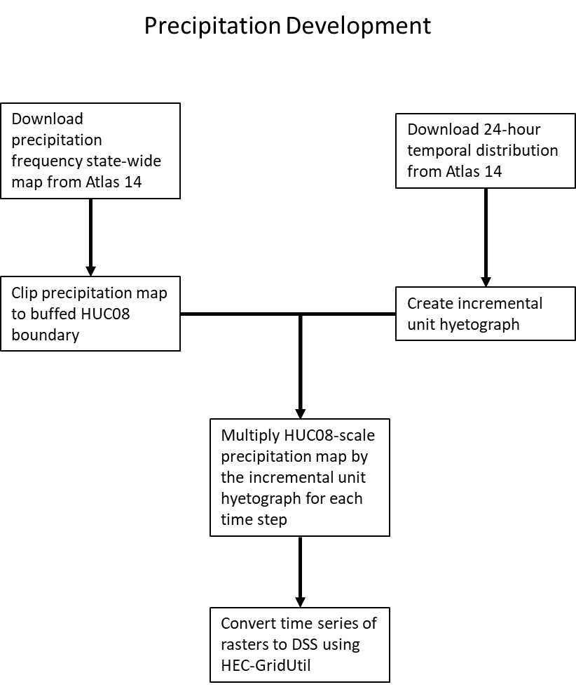
Figure B.1 – Flow chart demonstrating Stantec’s precipitation dataset derivation process
As can be seen in Figure B.2 and B.3 below, the cumulative rainfall amount at this stadium is shown to be 11.9-inches in RASMapper (utilizing the created precipitation raster) as well as on NOAA’s website. This confirms that the gridded raster dataset used within the model is functioning correctly.
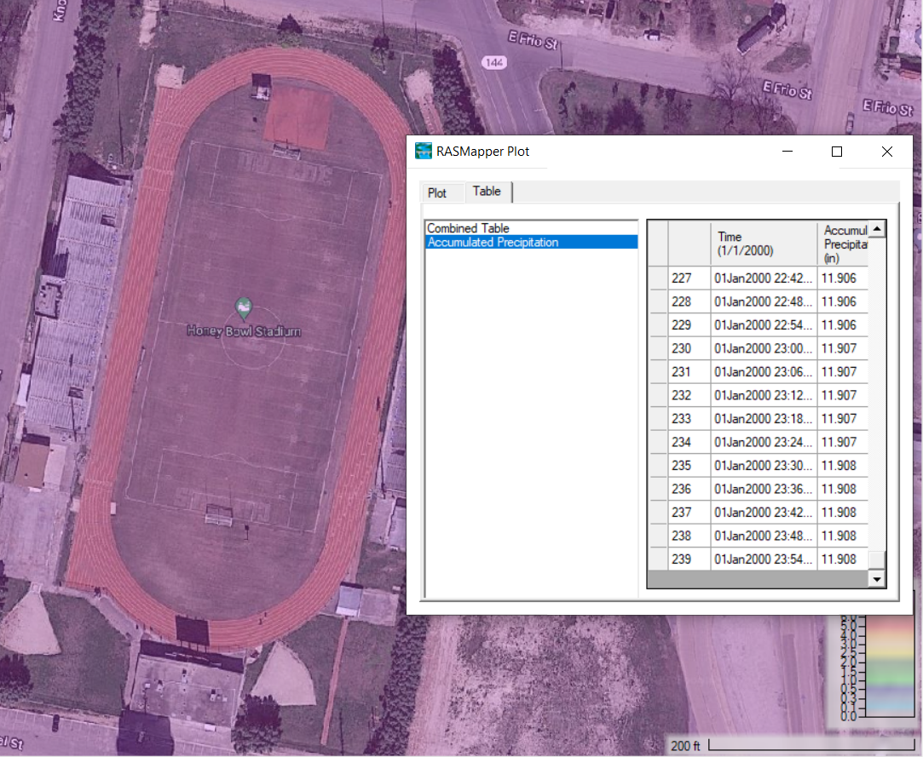
Figure B.2 – Cumulative 100-year, 24-hour precipitation at Honey Badger Stadium in Uvalde, TX
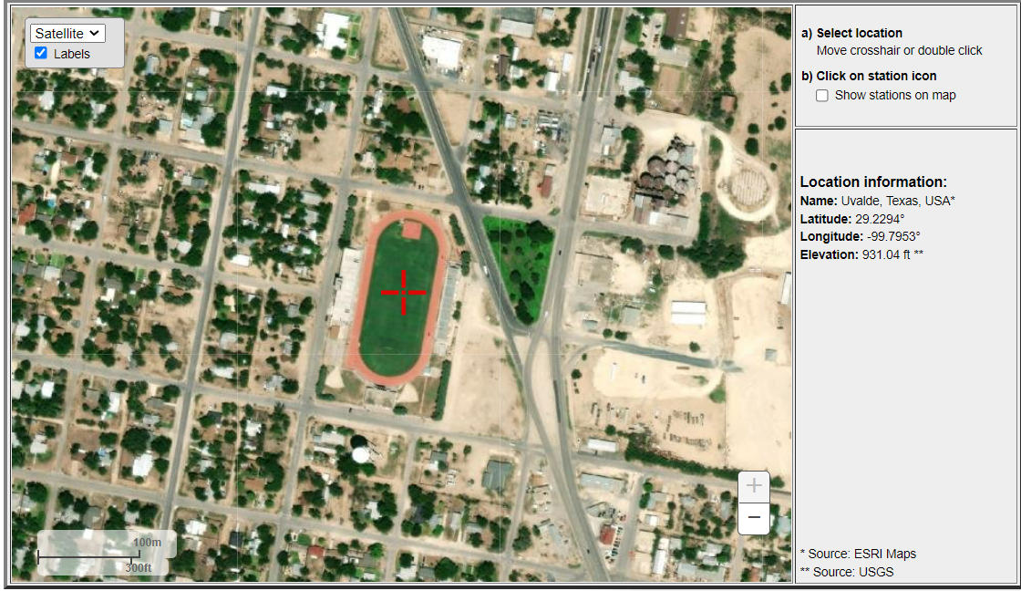
Figure B.3 –Honey Badger Stadium view from Atlas 14 browser

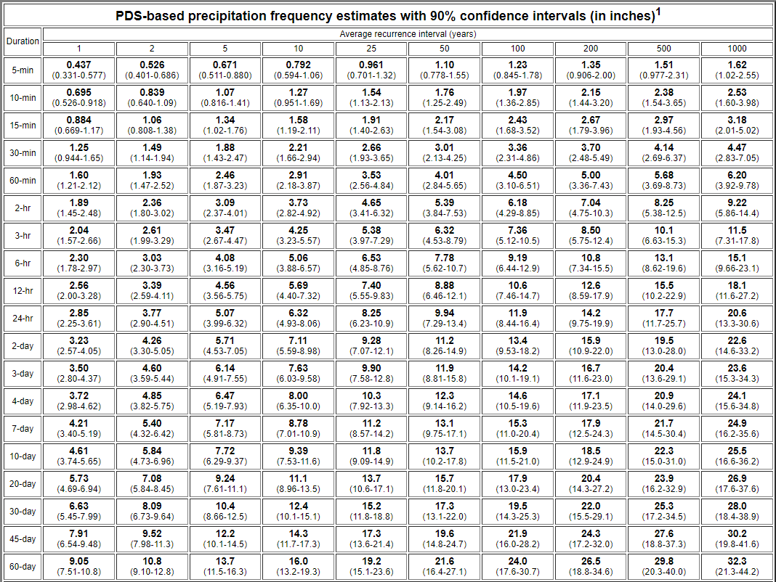
Figure B.4 – 100-yr 24-hr precipitation value from Atlas 14 (corresponding to location show in figure 2 and 3, Honey Badger stadium

Figure B.0-1. Comparison of Atlas 14 and normalized model cumulative precipitation.

Figure B.6 below provides an overview of the development methodology for the Curve Number and Manning’s n base data layers.
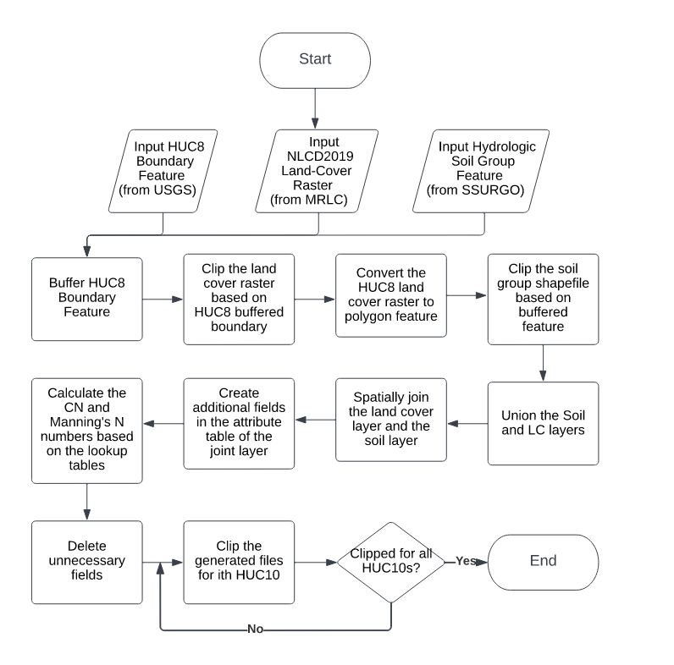
Figure B-6. Flow chart demonstrating Stantec’s curve number spatial dataset derivation process

Appendix C – Comparison of flow leveraging methods for Upper Nueces, Middle Nueces, and upper Frio BLE’s
Reference: Comparison of flow leveraging methods for Upper Nueces, Middle Nueces, and Upper Frio BLEs
Abstract
While developing BLE models along the Nueces and Frio Rivers, we observed unreasonably high flow rates in the downstream watersheds. The flows were determined to be unreasonable because after maximum adjustment of flow calibration parameters, the flows were higher than the upper confidence limits of peak flows estimated by Bulletin 17C analysis of USGS gage peak flows.
The USGS Scientific Investigations Report (SIR) 2012-5136 agreed with our observations. We investigated 4 solutions to provide models that tie-in to upstream models and produce results in agreement with USGS gage data.
- Mimic areal reduction in main channels using interior boundary condition lines
  - Method was complex and not easily understood by end users
  - Method required creating a new set of inputs that did not exist in other BLE models
- Increased infiltration parameters
  - Method did not produce reasonable results
- Altered terrain to provide maximum reservoir storage
  - Method did not produce reasonable results
- Synthetic hydrographs – Selected Method
  - Method was simple and produced reasonable results using the existing set of inputs

Introduction
While developing BLE models along the Nueces and Frio Rivers, we observed unreasonably high flow rates in the downstream watersheds. The flows were determined to be unreasonable because after maximum adjustment of flow calibration parameters, the flows were higher than the upper confidence limits of peak flows estimated by Bulletin 17C analysis of USGS gage peak flows.
Attenuated peaks were observed as we went downstream along these streams. Upon further investigation it was found that this area has a unique hydrology where upper portions of the watershed are susceptible to flash flooding being in the hill country. Upon exiting the hill country, the floodwater spreads out slowing down on its way downstream. This can be confirmed from the findings of a USGS study (Dietsch and Wehmeyer, 2012, SIR 2012-5136) summarized below.
- South Texas observes intense and isolated storms, where rainfall varies greatly over a short distance. (p. 35)
- Most rainfall along the Nueces basin evapotranspires, yet few evapotranspiration data is available. Lack of availability and use of evapotranspiration data can cause errors in representing actual hydrologic process of the watershed. (p. 35)
- The study utilized USGS gages 08193000, 08194000, 08194500 and 08210000 for model testing and calibration indicating the validity and accuracy of the data that is available at these gages (p. 8 Table 3)
- The study utilized a seven-day averaging method to improve the model statistics as they were having a difficulty in simulating flows during periods of sudden and intense runoff. (p. 35)
- Amongst the four gaging stations used for calibration 08194500 Nueces River near Tilden, Tex., had the highest(worse) RMSE as percentage of mean flow rate. Thus, indicating limitations of producing a well calibrated Nueces River model. (p. 35)
Currently, the BLE models being developed by Stantec utilize all the gages used by the USGS study that fall within the scoped HUC basins. The study from USGS supports Stantec’s concerns and limitations of producing a well calibrated hydrologic and hydraulic model at the Nueces River Watershed system.
The scope of the Base Level Engineering project requires the usage of rain on grid HEC-RAS models which has limitations.
- Currently, only one hyetograph can be applied to a 2D area. Other characteristics like infiltration and evapotranspiration can be applied spatially separately but are limited in use for removing water.
- Currently, spatially varied groundwater recharge (groundwater recharge across a watershed) is not intended for modeling in HEC-RAS.
Stantec has applied several approaches in an effort to develop a solution to modeling these unique hydrologic conditions.
Approach 1: Mimic the effects that an Areal Reduction Factor (ARF) would have on the peak flow rate along the main channel in a 2D ROG model
According to the William Asquith’s USGS ARF WRIR 99-4267, the total precipitation volume is halved for drainage areas of 3,000-sqmi; however, the BLE models developed by Stantec as part of this study are applying the full rainfall depth of the 100YR storm on all the models. Four of the HUC 8’s that Stantec is modeling are interconnected and total more than 8,500-sqmi in contributing drainage area. It is unrealistic to expect for a 1% annual chance event to occur across such a large area at the same time. Applying ARF’s to many interconnected 2D models is not as straightforward as it would be in a 1D model due to a variety of issues, for example the magnitude of points to consider (in order to avoid oversimplifying and underrepresenting floodplain extents in areas upstream of the point being considered) and the length of run-times. To overcome these obstacles, Stantec developed an approach which sought to incrementally reduce flows within the main stem to align with peak flow values that you would expect to see if you had applied an ARF for each of the increment’s total contributing drainage area. The steps below summarize the steps that were taken as part of this approach:
- A relationship was developed using multiple models that showed what the average percent reduction in peak flow was for various ARFs applied to the model’s spatial precipitation.
- A second relationship was developed and referred to as the reduction curve. This was developed by first using many points within a model where ARF rainfall had been applied to then find the trend line in average percent reduction (from the non-ARF precipitation model’s flow) across the entire time series for the model.
- Interior boundary condition lines were drawn within the models at locations with contributing drainage areas (in square miles) totaling 100, 250, 500, 1000, and then at every 500-sqmi thereafter.
- The base precipitation’s flowrate time series at these locations was brought into Excel and reduced by use of the reduction curve mentioned above.
- The difference in flowrate at each time step (between the base precipitation versus having the reduction curve applied) was obtained.
- The differences at each step were applied as negative flow hydrographs at the interior boundary conditions mentioned above (consideration was given for flow that may have already been removed at points u/s within the model).
- The method was successful in removing the flow at the points as desired without sudden contractions in the mapped floodplain.
The process was still cumbersome as many plan runs were required to be ran. In addition, it would have been challenging for the person picking up these models to follow the similar approach due to multiple simulations.
Approach 2: Infiltration methodology to remove excess volume
To remove excess flow from the models to better represent realistic flows passing from one HUC-8 to another. Exceptionally high infiltration rates were applied to the channel refinement areas. To test the methodology, extreme values were used. The channel refinement region SCS Curve Number was set to a value of 10, with an abstraction ratio of 1 and a minimum infiltration rate of 10 inches per hour. From this scenario, it was discovered that infiltration is only applied to the precipitation which falls on a given cell. Therefore, it was determined that this was not a feasible option to remove flow.
Approach 3: Altered Terrain to provide maximum reservoir storage
It was found upon investigation that multiple model areas within HUC 12110103 had full dams when the Lidar data was captured. Based on the aerial imagery and knowledge of the study area, the dams in the region are usually anticipated to be dry prior to flood events since their basic purpose is irrigation and the area observes long periods of drought conditions. To simulate the normal conditions within the Nueces River we excavated the Lidar based on the surface area and volume found on the National Inventory of Dams. This condition was modeled to remove the volume in our models that could have possibly contributed to unreasonably high flows at the gages. Once the Lidar was updated, we ran the HUC 12110103 models for following scenarios.
- Full flows from upstream models with rain
- Full flows from upstream models with no rain
Upon comparison of the model flows at USGS gages 08192000 and 08193000, it was found that the modeled flows remained unreasonably high even after burning the terrain representing a dry condition for the irrigation lakes. The second model run removed all the rain leaving just the upstream leveraged flow, and it was still unreasonably high. This terrain modification method showed that the flow reduction is not dependent on reservoir storage.
Approach 4: Synthetic Hydrographs
As an alternative to leveraging inflows from upstream models, a synthetic inflow hydrograph was created. Synthetic hydrograph transfers an attenuated narrow peak to the downstream model that helps in tying in the water surface elevation within 0.5-ft and allowing model flows to agree with statistical gage flow estimates.
This synthetic hydrograph is a 4-hour event which peaks after two hours and rises and falls at a rate of 25%. The peak flow of the synthetic hydrograph is initially selected by viewing the upstream model’s rating curve at the tie-in location to determine the flow rate for the tie-in water surface elevation. For models where this does not produce a tie-in, the HEC-RAS hydrograph multiplier option is used to appropriately increase or decrease the synthetic inflow hydrograph as needed for water surface elevation tie-in.
The idea behind using a synthetic hydrograph is to transfer enough flow to tie-in the water surface elevation, but not enough volume to affect the hydrographs at the gages. These could be easily replicated based on the upstream model’s rating curve hence offering an ease of use to the person who picks up the model at later stages.

Fig D-1. Synthetic inflow hydrograph for a 4-hour event

Figures related to Solution Investigation
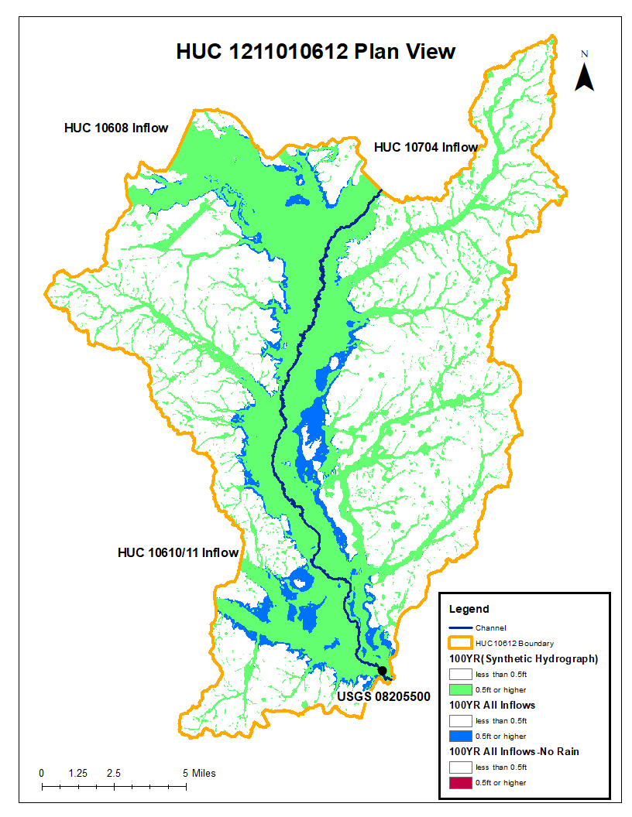
Fig D-2. Comparison of 100-year floodplain (Synthetic inflow v. full inflow from calibrated, upstream basins)

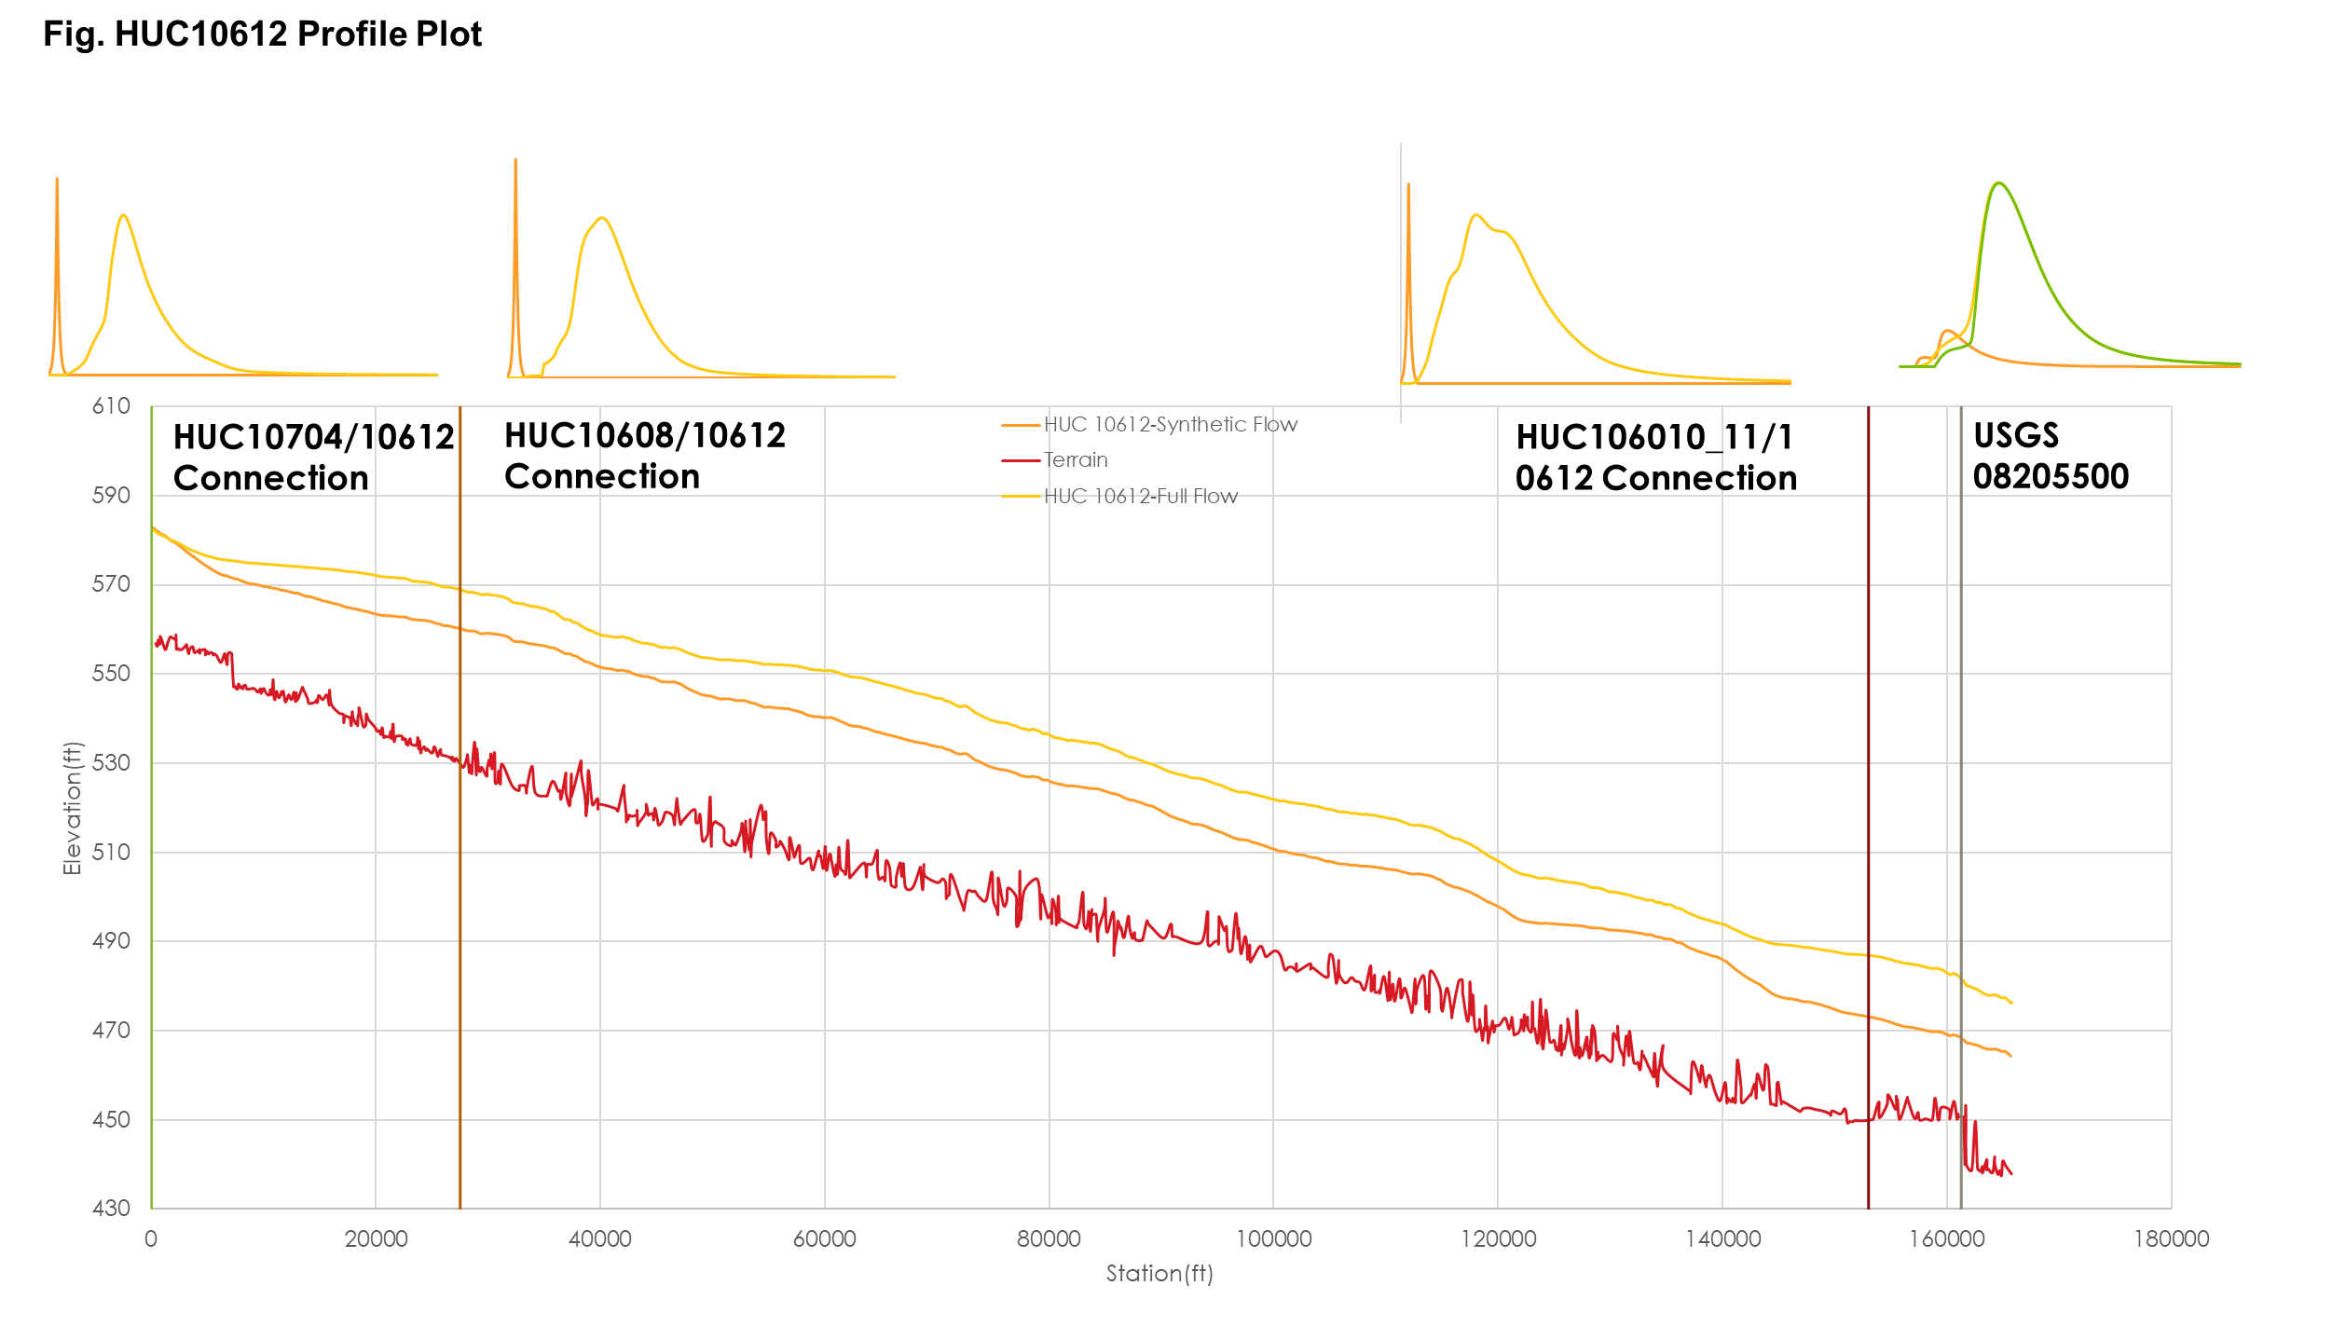

Fig D-3. Flow comparison at HUC10704 and 10612 Connection

Fig D-4. Flow comparison at HUC10608 and 10612 Connection

Fig D-5 . Flow comparison at HUC10610/11 and 10612 Connection

Fig D-6. Flow comparison at USGS 08205500

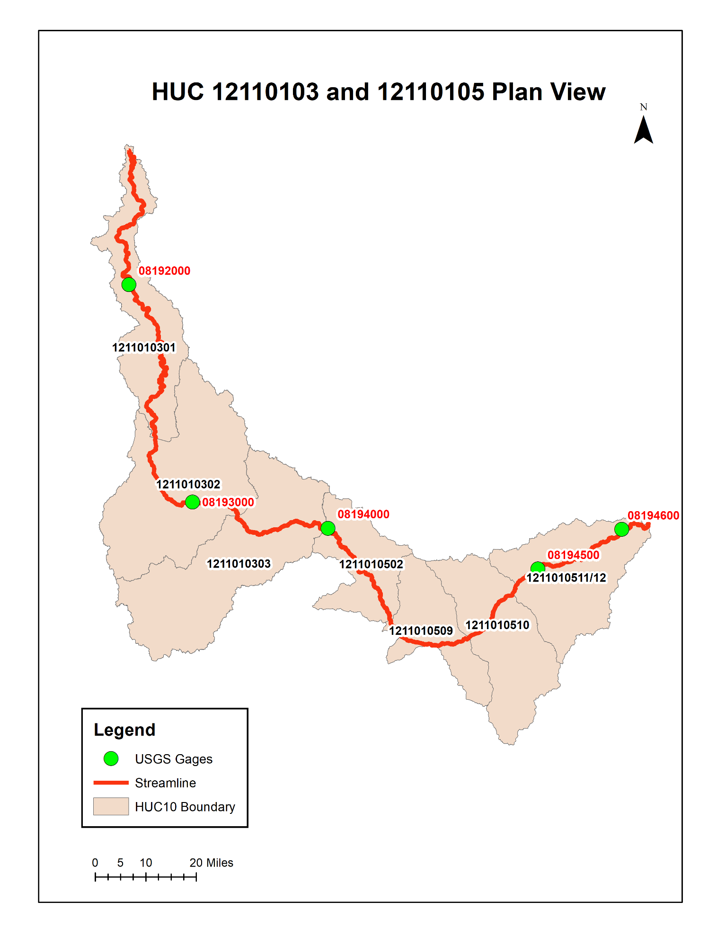
Fig D-7.

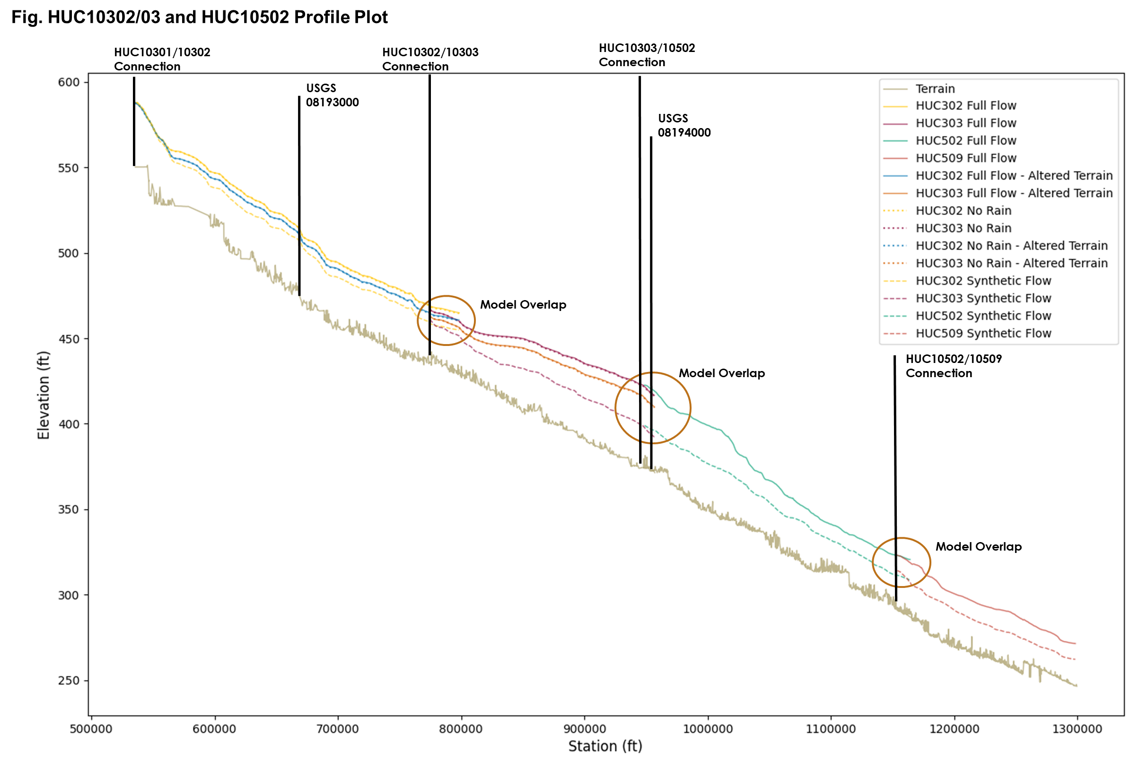
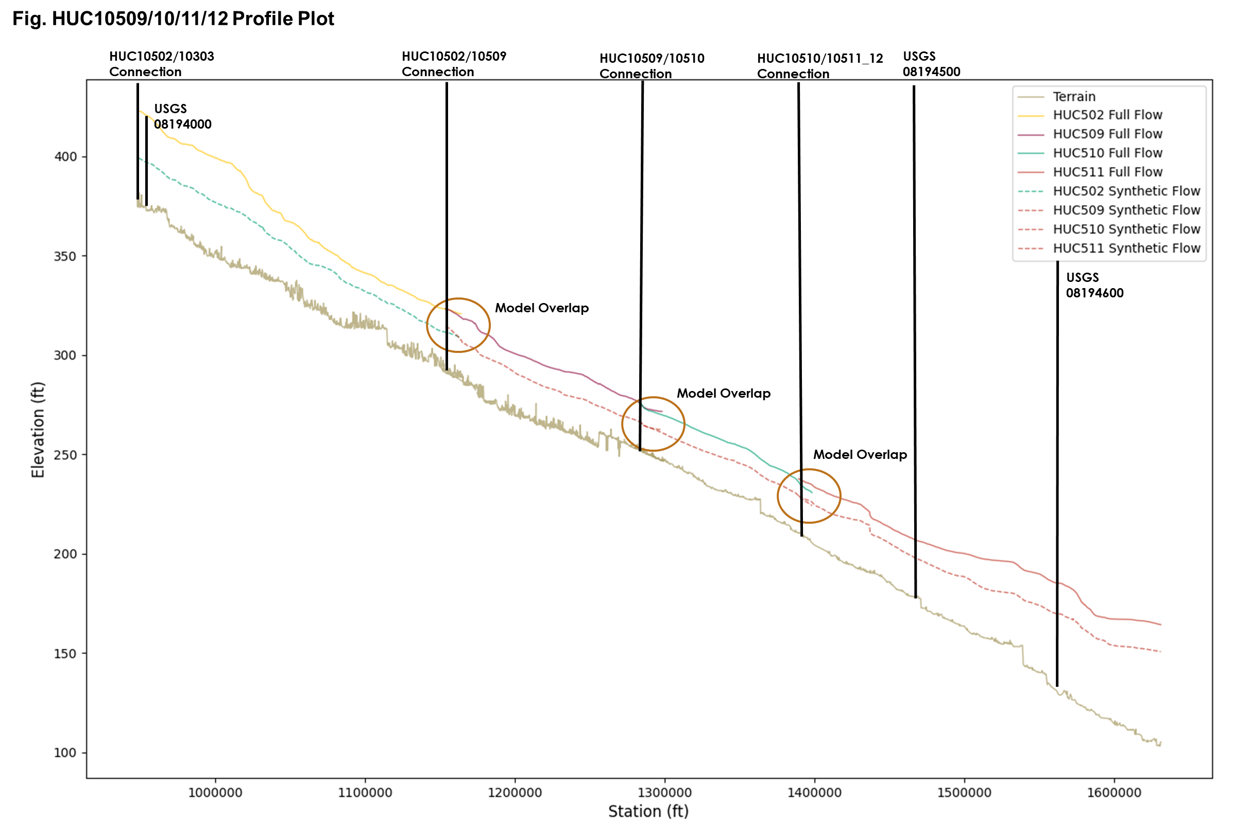
Fig. Flow comparison at HUC10301 and 10302 Connection

Fig. Flow comparison at USGS Gage 08193000

Fig. Rating Curve at USGS Gage 08193000

Fig. Flow comparison at HUC10302 and 10303 Connection

Fig. Flow comparison at HUC10303 and 10502 Connection

Fig. Flow comparison at USGS Gage 08194000

Fig. Rating Curve at USGS Gage 08194000

Fig. Flow comparison at HUC10501 and 10502 Connection

Fig. Flow comparison at HUC10502 and 10509 Connection

Fig. Flow comparison at HUC10503 and 10509 Connection

Fig. Flow comparison at HUC10505 and 10509 Connection

Fig. Flow comparison at HUC10507 and 10509 Connection

Fig. Flow comparison at HUC10508 and 10509 Connection

Fig. Flow comparison at HUC10509 and 10510 Connection

Fig. Flow comparison at HUC10510 and 10511_12 Connection

Fig. Flow comparison at USGS Gage 08194500

Fig. Rating Curve at USGS Gage 08194500

Fig. Flow comparison at USGS Gage 08194600

Appendix D – Statement from the Nueces River Authority

Appendix E – FEMA Model Review and Recommendations with Stantec Responses



https://www.fema.gov/sites/default/files/documents/fema_base-level-engineering-guidance_112021.pdf)

